**EMERALD ROYAL INTERNATIONAL SCHOOL MPAPE, ABUJA**

**LESSON PLAN AND NOTE FOR WEEK 7 ENDING 23/02/2024**

**TERM: Second**

**WEEK: 7th**

**DATE: 19/02/2024**

**CLASS: Nursery 2**

**SUBJECT: Letter work**

**TOPIC: Initial and final consonant 2**

**SUB—TOPIC: Initial and final consonant ‘tr ’and‘ tw’**

**PERIOD: 3rd**

**TIME: 09:30—10:10am**

**DURATION: 40 minutes**

**NUMBER IN CLASS : 13**

**AVERAGE AGE: 5 years**

**SEX: Mixed**

**LEARNING OBJECTIVES: By the end of the lesson, the Pupils should be able to:**

**1. Mention words with initial and final consonant ‘tr’**

**2. State words with initial and final consonant ‘tw’**

**RATIONALE: For Pupils to know words with initial and final consonant ‘tr’ and ‘tw’**

**PREVIOUS KNOWLEDGE: Pupils have learnt things in the classroom in previous lesson.**

**INSTRUCTIONAL MATERIALS : A chart of words with initial and final consonants**

**REFERENCE MATERIALS: My choice of English Language stage 3 by J.M. OMOTAYO**

**LESSON DEVELOPMENT**

|  |  |  |  |
| --- | --- | --- | --- |
| **STEPS** | **TEACHER'S ACTIVITIES** | **PUPILS' ACTIVITIES** | **LEARNING POINT** |
| **Introduction** | **Teacher introduces the lesson by singing nursery rhymes.** | **Pupils sing the rhymes along with the teacher.** | **To arouse pupils interest for the lesson ahead.** |
| **Presentation step 1** | **Teacher mentions words with initial and final consonant blends ‘tr’ to pupils and asks them to repeat after her.** | **Pupils listen to the teacher and repeat after her.** | **For proper understanding.** |
| **Step 2** | **Teacher States words with initial and final consonant blends ‘tw’ and also asks Pupils to repeat after her.** | **Pupils pay attention to the teacher and repeat after her.** | **For better understanding.** |
| **Board summary** | **Teacher writes the whole note of lesson on the board for pupils to copy. That is;**  **INITIAL AND FINAL CONSONANT 'TR'**  **' tr' as in**  **1. tree**  **2. trap**  **3. tray**  **4. train**  **5. track etc**  **INITIAL AND FINAL CONSONANT 'TW'**  **'tw' as in**  **1. twin**  **2. twice**  **3. twenty**  **4. twelve**  **5. tweet etc.** | **Pupils copy the note into their books** | **For onward study.** |
| **Evaluation** | **Teacher evaluates the lesson by asking pupils to spell and pronounce the words on the board one after the other.** | **Pupils go to the board and spell and pronounce the words on the board one after another.** | **To enhance pupils participation in class.** |
| **Conclusion** | **Teacher concludes the lesson by marking pupils books.** | **Pupils submit their books for marking** | **For endorsement.** |
| **Assignment** | **1. Mention 10 words with initial and final consonant blend ‘sw’**  **2. List 10 words with initial and final consonant ‘st’** | **Pupils do their assignment at home.** | **To encourage learning at home.** |

**LESSON PLAN AND NOTE FOR WEEK 7 ENDING 23/02/2024**

**TERM: Second**

**WEEK: 7th**

**DATE: 22/02/2024**

**CLASS: Nursery 2**

**SUBJECT: Letter work**

**TOPIC: Initial and final consonants 2**

**SUB—TOPIC: Initial and final consonant blends‘ sw’and ‘st’**

**PERIOD: 2nd**

**TIME: 08:50—09:30 am**

**DURATION: 40 minutes**

**NUMBER IN CLASS: 13**

**AVERAGE AGE: 5 years**

**SEX: Mixed:**

**LEARNING OBJECTIVES: By the end of the lesson, the Pupils should be able to;**

**1. Mention words with initial and final consonant ‘sw’**

**2. List words with initial and final consonant ‘st’**

**RATIONALE: For Pupils to know words with initial and final consonant ‘sw' and ‘st’**

**PREVIOUS KNOWLEDGE: Pupils have learnt words with initial and final consonant ' tr'and 'tw'**

**INSTRUCTIONAL MATERIALS: A chart of words with initial and final consonant 'sw' and 'st'**

**REFERENCE MATERIALS: My choice of English language stage 3 by J .M . OMOTAYO**

**LESSON DEVELOPMENT**

|  |  |  |  |
| --- | --- | --- | --- |
| **STEPS** | **TEACHER'S ACTIVITIES** | **PUPILS' ACTIVITIES** | **LEARNING POINT** |
| **Introduction** | **Teacher reviews the previous lesson.** | **Pupils pay attention to the teacher.** | **To arouse pupils interest for the lesson ahead.** |
| **Presentation step 1** | **Teacher mentions the words with initial and final consonant 'sw' and then asks Pupils to repeat after her.** | **Pupils listen to the teacher and repeat after her.** | **For proper understanding.** |
| **Step 2** | **Teacher lists words with initial and final consonant 'st' and also asks Pupils to repeat after her.** | **Pupils pay attention to the teacher and repeat after her.** | **For better understanding.** |
| **Board summary** | **Teacher summarizes the lesson by writing the whole note of lesson on the board for pupils to copy. That is;**  **INITIAL AND FINAL CONSONANT 'SW' ARE:**  **1. Sweet**  **2. Switch**  **3. Swim**  **4. Sweep**  **5. Swan etc.**  **INITIAL AND FINAL CONSONANT 'ST' ARE:**  **1. Test**  **2. Best**  **3. Past**  **4. Last**  **5. List etc.** | **Pupils copy the note into their exercise books.** | **For onward study.** |
| **Evaluation** | **Teacher asks pupils to all stand and then spell and pronounce the words on the board.** | **Pupils all stand and pronounce the words on the board.** | **To create platform for slow learners.** |
| **Conclusion** | **Teacher concludes the lesson by marking pupils books.** | **Pupils submit their books for marking.** | **For endorsement.** |
| **Assignment** | **1. Spell and write 10 words with initial and final consonant 'sw'.**  **2. Write 10 words with initial and final consonant 'st'.** | **Pupils do their assignment at home.** | **To encourage learning at home.** |

**LESSON PLAN AND NOTE FOR WEEK 7 ENDING 23/02/2024**

**TERM: 2nd**

**WEEK: 7th**

**DATE: 23/02/2024**

**GLASS: Nursery 2**

**SUBJECT: Letter work**

**TOPIC: Initial and final consonant 2**

**SUB—TOPIC: Words with initial and final consonant 'rm' and 'rp'.**

**PERIOD: 3rd**

**TIME: 09: 30—10:10am**

**DURATION: 40 minutes**

**NUMBER IN CLASS: 14**

**AVERAGE AGE: 5 years**

**SEX: Mixed**

**LEARNING OBJECTIVES: By the end of the lesson, the Pupils should be able to:**

**1. Mention words with initial and final consonant 'rm'**

**2. State words with initial and final consonant 'rp'**

**RATIONALE: For Pupils to learn how to read.**

**PREVIOUS KNOWLEDGE: Pupils have learnt initial and final consonant tr, tw, sw and st .**

**INSTRUCTIONAL MATERIALS: A chart of words with initial and final consonant blends.**

**REFERENCE MATERIALS: My choice of English language stage 3 by J.F. OMOTAYO**

**LESSON DEVELOPMENT**

|  |  |  |  |
| --- | --- | --- | --- |
| **Steps** | **Teacher's activities** | **Pupils' activities** | **Learning point** |
| **Introduction** | **Teacher introduces the lesson by reviewing the previous lesson.** | **Pupils pay attention to the teacher.** | **To arouse pupils interest for the lesson ahead.** |
| **Presentation step 1** | **Teacher mentions the examples of words with initial and final consonant 'rm' to pupils and asks them to repeat after her.** | **Pupils listen to the teacher and repeat after her.** | **For proper understanding.** |
| **Step 2** | **Teacher States the examples of words with initial and final consonant 'rp' to pupils and also asks them to repeat after her.** | **Pupils pay attention to the teacher and repeat after her.** | **For better understanding.** |
| **Board summary** | **Teacher writes the whole note of lesson on the board for pupils to copy. That is;**  **Initial and final consonant blends 'rm' and 'rp' are:**   |  |  | | --- | --- | | **Initial 'rm'** | **Initial 'rp'** | | **Worm** | **Harp** | | **Storm** | **Sharp** | | **Farm** | **Warp** | | **Alarm** | **Burp** | | **Firm** | **Harp** | | **Pupils copy the note into their exercise books.** | **For onward study.** |
| **Evaluation** | **Teacher asks pupils to all stand and then spell and pronounce the words on the board.** | **Pupils all stand and pronounce the words on the board all together.** | **To enhance Pupils participation in class.** |
| **Conclusion** | **Teacher concludes the lesson by marking pupils books.** | **Pupils submit their books for marking.** | **For endorsement.** |
| **Assignment** | **1. What are Digraphs?**  **2. Give 5 examples of digraphs.**  **3. Generate 5 words with digraphs 'ck'** | **Pupils do their assignment at home.** | **To encourage learning at home.** |

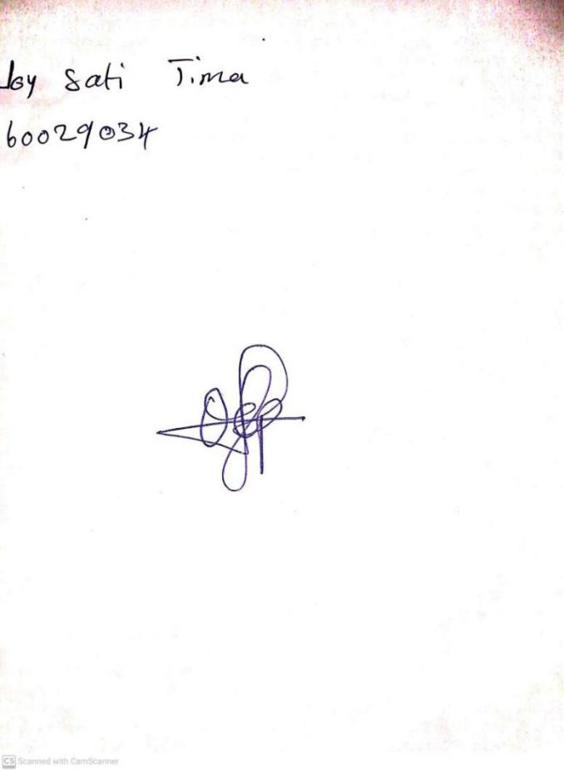

**16TH FEBRUARY, 2024**

**Perpetual Ojoma Ocheja**

**Stream Head Nursery**