**EMERALD ROYAL INTERNATIONAL SCHOOL MPAPE, ABUJA**

**LESSON PLAN AND NOTE FOR WEEK 2 PERIOD 1 ENDING 19/01/2024**

**TERM: 2nd**

**WEEK: 2**

**DATE: 15/01/2024**

**CLASS: Nursery 2**

**SUBJECT: Number work**

**TOPIC: Number Group 1—30**

**SUB—TOPIC: Counting set of objects in group.**

**PERIOD: 3rd**

**TIME: 08:50—09:30am**

**DURATION: 40 minutes**

**NUMBER IN CLASS: 13**

**AVERAGE AGE: 5 years**

**SEX: Mixed**

**LEARNING OBJECTIVES: By the end of the lesson, the pupils should be able to:**

**1. Count numbers 1—10 orally.**

**2. Identify and identify objects 1—10.**

**RATIONALE: For pupils to be able to count objects 1—10**

**PREVIOUS KNOWLEDGE: pupils have been learning counting of numbers.**

**INSTRUCTIONAL MATERIALS: Books, pencils, and crayons.**

**REFERENCE MATERIALS: My choice of mathematics stage 3.**

**LESSON DEVELOPMENT**

|  |  |  |  |
| --- | --- | --- | --- |
| **Steps** | **Teacher's activities** | **Pupils' activities** | **Learning point** |
| **Introduction** | **Teacher introduces the lesson by singing nursery number rhymes.** | **Pupils sing the number rhymes along with the teacher.** | **To get pupils minds ready for the lesson ahead.** |
| **Presentation step 1** | **Teacher presents the lesson by writing numbers 1—10 on the board, count and then asks pupils to repeat after her. As:**  **NUMBER 1—10**  **1 2 3 4 5**  **6 7 8 9 10** | **Pupils count the numbers after the teacher.** | **For proper understanding.** |
| **Step 2** | **Teacher writes group of objects on the board, count and asks Pupils to repeat after her.** | **Pupils pay attention to the teacher and repeat after her.** | **For better understanding.** |
| **Board summary** | **Teacher writes the whole note of lesson on the board for pupils to copy. That is:**  **SORTING AND CLASSIFYING**    **1 orange**    **2 pencils**    **3 oranges**    **4 triangles**    **5 cups**    **6 balls**    **7 squares**    **8 oranges**    **9 crayons**    **10 balls** | **Pupils copy the note into their exercise books** | **For onward understanding.** |
| **Evaluation** | **Teacher evaluates the lesson by asking pupils the following questions;**  **Which group has the following number of objects?**  **1. Two objects?**  **2. One object?**  **3. Five objects?**  **4. Three objects?**  **5. Four objects?** | **Pupils answer the questions ask by the teacher.** | **To assess pupils level of understanding.** |
| **Conclusion** | **Teacher concludes the lesson by marking pupils books.** | **Pupils submit their books for marking.** | **For endorsement.** |
| **Assignment** | **Count and write the numbers in each group of objects.**  **1. Cups =**    **2. Triangles =**    **3. Orange =**    **4. Balls =**    **5. Oranges =**    **6. Pencils =** | **Pupils do their assignment at home.** | **To encourage learning at home.** |

**LESSON PLAN AND NOTE FOR WEEK 2 PERIOD 2 ENDING 19/01/2024**

**TERM: 2nd**

**WEEK: 2**

**DATE: 16/01/2024**

**CLASS: Nursery 2**

**SUBJECT: Number Work**

**TOPIC: Number Group 1—30**

**SUB—TOPIC: Counting set of objects 11–20 in groups.**

**PERIOD: 2nd**

**TIME: 08:50—09:30am**

**DURATION: 40 minutes**

**NUMBER IN CLASS: 13**

**AVERAGE AGE: 5 years**

**SEX: Mixed**

**LEARNING OBJECTIVES: By the end of the lesson, the pupils should be able to:**

**1. Count numbers 1–20**

**2. Sort and identify objects 11—20**

**RATIONALE: For pupils to be able to count and identify objects in group 11–20.**

**PREVIOUS KNOWLEDGE: Pupils have learn counting of objects 1–10 in previous Lesson.**

**INSTRUCTIONAL MATERIALS: Books and pencils**

**REFERENCE MATERIALS: My choice of Mathematics stage 3.**

**LESSON DEVELOPMENT**

|  |  |  |  |
| --- | --- | --- | --- |
| **Steps** | **Teacher's activities** | **Pupils' activities** | **Learning point** |
| **Introduction** | **Teacher introduces the lesson by asking pupils to count number 1–10.** | **Pupils count number 1—10** | **To arouse pupils interest for the lesson proper.** |
| **Presentation step 1** | **Teacher present the lesson by writing numbers 1–20 on the board, count and then asks Pupils to repeat after her. Ie,**  **NUMBER 1—20**  **1 2 3 4 5 6 7 8 9 10 11 12 13 14 15 16 17 18 19 20.** | **Pupils count the number after the teacher.** | **To improve pupils counting ability.** |
| **Step 2** | **Teacher groups pupils books and pencils on the table and then count and asks Pupils to count after her.** | **Pupils pay attention to the teacher ant repeat after her.** | **To enhance pupils participation in class.** |
| **Board summary** | **Teacher writes the whole note of lesson on the board for pupils to copy into their books.**  **COUNTING OBJECTS IN GROUP**  **Group 1= 10 cups.**    **Group two is = 20 oranges.** | **Pupils copy the note into their books** | **For onward understanding.** |
| **Evaluation** | **Teacher evaluates the lesson by asking pupils to come out one after another and count the objects on the table.** | **Pupils count the objects on the table one after the other.** | **To enhance pupils counting skills.** |
| **Conclusion** | **Teacher concludes the lesson by marking pupils books.** | **Pupils submit their books for marking.** | **For endorsement.** |
| **Assignment** | **How many objects are in each group?**  **1 .**  **.**  **Group A= _____pencils**  **2.**    **Group B=_____oranges**  **3.**    **Group C=_____ orange**  **4.**    **Group D=______ cups**  **5.**    **Group E =_____ crayons** | **Pupils do their assignment at home.** | **To encourage learning at home.** |

**LESSON PLAN AND NOTE FOR WEEK 2 PERIOD 3 ENDING 19/01/2024**

**TERM: 2nd**

**WEEK: 2**

**DATE: 19/01/2024**

**CLASS: Nursery 2**

**SUBJECT: Number work**

**TOPIC: Number group 1–30**

**SUB—TOPIC: Counting and identification of objects in group 21–20**

**PERIOD: 3rd**

**TIME: 08:10–08:50am**

**DURATION: 40 minutes**

**NUMBER IN CLASS: 13**

**AVERAGE AGE: 5 years**

**SEX: Mixed**

**LEARNING OBJECTIVES: By the end of the lesson, the pupils should be able to:**

**1. Count number 1–30**

**2. Count objects in group 21–30**

**RATIONALE: For pupils to know counting of objects in groups.**

**PREVIOUS KNOWLEDGE: Pupils have learn counting of objects 1–20 in previous lesson.**

**INSTRUCTIONAL MATERIALS: Objects in the class**

**REFERENCE MATERIALS: My choice of Mathematics stage 3.**

**LESSON DEVELOPMENT**

|  |  |  |  |
| --- | --- | --- | --- |
| **Steps** | **Teacher's activities** | **Pupils' activities** | **Learning point** |
| **Introduction** | **Teacher introduces the lesson by singing nursery number rhymes.** | **Pupils sing the rhymes along with the teacher.** | **To arouse pupils interest for the lesson ahead.** |
| **Presentation step 1** | **Teacher writes numbers on the board 1–30 ,count and asks Pupils to repeat after her.**  **NUMBER 1–30**  **1 2 3 4 5 6 7 8 9**  **10 11 12 13 14 15**  **16 17 18 19 20 21**  **22 23 24 25 26 27**  **28 29 30** | **Pupils listen attentively to the teacher and repeat after her.** | **For proper understanding.** |
| **Step 2** | **Teacher draws objects in groups on the board for pupils to count and write their answers. That is;**  **1. Group A**        **Group A=_______ fruits?**  **2. Group B**    **Group B =____ oranges?**  **3. Group C**            **Group C = ____ cups?**  **4. Group D**            **Group D = ____ balls?**  **etc** | **Pupils count and write the answers to each group.** | **For better understanding.** |
| **Board summary** | **Based on the answer provided by the pupils, teacher then go through the lesson over again.** | **Pupils pay attention to the teacher.** | **For onward study.** |
| **Evaluation** | **Teacher evaluates the lesson by asking pupils to count number 1–30 one after the other.** | **Pupils count the numbers one after another.** | **To assess pupils counting ability.** |
| **Conclusion** | **Teacher concludes the lesson by singing number rhymes.** | **Pupils sing the rhymes along with the teacher.** | **To make learning fun.** |
| **Assignment** | **Count and write number 1–40** | **Pupils do their assignment at home.** | **To encourage learning at home.** |

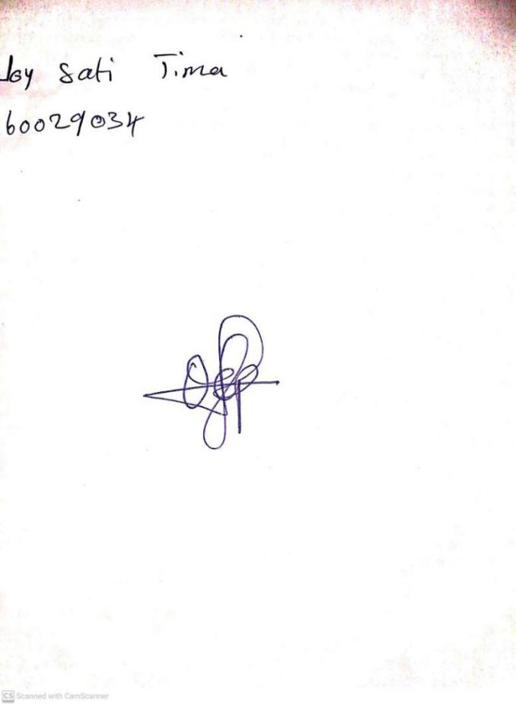

**12TH JANUARY, 2024**

**Perpetual Ojoma Ocheja**

**Stream Head Nursery**