LESSON PLAN/NOTE FOR WEEK 7 ENDING 16/06/2023

TERM: 3rd

WEEK: 7th

DATE: 13/06/2023

CLASS: Nursery 2

SUBJECT: Nature studies

TOPIC: Water–borne diseases

SUB—TOPIC: Meaning and examples of water —borne diseases.

PERIOD: 4th

TIME: 10:40—11:20am

DURATION: 40 minutes

NUMBER IN CLASS: 14

AVERAGE AGE: 5 years

SEX: Mixed

LEARNING OBJECTIVES: By the end of the lesson, the pupils should be able to:

1. Explain the meaning of water —borne diseases.

2. Mention the examples of water —borne diseases.

RATIONALE: For pupils to know the effects of drinking dirty water.

PREVIOUS KNOWLEDGE: Pupils have learnt about water storage in previous lesson.

INSTRUCTIONAL MATERIALS: pictures of Pupils suffering from water borne diseases.

REFERENCE MATERIALS: Basic science and technology for Nursery schools book 3 by OPEMIPO DADA.

LESSON DEVELOPMENT

|  |  |  |  |
| --- | --- | --- | --- |
| Steps | Teacher's activities | Pupils' activities | Learning point |
| Introduction | Teacher introduces the lesson by reviewing the previous lesson. | Pupils pay attention to the teacher. | To prepare pupils minds for the lesson ahead. |
| Presentation step 1 | Teacher explains the meaning of water—borne diseases to the pupils and asks them to repeat after her. | Pupils listen to the teacher and repeat after her. | For better understanding. |
| Step 2 | Teacher mentions the examples of water—borne diseases and also asks Pupils to repeat after her. | Pupils pay attention to the teacher and repeat after the teacher. | For better understanding. |
| Board summary | Teacher writes the whole note of lesson on the board for pupils to copy. That is;  Meaning of water—borne diseases  Water—borne diseases are diseases that people get when they drink dirty water. People get water—borne diseases because dirty water contains germs that make people sick.  Examples of water—borne diseases  1. Cholera  2. Diarrhoea  3. Typhoid fever  4. Guinea–worm infection  5. Dysentery. | Pupils copy the note into their exercise books. | For onward study. |
| Evaluation | Teacher evaluates the lesson by asking pupils the following questions;  1. What is the meaning of water—borne diseases?  2. Mention the examples of water—borne diseases. | Pupils answer the questions ask by the teacher. | To assess pupils level of understanding. |
| Conclusion | Teacher concludes the lesson by marking pupils books. | Pupils submit their books for marking. | For endorsement. |
| Assignment | Activity 21 page 68. Basic science textbook. | Pupils do their assignment at home. | To encourage learning at home. |

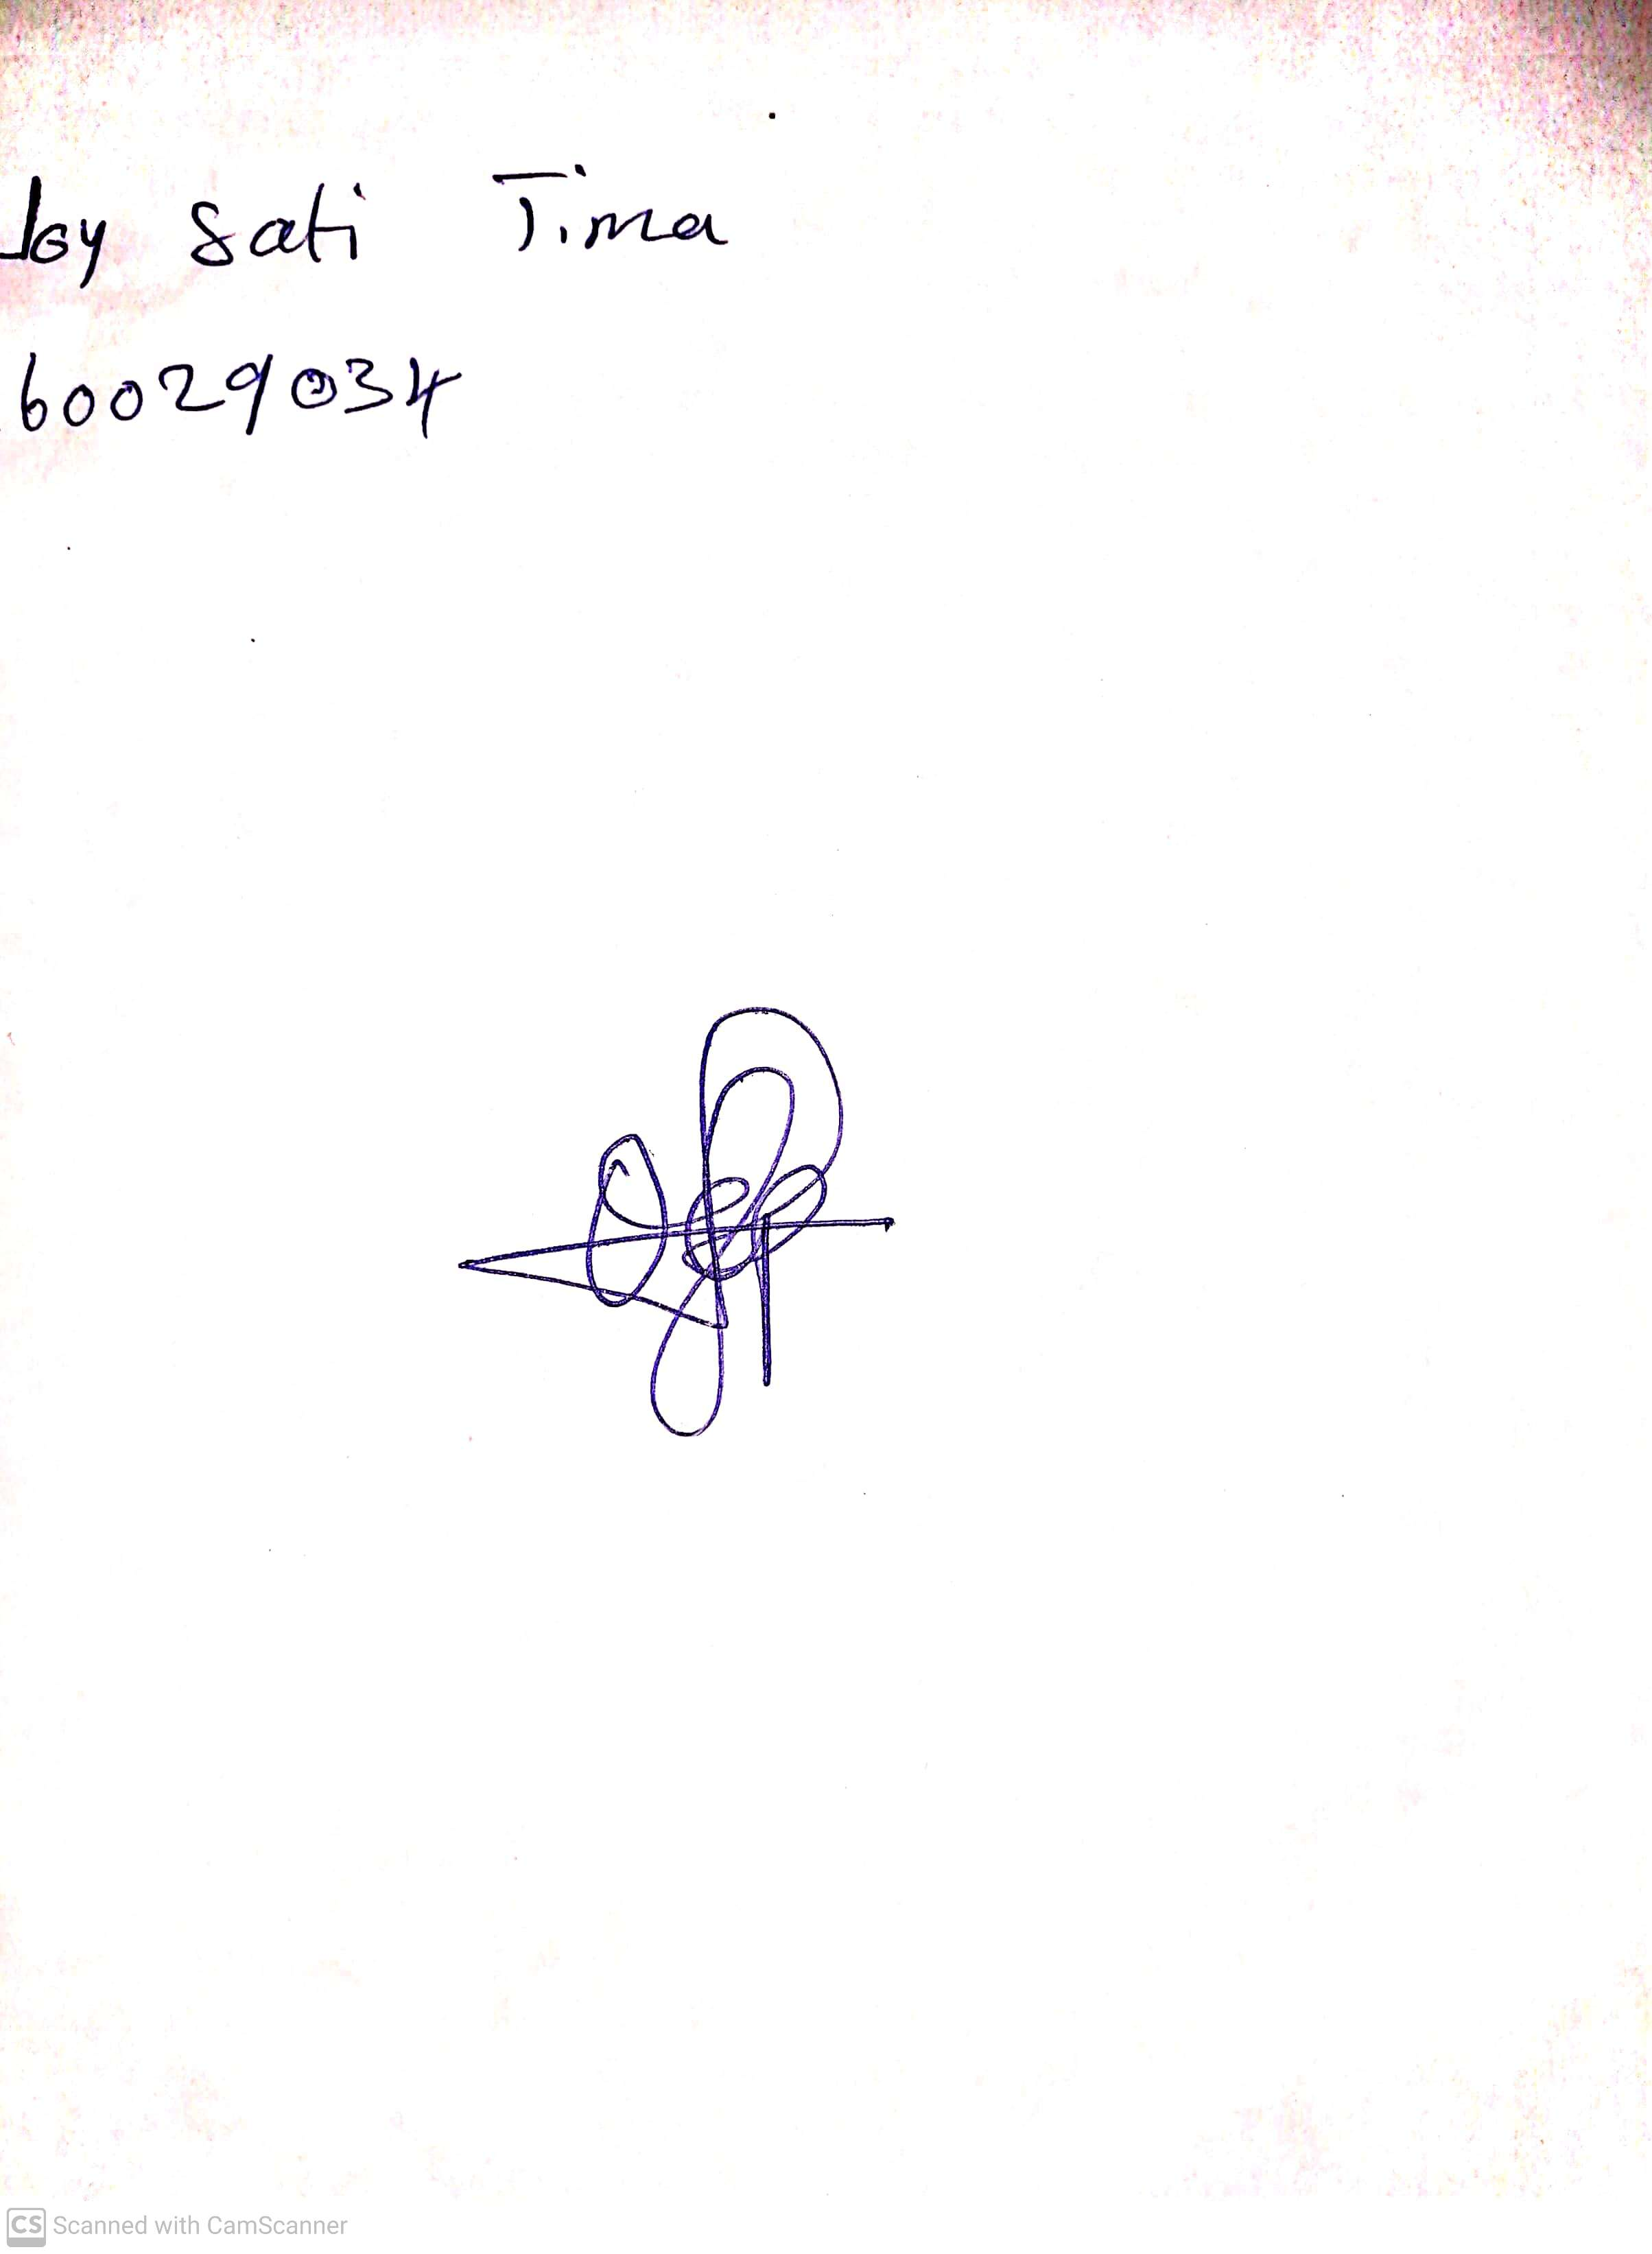

28th April, 2023

Perpetual Ojoma

Stream Head Nursery