**EMERALD ROYAL INTERNATIONAL SCHOOL, MPAPE ABUJA**

**LESSON PLAN AND NOTE FOR WEEK 1 ENDING 5TH MAY, 2023**

**TERM: THIRD**

**WEEK : 1**

**DATE: 2ND - 5TH MAY, 2023**

**SUBJECT : CHEMISTRY**

**TOPIC : WATER**

**SUB- TOPIC : 1. uses of water.**

1. **Laboratory preparation of water.**

**PERIOD: 1ST**

**TIME : 8: 10 - 8 :50**

**DURATION:**  **40 minutes**

**CLASS: SS1**

**NUMBER IN CLASS:**  **7**

**AVERAGE AGE: 14 years**

**SEX: mixed**

**LEARNING OBJECTIVES: By the end of the lesson, the students should be able to;**

1. State the uses of water.
2. State the apparatus used in preparation of water.
3. Explain the laboratory preparation of water.

**RATIONALE:** The students should understand the uses and preparation of water.

**PREVIOUS KNOWLEGDE:** The student have been taught the sources of water.

**INSTRUCTIONAL MATERIALS:** A chart showing the laboratory preparation of water.

**REFERENCE MATERIALS:** New school Chemistry for Senior Secondary Schools by Osei Yaw Ababio .

|  |  |  |  |
| --- | --- | --- | --- |
| **STEPS** | **TEACHER’S ACTIVITIES** | **STUDENTS’ ACTIVITIES** | **LEARNING POINTS** |
| **INTRODUCTION** | The teacher introduces the lesson by reviewing the previous lesson. | The students were active. | To arouse the students interest. |
| **PRESENTATION**  **STEP 1** | The teacher asks the students to state the uses of water. | The students states the uses of water. | To encourage critical thinking. |
| **STEP 2** | The teacher states the apparatus used in the preparation of water. | The students pay attention. | To keep them focus. |
| **STEP 3** | The teacher explains the preparation of water. | The students pay attention. | To keep them focus for better understanding. |
| **BOARD SUMMARY** | USES OF WATER We all use water for drinking, cooking, bathing, cleaning, washing, etc. Factories and large industries use water in large quantities for producing various products required for human welfare. Farmers also use water for irrigating and cultivating crops. Thus, water is necessary for many activities; therefore, it is an essential requirement of life.  The water cycle shows the continuous movement of water within the Earth and atmosphere. It is a complex system that includes many different processes. Liquid water evaporates into water vapor, condenses to form clouds, and precipitates back to earth in the form of rain and snow.  **LABORATORY PREPARATION OF WATER.**  **Preparation of Water**  Water was first prepared in 1781 by an English scientist Henry Cavendish. He discovered hydrogen gas when active metals reacted with sulphuric acid. The hydrogen gas released was highly inflammable and burnt to form a colourless product called water.  Zn + H2SO4 → ZnSO4 + H2↑  2H2 + O2 → 2H2O  Water is also produced by the reduction of metal oxide by hydrogen, burning of hydrogen in air and burning of hydrocarbons in air. Respiration of plants and animals also releases water.  IMG_256  C6H12O6 + 6O2 → 6CO2 + 6H2O + Energy  Glucose + Oxygen → Carbon dioxide + Water + Energy. | The students ask question for clarification. | To create room for slow learners. |
| **EVALUATION** | The teacher evaluates the students with the following questions;   1. State the uses of water. 2. State the apparatus used for the preparation of water. 3. Explain the preparation of water. | The students attempt the questions. | To ascertain their level of understanding. |
| **CONCLUSION** | The teacher concludes by copying note on the board. | The students copy the note into their note books. | For future use. |
| **HOME WORK** | Draw and label the apparatus for the laboratory preparation of water. | The students did your assignment and submit for marking and correction. | To encourage the students to study at home. |

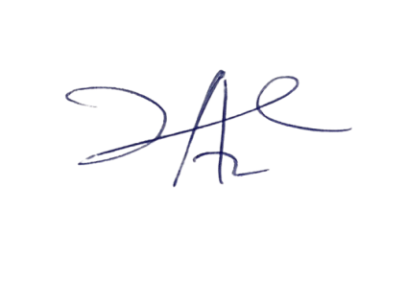

9/5/2023

Principal Head Instuctor