LESSON NOTE / PLAN FOR WEEK 8 ENDING 03/03/2023

TERM: 2nd

WEEK: 8th

DATE: 02/03/2023

CLASS: Nursery 2

SUBJECT: Letter work

TOPIC: Consonant Digraphs 1.

SUB—TOPIC: Generating words with consonant digraphs' ck' and 'ph'.

PERIOD: 2nd

TIME: 08:50—09:30am

DURATION: 40 minutes

NUMBER IN CLASS: 14

AVERAGE AGE: 5 years

SEX: Mixed

LEARNING OBJECTIVES: By the end of the lesson, the Pupils should be able to:

1. Generate words with consonant digraphs 'ck'

2. Mention words with consonant digraphs 'ph'

RATIONALE: For Pupils to know how to pronounce words with consonant digraphs ck and ph.

PREVIOUS KNOWLEDGE: Pupils have learnt the meaning and example of consonant digraphs

INSTRUCTIONAL MATERIALS: Char of words with consonant digraphs .

REFERENCE MATERIALS: Google. com

LESSON DEVELOPMENT

|  |  |  |  |
| --- | --- | --- | --- |
| Steps | Teacher's activities | Pupils' activities | Learning point |
| Introduction | Teacher introduces the lesson by asking pupils to Define consonant digraphs. | Pupils define consonant digraphs. | To prepare pupils minds for the lesson ahead. |
| Presentation step 1 | Teacher generates words with consonant digraphs 'ck' to pupils and then ask them to repeat after her. | Pupils listen attentively to the teacher and repeat after her. | For proper understanding. |
| Step 2 | Teacher mentions words with consonant digraphs 'ph' to pupils and also ask them to repeat after her. | Pupils pay attention to the teacher and repeat after her. | For better understanding. |
| Board summary | Teacher summarizes the lesson by writing the whole note of lesson on the board for pupils to copy into their books. That is; CONSONANT DIGRAPHS 'CK' AND 'PH' .  Consonant digraphs 'ck' are:  1. Clock  2. Black  3. Rock  4. Check  5. Stick etc.  Consonant digraphs 'ph' are:  1. Phone  2. Phonics  3. Phase  4. Phrase  5. Physics  6. Graph  7. Alpha  8. Morph  9. Photo  10. Phobia etc. | Pupils copy the note into their exercise books. | For onward study. |
| Evaluation | Teacher evaluates the lesson by going through the note on the board over again and then ask Pupils to read one after another. | Pupils pay attention to the teacher as she reads and then go to the board one after another and read. | To create platform for slow learners. |
| Conclusion | Teacher concludes the lesson by marking pupils books. | Pupils submit their books for marking. | For endorsement. |
| Assignment | 1. Generate Words with consonant digraphs ‘sh’.  1. Make words with consonant digraphs ‘ch’ | Pupils do their assignment at home. | To encourage learning at home. |

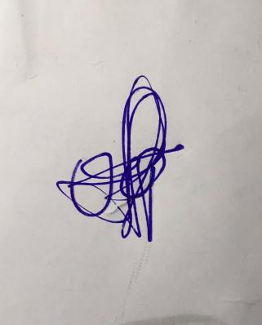

**29th March, 2023**

**Perpetual Ojoma Ocheja**

**Stream Head Nursery**