PRE-NURSERY SCHEME OF WORK ON NATURE STUDIES FIRST TERM.

WEEK 1:- Parts of the body (self awareness).

WEEK 2-3 :- Importance of the parts of the body (functions of body parts).

WEEK 4 :- Sense organs (identification of sense organs of the body).

WEEK 5-6:- Uses of sense organs (functions of the sense organs).

WEEK 7:- Plants.

WEEK 8-9:- Common seeds.

WEEK 10:- Fruits and vegetables.

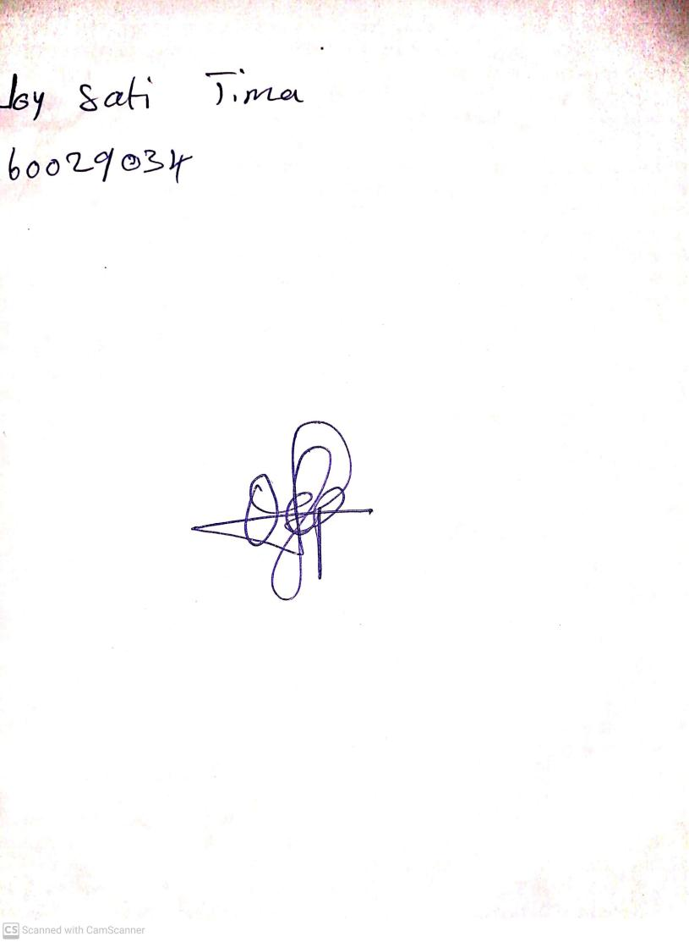

20th August, 2023

Perpetual Ojoma Ocheja

Stream Head Nursery