**LESSON PLAN AND NOTE 1 FOR WEEK 6 ENDING 20/10/2023**

**Term 1st term**

**Week 6th week**

**Date 17th October,2023**

**Class Nursery One**

**Subject Number Work**

**Topic Counting numbers 1-50.**

**Sub-topic Count numbers 1-25**

**Period 2nd period**

**Time 8:50 am**

**Duration 35 minutes**

**No in class 15**

**Average Age 3 years**

**Sex Mixed**

**Specific Objectives: By the end of the lesson ,the pupils should be able to:**

1. **Count numbers 1-25.**
2. **Identify numbers 1-25.**
3. **Write numbers 1-25.**

**Rationale: To make sure the pupils count numbers 1-50.**

**Previous Knowledge: The pupils can match & fill in missing numbers 1-40.**

**Instructional Resources: Chart, board, marker, etc.**

**Reference Material: The new mastering mathematics.**

**LESSON PRESENTATION**

|  |  |  |  |  |
| --- | --- | --- | --- | --- |
| **Steps** | **Teacher’s Activities** | **Pupils’ Activities** | **Learning Points** | |
| **Introduction** | **The teacher introduces the topic (counting numbers 1-50) to the pupils by rhyming it.** | **The pupils with the teacher rhyme the numbers 1-50.** | **To arouse the pupils’ interest.** | |
| **Step 1** | **The teacher assists the pupils to count numbers 1-25**  **1 2 3 4 5**  **6 7 8 9 10**  **11 12 13 14 15**  **16 17 18 19 20**  **21 22 23 24 25** | **The pupils counts numbers 1-25 with their teacher.** | | **For proper understanding.** |
| **Step 2** | **The teacher leads the pupils to identify numbers 1-25**  **2 15 24**  **14 21 18 9**  **4 17 19 16**  **23 11 25** | **The pupils participate with the teacher in identifying numbers 1-25.**  **2 15 24**  **14 21 18 9**  **4 17 19 16**  **23 11 25** | | **For better understanding.** |
| **Step 3** | **The teacher guides the pupils to write numbers 1-25 inside their notebooks.** | **The pupils write numbers 1-25 as the teacher guides them.** | | **For further understanding** |
| **Summary** | **The teacher summarizes the lesson by counting numbers 1-25.** | **The pupils have master and count numbers 1-25.** | | **For onward study.** |
| **Evaluation** | **Count numbers 1-25**  **1 2 3 4 5**  **6 7 8 9 10**  **11 12 13 14 15**  **16 17 18 19 20**  **21 22 23 24 25**  **Identify numbers 1-25.**  **4 17 19 16**  **23 11 25**  **2 15 24**  **14 21 18 9**  **Write numbers 1-25 inside their notebooks.** | **The pupils answers the question correctly.** | | **To ascertain the pupils’ understanding.** |
| **Conclusion** | **The teacher summarizes, reacts and corrects the lesson.** | **The pupils gives answers to the teacher’s questions** | | **To consolidate the lesson** |
| **Assignment** | **Count numbers 1-25**  **1 2 3 4 5**  **6 7 8 9 10**  **11 12 13 14 15**  **16 17 18 19 20**  **21 22 23 24 25**  **Identify numbers 1-25.**  **4 17 19 16**  **23 11 25**  **2 15 24**  **14 21 18 9**  **Write the following numbers below**   |  |  | | --- | --- | | **15** | **16** | |  |  | | **17** | **18** | |  |  | | **19** | **20** | |  |  | | **21** | **22** | |  |  | | **23** | **24** | |  |  | | **25** | **25** | |  |  | | **The pupils copy and do their homework at home.** | | **To encourage learning while at home.** |

**LESSON PLAN AND NOTE 2 FOR WEEK 6 ENDING 20/10/2023**

**Term 1st term**

**Week 6th week**

**Date 18th October,2023**

**Class Nursery One**

**Subject Number Work**

**Topic Counting numbers 1-50.**

**Sub-topic Count numbers 25-50**

**Period 2nd period**

**Time 8:50 am**

**Duration 35 minutes**

**No in class 15**

**Average Age 3 years**

**Sex Mixed**

**Specific Objectives: By the end of the lesson ,the pupils should be able to:**

1. **Count numbers 25-50.**
2. **Identify numbers 25-50.**
3. **Write numbers 25-50.**

**Rationale: To make sure the pupils count numbers 1-50.**

**Previous Knowledge: The pupils knows how to count numbers 1-25.**

**Instructional Resources: Chart, board, marker, etc.**

**Reference Material: The new mastering mathematics.**

**LESSON PRESENTATION**

|  |  |  |  |
| --- | --- | --- | --- |
| **Steps** | **Teacher’s Activities** | **Pupils’ Activities** | **Learning Points** |
| **Introduction** | **The teacher introduces the topic (counting numbers 1-50) to the pupils by rhyming it.** | **The pupils with the teacher rhyme the numbers 1-50.** | **To arouse the pupils’ interest.** |
| **Step 1** | **The teacher assists the pupils to count numbers 25-50**  **21 22 23 24 25**  **26 27 28 29 30**  **31 32 33 34 35**  **36 37 38 39 40**  **41 42 43 44 45**  **46 47 48 49 50** | **The pupils counts numbers 25-50 with their teacher.** | **For proper understanding.** |
| **Step 2** | **The teacher leads the pupils to identify numbers 25-50**  **25 32 26 37**  **29 27 30 40**  **50 45 44**  **46 43 41**  **49 35 28** | **The pupils participate with the teacher in identifying numbers 25-50.**  **25 32 26 37**  **29 27 30 40**  **50 45 44**  **46 43 41**  **49 35 28** | **For better understanding.** |
| **Step 3** | **The teacher guides the pupils to write numbers 25-50 inside their notebooks.** | **The pupils write numbers 25-50 as the teacher guides them.** | **For further understanding** |
| **Summary** | **The teacher summarizes the lesson by counting numbers 25-50** | **The pupils have master and count numbers 25-50.** | **For onward study.** |
| **Evaluation** | **Count numbers 25-50**  **21 22 23 24 25**  **26 27 28 29 30**  **31 32 33 34 35**  **36 37 38 39 40**  **41 42 43 44 45**  **46 47 48 49 50**  **Identify numbers 25-50.**  **50 45 44**  **46 43 41**  **49 35 28**  **Write numbers 25-50 inside their notebooks.** | **The pupils answers the question correctly.** | **To ascertain the pupils’ understanding.** |
| **Conclusion** | **The teacher summarizes, reacts and corrects the lesson.** | **The pupils gives answers to the teacher’s questions** | **To consolidate the lesson** |
| **Assignment** | **Count numbers 25-50**  **21 22 23 24 25**  **26 27 28 29 30**  **31 32 33 34 35**  **36 37 38 39 40**  **41 42 43 44 45**  **46 47 48 49 50**  **Identify numbers 25-50.**  **50 45 44**  **46 43 41**  **49 35 28**  **Write the following numbers below**   |  |  | | --- | --- | | **41** | **42** | |  |  | | **43** | **44** | |  |  | | **45** | **46** | |  |  | | **47** | **48** | |  |  | | **49** | **50** | |  |  | | **The pupils copy and do their homework at home.** | **To encourage learning while at home.** |

**LESSON PLAN AND NOTE 3 FOR WEEK 6 ENDING 20/10/2023**

**Term 1st term**

**Week 6th week**

**Date 20th October,2023**

**Class Nursery One**

**Subject Number Work**

**Topic Counting numbers 1-50.**

**Sub-topic Matching numbers 40-50**

**Period 2nd period**

**Time 8:50 am**

**Duration 35 minutes**

**No in class 15**

**Average Age 3 years**

**Sex Mixed**

**Specific Objectives: By the end of the lesson ,the pupils should be able to:**

1. **Match numbers 40-50.**
2. **Fill in the numbers 45-50.**

**Rationale: To make sure the pupils match numbers 1-50.**

**Previous Knowledge: The pupils knows how to count numbers 25-50.**

**Instructional Resources: Chart, board, marker, etc.**

**Reference Material: The new mastering mathematics.**

**LESSON PRESENTATION**

|  |  |  |  |
| --- | --- | --- | --- |
| **Steps** | **Teacher’s Activities** | **Pupils’ Activities** | **Learning Points** |
| **Introduction** | **The teacher introduces the topic (counting numbers 1-50) to the pupils by rhyming it.** | **The pupils with the teacher rhyme the numbers 1-50.** | **To arouse the pupils’ interest.** |
| **Step 1** | **The teacher assists the pupils to match numbers 40-50**  **40 50**  **41 49**    **42 48**  **43 47**  **44 46**  **45 45**  **46 44**  **47 43**  **48 42**  **49 41**  **50 40** | **The pupils match numbers 40-50 with their teacher.**  **40 50**  **41 49**    **42 48**  **43 47**  **44 46**  **45 45**  **46 44**  **47 43**  **48 42**  **49 41**  **50 40** | **For proper understanding.** |
| **Step 2** | **The teacher leads the pupils to fill in the numbers 45-50**  **45____ 47 ______ 49**  **____** | **The pupils participate with the teacher in filling in the missing numbers 45-50.**  **45 46 47**  **48 49 50** | **For better understanding.** |
| **Summary** | **The teacher summarizes the lesson by counting numbers**  **1-45** | **The pupils have master and count numbers 1-50.** | **For onward study.** |
| **Evaluation** | **Count numbers 1-50.**  **Match numbers 40-50**  **40 50**  **41 49**    **42 48**  **43 47**  **44 46**  **45 45**  **46 44**  **47 43**  **48 42**  **49 41**  **50 40** | **The pupils answers the question correctly.** | **To ascertain the pupils’ understanding.** |
| **Conclusion** | **The teacher summarizes, reacts and corrects the lesson.** | **The pupils gives answers to the teacher’s questions** | **To consolidate the lesson** |
| **Assignment** | **Match numbers 40-50**  **40 50**  **41 49**    **42 48**  **43 47**  **44 46**  **45 45**  **46 44**  **47 43**  **48 42**  **49 41**  **50 40**  **Fill in the missing numbers below**  **31____33____35____37**  **____ 39____ 41____ 43**  **____45____47____ 49**  **____** | **The pupils copy and do their homework at home.** | **To encourage learning while at home.** |

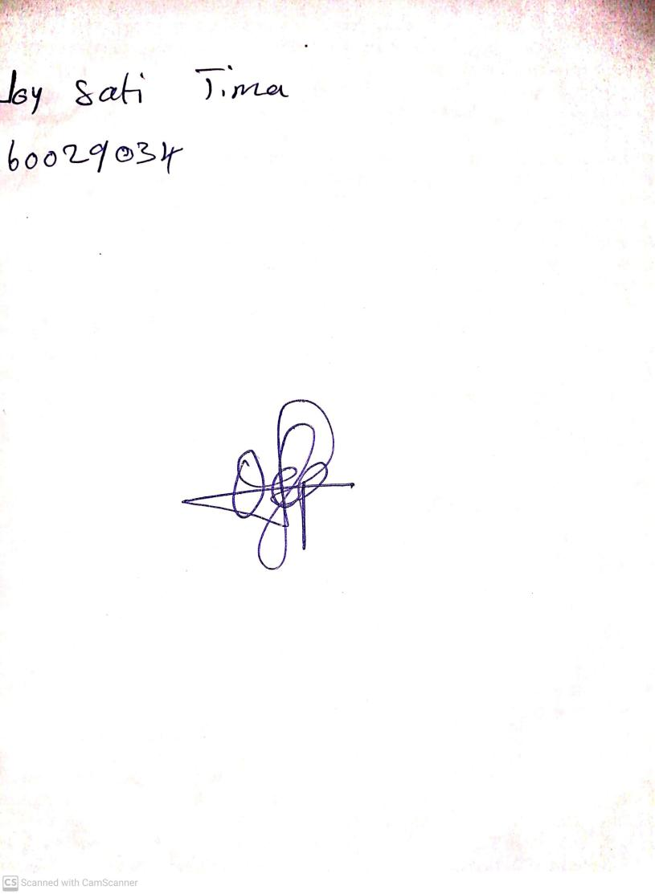

15th August, 2023

Perpetual Ojoma Ocheja

Stream Head Nursery