**LESSON PLAN AND NOTE FOR WEEK 5 ENDING 24/5/2024**

**Term 3rd term**

**Week 5th week**

**Date 22nd May, 2024**

**Class Nursery One**

**Subject Social Norms**

**Topic Safety at Home.**

**Sub-topic Define Safety at Home.**

**Period 4th period**

**Time 10:40 am**

**Duration 35 minutes**

**No in class 14**

**Average Age 3 years**

**Sex Mixed**

**Specific Objectives: By the end of the lesson, the pupils should be able to:**

1. **Define Safety at Home.**
2. **Identify sharp objects in the home to avoid to be safe.**

**Rationale: To ensure the pupils have knowledge of staying free from dangers in the home.**

**Previous Knowledge: The pupils can define environment.**

**Instructional Resources: Online research.**

**Reference Material: Smart Smart Civic Education by A.M Solu & T.Y Alabi, nursery 2**

**LESSON PRESENTATION**

|  |  |  |  |
| --- | --- | --- | --- |
| **Steps** | **Teacher’s Activities** | **Pupils’ Activities** | **Learning Points** |
| **Introduction** | **The teacher introduces the lesson by teaching the pupils the importance of staying safe always.** | **The pupils pays attention to the teacher.** | **To arouse the pupils’ interest.** |
| **Step 1** | **The teacher leads the pupils to define Safety at Home as “staying free from dangers’ in the home.** | **The pupils pay attention and repeats the definition of Safety at Home with the teacher.** | **For proper understanding.** |
| **Step 2** | **The teacher guides the pupils to recognize things to do in other to stay safe in home e.g**  **Avoid rough play.**  **Avoid running anyhow.**  **Avoiding playing with sharp objects.** | **The pupils identify the safety rules in the home that should be followed.** | **For better understanding.** |
| **Summary** | **The teacher summarizes the lesson by mentioning the ways of avoiding dangers at home which include**  **Not playing rough play.**  **Not playing with Electric plugs**  **Not playing with sharp objects etc.** | **The pupils listen and understands the lesson.** | **For onward study.** |
| **Evaluation** | **Question:**  **Define Safety at home?.**  **Mention two ways of staying safe in the home?.** | **The pupils answer the question correctly.** | **To ascertain the pupils’ understanding.** |
| **Conclusion** | **The teacher summarizes the lesson to the pupils.** | **The pupils gives answers to the teacher.** | **To consolidate the lesson.** |
| **Assignment** | **Question:**  **Define Safety at home?.**  **Mention two ways of staying safe in the home?.** | **The pupils copy and do their homework .** | **To encourage learning while at home.** |

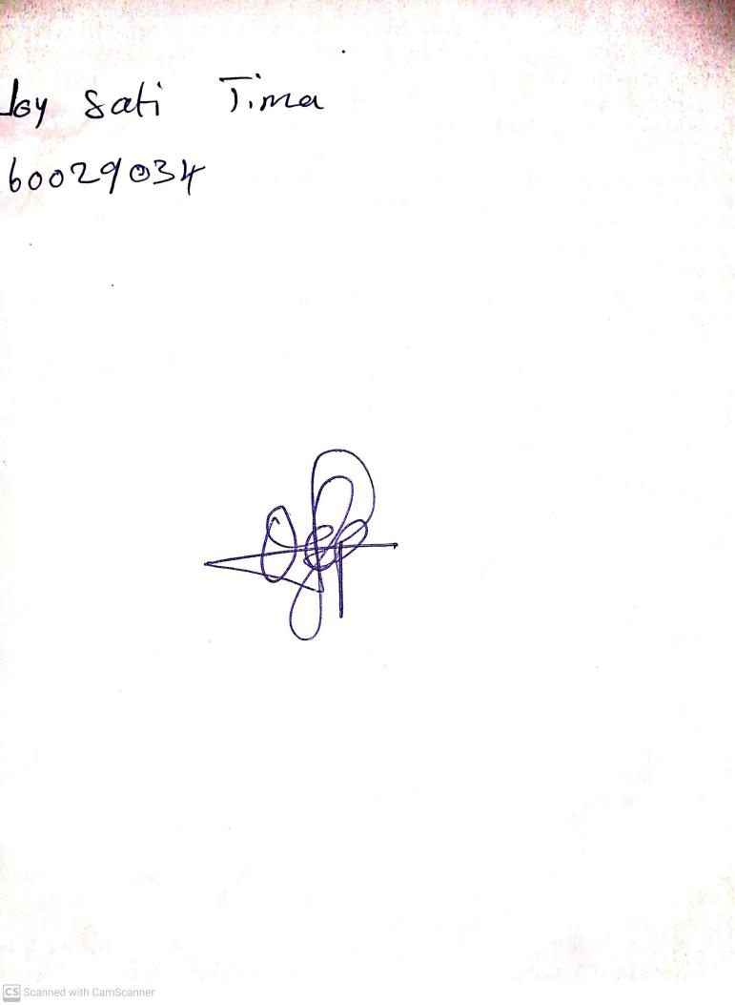

24th May, 2024

Perpetual Ojoma Ocheja

Stream Head Nursery