**EMERALD ROYAL INTERNATIONAL SCHOOL**

**MPAPE, ABUJA.**

**LESSON PLAN AND NOTE FOR WEEK 3 ENDING 27/09/2024**

**TERM: 1st**

**WEEK: 3rd**

**DATE: 23/09/2024**

**CLASS: Nursery 2**

**SUBJECT: Nature studies**

**TOPIC: My body**

**SUB—TOPIC: Parts of the body.**

**PERIOD: 4th**

**TIME: 10:40—11:20am**

**DURATION: 40 minutes**

**NUMBER IN CLASS: 14**

**AVERAGE AGE: 5 years**

**SEX: Mixed**

**LEARNING OBJECTIVES: By the end of the lesson, the pupils should be able to:**

**1. Mention parts of the body.**

**2. State the reasons for caring for the body**

**3. Outline the materials for caring for the body.**

**RATIONALE: For pupils to know parts of their body and why we should care for our body.**

**PREVIOUS KNOWLEDGE: Pupils have learnt about the meaning of first aid in previous lesson.**

**INSTRUCTIONAL MATERIALS: A chart of parts of the body.**

**REFERENCE MATERIALS: Basic science and technology for Nursery schools book 3 by OPEMIPO DADA.**

**LESSON DEVELOPMENT**

|  |  |  |  |
| --- | --- | --- | --- |
| **Steps** | **Teacher's activities** | **Pupils' activities** | **Learning point** |
| **Introduction** | **Teacher introduces the lesson by reviewing the previous lesson.** | **Pupils pay attention to the teacher.** | **To prepare pupils minds for the lesson ahead.** |
| **Presentation step 1** | **Teacher mentions the parts of the body to pupils and then asks them to repeat after her.** | **Pupils listen to the teacher and repeat after her.** | **To improve pupils listening and speaking ability.** |
| **Step 2** | **Teacher states the reasons for caring for the body parts to pupils and also asks them to repeat after her.** | **Pupils pay attention to the teacher and repeat her.** | **To enhance pupils participation in the class.** |
| **Step 3** | **Teacher outline the materials for caring for the parts of the body to pupils and also asks pupils to repeat after her.** | **Pupils listen attentively to the teacher and repeat after her.** | **To improve pupils speaking ability.** |
| **Board summary** | **Teacher writes the whole note of lesson on the board for pupils to copy into their books. That is;**  **Body parts:**    **The human body is made up of the following;**   1. **Head** 2. **Neck** 3. **Hair** 4. **Eyes** 5. **Nose** 6. **Mouth–teeth–tongue** 7. **Ears** 8. **hand** 9. **Foot** 10. **Toe** 11. **Leg** 12. **Nail** 13. **Fingers** 14. **Elbow etc.**   **Reasons for caring for our body:**   1. **To prevent diseases.** 2. **To look nice and beautiful.** 3. **To look neat.** 4. **To have self respect.** 5. **To prevent body odour.** 6. **To prevent body rashes and other skin infections.** 7. **To keep it healthy.** 8. **To keep it strong.**   **Materials used for caring for the body:**   1. **Soap** 2. **Sponge** 3. **Water** 4. **Cotton wool** 5. **Towel** 6. **Body cream or lotion** 7. **Hair brush or comb etc.** | **Pupils copy the note into their exercise books.** | **For onward study.** |
| **Evaluation** | **Teacher evaluates the lesson by asking pupils the following questions;**   1. **Mention the parts of the body.** 2. **Why do we care for our body?** 3. **State the materials for caring for the body.** | **Pupils answer the questions asked by the teacher.** | **To assess pupils level of understanding.** |
| **Conclusion** | **Teacher concludes the lesson by marking pupils books.** | **Pupils submit their books for marking.** | **For endorsement.** |
| **Assignment** | 1. **What is a cut?** 2. **Why do we care for cut?** | **Pupils do their assignment at home.** | **To encourage learning at home.** |

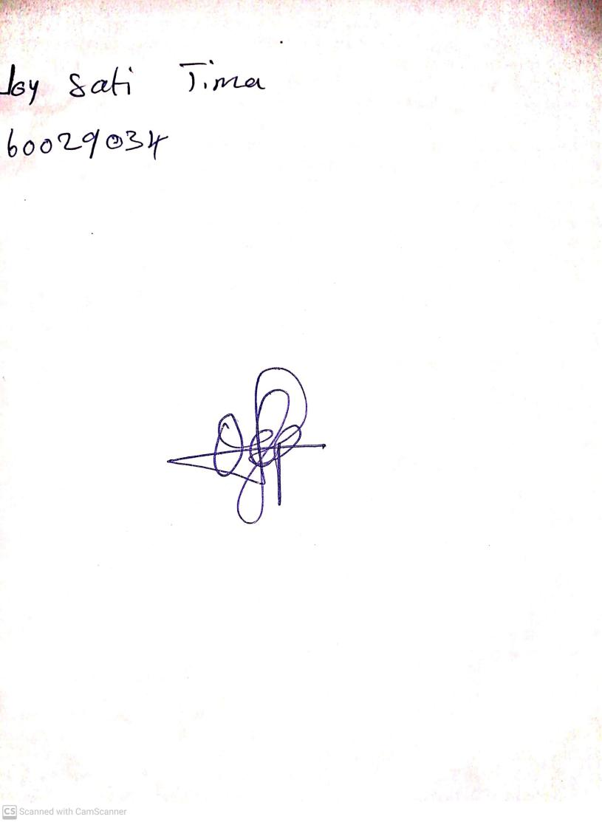

**20th September, 2024**

**Perpetual Ojoma Ocheja**

**Stream Head Nursery**