**LESSON PLAN AND NOTE 1 FOR WEEK 4 ENDING 2/2/2024**

**Term 2nd term**

**Week 4th week**

**Date 29th January,2024**

**Class Nursery One**

**Subject Number Work**

**Topic Counting numbers 1-90**

**Sub-topic Counting numbers 80-85**

**Period 4th period**

**Time 11:15 am**

**Duration 35 minutes**

**No in class 15**

**Average Age 3 years**

**Sex Mixed**

**Specific Objectives: By the end of the lesson ,the pupils should be able to:**

1. **Count numbers 80-85**
2. **Identify numbers 80-85**
3. **Write numbers 80-85**

**Rationale: To make sure the pupils know how to**

**Count, identify and write numbers 80-85**

**Previous Knowledge: The pupils have colour and match numbers 75-80**

**Instructional Resources: Chart, board, marker, etc.**

**Reference Material: The new mastering mathematics by Henry Z. Idogun.**

**LESSON PRESENTATION**

|  |  |  |  |
| --- | --- | --- | --- |
| **Steps** | **Teacher’s Activities** | **Pupils’ Activities** | **Learning Points** |
| **Introduction** | **The teacher introduces the topic (counting numbers 1-100) by rhyming.** | **The pupils together with the teacher rhyme the numbers 1-100.** | **To arouse the pupils’ interest.** |
| **Step 1** | **The teacher assists the pupils to count numbers 90-95.**  **80 81 82**  **83 84 85** | **The pupils count the numbers 80-85 with their teacher.** | **For proper understanding.** |
| **Step 2** | **The teacher leads the pupils to identify numbers 80, 81, 82, 83, 84, 85.** | **The pupils identify numbers 80, 81, 82 83, 84, 85.** | **For better understanding.** |
| **Step 3** | **The teacher guides the pupils to write numbers 80-85 inside their n otebooks.** | **The pupils write numbers 80-85 as the teacher guides them** | **For further understanding.** |
| **Summary** | **The teacher summarizes the lesson by counting numbers 80-85.** | **The pupils have master and count numbers 80-85.** | **For onward study.** |
| **Evaluation** | **Question:**  **Count numbers: 80-85 fluently.** | **The pupils answer the question correctly.** | **To ascertain the pupils’ understanding.** |
| **Conclusion** | **The teacher summarizes, reacts and corrects the pupils.** | **The pupils gives answers to the teacher's question.** | **To consolidate the lesson.** |
| **Assignment** | **Write the following numbers below**   |  |  | | --- | --- | | **80** | **81** | |  |  | | **82** | **83** | |  |  | | **84** | **85** | |  |  | | **The pupils copy and do their homework at home.** | **To encourage learning while at home.** |

**LESSON PLAN AND NOTES 2 FOR WEEK 4 ENDING 2/2/2024**

**Term 2nd term**

**Week 4th week**

**Date 31st January,2024**

**Class Nursery One**

**Subject Number Work**

**Topic Counting numbers 1-90**

**Sub-topic Counting numbers 85-90**

**Period 4th period**

**Time 11:30 am**

**Duration 35 minutes**

**No in class 18**

**Average Age 3 years**

**Sex Mixed**

**Specific Objectives: By the end of the lesson ,the pupils should be able to:**

1. **Count numbers 85-90**
2. **Identify numbers 85-90**
3. **Write numbers 85-90**

**Rationale: To make sure the pupils know how to**

**Count, identify and write numbers 85-90**

**Previous Knowledge: The pupils have colour and match numbers 80-85**

**Instructional Resources: Chart, board, marker, etc.**

**Reference Material: The new mastering mathematics by Henry Z. Idogun**

**LESSON PRESENTATION**

|  |  |  |  |
| --- | --- | --- | --- |
| **Steps** | **Teacher’s Activities** | **Pupils’ Activities** | **Learning Points** |
| **Introduction** | **The teacher introduces the topic (counting numbers 1-90) by rhyming.** | **The pupils together with the teacher rhyme the numbers 1-90** | **To arouse the pupils’ interest.** |
| **Step 1** | **The teacher assists the pupils to count numbers 85-90.**  **85 86 87**  **88 89 90** | **The pupils count the numbers 85-90 with their teacher.** | **For proper understanding.** |
| **Step 2** | **The teacher leads the pupils to identify numbers 85, 86, 87, 88, 89, 90.** | **The pupils identify numbers 85, 86, 87 88, 89, 90.** | **For better understanding.** |
| **Step 3** | **The teacher guides the pupils to write numbers 85-90 inside their notebooks.** | **The pupils write numbers 85-90 as the teacher guides them** | **For further understanding.** |
| **Summary** | **The teacher summarizes the lesson by counting numbers 85-90.** | **The pupils have master and count numbers 85-90.** | **For onward study.** |
| **Evaluation** | **Question:**  **Count numbers: 85-90 fluently.** | **The pupils answer the question correctly.** | **To ascertain the pupils’ understanding.** |
| **Conclusion** | **The teacher summarizes, reacts and corrects the pupils .** | **The pupils gives answers to the teacher's question.** | **To consolidate the lesson.** |
| **Assignment** | **Write the following numbers below**   |  |  | | --- | --- | | **85** | **86** | |  |  | | **87** | **88** | |  |  | | **89** | **90** | |  |  | | **The pupils copy and do their homework at home.** | **To encourage learning while at home.** |

**LESSON PLAN AND NOTES 3 FOR WEEK 4 ENDING 2/2/2024**

**Term**  **2nd term**

**Week** **4th week**

**Date** **2nd  February,2024**

**Class** **Nursery One**

**Subject** **Number Work**

**Topic**  **Counting numbers 1-90**

**Sub-topic** **Colouring and matching numbers 80-90**

**Period** **4th period**

**Time** **11:45 am**

**Duration** **35 minutes**

**No in class** **15**

**Average Age** **3 years**

**Sex** **Mixed**

**Specific Objectives: By the end of the lesson, the pupils should be able to:**

1. **Colour numbers 80-85**
2. **Match numbers 85-90**

**Rationale: To make sure the pupils colour & match numbers 80-90**

**Previous Knowledge: The pupils have count, identify & write numbers 85-90**

**Instructional Resources: Crayons, exercise books, pencils.**

**Reference Material: Exercise books, the new mastering mathematics by Henry Z. Idogun**

**LESSON PRESENTATION**

|  |  |  |  |
| --- | --- | --- | --- |
| **Steps** | **Teacher’s Activities** | **Pupils’ Activities** | **Learning Points** |
| **Introduction** | **The teacher introduces the topic (counting numbers 1-90) by rhyming.** | **The pupils together with the teacher rhyme the numbers 1-90** | **To arouse the pupils’ interest.** |
| **Step 1** | **The teacher draws numbers 80-85 inside their notebooks for the pupils to identify and colour** | **The pupils participate to identify and colour numbers 80-85.** | **For proper understanding.** |
| **Step 2** | **The teacher write down numbers 85-90 for the pupils to match inside their notebooks.**  **85 89**  **86 90**  **87 88**  **88 85**  **89 86**  **90 87** | **The pupils match the numbers 85-90.**  **85 89**  **86 90**  **87 88**  **88 85**  **89 86**  **90 87** | **For better understanding.** |
| **Summary** | **The teacher summarizes the lesson by counting numbers 85-90.** | **The pupils have master and count numbers 85-90.** | **For onward study.** |
| **Evaluation** | **Question:**  **Count numbers: 80-90** | **The pupils answer the question correctly.** | **To ascertain the pupils’ understanding.** |
| **Conclusion** | **The teacher summarizes, reacts and corrects the pupils.** | **The pupils gives answers to the teacher's question.** | **To consolidate the lesson.** |
| **Assignment** | **Match the following numbers**  **80 86**  **85 89**  **89 80**  **86 85**  **83 90**  **90 87**    **87 83** | **The pupils copy and do their homework at home.** | **To encourage learning while at home.** |

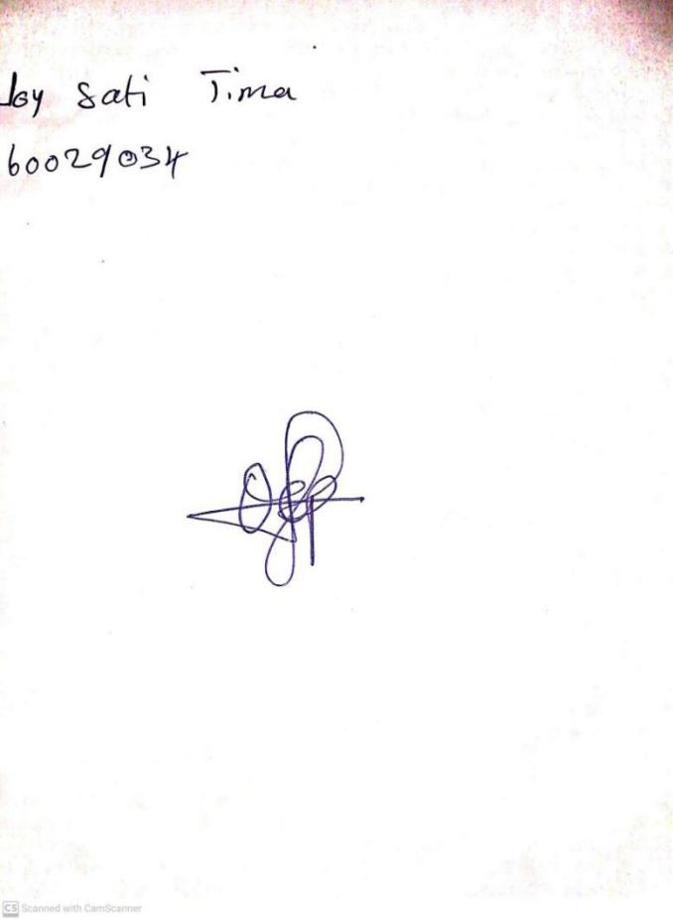

26TH January, 2024

Perpetual Ojoma Ocheja

Stream Head Nursery

**N.B THE EVALUATION SHOULD TALLY WITH THE LEARNING OBJECTIVES**

|  |  |
| --- | --- |
| **Evaluation** | **Question:**  **Count numbers: 80-90** |

**Specific Objectives: By the end of the lesson ,the pupils should be able to:**

1. **Colour numbers 80-85**
2. **Match numbers 85-90**

KINDLY DO SAME FOR THE OTHER NOTES