**EMERALD ROYAL INTERNATIONAL SCHOOL MPAPE, ABUJA**

**LESSON PLAN AND NOTE FOR WEEK 7 ENDING 23/02/2024**

TERM: 2nd

WEEK: 7th

DATE: 29/02/2024

CLASS: Nursery 2

SUBJECT: Nature studies

TOPIC: Bones

SUB—TOPIC: Meaning and types of bones

PERIOD: 4th

TIME: 10:40—11:20am

DURATION: 40 minutes

NUMBER IN CLASS: 13

AVERAGE AGE: 5 years

SEX: Mixed

LEARNING OBJECTIVES: By the end of the lesson, the pupils should be able to:

1. Explain the meaning of bones.

2. Mention the types and importance of bones.

3. States the first aid treatment for fracture.

RATIONALE: For pupils to know about bones in the body.

PREVIOUS KNOWLEDGE: pupils have been seeing bones of chicken and fish in their food.

INSTRUCTIONAL MATERIALS:A feed trip to the school laboratory to see a skeleton.

REFERENCE MATERIALS: Basic science and technology Nursery 3 by OPEMIPO DADA

LESSON DEVELOPMENT

|  |  |  |  |
| --- | --- | --- | --- |
| Steps | Teacher's activities | Pupils' activities | Learning point |
| Introduction | Teacher introduces the lesson by asking pupils the following questions;  Do you know why you can stand upright,sit,lie on a bed and walk around? It is because there are bones in your body. | Pupils answer the questions ask by the teacher. | To prepare pupils minds for the lesson ahead. |
| Presentation step 1 | Teacher explains the meaning of bones to pupils and ask them to repeat after her. | Pupils listen and repeat after the teacher. | For proper understanding. |
| Step 2 | Teacher mentions the types of bones and importance of bones to pupils and also ask them to repeat after her. | Pupils pay attention to the teacher and repeat after the teacher. | For better understanding. |
| Step 3 | Teacher States the first aid treatment for fracture to pupils and ask them to repeat after her. | Pupils listen attentively to the teacher and repeat after the teacher. | For further understanding. |
| Board summary | Teacher writes the whole note of lesson on the board for pupils to copy into their books. That is;  **BONES**    Bones are the hard tissue that forms the skeleton of a person or animal.  **TYPES OF BONES**  1. Flat bones(e.g skull bone)  2. Long bones(e.g femur)  3. Shirt bones (e.g carpal).  **IMPORTANCE OF BONES IN THE BODY**  Bones do three things for the body.  1. They support the body.  2. They protect the body.  3. They give the body it's shape.  **FIRST AID FOR FRACTURE**  1. Stop the bleeding  2. Keep the bones in place with a splint.  3. Put an ice pack on the wound to reduce swelling.  4. Take the injured person to a hospital. | Pupils copy the note into their exercise books. | For onward study. |
| Evaluation | Teacher evaluates the lesson by asking pupils questions as :   1. What are bones? 2. Mention the three (3) types of bones 3. List the importance of bones in the body. 4. What are the first aid treatment for bones? | Pupils answer the questions ask by the teacher. | To create platform for slow learners. |
| Conclusion | Teacher concludes the lesson by marking pupils books | Pupils submit their books for marking | For endorsement. |
| Assignment (home work) | Activity 14 page 52, basic science textbook | Pupils do their assignment at home . | To encourage learning at home. |

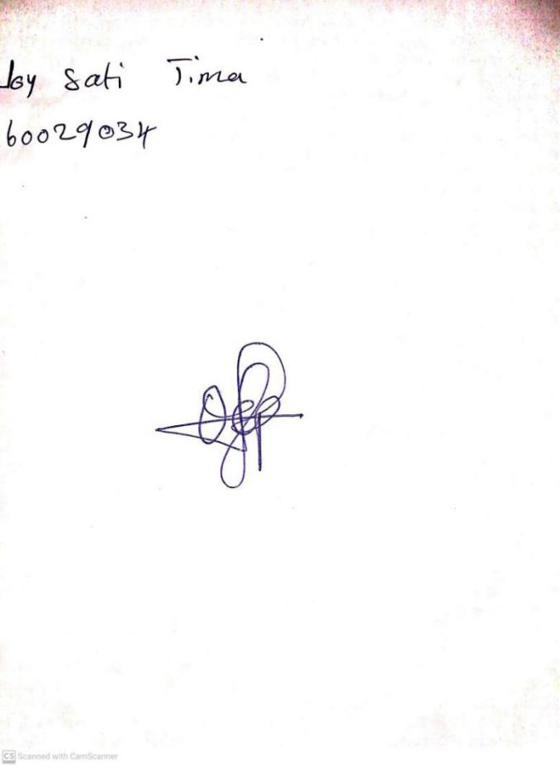

**16th February, 2024**

**Perpetual Ojoma Ocheja**

**Stream Head Nursery**