**LESSON PLAN AND NOTE 1 FOR WEEK 10 ENDING 15/11/2024**

**Term 1st  term**

**Week 10th week**

**Date 11th November,2024**

**Class Nursery one**

**Subject Letter work**

**Topic Matching letters Aa - Jj.**

**Sub-topic Matching objects to their names.**

**Period 2nd period**

**Time 8:50 am**

**Duration 35 minutes**

**No in class 15**

**Average Age 3 years**

**Sex Mixed**

**Specific Objectives: By the end of the lesson the pupils should be able to;**

1. **Match letters Aa - Jj.**
2. **Match objects with letter Aa - Jj.**

**Rationale: To make sure the pupils match letter Aa-Jj.**

**Previous knowledge: The pupils can trace letter Qq - Uu.**

**Instructional Resources: Chart, board, marker, exercise books, pencils.**

**Reference Materials: Online Research,chart,board.**

**LESSON PRESENTATION**

|  |  |  |  |
| --- | --- | --- | --- |
| **Steps** | **Teacher’s Activities** | **Pupils’ Activities** | **Learning points** |
| **Introduction** | **The teacher introduces the topic (Match letters Aa - Jj) to the pupils.** | **The pupils listen attentively to the teacher.** | **To arouse the interest of the pupils.** |
| **Step 1** | **The teacher assists the pupils to match letters Aa - Jj inside their notebooks.**  **Aa Jj**  **Bb Ii**  **Cc Hh**  **Dd Gg**  **Ee Ff**  **Ff Ee**  **Gg Dd**  **Hh Cc**  **Ii Bb**  **Jj Aa** | **The pupils individually match letters Aa - Jj inside their notebooks.**  **Aa Jj**  **Bb Ii**  **Cc Hh**  **Dd Gg**  **Ee Ff**  **Ff Ee**  **Gg Dd**  **Hh Cc**  **Ii Bb**  **Jj Aa** | **For proper understanding.** |
| **Step 2** | **The teacher leads the pupils to match objects to letter Aa - Jj**  **image of a baby Jj**  **image of an egg Hh**  **image of a house Ee**  **image of a jug Bb** | **The pupils match objects to letter Aa - Jj.**  **image of a baby Jj**  **image of an egg Hh**  **image of a house Ee**  **image of a jug Bb** | **For better understanding.** |
| **Summary** | **The teacher summarizes the lesson by sounding capital and small letter Aa - Jj.** | **The pupils can sound capital and small letter Aa - Jj.** | **For onward study.** |
| **Evaluation** | 1. **Match letters Aa - Jj below**   **Aa Jj**  **Bb Ii**  **Cc Hh**  **Dd Gg**  **Ee Ff**  **Ff Ee**  **Gg Dd**  **Hh Cc**  **Ii Bb**  **Jj Aa**   1. **Match objects to their letters below**   **image of a baby Jj**  **image of an egg Hh**  **image of a house Ee**  **image of a jug Bb** | **The pupils answer the question correctly.** | **To ascertain the pupils’ understanding.** |
| **Conclusion** | **The teacher summarizes, reacts & corrects the pupils.** | **The pupils answer to the teacher’s questions.** | **To consolidate the lesson.** |
| **Assignment** | 1. **Match letters Aa - Jj below**   **Aa Jj**  **Bb Ii**  **Cc Hh**  **Dd Gg**  **Ee Ff**  **Ff Ee**  **Gg Dd**  **Hh Cc**  **Ii Bb**  **Jj Aa**   1. **Match the following objects to their letters**   **image of a cloud Ff**  **image of a dog Cc**  **image of a fan Dd** | **The pupils copy and do their homework at home.** | **To encourage learning while at home.** |

**LESSON PLAN AND NOTE 2 FOR WEEK 10 ENDING 15/11/2024**

**Term 1st  term**

**Week 10th week**

**Date 13th November,2024**

**Class Nursery one**

**Subject Letter work**

**Topic Matching letters Kk - Tt.**

**Sub-topic Match objects to letters Kk - Tt.**

**Period 4th period**

**Time 10:40 am**

**Duration 35 minutes**

**No in class 15**

**Average Age 3 years**

**Sex Mixed**

**Specific Objectives: By the end of the lesson the pupils should be able to;**

1. **Match letters Kk - Tt.**
2. **Match objects to letters Kk - Tt.**

**Rationale: To make sure the pupils match letters Kk-Tt.**

**Previous knowledge: The pupils can match letters Aa - Jj.**

**Instructional Resources: Chart, board, marker, exercise books, pencils.**

**Reference Materials: Online Research,chart,board.**

**LESSON PRESENTATION**

|  |  |  |  |
| --- | --- | --- | --- |
| **Steps** | **Teacher’s Activities** | **Pupils’ Activities** | **Learning points** |
| **Introduction** | **The teacher introduces the topic (Match letters Kk-Tt) to the pupils.** | **The pupils listen attentively to the teacher.** | **To arouse the interest of the pupils.** |
| **Step 1** | **The teacher assists the pupils to match letters Kk - Tt inside their notebooks.**  **Kk Tt**  **Ll Ss**  **Mm Rr**  **Nn Qq**  **Oo Pp**  **Pp Oo**  **Qq Nn**  **Rr Mm**  **Ss Ll**  **Tt Kk** | **The pupils individually match letters Kk - Tt.**  **Kk Tt**  **Ll Ss**  **Mm Rr**  **Nn Qq**  **Oo Pp**  **Pp Oo**  **Qq Nn**  **Rr Mm**  **Ss Ll**  **Tt Kk** | **For proper understanding.** |
| **Step 2** | **The teacher leads the pupils to match objects to letter Kk - Tt**  **image of a kettle Tt**  **image of a mop Nn**  **image of a nose Oo**  **image of an orange Mm**  **image of a tap Kk** | **The pupils match the objects to the letters.**  **image of a kettle Nn**  **image of a mop Kk**  **image of a nose Tt**  **image of an orange Mm**  **image of a tap Oo** | **For better understanding.** |
| **Summary** | **The teacher summarizes the lesson by sounding letters Kk - Tt to the pupils.** | **The pupils can sound letters Kk Tt.** | **For onward study.** |
| **Evaluation** | 1. **Match the letters below?**   **Kk Tt**  **Ll Ss**  **Mm Rr**  **Nn Qq**  **Oo Pp**  **Pp Oo**  **Qq Nn**  **Rr Mm**  **Ss Ll**  **Tt Kk**   1. **Match the objects to the letters?**   **image of a kettle Tt**  **image of a mop Nn**  **image of a nose Oo**  **image of an orange Mm**  **image of a tap Kk** | **The pupils answer the question correctly.** | **To ascertain the pupils’ understanding.** |
| **Conclusion** | **The teacher summarizes, reacts & corrects the pupils.** | **The pupils answer to the teacher’s questions.** | **To consolidate the lesson.** |
| **Assignment** | 1. **Match the letters below?**   **Kk Tt**  **Ll Ss**  **Mm Rr**  **Nn Qq**  **Oo Pp**  **Pp Oo**  **Qq Nn**  **Rr Mm**  **Ss Ll**  **Tt Kk**   1. **Match the objects to the letters?**   **image of a kettle Tt**  **image of a mop Nn**  **image of a nose Oo**  **image of an orange Mm**  **image of a tap Kk** | **The pupils copy and do their homework at home.** | **To encourage learning while at home.** |

**LESSON PLAN AND NOTE 3 FOR WEEK 10 ENDING 15/11/2024**

**Term 1st  term**

**Week 10th week**

**Date 15th November,2024**

**Class Nursery one**

**Subject Letter work**

**Topic Matching letters Uu - Zz.**

**Sub-topic Matching objects to letter Uu - Zz.**

**Period 2nd period**

**Time 8:50 am**

**Duration 35 minutes**

**No in class 15**

**Average Age 3 years**

**Sex Mixed**

**Specific Objectives: By the end of the lesson the pupils should be able to;**

1. **Matching letters Uu - Zz.**
2. **Matching objects to letter Uu - Zz.**

**Rationale: To make sure the pupils match letters Uu - Zz.**

**Previous knowledge: The pupils can match letters Kk - Tt.**

**Instructional Resources: Chart, board, marker, exercise books, pencils.**

**Reference Materials: Online Research,chart,board.**

**LESSON PRESENTATION**

|  |  |  |  |
| --- | --- | --- | --- |
| **Steps** | **Teacher’s Activities** | **Pupils’ Activities** | **Learning points** |
| **Introduction** | **The teacher introduces the topic (Matching letters Uu - Zz) to the pupils.** | **The pupils listen attentively to the teacher.** | **To arouse the interest of the pupils.** |
| **Step 1** | **The teacher assists the pupils to match letters Uu - Zz inside their notebooks.**  **Aa Jj**  **Bb Ii**  **Cc Hh**  **Dd Gg**  **Ee Ff**  **Ff Ee**  **Gg Dd**  **Hh Cc**  **Ii Bb**  **Jj Aa** | **The pupils individually sound the letters Gg, Hh, Ii, Jj.** | **For proper understanding.** |
| **Step 2** | **The teacher leads the pupils to match objects to letter Aa - Jj**  **image of a baby Jj**  **image of an egg Hh**  **image of a house Ee**  **image of a jug Bb** | **The pupils identify the letter Gg, Hh, Ii, Jj after the teacher.** | **For better understanding.** |
| **Summary** | **The teacher summarizes the lesson by sounding letters Gg, Hh, Ii, Jj to the pupils.** | **The pupils can sound letters Gg, Hh, Ii, Jj** | **For onward study.** |
| **Evaluation** | 1. **Identify these letters below?**   **Hh Ii**    **Gg Jj** | **The pupils answer the question correctly.** | **To ascertain the pupils’ understanding.** |
| **Conclusion** | **The teacher summarizes, reacts & corrects the pupils.** | **The pupils answer to the teacher’s questions.** | **To consolidate the lesson.** |
| **Assignment** | **Trace capital and small letter Gg, Hh, Ii, Jj?**  **untraced letter Gg untraced letter Hh**    **untraced letter Ii untraced letter Jj** | **The pupils copy and do their homework at home.** | **To encourage learning while at home.** |

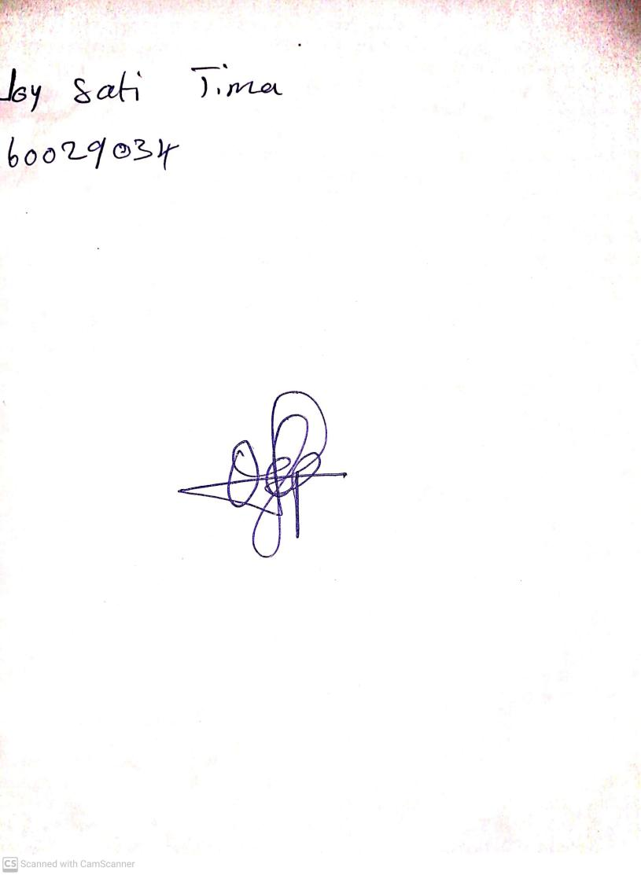

15th November, 2024

Perpetual Ojoma Ocheja

Stream Head Nursery