**Lesson Plan/Note for Week One Ending 13/1/2023.**

**Term:** 2nd.

**Week:** One.

Class: SS 2

**Date: 9/1/2023.**

**Subject:** Economics

**Topic:** Labour market.

**Sub-Topic:** concept of unemployment, types and causes.

**Time:** 8:50 9:30

**Duration:** 40 Minutes

**Number in class:** 5 students.

**Sex:** mixed

**Average Age:** 14 years

**Period:** 2nd

**Specific objectives:** By the end of the lesson, the students should be able to:

(1) Define unemployment

(11) state the causes of unemployment.

(111) mention the types of unemployment.

**Rationale:** Forthe students to be able to state why people are unemployed and the types.

**Previous knowledge:** The students have seen some of their brothers or uncle that are unemployed.

**Instructional Material**: A chart showing people or applicants looking for work.

**Reference material:** Gbenga Babalola (2017) Metropolitan economics for senior Secondary schools.

**LESSON DEVELOPMENT**

|  |  |  |  |
| --- | --- | --- | --- |
| **Stages/steps** | **Teacher's Activities** | **Students' Activities** | **Learning points.** |
| **Introduction** | Review the previous lesson | Participate actively in the class discussion. | To arouse the students interest to learn. |
| **Step 1** | Defines unemployment as: A situation whereby people of working age are not able to find paid job. | Listen carefully to the teacher and ask questions. | For better understanding of the lesson. |
| **Step 11** | Guides the students to state the causes of unemployment. | State the causes of unemployment as: (1) lack of capital (2) over population (3) lack of skills etc. | To enhance their logical reasoning. |
| **Step 111** | Mentions the types of unemployment as: (1) structural (2) seasonal (3) cyclical etc | Pay attention and ask questions. | . To encourage good listening skills. |
| **Summary** | Summarizes the lesson as:  **Unemployment**  Unemployment is a situation whereby people of working age are not able to find paid job. This occurs when people are willing but without work and are actively seeking work.  **Types of unemployment**  (1) Structural unemployment: This is associated with the inadequacy of productive capacity to create enough jobs for all those able and willing to work.  (2) Disguised unemployment: This implies that many workers are engaged in productive work. For example, where most unemployment exist in this form, people are found apparently to be engaged in agricultural works. Even if many workers are withdrawn, the same work will continue to be done by fewer people.  (3) Cyclical unemployment: This is cause by the trade or business circles. It results from profit and loss, and fluctuations in the deficiency of effective demand, production is slow down.  (4) Seasonal unemployment: This occurs at certain seasons of the year. It is common among industries where in a certain period of the year there is heavy work, while in the rest, the work is lean.  (5) Underemployment: This refers to that State in which the self- employed working people are not working according to their capacity. This is when someone is employed below his/ her qualification.  (6) Voluntary unemployment: This occurs when a working person willingly withdraw himself from work. Either the person wants to a wage or does not want to work at all.  (7) Involuntary unemployment: This occurs at a particular time when the number of workers is more than the number of jobs. This state of affairs arises because of insufficiency or non- availability of work.  (8) Frictional unemployment: This occurs as a result of the changes in the techniques of production. Eg use of machines in production as a result of advancement in technology.  (9) Residual unemployment: This is cause by mental or physical disabilities.  (10) casual unemployment: This is common with the unskilled type of labour example part time jobs.  **Causes of unemployment**  (1) lack of capital: The less developing countries are facing the problem of capital shortage.  (2) Over population: When the population of a country is high, there would be many people of working age who would not be employed.  (3) Seasonal variations: There are many industries, which produce goods seasonally, like the publishing industries.  (4) lack of effective demand: When aggregate supply increases than the aggregate demand, unemployment prevails.  (5) Lack of skills: Some people are uneducated and have no skills about any particular jobs. So they can not get a job.  (6) Poor performance of agricultural sector. | Copy and submit the Note book for marking | For future purpose. |
| **Evaluation** | Evaluates the students as:  (1) What is unemployment?  (2) State 4 causes of unemployment  (3) Mention 5 types of unemployment. | Respond to the questions | Ascertaining the attainment of the stated objectives. |
| **Conclusion:** | Rounds up the lesson by marking and correcting students work | Check and do their correction | Consolidation of the lesson |
| **Assignment** | Gives home work as:  (1) mention and explain 5 consequences of unemployment.  (2) List and explain 6 solution to the problem of unemployment. | Respond by doing the home work at home. | To ensure continuity of learning. |

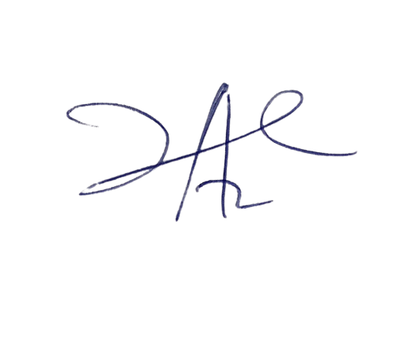

6/3/2023

Principal Head Instructor