**EMERALD ROYAL INTERNATIONAL SCHOOL**

**MPAPE, ABUJA.**

**LESSON PLAN AND NOTE FOR WEEK 5 PERIOD 1 ENDING 11/10/2024**

**TERM: FIRST**

**WEEK: 5TH**

**DATE: 07/10/2024**

**CLASS: NURSERY 2**

**SUBJECT: LITERACY**

**TOPIC: THREE LETTER WORDS CROSS CUTTING "a" "e" "i".**

**SUB-TOPIC: THREE LETTER WORDS CROSS CUTTING "a".**

**PERIOD: 1ST**

**TIME: O8:50-09:30.**

**DURATION: 40 MINUTES.**

**NUMBER IN CLASS: 17**

**AVERAGE AGE: 5 YEARS.**

**SEX: MIXED.**

**SPECIFIC OBJECTIVES: BY THE END OF THE LESSON,THE PUPILS SHOULD BE**

**ABLE TO:**

**1. IDENTIFY THREE LETTER WORDS CROSS CUTTING**

**"a".**

**2. SPELL AND PRONOUNCE THREE LETTER WORDS**

**CROSS CUTTING "a".**

**RATIONALE: FOR PUPILS TO BE ABLE TO SPELL AND PRONOUNCE**

**THERE LETTER WORDS CROSS CUTTING "a".**

**PREVIOU KNOWLEDGE: PUPILS HAVE LEARNT THREE LETTER WORDS ENDING WITH "IB" IN PREVIOUS LESSON.**

**INSTRUCTIONAL MATERIALS: A CHART OF THREE LETTER WORDS CROSS**

**CUTTING "a"**

**REFERENCE MATERIALS: MASTERING ENGLISH BOOK 2 BY J. M OMOGBAI**

**LESSON DEVELOPMENT**

|  |  |  |  |
| --- | --- | --- | --- |
| **STAGES/STEPS** | **TEACHER’S ACTIVITIES** | **PUPILS’ ACTIVITIES** | **LEARNING POINTS** |
| **INTRODUCTION** | **Teacher introduces the lesson by reviewing the previous lesson.** | **Pupil listen to the teacher attentively.** | **To arouse pupils interest for the lesson ahead.** |
| **PRESENTATION**  **STEP 1** | **Teacher presents the lesson by writing three letter words cross cutting "a" on the board, identify and then asks pupils to repeat after her.** | **Pupils pay attention and repeat after the teacher.** | **For proper understanding of the lesson .** |
| **STEP 2** | **Teacher spells and pronounce the three letter words cross cutting "a" on the board and also asks pupils to repeat after her.** | **Pupils spelled the three letter words on the board after the teacher.** | **For better understanding of the lesson.** |
| **BOARD SUMMARY** | **Teacher summarizes the lesson by writing the whole note of lesson on the board for pupils to copy into their books.that is,**  **THREE LETTER WORDS CROSS CUTTING "a" ARE:**  **"a" as in**   1. **Bat** 2. **Cat** 3. **Fat** 4. **Hat** 5. **Mat** 6. **Pat** 7. **Rat** 8. **Sat** 9. **Has** 10. **Gas** 11. **Man** 12. **Fan** 13. **Van** 14. **Ban** 15. **Can** 16. **Arm** 17. **Bag** 18. **Sag** 19. **Lag** 20. **Rag** 21. **Cab** 22. **Sad etc.** | **Pupils copy the note into their exercise books.** | **For onward study.** |
| **EVALUATION** | **Teacher asks pupils to go to the board one after the other and read the three Letter words cross cutting "a".** | **Pupils read the note on the board one after another.** | **To assess pupils level of understanding of the lesson so far.** |
| **CONCLUSION** | **Teacher marks pupils books.** | **Pupils submit their books for marking.** | **For endorsement.** |
| **ASSIGNMENT** | **Fill in the missing letters and pronounce.**   1. **V__ n** 2. **C __ n** 3. **S__ t** 4. **P__ t** 5. **G__ s** 6. **T __ p** 7. **H__s** 8. **B__n** 9. **F__t** 10. **L__ p** | **Pupils do their assignment at home.** | **To encourage learning at home.** |

**LESSON PLAN AND NOTE FOR WEEK 5 PERIOD 2 ENDING 11/10/2024**

**TERM: FIRST**

**WEEK: 5TH**

**DATE: 08/10/2024**

**CLASS: NURSERY 2**

**SUBJECT: LITERACY**

**TOPIC: THREE LETTER WORDS CROSS CUTTING "a" "e" "i"**

**SUB-TOPIC: THREE LETTER WORDS CROSS CUTTING "e"**

**PERIOD: 2ND**

**TIME: O8:50-09:30.**

**DURATION: 40 MINUTES.**

**NUMBER IN CLASS: 17**

**AVERAGE AGE: 5 YEARS.**

**SEX: MIXED.**

**SPECIFIC OBJECTIVES: BY THE END OF THE LESSON,THE PUPILS SHOULD BE**

**ABLE TO:**

**1. IDENTIFY THREE LETTER WORDS CROSS CUTTING**

**"e"**

**2. SPELL AND PRONOUNCE THREE LETTER WORDS**

**CROSS CUTTING "e"**

**RATIONALE: FOR PUPILS TO BE ABLE TO READ WORDS WITH**

**VOWEL "e"**

**PREVIOU KNOWLEDGE: PUPILS HAVE LEARNT THREE LETTER WORDS CROSS CUTTING "a" IN PREVIOUS LESS0N.**

**INSTRUCTIONAL MATERIALS: A CHART OF THREE LETTER WORDS CROSS**

**CUTTING "e"**

**REFERENCE MATERIALS: MASTERING ENGLISH 2 BY J. M OMOGBAI.**

**LESSON DEVELOPMENT**

|  |  |  |  |
| --- | --- | --- | --- |
| **STAGES/STEPS** | **TEACHER’S ACTIVITIES** | **PUPILS’ ACTIVITIES** | **LEARNING POINTS** |
| **INTRODUCTION** | **Teacher introduces the lesson by reviewing the previous lesson.** | **Pupil listen attentively to the teacher.** | **To arouse pupils interest for the lesson ahead.** |
| **PRESENTATION**  **STEP 1** | **Teacher presents the lesson by writing three Letter words cross cutting "e" on the board, identify and then asks pupils to repeat after.** | **Pupils listen and repeat after the teacher.** | **For proper understanding of the lesson .** |
| **STEP 2** | **Teacher spells and pronounce the three letter words cross cutting "e" on the board and also asks pupils to repeat after her.** | **Pupils pay attention and repeat after the teacher.** | **For better understanding of the lesson.** |
| **BOARD SUMMARY** | **Teacher summarizes the lesson by writing the whole note of lesson on the board for pupils to copy into their books.That is;**  **THREE LETTER WORDS CROSS CUTTING "E" ARE:**  **"e" as in;**   1. **Bed** 2. **Leg** 3. **Set** 4. **Bet** 5. **Ben** 6. **Peg** 7. **Men** 8. **End** 9. **Pet** 10. **Pen** 11. **Ten** 12. **Net** 13. **Den** 14. **Hen** 15. **Bet** 16. **Fed** 17. **Get** 18. **Beg** 19. **Wet** 20. **Egg etc.** | **Pupils copy the note into their exercise books.** | **For onward study.** |
| **EVALUATION** | **Teacher asks Pupils to read the three Letter words cross cutting "e" on the board one after the other.** | **Pupils read the note on the board one after another.** | **To assess pupils understanding of the lesson.** |
| **CONCLUSION** | **Teacher marks pupils books.** | **Pupils submit their books for marking.** | **For endorsement.** |
| **ASSIGNMENT** | **Spell, pronounce and write 10 three Letter words cross cutting vowel "i" .** | **Pupils do their assignment at home.** | **To encourage learning at home.** |

**LESSON PLAN AND NOTE FOR WEEK 5 PERIOD 3 ENDING 11/10/2024**

**TERM: FIRST**

**WEEK: 5TH**

**DATE: 11/10/2024**

**CLASS: NURSERY 2**

**SUBJECT: LITERACY**

**TOPIC: THREE LETTER WORDS CROSS CUTTING "a", "e","i"**

**SUB-TOPIC: THREE LETTER WORDS CROSS CUTTING "i"**

**PERIOD: 3RD**

**TIME: 08:10- 08:50am**

**DURATION: 40 MINUTES.**

**NUMBER IN CLASS: 17**

**AVERAGE AGE: 5 YEARS.**

**SEX: MIXED.**

**SPECIFIC OBJECTIVES: BY THE END OF THE LESSON,THE PUPILS SHOULD**

**BE ABLE TO:**

**1. IDENTIFY THREE LETTER WORDS CROSS CUTTING**

**"i".**

**2. SPELL AND PRONOUNCE THREE LETTER WORDS**

**CROSS CUTTING "i".**

**RATIONALE: FOR PUPILS TO KNOW HOW TO PRONOUNCE WORDS**

**WITH VOWEL "i".**

**PREVIOU KNOWLEDGE: PUPILS HAVE LEARNT ABOUT THREE LETTER WORDS CROSS CUTTING "e" IN PREVIOUS LESS0N.**

**INSTRUCTIONAL MATERIALS: A CHART OF WORDS CROSS CUTTING "i".**

**REFERENCE MATERIALS: MASTERING ENGLISH BOOK 2 BY J.M OMOGBAI.**

**LESSON DEVELOPMENT**

|  |  |  |  |
| --- | --- | --- | --- |
| **STAGES/STEPS** | **TEACHER’S ACTIVITIES** | **PUPILS’ ACTIVITIES** | **LEARNING POINTS** |
| **INTRODUCTION** | **Teacher introduces the lesson by reviewing the previous lesson.** | **Pupils pay attention to the teacher.** | **To arouse pupils interest for the lesson ahead.** |
| **PRESENTATION**  **STEP 1** | **Teacher presents the lesson by writing three letter words cross cutting "i" on the board, identify and then asks pupils to repeat after her.** | **Pupils listen to the teacher and repeat after her.** | **For proper understanding of the lesson .** |
| **STEP 2** | **Teacher guides pupils to spell and pronounce the words cross cutting "i" on the board.** | **Pupils spell and pronounced the words on the board.** | **For better understanding of the lesson.** |
| **BOARD SUMMARY** | **Teacher summarizes the lesson by preparing pupils books for them to copy the note on the board.ie,**  **Three Letter words cross cutting vowel " i" are:**  **"i" as in;**   1. **Pin** 2. **Bit** 3. **Fit** 4. **Pit** 5. **Sit** 6. **Kit** 7. **Lit** 8. **Wit** 9. **Dig** 10. **Wig** 11. **Big** 12. **Pig** 13. **Kid** 14. **Did** 15. **Sin** 16. **Fin** 17. **Win** 18. **Zip** 19. **Lip** 20. **Oil etc.** | **Pupils copy the note into their exercise books.** | **For onward study.** |
| **EVALUATION** | **Teacher evaluates the lesson by asking pupils to all stand and spell and pronounce the three Letter words cross cutting vowel "i" on the board all together.** | **Pupils all stand and spelled and pronounced the words on the board.** | **To create platform for slow learners.** |
| **CONCLUSION** | **Teacher concludes the lesson by marking pupils books.** | **Pupils submit their books for marking.** | **For endorsement.** |
| **ASSIGNMENT** | **Answer the following questions:**   1. **Write 5 three Letter words cross cutting vowel "o".** 2. **State 5 three Letter words cross cutting vowel "u".**   **(Submit on Monday)** | **Pupils do their assignment at home.** | **To encourage learning at home.** |

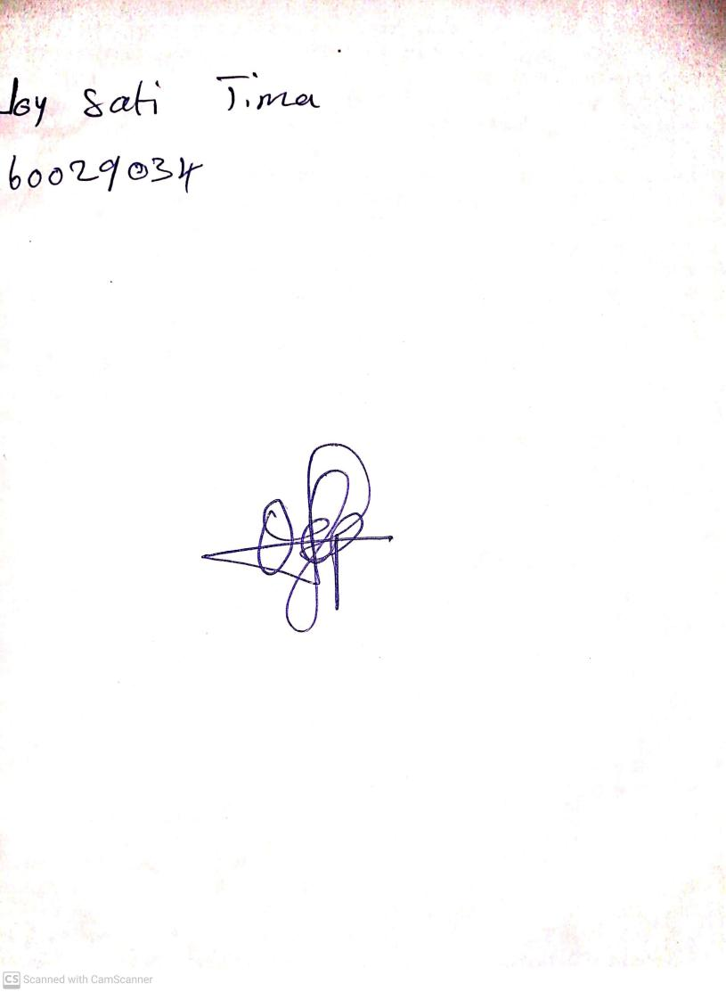

**11th October, 2024**

**Perpetual Ojoma Ocheja**

**Stream Head Nursery**