**EMERALD ROYAL INTERNATIONAL SCHOOL**

**MPAPE, ABUJA.**

**LESSON PLAN AND NOTE FOR WEEK 9 ENDING 10TH NOVEMBER,2023**

TERM : First term.

WEEK : 9

SUBJECT: Social Norms

TOPIC: Greetings.

SUB-TOPIC: Saying " good bye".

DATE: 8/9/2023

DURATION: 40 minutes

TIME: 10:40-11:20

PERIOD: 5th

CLASS: pre-nursery

NUMBER OF PUPILS: 10

AVERAGE AGE: 2

SEX: Mixed

SPECIFIC OBJECTIVES: By the end of the lesson, the pupils should be able to:-

1. Learn how to say goodbye.

2. Understand when to say "good bye."

RATIONALE: For pupils to have good moral and be respectful.

PREVIOUS KNOWLEDGE: Pupils have learnt how to say welcome in their previous lesson.

INSTRUCTIONAL MATERIALS: picture book.

REFERENCE: Smart start Civic education for nursery Schools book 1 by T.Y. Alabi and A. M. Solu.

LESSON DEVELOPMENT

|  |  |  |  |
| --- | --- | --- | --- |
| Stages/steps | Teacher's activities | Pupils' activities | Learning points |
| Introduction | Teacher introduces the lesson by going over the previous lesson. | Pupils pay attention to the teacher . | To draw pupils attention to the lesson ahead. |
| Presentation  Step 1 | Teacher shows the pupils the picture of children in the picture book waving their hands and saying " Good bye". Teacher also tells the pupils to wave their hands and say "Goodbye" repeatedly. | Pupils point at the children in the picture book. Pupils also wave their hands and say " good bye "repeatedly. | To improve better understanding. |
| Step 2 | Teacher explains to the pupils that we say goodbye to our parents, teachers and friends when we are leaving them to another place or when they are leaving us to another place. | Pupils pay attention to the teacher's explanation and practice to say goodbye to their teachers when they are going home from school. | For better understanding of the lesson. |
| Summary | Teacher summarizes the lesson by going over the topic for more understanding. | Pupils pay attention to the teacher's explanation. | To ensure better understanding of the lesson. |
| Evaluation | Teacher asks the pupils :-   1. Who do we say goodbye to? 2. When do we say goodbye? | Pupils respond to the teacher's question correctly. | To assess pupils level of understanding of the lesson. |
| Conclusion | Teacher ends the lesson by correcting the pupils who were not able to answer the questions. | Pupils take the corrections given to them by the teacher. | For onwards learning. |

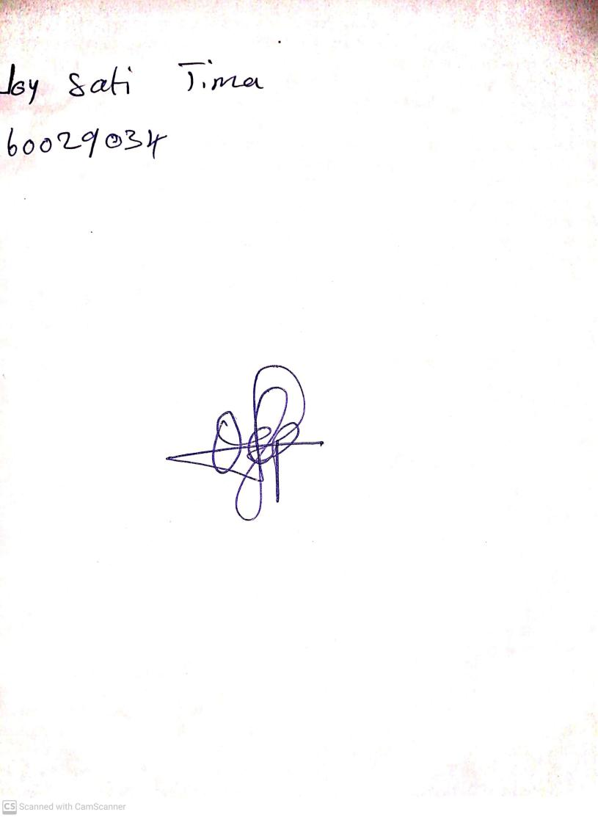

25th August, 2023

Perpetual Ojoma Ocheja

Stream Head Nursery