**EMERALD ROYAL INTERNATIONAL SCHOOL**

**MPAPE, ABUJA.**

**LESSON PLAN AND NOTE FOR WEEK 3 PERIOD 1 ENDING 29/09/2023**

TERM: FIRST

WEEK: 3RD

DATE: 25/09/2023

CLASS: NURSERY 2

SUBJECT: LETTER WORK

TOPIC: THREE LETTER WORDS ENDING “ED” “EN” “ET”

"EG"

SUB-TOPIC: THREE LETTER WORDS ENDING IN “ED” AND “EN”

PERIOD: 1ST PERIOD

TIME: 08: 50 - 09:30am

DURATION: 40 MINUTES.

NUMBER IN CLASS: 14

AVERAGE AGE: 5 YEARS.

SEX: MIXED.

SPECIFIC OBJECTIVES: BY THE END OF THE LESSON,THE PUPILS SHOULD BE

ABLE TO:

1. IDENTIFY THREE LETTER WORDS ENDING IN "ED" AND

"EN"

2. SPELL AND PRONOUNCE WORDS WITH “ED”AND "EN"

RATIONALE: FOR PUPILS TO BE ABLE TO SPELL AND PRONOUNCE

WORDS ENDING “ED" AND "EN”

PREVIOU KNOWLEDGE: PUPILS HAVE LEARNT ABOUT THREE LETTER WORDS

ENDING IN “AT”“AD”IN PREVIOUS LESSON.

INSTRUCTIONAL MATERIALS: A CHART OF THREE LETTER WORDS THAT ENDS IN

" ED" AND "EN"

REFERENCE MATERIALS: MASTERING ENGLISH FOR NURSERY SCHOOLS BOOK 2

BY J.M OMOGBAI .

**LESSON DEVELOPMENT**

|  |  |  |  |
| --- | --- | --- | --- |
| STAGES/STEPS | TEACHER’S ACTIVITIES | PUPILS’ ACTIVITIES | LEARNING POINTS |
| INTRODUCTION | Teacher introduces the lesson by reviewing the previous lesson. | Pupils listen attentively to the teacher. | To arouse pupils interest for the lesson ahead. |
| PRESENTATION  STEP 1 | Teacher writes three letter words ending in “ed”, “en” on the board identify and asks pupils to repeat after her. | Pupils listen attentively to the teacher and repeat after her. | For proper understanding . |
| STEP 2 | Teacher spells and pronounce the words on the board to pupils and also asks them to repeat after her. | Pupils pay attention to the teacher and repeat after her. | For better understanding of the lesson. |
| BOARD SUMMARY | Teacher writes the whole not of lesson on the board for pupils to copy. That is:  Three letter words ending in “ed”, “en”:  “ed” as in;   1. Bed 2. Fed 3. Red 4. Ted 5. Led etc   “ en” as in;   1. Ben 2. Hen 3. Men 4. Ten 5. Pen 6. Den etc. | Pupils copy the note into their exercise books. | For onward study. |
| EVALUATION | Teacher evaluates the lesson by asking pupils to spell and pronounce words ending in “ed” and “en” on the board one after another. | Pupils listen to the teacher and read the note on the board one after another. | To assess pupils reading skills. |
| CONCLUTION | Teacher concludes the lesson by marking pupils books. | Pupils submit their books for marking. | For endorsement. |
| ASSIGNMENT | Fill in the missing letters:   1. B ---- d 2. R ---- d 3. F ----- d 4. T ----- d 5. L ----- d 6. B ---- n 7. H ---- n 8. M ---- n 9. T ---- n 10. P ---- n | Pupils do their assignment at home. | To encourage learning at home. |

**LESSON PLAN AND NOTE FOR WEEK 3 PERIOD 2 ENDING 29/09/2023**

TERM: FIRST

WEEK: 3RD

DATE: 26/09/2023

CLASS: NURSERY 2

SUBJECT: LETTER WORK

TOPIC: THREE LETTER WORDS ENDING IN “ed" “en"“et" "eg"

SUB-TOPIC: THREE LETTER WORDS ENDING IN “et”

PERIOD : 2ND PERIOD

TIME: 08: 50 - 09:30am

DURATION: 40 MINUTES.

NUMBER IN CLASS: 14

AVERAGE AGE: 5 YEARS.

SEX: MIXED.

SPECIFIC OBJECTIVES: BY THE END OF THE LESSON,THE PUPILS SHOULD BE

ABLE TO:

1. IDENTIFY THREE LETTER WORDS ENDING IN “et”.
2. SPELL AND PRONOUNCE THREE LETTER WORDS

ENDING “et"

RATIONALE: FOR PUPILS TO BE ABLE TO SPELL AND PRONOUNCE WORDS ENDING WITH “et”

PREVIOU KNOWLEDGE: PUPILS HAVE LEARNT ABOUT THREE LETTER WORDS ENDING IN “ed” AND “en” PREVIOUS LESSON.

INSTRUCTIONAL MATERIALS: CHART OF THREE LETTER WORDS ENDING IN “et”.

REFERENCE MATERIALS: MASTERING ENGLISH FOR NURSERY SCHOOLS BOOK 3

BY J.M OMOGBAI.

**LESSON DEVELOPMENT**

|  |  |  |  |
| --- | --- | --- | --- |
| STAGES/STEPS | TEACHER’S ACTIVITIES | PUPILS’ ACTIVITIES | LEARNING POINTS |
| INTRODUCTION | Teacher introduces the lesson by asking pupils to spell and pronounce words ending in “ed” and “en” . | Pupils spell and pronounce words with “at” and “ad”. | To arouse pupils interest for the lesson ahead. |
| PRESENTATION  STEP 1 | Teacher writes three letter words ending in “et” on the board, identify to pupils and then asks them to repeat after her. | Pupils listen attentively to the teacher and repeat after her. | For proper understanding . |
| STEP 2 | Teacher quides pupils on how to spell and pronounce the three letter words ending in “et” on the board and also asks them to repeat after her. | Pupils pay attention to the teacher and repeat after her. | For better understanding of the lesson. |
| BOARD SUMMARY | Teacher writes the whole not of lesson on the board for pupils to copy. That is;  Three letter words ending in “et” :  Three letter words ending in “et” are:   1. Vet 2. Set 3. Met 4. Bet 5. Pet 6. Net 7. Ret 8. Tet 9. Wet 10. Cet etc. | Pupils copy the note into their exercise books. | For onward study. |
| EVALUATION | Teacher evaluates the lesson by asking pupils to all stand and,   1. Identify the three letter words ending in "et" on the board. 2. Spell and pronounce words ending in “et" on the board. | Pupils listen to the teacher and read the note on the board one after another. | To assess pupils reading skills. |
| CONCLUTION | Teacher concludes the lesson by marking pupils books. | Pupils submit their books for marking. | For endorsement. |
| ASSIGNMENT | Spell and pronounce 10 words ending in “et” | Pupils do their assignment at home. | To encourage learning at home. |

**LESSON PLAN AND NOTE FOR WEEK 3 PERIOD 3 ENDING 29/09/2023**

TERM: FIRST

WEEK: 3RD

DATE: 29/09/2023

CLASS: NURSERY 2

SUBJECT: LETTER WORK

TOPIC: THREE LETTER WORDS ENDING IN “ED,EN,ET,EG.

SUB-TOPIC: THREE LETTER WORDS ENDING IN “EG”.

PERIOD: 3RD PERIOD

TIME: 08: 50 - 09:30am

DURATION: 40 MINUTES.

NUMBER IN CLASS: 14

AVERAGE AGE: 5 YEARS.

SEX: MIXED.

SPECIFIC OBJECTIVES: BY THE END OF THE LESSON,THE PUPILS SHOULD BE

ABLE TO:

1. IDENTIFY THREE LETTER WORDS ENDING IN “EG”.
2. SPELL AND PRONOUNCE THREE LETTER WORDS ENDING IN “EG”.

RATIONALE: FOR PUPILS TO KNOW HOW TO PRONOUNCE WORDS

ENDING IN“EG”.

PREVIOU KNOWLEDGE: PUPILS HAVE LEARNT ABOUT THREE LETTER WORDS

ENDING IN“ET”

REFERENCE MATERIALS: MASTERING ENGLISH FOR NURSERY SCHOOLS BOOK 3

BY J.M OMOGBAI .

**LESSON DEVELOPMENT**

|  |  |  |  |
| --- | --- | --- | --- |
| STAGES/STEPS | TEACHER’S ACTIVITIES | PUPILS’ ACTIVITIES | LEARNING POINTS |
| INTRODUCTION | Teacher reviews the previous lesson to pupils. | Pupils listen attentively to the teacher. | To arouse pupils interest for the lesson ahead. |
| PRESENTATION  STEP 1 | Teacher writes three letter words ending in “eg” on the board for pupils to identify. | Pupils listen attentively to the board and identify . | For proper understanding . |
| STEP 2 | Teacher spells and pronounce three letter words ending in “eg” on the board and then asks pupils to repeat after her. | Pupils pay attention to the teacher and repeat after her. | For better understanding of the lesson. |
| BOARD SUMMARY | Teacher writes the whole not of lesson on the board for pupils to copy.ie,  Three letter words ending in “eg”  Three letter words ending “eg” are:   1. Leg 2. Peg 3. Beg 4. Keg 5. Meg 6. Seg 7. Neg 8. Reg 9. Teg 10. Veg 11. Zeg etc. | Pupils copy the note into their exercise books. | For onward study. |
| EVALUATION | Teacher evaluates the lesson by asking pupils to all stand and,   1. Identify the three letter words ending in "eg" on the board. 2. Spell and pronounce the words that ends in “eg” on the board one after another. | Pupils listen to the teacher and read the note on the board one after another. | To assess pupils reading skills. |
| CONCLUTION | Teacher concludes the lesson by marking pupils books. | Pupils submit their books for marking. | For endorsement. |
| ASSIGNMENT | Spell and pronounce ten (10) three letter words that ends in” eg”. | Pupils do their assignment at home. | To encourage learning at home. |

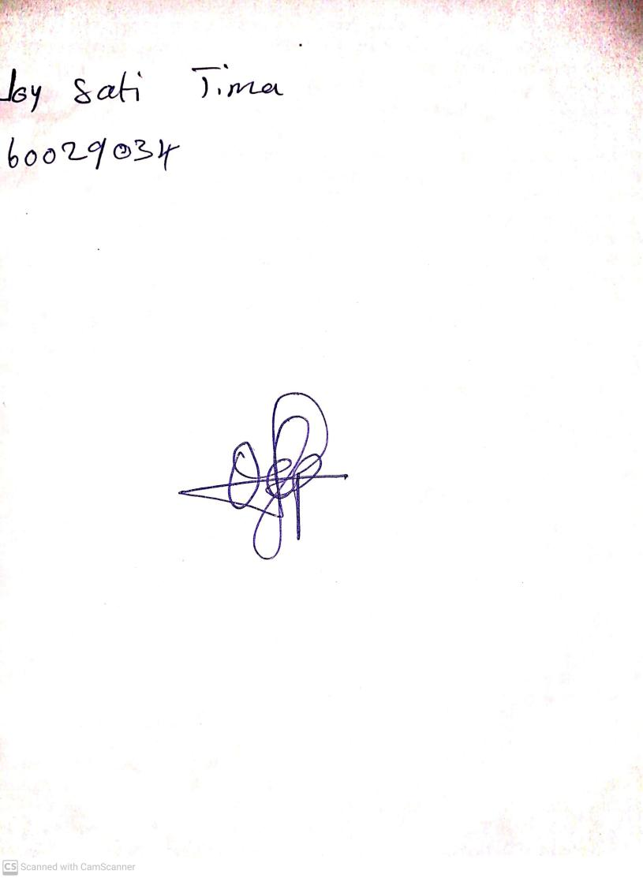

18th September, 2023

Perpetual Ojoma Ocheja

Stream Head Nursery