**LESSON PLAN FOR WEEK 1 ENDING 13TH JANUARY, 2023**

|  |  |
| --- | --- |
| TERM | 2ND |
| WEEK | 1 |
| DATE | 9th -13th January,2023 |
| SUBJECT | GOVERNMENT |
| TOPIC | Pre-Colonial System |
| SUB-TOPIC | The Igbo Political System |
| TIME | 11:10-11:50AM |
| PERIOD | 5TH |
| DURATION | 35 Minutes |
| CLASS | SS2 |
| NO IN CLASS | 4 |
| AVERAGE AGE | 14-15 Years |
| SEX | Mixed |
| LEARNING OBJECTIVES | By the end of the topic, the scholars should be able to:  i.Explain the Igbo political system.  ii.Describe the structural organization of the Igbo political system. |
| RATIONALE | To acquaint scholars with the Igbo political system. |
| PREVIOUS KNOWLEDGE | The scholars have been exposed to the Hausa/Fulani political system. |
| INTSRUTCIONAL RESOURCES | Charts from textbook explaining the topic. |
| REFERENCE MATERIAL | Essential Government For Senior Secondary Schools.  Debie.C. Chris |

**LESSON DEVELOPMENT**

|  |  |  |  |
| --- | --- | --- | --- |
| STEPS | TEACHER’S ACTIVITIES | SCHOLARS ACTIVITIES | LEARNIG POINTS |
| Introduction | The teacher introduces the topic by asking the scholars to mention two advisers in the Sokoto Caliphate. | The scholars mention two advisers in the Sokoto Caliphate as:  -The Waziri  -The Dogara. | To arouse the scholars interest towards the topic. |
| Step 1 | The teacher explains the Igbo political system. | The scholars pay attention. | To enhance proper understanding of the topic. |
| Step 2 | The teacher describes the structural organization of the Igbo political system. | The scholars listen and ask relevant questions on the topic. | To encourage critical thinking on the topic. |
| Board Summary | The teacher summarizes the lesson thus:  **THE IGBO POLITCAL SYSTEM**  The Igbo political system may be seen as a fragmented political system. Many institutions were in place and political authority was shared among them. For example, the Ofo title holders (council of Elders), Ozo title holders and age grades were all involved in the sharing of power. No wonder then that, the term “Acephalous” was used to describe the political system. There was the absence of centralization of power and authority in Igbo system as it was more of the people’s direct participation in their government (Direct Democracy).  **STRUCTURAL ORGANISATION OF THE IGBO POLITICAL SYSTEM.**  I.Village administration: The Igbo political system was based on the village as the political unit. A village is seen as inhabited by a group of related families. Each family head held the Ofo title and all of them put together formed the council of Elders. The council governed the village. The most senior Ofo title holder was referred to as the Okpara, and he had the right to preside over meetings, while issues affecting the people were discussed and implemented.  2.The age grades: There were young men that belonged to the same age group, and they performed the following functions:  **i.Administration:** They were involved in the administration of the village.  **ii.Performance of public duties:** They helped in the repair of roads, cleaning the market square,etc.  **iii: Maintenance of law and order:** they acted as the police to ensure law and order.  **iv.implementation of policies**: They helped in the implementation of policies made by the Council of Elders.  **v.Abuse of power:** They assisted in checking the abuse of powers by the paramount rulers and Council of Elders.  **3.The Executive:** The affairs of the village are discussed from time to time by the family heads.  **4.The Legislature**: The villagers made laws themselves and even the age grades could enact a law which the Elders would accept.  5.**The Judiciary:** In this area, family heads settle disputes between families.  6.**The Ozo title holders:** Some wealthy and influential men took this title which was very expensive. This makes them to be recognized in the society and also to preside over meetings on issues affecting the community with the Elders Council.  **7.Type of political system**: The political system was more of a Republican. Decisions were reached by consensus. | The students copy notes into their notebooks. | For future reference. |
| Evaluation | The teacher evaluates the scholars thus:  i.Briefly describe the Igbo political system.  ii.Explain the structural organization of the Igbo political system. | The scholars attempt the questions. | To assess their understanding of the topic. |
| Conclusion | The teacher check scholars notes and make corrections. | The scholars take corrections made by the teacher. | For better understanding of the topic. |
| Assignment | The teacher give the scholars home work:  Mention five functions of the Ofo title holders in the Igbo political system. | The scholars copy their home work to do it at home. | To encourage scholars to learn and study while at home. |

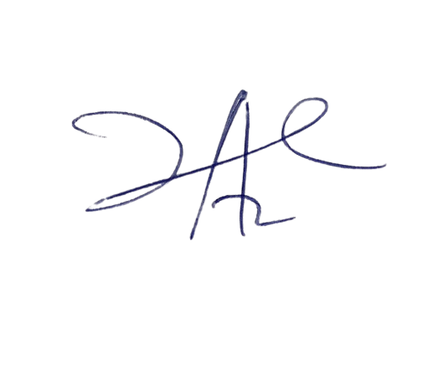

Perpetua Iheme

Head Instructor