EMERALD ROYAL INTERNATIONAL SCHOOL,MPAPE ABUJA.

LESSON PLAN FOR WEEK 1 ENDING 12TH JANUARY ,2024

|  |  |
| --- | --- |
| TERM | 2nd |
| WEEK | 1 |
| DATE | 9th-12th January, 2024. |
| SUBJECT | Social Norms |
| TOPIC | Myself |
| SUB-TOPIC | My Name |
| PERIOD | 4th |
| TIME | 10:40-11:20AM |
| DURATION | 40 Minutes |
| CLASS | Pre-Nursery |
| NO IN CLASS | 17 |
| AVERAGE AGE | 2 Years |
| SEX | Mixed |
| LEARNING OBJECTIVES | By the end of the lesson, the pupils should be able to:  i.Say their names.  ii.Say their surnames |
| RATIONALE | For the pupils to know about themselves. |
| PREVIOUS KNOWLEDGE | Pupils can answer to their names when called upon. |
| INSTRUCTIONAL RESOURCES | Pupils in the classroom. |
| REFERENCE | Smart Start Civic Education for Nursery Schools. Book 1  T.Y Alabi and A.M Solu |

LESSON DEVELOPMENT

|  |  |  |  |
| --- | --- | --- | --- |
| STEPS | TEACHER’S ACTIVITIES | PUPILS’ ACTIVITIES | LEARNING POINTS |
| Introduction | The teacher introduces the lesson by singing a nursery rhyme for the pupils. | The pupils sing along with the teacher. | To stimulate pupils attention for the lesson. |
| Presentation  Step 1 | The teacher models to the pupils on how they can say their names. That is, the teacher touches herself and say “My name is Mrs Gloria”. | The pupils pay attention to the teacher as she models how one can say his/her name. | To give the pupils an idea on the proper way to introduce oneself. |
| Step 2 | The teacher teaches the pupils to say their surnames as:  “My name is Mrs Gloria”. The teacher then asks the pupils to repeat after her and say their names  And surnames. | The pupils listen to the teacher and repeats after her to say their names and surnames as:  “My name is Adeyemi Precious”. | To improve pupils speaking ability and for them to be able to say their names and surnames. |
| Summary | The teacher summarises the lesson by asking the pupils to say their names. | The pupils say their names. | To ensure proper understanding of the lesson. |
| Evaluation | The teacher calls out the pupils one after another and asks “What is your name?”. | The pupils respond to the teacher’s question. | To ascertain pupils understanding of the lesson. |
| Conclusion | The teacher ends the lesson by playing a video clip for the pupils to watch. | The pupils sit and pay attention to watch the video. | To improve pupils’ attention span. |
| Assignment | The teacher encourages the pupils to practice more on how to introduce themselves at home. | The pupils practice how to say their names and surnames at home. | To encourage learning at home. |

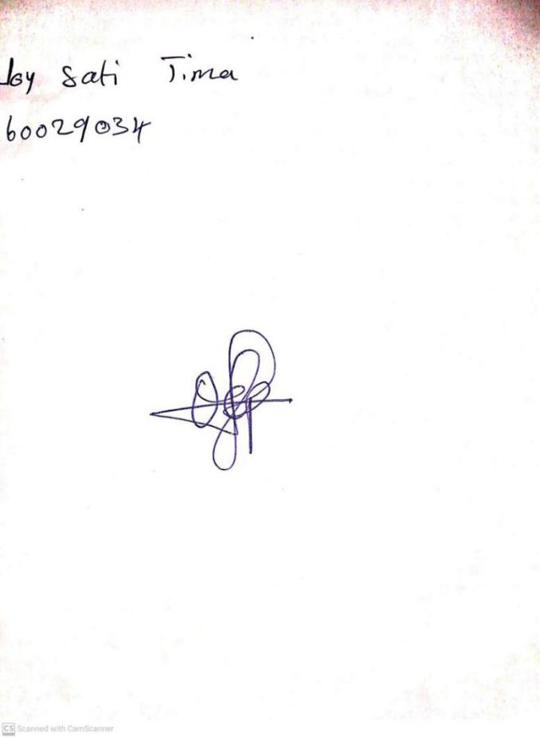

**10TH JANUARY, 2024**

**Perpetual Ojoma Ocheja**

**Stream Head Nursery**