**EMERALD ROYAL INTERNATIONAL SCHOOL**

**MPAPE, ABUJA.**

**LESSON PLAN AND NOTE FOR WEEK 2 ENDING 20/09/2024**

**TERM: 1st**

**WEEK: 2nd**

**DATE: 16/09/2024**

**CLASS: Nursery 2**

**SUBJECT: Nature studies**

**TOPIC: First aid:Uses**

**SUB—TOPIC: Items in first aid kit and their uses.**

**PERIOD: 4th**

**TIME: 10:40—11:20am**

**DURATION: 40 minutes**

**NUMBER IN CLASS: 14**

**AVERAGE AGE: 5 years**

**SEX: Mixed**

**LEARNING OBJECTIVES: By the end of the lesson, the pupils should be able to:**

**1. Mention first aid items.**

**2. State the uses of the first aid items.**

**RATIONALE: For pupils to know more about first aid and it's items and uses.**

**PREVIOUS KNOWLEDGE: Pupils have learnt about the meaning of first aid and first aid kit in**

**Previous lesson.**

**INSTRUCTIONAL MATERIALS: Razor blade, scissors, and bandage.**

**REFERENCE MATERIALS: Basic science and technology for Nursery schools book 3 by OPEMIPO DADA.**

**LESSON DEVELOPMENT**

|  |  |  |  |
| --- | --- | --- | --- |
| **Steps** | **Teacher's activities** | **Pupils' activities** | **Learning point** |
| **Introduction** | **Teacher introduces the lesson by reviewing the previous lesson.** | **Pupils pay attention to the teacher.** | **To prepare pupils minds for the lesson ahead.** |
| **Presentation step 1** | **Teacher mentions the first aid items to pupils and then asks them to repeat after her.** | **Pupils listen to the teacher and repeat after her.** | **To improve pupils listening and speaking ability.** |
| **Step 2** | **Teacher States the uses of the first aid items to pupils and also asks them to repeat after her.** | **Pupils pay attention to the teacher and repeat her.** | **To enhance pupils participation in the class.** |
| **Board summary** | **Teacher writes the whole note of lesson on the board for pupils to copy into their books. That is;**  **First aid items:**  **Items in first aid kit are:**   1. **Cotton wool** 2. **Scissors** 3. **Plaster** 4. **Razor blade** 5. **Bandage** 6. **Tea spoon** 7. **G.V** 8. **Disposable sterile gloves.** 9. **Safety pins** 10. **Mentholated spirit** 11. **Eye wash** 12. **Iodine** 13. **Antiseptic** 14. **Insect bite cream** 15. **Eye patch** 16. **Pain reliever etc.**   **Uses of first aid items:**  **1.Cotton wool is used for cleaning blood.**  **2. Plaster is use to stick treatment to the wound.**  **3. Bandage is use to tie dislocation .**  **4. Eye wash is used for washing the eyes.**  **5. Iodine is used for cleaning wounds to keep germs away.**  **6. Safety pin is used for holding the ends of a bandage.**  **7. Scissors is used for cutting plaster and bandage.**  **8. Plaster is used for covering wounds to keep germs away.**  **9. Gloves are used for protecting the hands.**  **10. Eye patch is used to cover an injured eye.**  **11. Antiseptic wash is used for washing wounds to keep germs away.**  **12. Pain reliever is used to reduce the pain that an injured person feels.** | **Pupils copy the note into their exercise books.** | **For onward study.** |
| **Evaluation** | **Teacher evaluates the lesson by asking pupils the following questions;**   1. **Mention the first aid items that you know.** 2. **State the uses of the items.** | **Pupils answer the questions asked by the teacher.** | **To assess pupils level of understanding.** |
| **Conclusion** | **Teacher concludes the lesson by marking pupils books.** | **Pupils submit their books for marking.** | **For endorsement.** |
| **Assignment** | **Mention ten(10) parts of your body.** | **Pupils do their assignment at home.** | **To encourage learning at home.** |

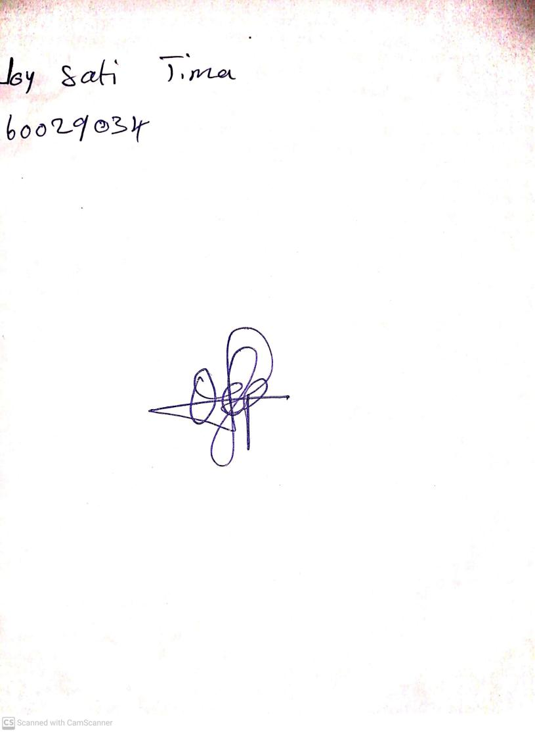

**13th September, 2024**

**Perpetual Ojoma Ocheja**

**Stream Head Nursery**