**EMERALD ROYAL INTERNATIONAL SCHOOL MPAPE, ABUJA**

**NURSERY 2 (TWO) SCHEME OF WORK**

**1ST TERM**

**GRAMMAR**

|  |  |  |
| --- | --- | --- |
| **WEEKS** | **TOPICS** | **CONTENT/ACTIVITIES** |
| **1-2** | **Nouns** | **Guide pupils to list, pronounce, spell and use names of people in sentences correctly.** |
| **3-4** | **Nouns** | **Guide pupils to list, pronounce, spell and use names of things in sentences correctly.** |
| **5-6** | **Nouns** | **Guide pupils to list, pronounce, spell and use names of places in sentences correctly.** |
| **7-8** | **Singular nouns** | **Name of one person, thing, or place. Examples.** |
| **9-10** | **Plural nouns** | **Meaning , examples.** |
| **11-12** | **Gender** | **Different male and female names of persons and animals.**  **Examples.** |
| **13** | **Revision** |  |
| **14** | **Examination** |  |

**EMERALD ROYAL INTERNATIONAL SCHOOL MPAPE, ABUJA**

**NURSERY 2 (TWO) SCHEME OF WORK**

**2ND TERM**

**GRAMMAR**

|  |  |  |
| --- | --- | --- |
| **WEEKS** | **TOPICS** | **CONTENT/ACTIVITIES** |
| **1-2** | **Introducing verbs** | **Verb- as an action or doing word. Examples.** |
| **3-4** | **Verb: the present simpler tense.** | **Expressing actions in “every day” tense. Examples ‘ I like it’, ‘we like it’, ‘you like it’, ‘they like it’.** |
| **5-6** | **Verb: the present continuous tense.** | **-e.g- it is running.**  **- she is dancing.**  **-they are sleeping.** |
| **7** | **Regular verb: past tense.** | **Actions that have taken place or occurred some times ago. E.g he jumped over the wall.**  **She washed the cloth etc.** |
| **8** | **Irregular verb: past tense.** | **Actions that have taken place or occurred some times ago. E.g came,said,ate, saw, did, went, ran etc.** |
| **9-10** | **Opposites** | **Contrary meaning of words. E.g go-come, sit-stand etc.** |
| **11-12** | **Possessive pronouns** | **Expressing ownership by using pronoun. He is my father, this is his book, that is its tail etc.** |
| **13** | **Revision** |  |
| **14** | **Examination** |  |

**EMERALD ROYAL INTERNATIONAL SCHOOL MPAPE, ABUJA**

**NURSERY 2 (TWO) SCHEME OF WORK**

**3RD TERM**

**GRAMMAR**

|  |  |  |
| --- | --- | --- |
| **WEEKS** | **TOPICS** | **CONTENT/ACTIVITIES** |
| **1-2** | **More opposites** | **More of opposite words.** |
| **3-4** | **Adjectives : colours** | **- a green leaf, a white ball, a white wall, a black bag.**  **- using names of colours to describe or modify nouns.** |
| **5-6** | **Adjectives: numbers** | **Examples- two books, six dogs.** |
| **7-8** | **Adjectives: (General)** | **Other words to describe or modify nouns. E.g a fast car, a big dog, a tall man, a lazy person etc.** |
| **9-10** | **Personal: pronouns** | **Words used in the place of nouns. E.g I, you, she, he, it.**  **Plural form - we, they, etc.** |
| **11** | **Adverbs** | **Words that describe or modify verbs. E.g she walks slowly, he eats fast, read loudly.** |
| **12** | **Preposition** | **Words that show the position relationship between. E.g the book is on the table.**  **She is standing near the door.**  **Put the mango in the bag.** |
| **13** | **Revision** |  |
| **14** | **Examination** |  |

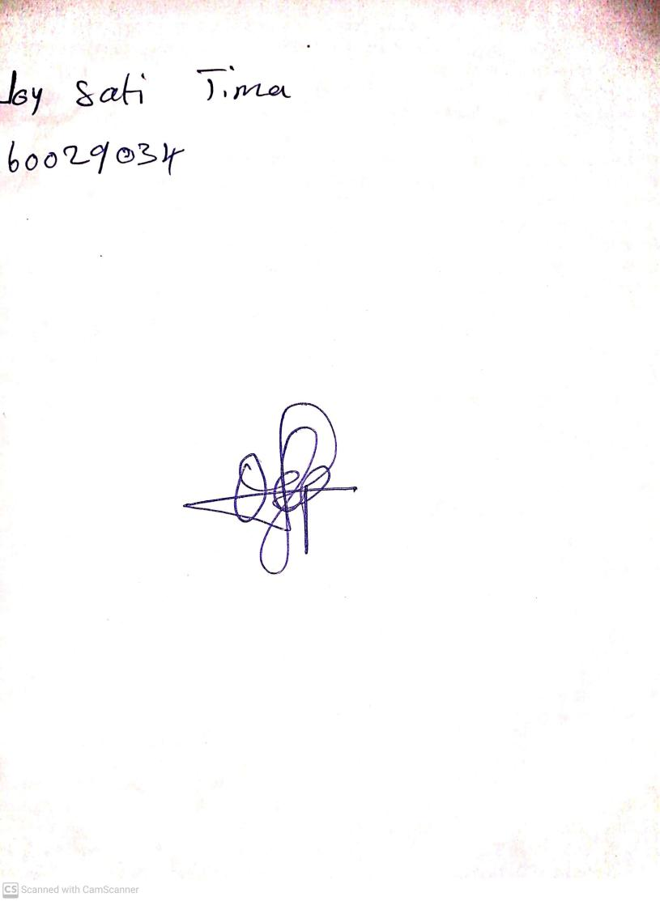

11TH OCTOBER, 2023

Perpetual Ojoma Ocheja

Stream Head Nursery