**EMERALD ROYAL INTERNATIONAL SCHOO,**

**MPAPE ABUJA.**

**THIRD TERM PRE-NURSERY SCHEME OF WORK ON LETTER WORK.**

**WEEK 1: Match same letters Aa-Zz, identification of letters Aa-Zz(upper case and lower case).**

**WEEK2: Matching letters Aa-Ee with picture word ,two letter words and copying letters Aa**

**and Bb.**

**WEEK3: Matching letters Ff-Jj with picture words and copying letter Cc-Ff.**

**WEEK4: Matching letters Kk-Oo with picture words.**

**WEEK5: Matching letters Pp-Tt with picture words.**

**WEEK6: Matching letters Uu-Zz with picture word, colouring and tracing ,copying letters Gg-Kk.**

**WEEK7: Matching letters Aa-Zz with picture word ,two letter words.**

**WEEK8: Matching objects and their names and copying letter Ll-Pp.**

**WEEK9: Aiphabets- fill in the missing alphabets A-Z.**

**WEEK10: Matching objects with their names and copying letters Qq-Uu.**

**WEEK11: Copying letters Vv-Zz.**

**WEEK12: Matching objects and their names and copying lettersAa-Zz.**

**WEEK13: Revision.**

**WEEK14: Examination.**

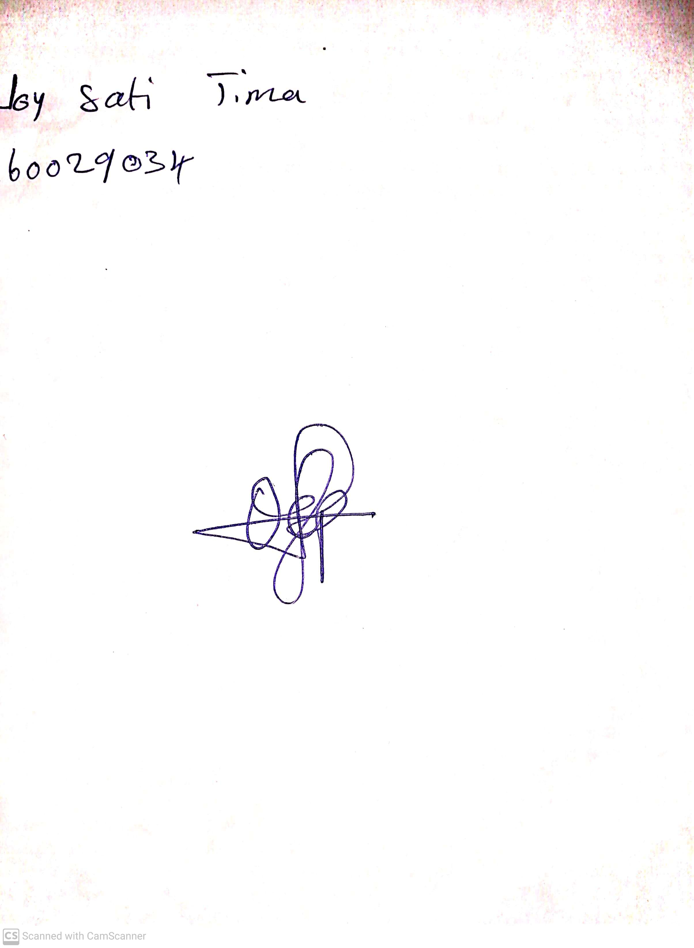

21ST JUNE, 2023

Perpetual Ojoma

Stream Head Nursery