**EMERALD ROYAL INTERNATIONAL SCHOOL MPAPE, ABUJA**

**NURSERY 2 (TWO) SCHEME OF WORK**

**1ST TERM**

**NUMERACY**

|  |  |  |
| --- | --- | --- |
| **WEEKS** | **TOPICS** | **CONTENT/ACTIVITIES** |
| **1** | **Counting and writing of numbers 1-20** | **-Count,write and identify 1-20**  **- Colour and paint numbers**  **-match numbers with pictures** |
| **2** | **Number 21-25** | **Count and write 1-25, 25-1.** |
| **3** | **Odd and even numbers** | **Meaning of old and even numbers 1-20.** |
| **4** | **Time measurement o’clock , half past** | **Clock face showing second, minute and hour hands.** |
| **5** | **Number 25-30** | **Write 1-25,26-30,1-30,30-1.** |
| **6** | **Shapes: circle, triangle, square, rectangle.** | **Study, match, trace and know more about shapes.** |
| **7** | **Shapes: circle, triangle, square, rectangle.** | **-sing the shapes song**  **-shapes of objects in class.**  **-colour and paint shapes with different colours.** |
| **8** | **Roman numerals: i to x** | **Roman numerals as one of the indigenous ways of writing numbers.** |
| **9** | **Moulding of numbers 1-30, Roman numerals xi - xx.** | **Moulding number 1-10,11-20,21-30 with clay.** |
| **10** | **Multiplication table 2.** | **2x1=2, 2x2=4 etc.** |
| **11-12** | **Revision** |  |
| **13-14** | **Examination** |  |

**EMERALD ROYAL INTERNATIONAL SCHOOL MPAPE, ABUJA**

**NURSERY 2 (TWO) SCHEME OF WORK**

**2ND TERM**

**NUMERACY**

|  |  |  |
| --- | --- | --- |
| **WEEKS** | **TOPICS** | **CONTENT/ACTIVITIES** |
| **1** | **Revision** | **Revision of 1st term’s work** |
| **2** | **Number group** | **Count sets of objects in groups from 11-30 e.g 12 books, 23 pens etc** |
| **3** | **Numbers 31-35** | **Identify, count and write 31-35,35-31** |
| **4** | **Ordinal numbers (positioning): 1st to 9th** | **Explain ordinal numbers, state the positioning of a person or object e.g first (1st) second (2nd) etc.** |
| **5** | **Descending order of numbers** | **Meaning, e.g 13,12,14,10,11=14,13,12,11,10.** |
| **6** | **Ascending order of numbers** | **Meaning e.g 20,26,23,24,25=20,23,24,25,26.** |
| **7** | **Multiplication table 3** | **3x1=3,3x2=6.** |
| **8** | **Fraction: half(1/2)** | **Meaning of fraction (I/2)** |
| **9** | **Numbers 36-40** | **Identify, count and write 36-40,1-40, 40-1.** |
| **10-11** | **Revision** |  |
| **12-13** | **examination** |  |

**EMERALD ROYAL INTERNATIONAL SCHOOL MPAPE, ABUJA**

**NURSERY 2 (TWO) SCHEME OF WORK**

**3RD TERM**

**NUMERACY**

|  |  |  |
| --- | --- | --- |
| **WEEKS** | **TOPICS** | **CONTENT/ACTIVITIES** |
| **1** | **Revision** | **Revision of 2nd term’s work.** |
| **2** | **Numbers 41-45** | **Read, count and write 41-45,1-45, reverse counting 45-1.** |
| **3** | **Greater than (>),**  **Less than (<)** | **Fold right arm and left arm to illustrate the signs.** |
| **4** | **Place value of numbers** | **- simple meaning of place value**  **-use of abacus to arrange the place value 1-50.** |
| **5** | **Length** | **Simple meaning of length and examples.** |
| **6** | **Numbers 46-50** | **Count and write 46-50, 1-50, 50-1.** |
| **7** | **Numbers in words 1-10** | |  | | --- | | **flash cards of numbers in words 1-10.** | |
| **8** | **Numbers in words 11-20** | **Flash cards of numbers in words 11-20.** |
| **9** | **Simple addition (numbers 1-9)** | **Meaning and it’s sign (+), e.g 2+3 =5** |
| **10** | **Simple subtraction (numbers 1-9)** | **Meaning and it’s sign (-), e.g 3-2=1** |
| **11** | **Money: #1, #20 etc** | **Meaning of money and it’s uses.** |
| **12** | **Revision** |  |
| **13** | **Examination** |  |

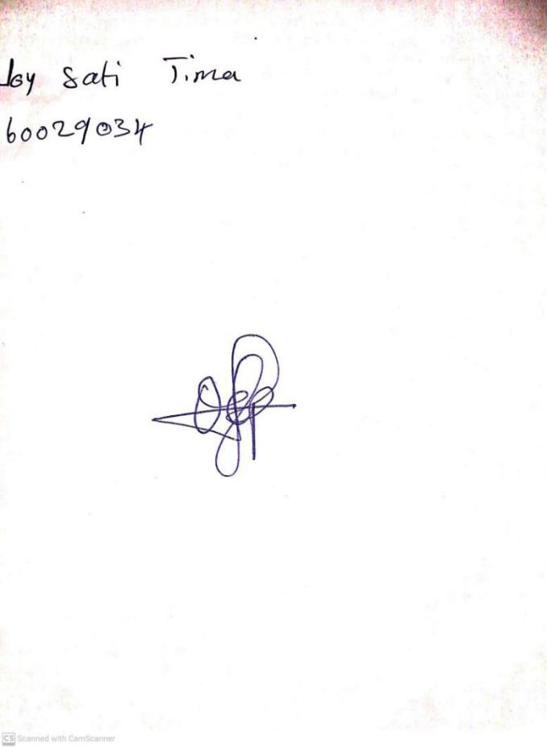

5TH January, 2024

Perpetual Ojoma Ocheja

Stream Head Nursery