**Lesson Plan/ Note for Week one Ending 13/1 /2023.**



**Term:** 2nd

**Week:** one

**Date:** 10/1/2023

**Subject:** Economics

**Topic:** firm and industry

**Sub-Topic:** meaning of private and public enterprises and characteristics.

**Period:** 9th

**Time:** 10:30 -11:10.

**Duration:** 40 minutes

**Class:** ss1

**Number in class**: 7 Students.

**Average Age:** 14 Years.

**Sex:** mixed

**Specific objectives:** By the end of the lesson, the students should be able to:

(1) Define private and public enterprise

(11) State the characteristics of private and public enterprises.

**Rationale:** To be able to State the characteristics of business enterprises.

**Previous knowledge:** The students have been seeing shops and business enterprise around.

**Instructional Material:** A chart showing business premises or shops.

**Reference material:** Ande C E (2020) Essential Economics for senior Secondary schools.

**LESSON DEVELOPMENT**

|  |  |  |  |
| --- | --- | --- | --- |
| **Stages/steps** | **Teacher's Activities** | **Students' Activities** | **Learning points** |
| **Introduction** | Review the previous lesson | Participate actively in the class discussion. | To arouse the students’ interest to learn. |
| **Step 1** | Defines private and public enterprises as : private enterprise are the enterprises that are owned and managed by private individuals. While public enterprise are the enterprises that are owned and managed by the government. | Pay attention and ask questions when necessary. | For better understanding of the lesson. |
| **Step 11** | Guides the students to state the characteristics of private and public enterprises. | Respond to the activity. | To enable students’ reason logically. |
| **Summary** | Summarizes the lesson as:  **Private enterprise**  Private enterprise are the enterprises that are owned an managed by private individuals. Examples are sole proprietorship, partnership, private and public limited companies and co-operative societies. The major aim is to make or maximize profits.  **Characteristics of private enterprise**  (1) private individuals provide the capital.  (2) Ownership belongs to the private individuals.  (3) The objective of the business is to make profit.  (4) Accountability is to the owner.  (5) Owners Borne the risks of the business.  (6) owners manage the business themselves.  **Public enterprise**  Public enterprise are the types of business organization which are owned, controlled and managed by the government. This type of business is either owned by the local, state and federal Government. The major objective is to provide social services to the people. They are associated with such name as authority, corporation, boards and commissions. Examples are public corporation and companies owned by government such as National Electric Power Authority (NEPA), Nigeria Port Authority (NPA), Nigeria Television Authority (NTA) etc.  **Characteristics o**f **public enterprises.**  (1) Government provides the capitals.  (2) ownership belongs to the government.  (3) objectives is to provide social services.  (4) Management is accountable to the government.  (5) Government and tax payers borne the risks.  (6) Boards of directors manage the business.  (7) Public enterprise is a legal entity. | Copy and submit the Note book for marking. | For future reference. |
| **Evaluation** | Evaluates the students as:  (1) Explain private and public enterprises.  State two characteristics of private and public enterprises. | Respond to the questions | Ascertaining the attainment of the stated objectives |
| **Conclusion** | Rounds up the lesson by marking and correcting students work | Check and do their correction | Consolidation of the lesson |
| **Assignment** | Gives home work as:  (1) Explain the following:  (a) sole proprietorship.  (b) partnership  (c) Cooperative society.  (d) joint stock company. | Respond by doing the home work at home. | To ensure continuity of learning. |

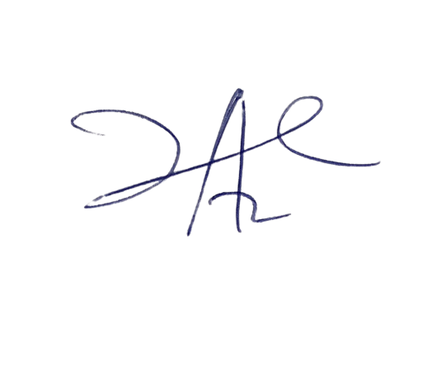

**6/3/2023**

**Principal Head Instructor**