**LESSON PLAN/NOTE FOR WEEK 8 ENDING 23/06/2023**

**Date**: 26/06/2023

**Week**: 8

**Class**: SS 2

**Subject**: Economics

**Topic**: Types of financial institution

**Sub-Topic:** Meaning of primary and secondary market and methods.

**Period**: 2nd

**Time**: 8:50-9:30

**Duration**: 40 Minutes

**Number in class**: 4 students

**Average Age:** 14 Years

**Sex**: Mixed

**Specific objectives:** By the end of the lesson, the students should be able to:

(1) Define primary Market

(11) State the methods of issuing securities in the primary Market.

(111) Explain secondary market

**Rationale**: For the students to be able to differentiate between primary and secondary market and how loans are acquired.

**Previous knowledge**: The students have seen people borrowing money for investment or to boost their businesses.

**Instructional material**: A chart showing people trading in the primary and secondary market for short-term and long-term loans.

**Reference material:** Cole Esan (2020) Essential Economics for senior secondary schools.

**LESSON DEVELOPMENT**

|  |  |  |  |
| --- | --- | --- | --- |
| **Stages/steps** | **Teacher's Activities** | **Students' Activities** | **Learning points** |
| **Introduction** | Review the previous lesson. | Participate actively in the class discussion | To arouse the students interest to learn. |
| **Step 1** | Defines primary Market as: primary Market is a market for new long-term capital. This is when the securities are sold for the first time. | Listen carefully to the teacher. | For better understanding of the lesson. |
| **Step 11** | Asks the students to state the methods of issuing securities in the primary Market. | State the methods of issuing securities in the primary Market as: (1) initial offering (2) Right issue etc. | To encourage critical thinking. |
| **Step 111** | Guides the students to explain secondary market. | Participate actively in the class activity. | To enable the students to reason logically. |
| **Board summary** | Summarizes the lesson as:  **Primary Market.**  Primary Market is a market for new long-term capital. The primary Market is the market where the securities are sold for the first time. It is therefore called new issue market (NIM). In a primary issue, the securities are issued by the company directly to investors. The company receives the money and issues new security certificate to the investors. The primary issue are used by companies for the purpose of settling up new business or for expanding or modernising the existing business. Borrowers in the new issue market may be raising capital for converting private capital into public capital. This is known as "going public" .  **Methods of issuing securities in the primary Market.**  (1) Initial offering  (2) Right issue (for existing companies  (3) preferential issue.  **Secondary Market**  Secondary Market is the financial market for trading of securities that have already been issued in an initial private or public offering. In other words, secondary market can be referred to as the market for any kind of used goods. It is the market that exists in a new security just after the new issue. It is often referred to as the ' aftermarket '. Once a newly issued stock is listed on a stock exchange, investors and speculators can easily trade on the exchange, as market nfakers provide bids and offers in new stock. | Copy and submit the note book for marking | For future reference. |
| **Evaluation** | Evaluates the students as:  (1) Define Primary Market  (2) State 3 methods of issuing securities in the primary Market  (3) Explain secondary market | Respond to the questions | Ascertaining the attainment of the stated objectives. |
| **Conclusion** | Rounds up the lesson by marking and correcting students work | Check and do their correction | Consolidation of the lesson. |
| **Assignment** | Gives home work as:  (1) Mention and explain 4 types of securities. | Respond to the questions by doing the home work at home. | To ensure continuity of learning. |

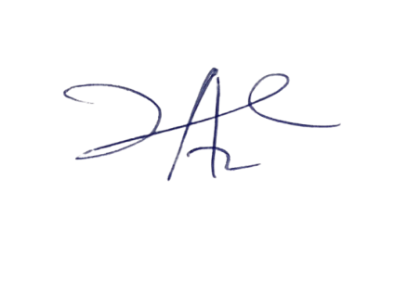

17/8/2023

Principal Head Instuctor