EMERALD ROYAL INTERNATIONAL SCHOOL

MPAPE, ABUJA.

LESSON PLAN/NOTE FOR WEEK 4 ENDING 1ST FEBRUARY,2024.

SUBJECT: Nature studies

TOPIC: Insects

SUB-TOPIC: Definition of insects and identification of insects.

DATE: 30th January, 2024.

DURATION: 40minutes

TIME: 09:30----10:10

PERIOD: 3rd

CLASS: Pre-nursery

NUMBER OF PUPILS: 17

AVERAGE AGE: 2 years

SEX: mixed

SPECIFIC OBJECTIVES: By the end of the lesson, the pupils should be able to:-

1. Define insects.

2 . Identify common insects.

RATIONALE: For pupils to be able to identify insects around them.

PREVIOUS KNOWLEDGE: PUPILS have seen insects crawling on the school floor.

INSTRUCTIONAL MATERIALS: Chart

REFERENCE: Showers Kiddies Books Elementary Science Nursery 1 by Showers Books.

LESSON DEVELOPMENT

|  |  |  |  |
| --- | --- | --- | --- |
| Stages/steps | Teacher's activities | Pupils' activities | Learning points |
| Introduction | Teacher introduces the lesson by asking the pupils to look down on the floor to check if they can see any small animal that is moving on floor. After that , the teacher introduces the topic of the lesson as "Insects". | Pupils look down the floor to check if they can see any animals that is moving on the floor. Pupils reply to the teacher that they can see an ant. | To get the pupils ready for the lesson. |
| Presentation  Step 1 | Teacher defines insects as:- "Insects are very tiny animals that lives in our environment." Teacher also asks the pupils to repeat after him/her. | Pupils Listen and repeat after the teacher. | To ensure pupils can define insects. |
| Step ,2 | Teacher shows the pupils the pictures of an Insects on a chart for them to see and identify such as:-   1. Cockroach 2. Mosquito 3. Ant 4. Spider 5. Butterfly 6. Housefly | Pupils look at the chart and identify the Insects shown to them by the teacher. | To ensure pupils can identify insects. |
| Summary | Teacher summarizes the lesson by going over the lesson again for better understanding. | Pupils listen to the teacher as he/she is explaining the lesson again. | To ensure pupils can understand the lesson. |
| Evaluation | Teacher asks the pupils to:-   1. Define insects. 2. Identify insects on a chart. | Pupils answer the teacher's questions. | To assess the level of understanding. |
| Conclusion | Teacher ends the lesson by playing a video clips on insects for the pupils to watch. | Pupils sit on a mat and watch the video. | To improve pupils attention span. |
| Assignment | Teacher asks the pupils to circle insects among other animals in their text books. | Pupils do the assignment at home. | To encourage learning at home. |

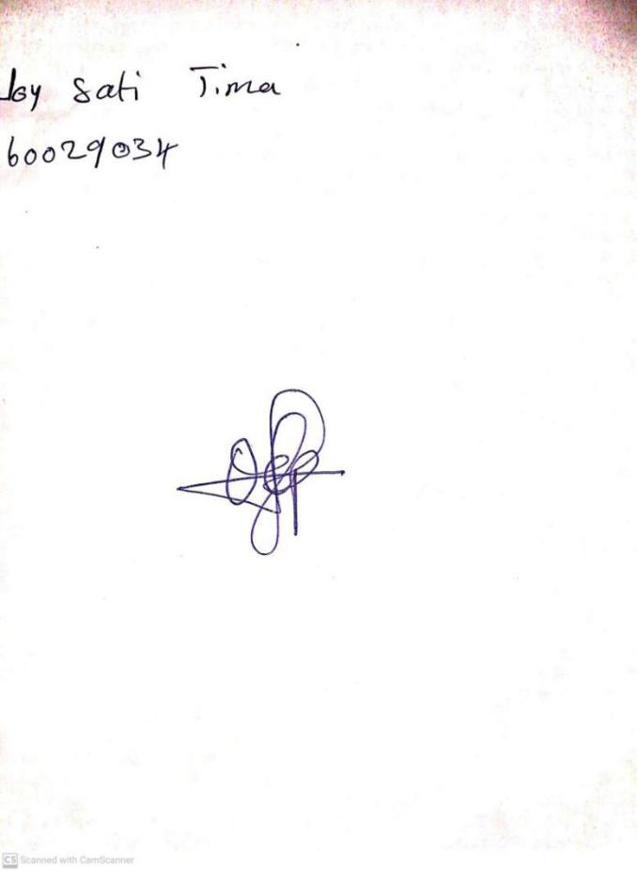

**26TH JANUARY, 2024**

**Perpetual Ojoma Ocheja**

**Stream Head Nursery**