**Lesson Plan/Note for Week6 Ending 17/02/2023.**

**Term:** 2nd

**Week:** 6.

**Date**: 15/02/2023.

**Class**: SS 1.

**Subject**: Economics.

**Topic**: Population.

**Sub-Topic:** Geographical and Occupational Distribution of population.

**Period**: 4th.

**Time**: 10:30-11:10.

**Duration:** 40 Minutes.

**Number in class**: 7 Students.

**Average Age:** 14 Years.

**Sex:** Mixed.

**Specific objectives:** By the end of the lesson, the students should be able to:

(1) Define Occupational Distribution.

(11) State the factors that influence occupation distribution.

(111) Describe Geographical Distribution.

**Rationale:** To be able to identify the population that is working in different areas.

**Previous knowledge:** The students have seen the different types of job people do and the area they live in.

**Instructional Material**: A chart showing people in different occupation the area.

**Reference material:** Ande C.E (2020) Essential Economics for senior Secondary schools.

**LESSON DEVELOPMENT.**

|  |  |  |  |
| --- | --- | --- | --- |
| **Stages/Steps** | **Teacher's Activities** | **Students' Activities** | **Learning points.** |
| **Introduction** | Review the previous lesson. | Participate actively in the class discussion. | To arouse the students’ interest to learn. |
| **Step 1** | Defines Occupational Distribution as: Occupational Distribution refers to the classification of the working population into different types of work they engage in. | Listen carefully to the teacher. | For better understanding of the lesson. |
| **Step 11** | Asks the students to state the factors that influence occupation distribution. | State the factors that influence occupation distribution as: (1) level of education (2) level of technology etc. | To encourage critical thinking. |
| **Step 111** | Guides the students to describe geographical distribution. | Respond to the class activity | To enhance their logical reasoning. |
| **Board Summary** | Summarises the lesson as:  **Occupational Distribution**  Occupational Distribution refers to the classification of the working population into different types of work they engage in.  **Factors that influence occupation distribution**  The occasional distribution in any population is influenced a number of factors. These are:  (1) The level of education. (2) The level of technology. (3) Availability of natural resources. (4) The types of productive activities. The major types of productive activities or industries are primary (extractive), manufacturing, construction, commercial, direct and indirect services. Farming, mining, fishing, lumbering etc are the major occupationally distributed population in west Africa.  **Geographical Distribution**  Geographical Distribution refers to the spread of people into separate geographical areas within a country. The distribution may be due to occupation, presence of mineral resources, historical factors, seat of government, availability of social amenities. | Copy and submit their note book for marking. | For future reference. |
| **Evaluation** | Evaluates the students as:  (1) Define Occupational Distribution.  (2) State 3 factors that influence occupation distribution.  (3) Describe Geographical Distribution | Respond to the questions | Ascertaining the attainment of the stated objectives. |
| **Conclusion** | Rounds up the lesson by marking and correcting students work. | Check and do their correction | Consolidation of the lesson. |
| **Assignment** | Gives home work as:  (1) State 5 reasons for high population density in Nigeria. | Respond by doing the home work at home. | To ensure continuity of learning. |

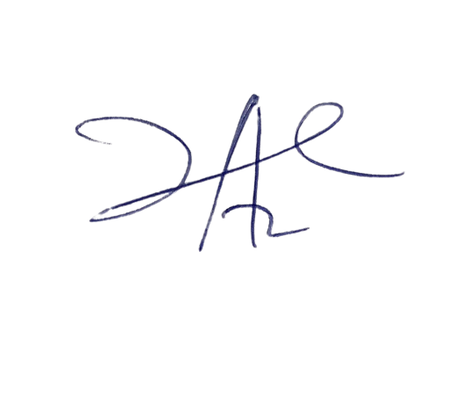

6/3/2023

Principal Head Instructor