LESSON PLAN/ NOTE FOR WEEK 10 PERIOD 1 ENDING 07 /07/2023

TERM: 3rd

WEEK: 10th

DATE: 03/07/2023

CLASS: Nursery 2

SUBJECT: Number work

TOPIC: Simple subtraction(Numbers 1— 9)

SUB—TOPIC: Simple meaning of subtraction and its sign (—),examples

PERIOD: 1st

TIME: 08:50—09:30 am

DURATION: 40 minutes

NUMBER IN CLASS: 14

AVERAGE AGE: 5 years

SEX: Mixed

LEARNING OBJECTIVES: By the end of the lesson, the Pupils should be able to:

1. Explain the meaning of subtraction

2. Identify subtraction sign and examples

RATIONALE: For Pupils to know the meaning of subtraction.

PREVIOUS KNOWLEDGE: Pupils have learnt about addition in previous lesson.

INSTRUCTIONAL MATERIALS: pencils and bottles top

REFERENCE MATERIALS: Mastering Mathematics for Nursery schools book 3 by Henry Z.Idogun

LESSON DEVELOPMENT

|  |  |  |  |
| --- | --- | --- | --- |
| STAGES/ STEPS | TEACHER'S ACTIVITIES | PUPILS' ACTIVITIES | LEARNING POINT |
| Introduction | Teacher reviews the previous lesson. | Pupils listen attentively to the teacher. | To arouse pupils interest for the lesson. |
| Presentation step 1 | Teacher explains the meaning of subtraction to pupils and then ask them to repeat after her. | Pupils listen to the teacher and repeat after her. | For proper understanding. |
| Step 2 | Teacher writes the sign for subtraction and examples on the board for pupils to identify and also ask them to repeat after her. | Pupils pay attention to the teacher and repeat after her. | To enhance Pupils participation in class. |
| Board summary | Teacher summarizes the lesson by writing the whole note of lesson on the board for pupils to copy into their bookS as;  SUBTRACTIONS  Subtraction is simply the process of taking one quantity and removing part of it to work out what is left.  It is the opposite of addition, because we are reducing the value of the number rather than increasing it by adding more numbers.  Subtraction sign is (–)  Examples of subtraction  Question  Subtract the following numbers  1.8–5  2. 9–3  3. 7–1  4. 9–5  5. 7–2  6. 6–5  7. 8–3  8. 5–3  Solution:  1. 8–5= 3  00000000–00000=3  2. 9–3= 6  000000000–000=6  3. 7–1= 6  0000000–0 =6  4. 9–5= 4  000000000–00000=4  5. 7–2= 5  0000000–00=5  6. 6–5= 1  000000–00000=1  7. 8–3= 5  00000000–000=5  8. 5–3= 2  00000–000=2 | Pupils copy the note into their exercise books. | For onward study. |
| Evaluation | Teacher evaluates the lesson by asking pupils the following questions;  1. What is the meaning of subtraction  2. What is the sign for subtraction? | Pupils answer the questions ask by the teacher. | To assess pupils level of understanding. |
| Conclusion | Teacher concludes the lesson by marking pupils books. | Pupils submit their books for marking. | For endorsement. |
| Assignment | Subtract the following:  1. 8–2=  2. 6–2=  3. 9–4=  4. 6–5=  5. 8–1= | Pupils do their assignment at home. | To encourage learning at home. |

LESSON PLAN/NOTE FOR WEEK 10 PERIOD 2 ENDING 07/07/2023

TERM: 3rd

WEEK: 10th

DATE: 04/07/2023

CLASS: Nursery 2

SUBJECT: Number work

TOPIC: Simple subtraction(Numbers 1–9)

SUB—TOPIC: Subtraction of numbers 1–5

PERIOD: 2nd

TIME: 08:50—09:30 am

DURATION: 40 minutes

NUMBER IN CLASS: 14

AVERAGE AGE: 5 years

SEX: Mixed

LEARNING OBJECTIVES: By the end of the lesson, the Pupils should be able to:

1. Identify numbers 1–5

2. Subtract numbers 1–5

RATIONALE: For Pupils to subtraction of numbers 1–5

PREVIOUS KNOWLEDGE: Pupils have learnt the meaning of subtraction and some examples.

INSTRUCTIONAL MATERIALS: Bottle tops and crayons..

REFERENCE MATERIALS: New General Mathematics for primary schools book 1. By J Aderohunmu etal.

LESSON DEVELOPMENT

|  |  |  |  |
| --- | --- | --- | --- |
| STAGES/ STEPS | TEACHER'S ACTIVITIES | PUPILS' ACTIVITIES | LEARNING POINT |
| Introduction | Teacher reviews the previous lesson. | Pupils listen attentively to the teacher. | To arouse pupils interest for the lesson. |
| Presentation step 1 | Teacher writes number 1–5 on the board, count and then ask pupils to repeat after her. | Pupils listen to the teacher and repeat after her. | For proper understanding. |
| Step 2 | Teacher guides pupils to solve some questions on the board. | Pupils solve the questions on the board . | To enhance Pupils participation in class. |
| Board summary | Teacher writes the whole note of lesson on the board for pupils to copy into their books. That is;  Subtraction of numbers 1–5  Subtract the following numbers  1. 4–2  2. 4–3  3. 5–4  4. 4–1  5. 2–1  Solution  1.4–2= 2  0000–00= 2  2. 4–3= 1  0000–000=1  3. 5–4= 1  00000–0000=1  4. 4–1= 3  0000–0=3  5. 2–1= 1  00–0= 1 | Pupils copy the note into their exercise books. | For onward study. |
| Evaluation | Teacher evaluates the lesson by asking pupils to count their bottle tops to find out if the answer's are correct. | Pupils all count the bottle tops individually on their table. | To assess Pupils level of understanding. |
| Conclusion | Teacher concludes the lesson by marking pupils books. | Pupils submit their books for marking. | For endorsement. |
| Assignment | Subtract these numbers   1. 5 — 3=_____ 2. 5 — 4=_____ 3. 4 — 4=_____ 4. 3 — 1=_____ 5. 4 — 1=_____ | Pupils do their assignment at home. | To encourage learning at home. |

LESSON PLAN/NOTE FOR WEEK 10 PERIOD 3 ENDING 07/07/2023

TERM: 3rd

WEEK: 10th

DATE: 07/07/2023

CLASS: Nursery 2

SUBJECT: Number work

TOPIC: Simple subtraction (numbers 1–9)

SUB—TOPIC: Subtraction of numbers 6–9

PERIOD: 3rd

TIME: 08: 10–80 :50am

DURATION: 40 minutes

NUMBER IN CLASS: 14

AVERAGE AGE: 5 years

SEX: Mixed

LEARNING OBJECTIVES: By the end of the lesson, the Pupils should be able to:

1. Identify number 6–9

2. Solve simple Subtraction from 6–9

RATIONALE: For Pupils to learn more of subtractions

PREVIOUS KNOWLEDGE: Pupils have learnt Subtraction of numbers 6–9

INSTRUCTIONAL MATERIALS: Bottle tops

REFERENCE MATERIALS: The New Mastering Mathematics for Nursery schools book 3 by Henry Z.Idogun

LESSON DEVELOPMENT

|  |  |  |  |
| --- | --- | --- | --- |
| STAGES/ STEPS | TEACHER'S ACTIVITIES | PUPILS' ACTIVITIES | LEARNING POINT |
| Introduction | Teacher introduces the lesson by reviewing the previous lesson. | Pupils pay attention to the teacher. | To arouse pupils interest for the lesson. |
| Presentation step 1 | Teacher writes numbers 6–9 on the board for pupils to identify. As  6 7 8 9 | Pupils listen to the teacher and identify the numbers. | For proper understanding. |
| Step 2 | Teacher guides pupils to solve the following questions; | Pupils take turns to solve the questions on the board. | To enhance Pupils participation in class. |
| Board summary | Teacher summarizes the lesson by writing note on the board for pupils to copy. That is;  Subtraction of numbers 6–9  Subtract the following:   1. 6–0 2. 7–3 3. 7–4 4. 9–9 5. 8–6 6. 9–6   Solution  1. 6–0= 6  000000–()=6  2. 7–3=4  0000000–000= 4  3. 7–4= 3  0000000–0000= 3  4. 9–9= 0  000000000–000000000= 0  5. 8–6= 2  00000000–000000= 2  6. 9–6= 3  000000000–000000= 3 | Pupils copy the note into their exercise books. | For onward study. |
| Evaluation | Teacher evaluates the lesson by asking pupils the following questions orally;  Find the answer for the following:  1.9–8=  2. 8–3=  3. 9–2=  4. 8–6=  5. 7–4= | Pupils answer the questions ask by the teacher. | To assess Pupils level of understanding. |
| Conclusion | Teacher concludes the lesson by marking pupils books. | Pupils submit their books for marking. | For endorsement. |
| Assignment | Find the answer to for the following: | Pupils do their assignment at home. | To encourage learning at home. |

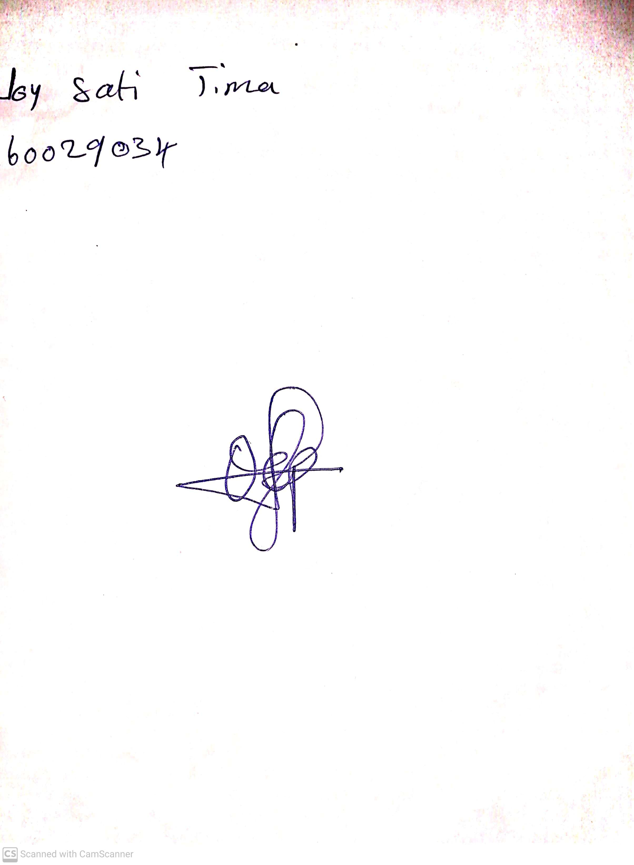

10th May, 2023

Perpetual Ojoma

Stream Head Nursery