**EMERALD ROYAL INTERNATIONAL SCHOOL MPAPE, ABUJA**

**LESSON PLAN AND NOTE FOR WEEK 10 PERIOD 1 ENDING 15/11/2024**

**TERM: FIRST**

**WEEK: 10TH**

**DATE: 11/11/2024**

**CLASS: NURSERY 2**

**SUBJECT: LITERACY**

**TOPIC: READING EXERCISES ON THREE LETTER WORDS (RHYMING WORDS).**

**SUB-TOPIC: MEANING AND EXAMPLES OF RHYMING WORDS.**

**PERIOD: 3RD**

**TIME: 09: 30-10: 10 am**

**DURATION: 40 MINUTES**

**NUMBER IN CLASS: 16**

**AVERAGE AGE: 4**

**SEX: MIXED**

**SPECIFIC OBJECTIVES: BY THE END OF THE LESSON, THE PUPILS SHOULD BE ABLE**

**TO:**

1. **EXPLAIN THE MEANING OF RHYMING WORDS.**
2. **MENTION SOME EXAMPLES OF RHYMING WORDS.**

**RATIONALE: FOR PUPILS TO BE ABLE TO KNOW THE MEANING AND EXAMPLES OF RHYMING WORDS.**

**PREVIOUS KNOWLEDGE: PUPILS HAVE LEARNT THREE LETTER WORDS ACROSS THE FIVE VOWELS IN PREVIOUS LESSON.**

**INSTRUCTIONAL MATERIALS: A CHART OF RHYMING WORDS.**

**REFERENCE MATERIALS: THE NEW MASTERING ENGLISH FOR NURSERY SCHOOLS BOOK 2 BY J.M OMOGBAI**

**TOP STAR MY CHOICE OF ENGLISH LANGUAGE STAGE 3 BY**

**J.F OMOTAYO.**

**LESSON DEVELOPMENT**

|  |  |  |  |
| --- | --- | --- | --- |
| **STAGES/STEPS** | **TEACHER’S ACTIVITIES** | **PUPILS’ ACTIVITIES** | **LEARNING POINT** |
| **INTODUCTION** | **Teacher introduces the lesson by reviewing the previous lesson.** | **Pupils listen attentively to the teacher.** | **To arouse pupils interest for the lesson ahead.** |
| **PRESENTATION STEP 1** | **Teacher explains the meaning of rhyming words to pupils and then asks them to repeat after her.** | **Pupils pay attention to the teacher and repeat after her.** | **For proper understanding.** |
| **STEP 2** | **Teacher mention the examples of rhyming words to pupils and also asks them to repeat after her.** | **Pupils listen very attentively to the teacher and repeat after her.** | **For better understanding of the lesson.** |
| **BOARD SUMMARY** | **Teacher summarizes the lesson by writing the whole note of lesson on the board for pupils to copy into their books. That is;**  **Three letter words (rhyming words)**  **Rhyming words are words that sound the same and often have the same letter endings.**  **Examples of rhyming words are;**   1. **Cat ---- rat** 2. **Pin ----- fin** 3. **Got ----- pot** 4. **Men ---- pen** 5. **Man ----- pan** 6. **Pun ----- sun** 7. **Not ------ cot etc.** | **Pupils copy the note on the board into their exercise books.** | **For onward study.** |
| **EVALUATION** | **Teacher evaluates the lesson by asking the following questions:**   1. **Explain the meaning of rhyming words.** 2. **Mention the examples of rhyming words.** | **Pupils answer the questions asked by the teacher.** | **To asses pupils level of understanding of the lesson.** |
| **CONCLUSION** | **Teacher concludes the lesson by marking pupils books.** | **Pupils submit their books for marking.** | **For endorsement.** |
| **ASSIGNMENT** | **Answer the following questions;**   1. **What are rhyming words?** 2. **Mention 10 examples of rhyming words.** | **Pupils do their assignment at home.** | **To encourage learning at home.** |

**LESSON PLAN AND NOTE FOR WEEK 10 PERIOD 2 ENDING 15/11/2024**

**TERM: FIRST**

**WEEK: 10TH**

**DATE: 12/11/2024**

**CLASS: NURSERY 2**

**SUBJECT: LITERACY**

**TOPIC: READING EXERCISES ON THREE LETTER WORDS(RHYMING**

**WORDS).**

**SUB-TOPIC: MATCHING AND CIRCLING OF THREE LETTERS RHYMING WORDS**

**PERIOD: 2ND**

**TIME: 08: 50-09: 30 am**

**DURATION: 40 MINUTES**

**NUMBER IN CLASS: 16**

**AVERAGE AGE: 4**

**SEX: MIXED**

**SPECIFIC OBJECTIVES: BY THE END OF THE LESSON, THE PUPILS SHOULD BE ABLE TO:**

1. **MATCH THREE LETTERS RHYMING WORDS.**
2. **CIRCLE THREE LETTERS RHYMING WORDS.**

**RATIONALE: FOR PUPILS TO KNOW WORDS THAT RHYMES.**

**PREVIOUS KNOWLEDGE: PUPILS HAVE LEARNT THE MEANING AND EXAMPLES OF RHYMING WORDS IN PREVIOUS LESSON.**

**INSTRUCTIONAL MATERIALS: A CHART OF THREE LETTER RHYMING WORDS.**

**REFERENCE MATERIALS: THE NEW MASTERING ENGLISH FOR NURSERY SCHOOLS BOOK 2 BY J. M OMOGBAI**

**TOP STAR MY CHOICE OF ENGLISH LANGUAGE STAGE 3 BY**

1. **F OMOTAYO**

**LESSON DEVELOPMENT**

|  |  |  |  |
| --- | --- | --- | --- |
| **STAGES/STEPS** | **TEACHER’S ACTIVITIES** | **PUPILS’ ACTIVITIES** | **LEARNING POINT** |
| **INTODUCTION** | **Teacher introduces the lesson by reviewing the previous lesson.** | **Pupils listen attentively to the teacher.** | **To arouse pupils interest for the lesson ahead.** |
| **PRESENTATION STEP 1** | **Teacher writes some rhyming words on the board,match for pupils to understand and then asks pupils to repeat after her.** | **Pupils pay attention to the teacher and repeat after her.** | **For proper understanding.** |
| **STEP 2** | **Teacher also writes some three letters words on the board and then circle the rhyming words for pupils to see and also asks them to repeat after her.** | **Pupils listen very attentively to the teacher and repeat after her.** | **For better understanding of the lesson.** |
| **BOARD SUMMARY** | **Teacher summarizes the lesson by writing the whole note of lesson on the board for pupils to copy into their books. That is:**  **Three letter rhyming words**   1. **Match the following words that rhymes with the first word.** 2. **boy rat dig** 3. **Cat toy bat** 4. **Pig tag fag** 5. **Bag big joy** 6. **Circle two words that rhyme with the first word.** 7. **SEX mud fix cat mix** 8. **COW now get how hat.** 9. **LEG gas bus beg peg.** 10. **TOP tow hop pop win.** 11. **PET set let fin box.** | **Pupils copy the note into their exercise books and then match and circle the rhyming words.** | **For onward study.** |
| **EVALUATION** | **Teacher evaluates the lesson by asking the following questions one after the other;**   1. **Mention the words that rhyme with the other:**   **Examples ,**  **boy, cat , pig and bag.**   1. **List the words that rhyme with another: examples,**   **six, cow, leg, top, and pet.** | **Pupils answer the questions asked by the teacher.** | **To asses pupils level of understanding of the lesson.** |
| **CONCLUSION** | **Teacher concludes the lesson by marking pupils books.** | **Pupils submit their books for marking.** | **For endorsement.** |
| **ASSIGNMENT** | **Write 2 three letters words that rhyme with the following words;**   1. **Cat** 2. **Bus** 3. **Gas** 4. **Pig** 5. **Boy** 6. **Mud** 7. **Cow** 8. **Hop** 9. **Pet** | **Pupils do their assignment at home.** | **To encourage learning at home.** |

**LESSON PLAN AND NOTE FOR WEEK 10 PERIOD 3 ENDING 15/11/2024**

**TERM: FIRST**

**WEEK: 10TH**

**DATE: 15/11/2024**

**CLASS: NURSERY 2**

**SUBJECT: LITERACY**

**TOPIC: READING EXERCISE ON THREE LETTER WORDS (RHYMING WORDS) .**

**SUB-TOPIC: SIMPLE SENTENCES ON RHYMING WORDS**

**PERIOD: 3RD**

**TIME: 09: 30-10: 10 am**

**DURATION: 40 MINUTES**

**NUMBER IN CLASS: 16**

**AVERAGE AGE: 4**

**SEX: MIXED**

**SPECIFIC OBJECTIVES: BY THE END OF THE LESSON, THE PUPILS SHOULD BE ABLE TO:**

1. **STATE THREE LETTER RHYMING WORDS**
2. **READ SIMPLE SENTENCES ON THREE LETTER**

**RHYMING WORDS.**

**RATIONALE: FOR PUPILS TO BE ABLE TO READ SIMPLE SENTENCES.**

**PREVIOUS KNOWLEDGE: PUPILS HAVE LEARNT THREE LETTER RHYMING WORDS IN PREVIOUS LESSON.**

**INSTRUCTIONAL MATERIALS: A CHART OF THREE LETTERS SIMPLE SENTENCES ON RHYMING WORDS .**

**REFERENCE MATERIALS: TOP STAR MY CHOICE OF ENGLISH LANGUAGE STAGE 3 BY J.F OMOTAYO.**

**LESSON DEVELOPMENT**

|  |  |  |  |
| --- | --- | --- | --- |
| **STAGES/STEPS** | **TEACHER’S ACTIVITIES** | **PUPILS’ ACTIVITIES** | **LEARNING POINT** |
| **INTODUCTION** | **Teacher introduces the lesson by reviewing the previous lesson.** | **Pupils listen attentively to the teacher.** | **To arouse pupils interest for the lesson ahead.** |
| **PRESENTATION STEP 1** | **Teacher states the three letters rhyming words to pupils and then asks them to repeat after her.** | **Pupils pay attention to the teacher and repeat after her.** | **For proper understanding.** |
| **STEP 2** | **Teacher writes simple sentences on rhyming words on the board, read and also asks pupils to repeat after her.** | **Pupils listen very attentively to the teacher and repeat after her.** | **For better understanding of the lesson.** |
| **BOARD SUMMARY** | **Teacher summarizes the lesson by writing the whole note of lesson on the board for pupils to copy into their books. That is;**  **Simple sentences on three letters rhyming words are;**   1. **Dan and pan** 2. **Pat and cat** 3. **Cap and lap** 4. **Ben and hen** 5. **Meg and peg** 6. **Kit and pit** 7. **Pig and dig** 8. **Pet and wet** 9. **Fat and cat** 10. **Ted and bed**   **Simple sentences**   1. **Dan has a pan** 2. **Dad pat a cat** 3. **The cap is on his lap** 4. **Ben fed his hen** 5. **Meg has a red peg** 6. **His kit is in a pit** 7. **The pig can dig** 8. **My pet is wet** 9. **A fat cat ran** 10. **Ted is on the bed.** | **Pupils copy the note on the board into their exercise books.** | **For onward study.** |
| **EVALUATION** | **Teacher evaluates the lesson by asking the following questions:**   1. **State the three letters rhyming words on the board.** 2. **Read the simple sentences on three letter rhyming words on the board one after another.** | **Pupils answer the questions asked by the teacher.** | **To asses pupils level of understanding of the lesson.** |
| **CONCLUSION** | **Teacher concludes the lesson by marking pupils books.** | **Pupils submit their books for marking.** | **For endorsement.** |
| **ASSIGNMENT** | **Spell and pronounce the following four (4) letter words:**   1. **Tank** 2. **Lamp** 3. **Flag** 4. **Hand** 5. **Crab** 6. **Mask** 7. **Pant** 8. **Band** 9. **Lamb** 10. **Clap** 11. **Sand** 12. **Pram.** | **Pupils do their assignment at home.** | **To encourage learning at home.** |

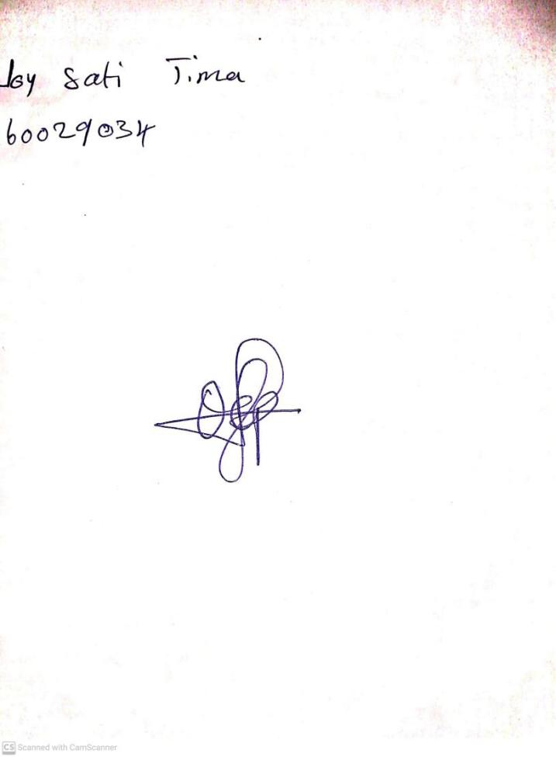

**8th November, 2024**

**Perpetual Ojoma Ocheja**

**Stream Head Nursery**