**EMERALD ROYAL INTERNATIONAL SCHOOL**

**MPAPE, ABUJA.**

**LESSON PLAN AND NOTE FOR WEEK 6 ENDING 16/02/2024**

**TERM: Second**

**WEEK: 6th**

**DATE: 13/02/2024**

**CLASS: Nursery 2**

**SUBJECT: Nature studies**

**TOPIC: Care of Nose**

**SUB—TOPIC: Uses and care of the nose**

**PERIOD: 3rd**

**TIME: 09:30–10:10am**

**DURATION: 40 minutes**

**NUMBER IN CLASS: 13**

**AVERAGE AGE: 5 years**

**SEX: Mixed**

**LEARNING OBJECTIVES: By the end of the lesson, the Pupils should be able to:**

**1. Identify nose.**

**2. State the uses of the nose.**

**3. Understand how we care for our nose.**

**4. Mention the first aid treatment for nose bleeds.**

**RATIONALE: For pupils to know how to care for their nose.**

**PREVIOUS KNOWLEDGE: Pupils are breathing through their nose.**

**INSTRUCTIONAL MATERIALS: Pictures of nose in pupils text books.**

**REFERENCE MATERIALS: Basic science and technology for Nursery schools book 3 by OPEMIPO DADA**

**LESSON DEVELOPMENT**

|  |  |  |  |
| --- | --- | --- | --- |
| **Stages/steps** | **Teacher's activities** | **Pupils' activities** | **Learning point** |
| **Introduction** | **Teacher introduces the lesson by singing nursery rhymes.** | **Pupils sing the rhymes along with the teacher.** | **To prepare pupils interest for the lesson ahead.** |
| **Presentation step 1** | **Teacher asks pupils to touch their nose and then tell Pupils that the nose is found on the face. It is a sense organ and then ask Pupils to repeat after her.** | **Pupils touch their nose and repeat after the teacher.** | **For identification and improving pupils proper understanding.** |
| **Step 2** | **Teacher States the uses of the nose and the ways of caring for our nose.** | **Pupils pay attention to the teacher.** | **For better understanding.** |
| **Step 3** | **Teacher mentions the first aid treatment for nose bleeds to pupils and also ask them to repeat after her.** | **Pupils listen and repeat after the teacher.** | **For further understanding.** |
| **Board summary** | **Teacher writes the whole note of lesson on the board for pupils to copy into their books. That is;**  **THE NOSE**    **1. The nose is found on the case.it is a sense organ.**  **USES OF THE NOSE**  **1. The nose is used for breathing.**  **2. The nose is used for smelling.**  **3. The nose is also used for sneezing.**  **HOW TO CARE FOR THE NOSE**  **1. Do not put sharp objects into your nose.**  **2. Do not put your fingers into your nostrils.**  **FIRST AID TREATMENT FOR NOSE BLEEDING**  **1. Sit upright and lean forward.**  **2. Pinch your nostrils shut with your thumb and index finger. Breathe with your mouth.** | **Pupils copy the note into their exercise books.** | **For onward study.** |
| **Evaluation** | **Teacher evaluates the lesson by asking pupils the following questions;**  **1.point at your nose.**  **2. Nose is used for what?**  **3. How do we care for our nose.**  **4. What are the first aid treatment for nose?** | **Pupils answer the questions ask by the teacher.** | **To assess pupils level of understanding.** |
| **Conclusion** | **Teacher concludes the lesson by marking pupils notes.** | **Pupils submit their books for marking.** | **For endorsement.** |
| **Assignment** | **Activity 13 page 48 basic science textbook.** | **Pupils do their assignment at home.** | **To encourage learning at home.** |

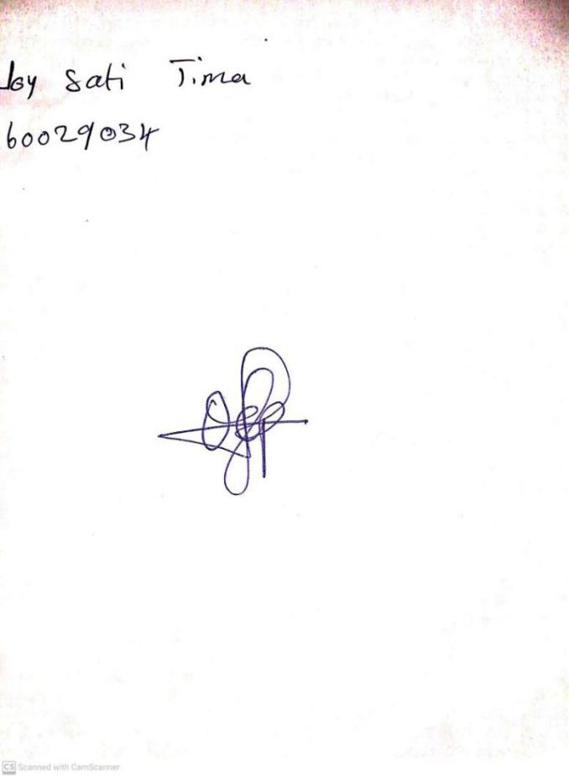

**9th February, 2024**

**Perpetual Ojoma Ocheja**

**Stream Head Nursery**