LESSON PLAN AND NOTE FOR WEEK 7 ENDING 27/10/2023

TERM: 1st

WEEK: 7th

DATE: 23/10/2023

CLASS: Nursery 2

SUBJECT: Nature studies

TOPIC: Non living things

SUB—TOPIC: Meaning and examples of non living things.

PERIOD: 4th

TIME: 10:40—11:20am

DURATION: 40 minutes

NUMBER IN CLASS: 14

AVERAGE AGE: 5 years

SEX: Mixed

LEARNING OBJECTIVES: By the end of the lesson, the pupils should be able to:

1. Define non living things.

2. Mention the examples of non living things in school.

3. States the non living things at home.

RATIONALE: For pupils to know what non living things means.

PREVIOUS KNOWLEDGE: Pupils have learnt about living things in previous lesson.

INSTRUCTIONAL MATERIALS: stone, books, pencils, chairs, and desk.

REFERENCE MATERIALS: Basic science and technology for Nursery schools book 3 by OPEMIPO DADA.

LESSON DEVELOPMENT

|  |  |  |  |
| --- | --- | --- | --- |
| Steps | Teacher's activities | Pupils' activities | Learning point |
| Introduction | Teacher introduces the lesson by reviewing the previous lesson. | Pupils pay attention to the teacher. | To prepare pupils minds for the lesson ahead. |
| Presentation step 1 | Teacher defines non living things to pupils and then asks them to repeat after her. | Pupils listen to the teacher and repeat after her. | To improve pupils listening and speaking ability. |
| Step 2 | Teacher mentions the examples of non living things in school to pupils and also asks them to repeat after her. | Pupils pay attention to the teacher and repeat her. | To enhance pupils participation in the class. |
| Step 3 | Teacher states the examples of non living things at home to pupils and also asks pupils to repeat after her. | Pupils listen attentively to the teacher and repeat after her. | To improve pupils speaking ability. |
| Board summary | Teacher writes the whole note of lesson on the board for pupils to copy into their books. That is;  Non living things:  Non living things are the objects that do not have life in them. They cannot eat, grow or produce young ones like living things.  Examples of non living things in school:   1. Pencil 2. School bags 3. Eraser 4. Ruler 5. Duster 6. Food flask 7. Marker 8. Sharpener 9. Books 10. Desk 11. Water bottle etc.   Examples of non living things at home:   1. Fan 2. Shoes 3. Bags 4. Gas cylinder 5. Electric iron 6. Plate 7. Spoon 8. Knife 9. Cream 10. Bed etc. | Pupils copy the note into their exercise books. | For onward study. |
| Evaluation | Teacher evaluates the lesson by asking pupils the following questions;   1. Define non living things. 2. Mention the examples of non living things in school. 3. States the examples of non living things at home. | Pupils answer the questions asked by the teacher. | To assess pupils level of understanding. |
| Conclusion | Teacher concludes the lesson by marking pupils books. | Pupils submit their books for marking. | For endorsement. |
| Assignment | 1. What are living things? 2. Define non living things. 3. List 5 living things and 5 non living things. | Pupils do their assignment at home. | To encourage learning at home. |

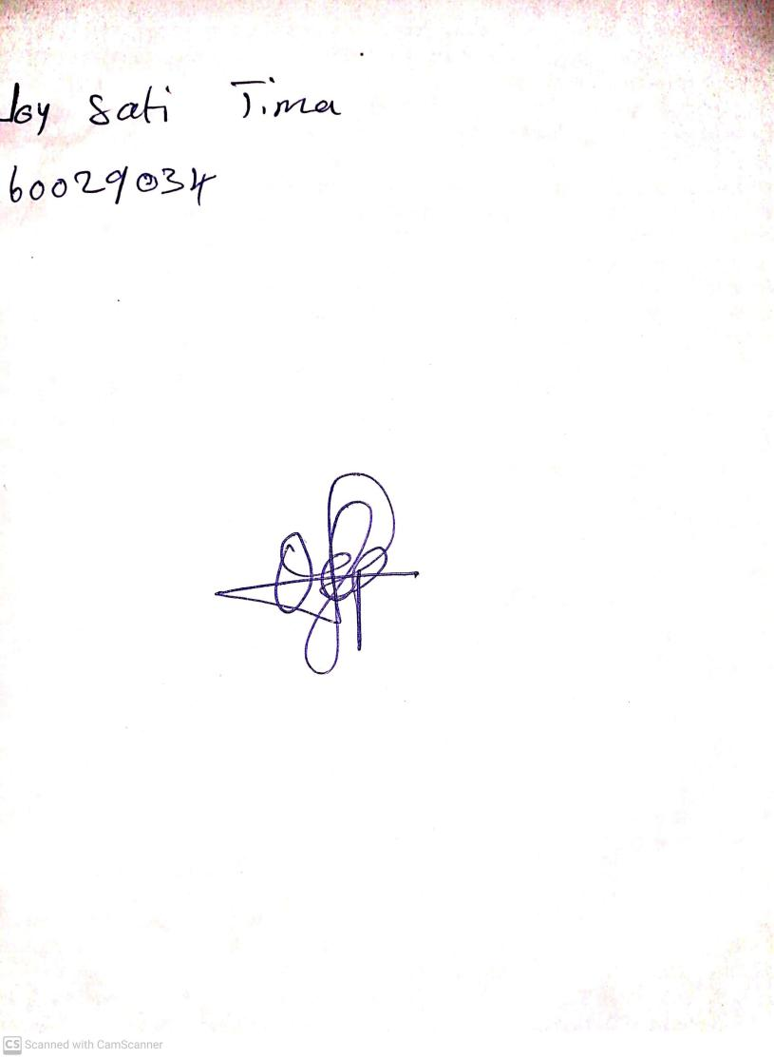

27th August, 2023

Perpetual Ojoma Ocheja

Stream Head Nursery