EMERALD ROYAL INTERNATIONAL SCHOOL

MPAPE, ABUJA.

LESSON NOTE FOR WEEK 2 ENDING 19TH JANUARY, 2024.

SUBJECT: Number Work

TOPIC: Counting Numbers 1 - 15

SUB-TOPIC: Matching numbers 1 - 10

DATE: 16/01/2024.

DURATION: 40 minutes.

TIME: 08:50--09:30.

PERIOD: 2nd

CLASS: Pre-nursery

NUMBER OF PUPILS: 17

AVERAGE AGE: 2 YEARS

SEX: Mixed.

SPECIFIC OBJECTIVES: By the end of the lesson, the pupils should be able to:-

1. Count numbers 1 - 15
2. Trace numbers 1 - 10

RATIONALE: For pupils to be able to Identify numbers.

PREVIOUS KNOWLEDGE: Pupils have been counting numbers.

INSTRUCTIONAL MATERIALS: N umber chart, flash cards etc

REFERENCE:Mastering mathematics for nursery schools book 1 by Henry Idogun.

LESSON DEVELOPMENT

|  |  |  |  |
| --- | --- | --- | --- |
| STAGES/STEPS | TEACHER’S ACTIVITIES | PUPILS’ ACTIVITIES | LEARNING POINTS |
| INTRODUCTION | Teacher introduces the lesson by singing a number rhyme for the pupils. | Pupils sing the rhyme along with the teacher. | To arouse pupils interest in the lesson. |
| PRESENTATION  STEP 1 | Teacher leads the pupils to count numbers 1-15 on the board.  1 2 3 4 5 6 7 8 9 10 11 12 13 14 15 | Pupils count numbers 1 - 15 after the teacher on the board. | For better understanding of the lesson . |
| STEP2 | Teacher guides the pupils to writes trace numbers 1 -10. | Pupils trace numbers 1-10.  Tracing Numbers 1-10 - Free | For proper understanding of the lesson. |
| SUMMARY | Teacher counts and points at numbers 1 - 15 for the pupils. | PUPILS count numbers 1 - 15 after the teacher. | For more understanding of the lesson. |
| EVALUATION | Teacher asks Pupils to 1. count numbers 1 - 15.  2.Trace numbers 1- 10 | Pupils answers the teacher”s questions. | To assess pupils understanding of the lesson. |
| CONCLUSION | Teacher plays a number video clip for the pupils to watch. | Pupils sit and watch the video. | To improve pupils listening ability. |
| ASSIGNMENT (HOME WORK) | Count numbers 1 - 15  1 2 3 4 5 6 7 8 9 10 11 12 13 14 15. | Pupils do their assignment at home. | To encourage pupils to learn at home. |

EMERALD ROYAL INTERNATIONAL SCHOOL MPAPE, ABUJA.

.

LESSON NOTE FOR WEEK 2 ENDING 19TH JANUARY, 2024.

SUBJECT Number Work

TOPIC: Counting Numbers 1 - 15

SUB-TOPIC: Matching numbers 1 - 10

DATE: 16/01/2024.

DURATION: 40 minutes.

TIME: 08:50--09:30.

PERIOD: 2ND

CLASS: Pre-nursery

NUMBER OF PUPILS: 17

AVERAGE AGE: 2 YEARS

SEX: Mixed.

SPECIFIC OBJECTIVES: By the end of the lesson, the pupils should be able to:-

1. Identify numbers 1 - 15
2. Match numbers 1 - 10

RATIONALE: For pupils to be able to Identify numbers.

PREVIOUS KNOWLEDGE: Pupils have been counting numbers.

INSTRUCTIONAL MATERIALS: N umber chart, flash cards etc

REFERENCE:Mastering mathematics for nursery schools book 1 by Henry Idogun.

LESSON DEVELOPMENT

|  |  |  |  |
| --- | --- | --- | --- |
| STAGES/STEPS | TEACHER’S ACTIVITIES | PUPILS’ ACTIVITIES | LEARNING POINTS |
| INTRODUCTION | Teacher introduces the lesson by singing a number rhyme for the pupils. | Pupils sing the rhyme along with the teacher. | To arouse pupils interest in the lesson. |
| PRESENTATION  STEP 1 | Teacher counts numbers 1 - 15 for the pupils to repeat after her. | Pupils count numbers 1 - 15 after the teacher. | For better understanding of the lesson . |
| STEP2 | Teacher guides each pupils to match numbers 1 -10. | Pupils match numbers 1-10. 1 10  2 8  3 9  4 7  5 6  6 3  7 5  8 2  9 4  10 1 | For proper understanding of the lesson. |
| SUMMARY | Teacher counts numbers 1 - 15 for the pupils. | PUPILS count numbers 1 - 15 after the teacher. | For more understanding of the lesson. |
| EVALUATION | Teacher asks Pupils to count numbers 1 - 15. | Pupils count numbers 1 - 15. | To assess pupils understanding of the lesson. |
| CONCLUSION | Teacher plays a number video clip for the pupils to watch. | Pupils sit and watch the video. | To improve pupils listening ability. |
| ASSIGNMENT (HOME WORK) | Count these numbers 1 - 15  1 2 3 4 5 6 7 8 9 10 11 12 13 14 15. | Pupils do their assignment at home. | To encourage pupils to learn at home. |

EMERALD ROYAL INTERNATIONAL SCHOOL

MPAPE, ABUJA.

LESSON NOTE FOR WEEK 2 ENDING 19TH JANUARY, 2024.

SUBJECT: Number Work

TOPIC: Counting Numbers 1 - 15

SUB-TOPIC: Matching numbers 1 - 10 with objects

DATE: 18/01/2024.

DURATION: 40 minutes.

TIME: 10: 40 -11: 20.

PERIOD: 4th

CLASS: Pre-nursery

NUMBER OF PUPILS: 17

AVERAGE AGE: 2 YEARS

SEX: Mixed.

SPECIFIC OBJECTIVES: By the end of the lesson, the pupils should be able to:-

1. Identify numbers 1 - 15
2. Match numbers with objects

RATIONALE: For pupils to be able to match numbers with objects.

PREVIOUS KNOWLEDGE: Pupils have been counting numbers.

INSTRUCTIONAL MATERIALS: number chart, flash cards, cups, pencils, balls, crayons etc

REFERENCE:Mastering mathematics for nursery schools book 1 by Henry Idogun.

LESSON DEVELOPMENT

|  |  |  |  |
| --- | --- | --- | --- |
| STAGES/STEPS | TEACHER’S ACTIVITIES | PUPILS’ ACTIVITIES | LEARNING POINTS |
| INTRODUCTION | Teacher introduces the lesson by singing a number rhyme for the pupils. | Pupils sing the rhyme along with the teacher. | To arouse pupils interest in the lesson. |
| PRESENTATION  STEP 1 | Teacher counts numbers 1 - 15 for the pupils to repeat after her. | Pupils count numbers 1 - 15 after the teacher. | For better understanding of the lesson . |
| STEP2 | Teacher guides each pupils to match numbers 1 -10. | Pupils match numbers with objects. I.e  1  2  c  3  4  5  6  7  8  9  10 | For proper understanding of the lesson. |
| SUMMARY | Teacher counts numbers 1 - 15 for the pupils. | PUPILS count numbers 1 - 15 after the teacher. | For more understanding of the lesson. |
| EVALUATION | Teacher asks Pupils to 1. count numbers 1 - 15.  2.Match the numbers with the objects correctly on the board. | Pupils answer the teacher”s questions. | To assess pupils understanding of the lesson. |
| CONCLUSION | Teacher plays a number video clip for the pupils to watch. | Pupils sit and watch the video. | To improve pupils listening ability. |
| ASSIGNMENT (HOME WORK) | Count the objects | Pupils do their assignment at home. | To encourage pupils to learn at home. |

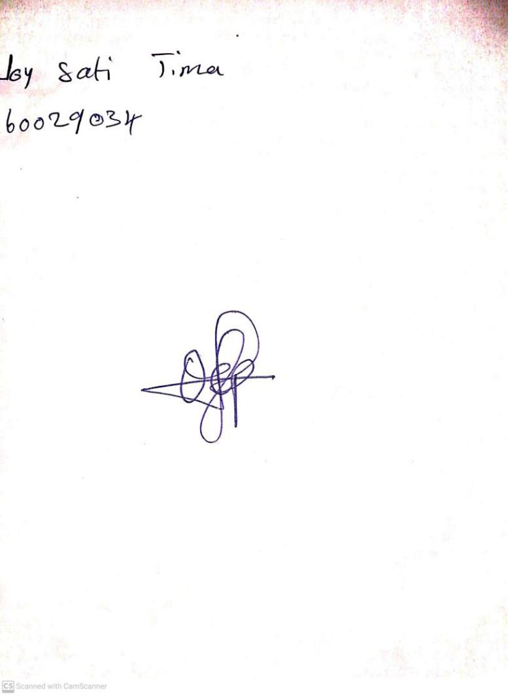

12TH January, 2024

Perpetual Ojoma Ocheja

Stream Head Nursery