**EMERALD ROYAL INTERNATIONAL SCHOOL MPAPE, ABUJA.**

**LESSONS PLAN AND NOTE FOR WEEK 4 ENDING 17 MAY 2024**

**TERM: 3rd**

**WEEK: 4**

**DATE: 13/05/2024**

**CLASS: Nursery 2**

**SUBJECT: Nature studies**

**TOPIC: Water : Characteristics**

**SUB—TOPIC: Characteristics of clean and dirty water.**

**PERIOD: 4th**

**TIME: 10:40 — 11:20am**

**DURATION: 40 minutes**

**NUMBER IN CLASS: 13**

**AVERAGE AGE: 5 years**

**SEX: Mixed**

**LEARNING OBJECTIVES: By the end of the lesson, the pupils should be able to:**

**1. Identify clean water and dirty water.**

**2. State the characteristics of clean water.**

**3. Mention the characteristics of dirty water.**

**RATIONALE: For pupils to know the characteristics of clean and dirty water.**

**PREVIOUS KNOWLEDGE: Pupils have learnt the uses of water in previous lesson.**

**INSTRUCTIONAL MATERIALS: A bowl of clean water and a bowl of dirty water.**

**REFERENCE MATERIALS: Basic science and technology for Nursery schools book 3 by OPEMIPO DADA.**

**LESSON DEVELOPMENT**

|  |  |  |  |
| --- | --- | --- | --- |
| **Steps** | **Teacher's activities** | **Pupils' activities** | **Learning point** |
| **Introduction** | **Teacher introduces the lesson by asking pupils if it is good to drink dirty water?** | **Pupils answer the question asked by the teacher.** | **To prepare pupils minds for the lesson ahead.** |
| **Presentation step 1** | **Teacher displays the two bowl of water on the ground and pour sand on one of the bowl and then asks pupils to identify which of the water that is clean and that which is dirty.**  **Bowl (a)**  **Bowl (b)** | **Pupils listen to the teacher and identify.** | **To improve pupils identify skills.** |
| **Step 2** | **Teacher States the characteristics of clean and then asks Pupils to repeat after her.** | **Pupils pay attention to the teacher and repeat after the teacher.** | **For proper understanding.** |
| **Step 3** | **Teacher mentions the characteristics of dirty water to pupils and also asks them to repeat after her.** | **Pupils listen attentively to the teacher and repeat after her.** | **For better understanding.** |
| **Board summary** | **Teacher summarizes the lesson by writing the whole note of lesson on the board for pupils to copy. That is;**  **CHARACTERISTICS OF WATER**  **Clean and safe water**  **Water can be clean and safe. It can also be dirty and unsafe for drinking, bathing and cooking.**  **Characteristics of clean water .**  **1. Clean water has no colour.**  **2. Clean water has no smell.**  **3. Clean water has no taste.**  **Characteristics dirty water**  **1. Dirty water has colour.**  **2. Dirty water has smell.**  **3. Dirty water can not be use for drinking etc.** | **Pupils copy the note into their exercise books.** | **For onward study.** |
| **Evaluation** | **Teacher evaluations the lesson by asking pupils the following questions.**  **1. Which of the following water is safe for drinking?**  **(a) clean water**  **(b) dirty water**  **2. What are the characteristics of clean water?**  **3. Mention the characteristics of dirty water.** | **Pupils answer the questions ask by the teacher.** | **To assess Pupils level of understanding.** |
| **Conclusion** | **Teacher concludes the lesson by marking pupils books.** | **Pupils submit their books for marking.** | **For endorsement.** |
| **Assignment** | **Activity 18 page 62 Basic science text book.** | **Pupils do their assignment at home.** | **To encourage learning at home.** |

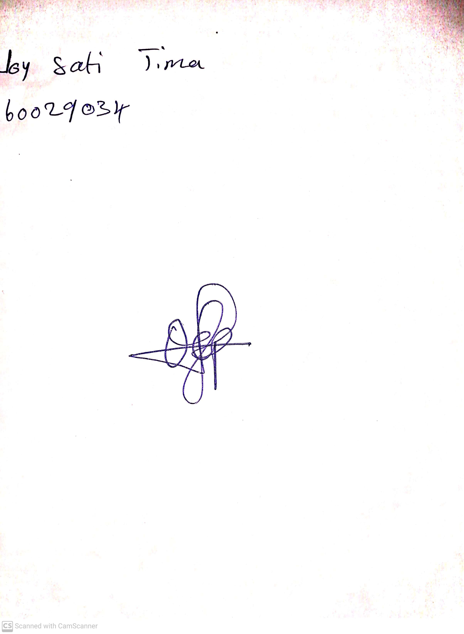

**3rd May, 2024**

**Perpetual Ojoma Ocheja**

**Stream Head Nursery**