**EMERALD ROYAL INTERNATIONAL SCHOOL, MPAPE ABUJA**

**LESSON PLAN AND NOTE FOR WEEK 2 ENDING FRIDAY, 19TH JANUARY, 2024**

**TERM:** FIRST TERM

**WEEK:** WEEK 2

**SUBJECT:** ENGLISH LANGUAGE (SPEECH)

**TOPIC:** GREETING AND COMMAND

**SUB-TOPIC:** SIMPLE GREETINGS AND COMMANDS

**DATE:** WEDNESDAY, 17TH JANUARY, 2024

**TIME:** 02:00 – 02:30PM

**DURATION:** 30 MINUTES

**PERIOD:** 9TH

**CLASS:** NURSERY 3

**NUMBER IN CLASS:** TWELVE

**AVERAGE AGE:** FIVE

**SEX:** MIXED

**LEARNING OBJECTIVES:** By the end of the lesson, the pupils should be able to:

1. Define simple greetings
2. Define simple commands
3. Practice simple greetings and commands

**RATIONALE:** for pupils to learn how to greet and make commands

**PREVIO US KNOWLEGDE:** pupils have learn about the school compound.

**INSTRUCTIONAL MATERIALS:**

1. Individual pupils
2. Textbook

**REFERENCE MATERIALS:**

1. Nigeria Primary English book 1 by B. Someye, D Dallas etal 2000

**LESSON DEVELOPMENT**

|  |  |  |  |
| --- | --- | --- | --- |
| **STAGES/STEPS** | **TEACHER’S ACTIVITIES** | **PUPILS’ ACTIVITIES** | **LEARNING POINTS** |
| **INTRODUCTION** | Previews previous knowledge. | Response to the teacher and listens attentively | Introducing the lesson and arousing interest |
| **PRESENTATION**  **STEP 1** | Teaches and explain the meaning of simple greeting  **Meaning of simple greeting**  Simple greeting is an act of showing respect and regards for people, especially elderly people. Greeting can be done in different form.  Example   1. Good morning 2. Good afternoon 3. Good evening | Listen attentively and learn. | For better understanding |
| **STEP 2** | Teaches and explain the meaning of simple command.  **Meaning of simple commands**  Simple command is an act of giving an order or telling someone to do something in a forceful and often official way | Listen attentively and learn. | For proper understanding |
| **STEP 3** | Teaches and guides the pupils to practice simple greeting and command  **Pupils:** Good morning miss Joy.  **Miss Joy**: Good morning every. How are you doing?  **Pupils**: Fine, thank you ma.  **Miss Joy:** sit down! | Engage in simple greeting and command. |  |
| **SUMMARY** | Summarises the lesson by emphasising on the main concept and writes note on the board. | Listen and copy their notes | For onward study |
| **EVALUATION** | Ask pupils to:   1. Give the meaning of simple greeting. 2. Give the meaning of simple command. 3. Engage in simple greeting and command with each other in the class. | Respond to the teacher’s question | Based on the stated objectives |
| **CONCLUSION** | Summarizes, corrects and mark pupils’ notebooks. | Submit their notebooks for marking. | Clarifying the concept |
| **HOME WORK** | Nigeria Primary English book 1 page 101. | Return with their home work for marking | Extending the lesson home |

**LESSON PLAN AND NOTE FOR WEEK 2 ENDING FRIDAY, 19TH JANUARY, 2024**

**TERM:** FIRST TERM

**WEEK:** WEEK 2

**SUBJECT:** ENGLISH LANGUAGE (GRAMMAR)

**TOPIC:** GRAMMAR

**SUB-TOPIC:** SIMPLE PAST TENSE

**DATE:** MONDAY, 15TH JANUARY, 2024

**TIME:** 01:20 – 02:00PM

**DURATION:** 45 MINUTES

**PERIOD:** 8TH

**CLASS:** NURSERY 3

**NUMBER IN CLASS:** TWELVE

**AVERAGE AGE:** FIVE

**SEX:** MIXED

**LEARNING OBJECTIVES:** By the end of the lesson, the pupils should be able to

1. Give the meaning of simple past tense.
2. Give the examples of simple past tense.

**RATIONALE:** for pupils to know the meaning and examples of simple past tense.

**PREVIOUS KNOWLEGDE:** pupils have learnt about words ending in ‘ing’ **INSTRUCTIONAL MATERIALS:**

1. Flash cards
2. pictorial charts

**REFERENCE MATERIALS:**

1. Nigeria Primary English book 1 by B. Someye, D Dallas etal 2000

**LESSON DEVELOPMENT**

|  |  |  |  |
| --- | --- | --- | --- |
| **STAGES/STEPS** | **TEACHER’S ACTIVITIES** | **PUPILS’ ACTIVITIES** | **LEARNING POINTS** |
| **INTRODUCTION** | Review previous knowledge. | Answer the teacher’s question. | Introducing the lesson and arouse the pupils’ interest. |
| **PRESENTATION STEP 1** | Teaches and explain the meaning of simple past tense.  **Meaning of simple past tense**  A simple past tense is used to say what has happened on done in the past. | Learns carefully. | Meaning of a pronoun and examples of nouns. |
| **STEP 2** | Teaches and guides pupils to give examples of simple past tense.  **Examples of simple past tense**  **Present tense past tense**   1. Give gave 2. See saw 3. Dance danced 4. Cry cried 5. Sing sang 6. Wash washed 7. Fall fell 8. Play played 9. Sit sat 10. Travel travelled | Learns attentively. | Sentence making using pronouns. |
| **SUMMARY** | Summarises the lesson by emphasising on the main concept and writes note on the board. | Listens and copy their notes | For onward study |
| **EVALUATION** | Ask pupils to:  write the past tense of the following   1. Play 2. Sit 3. Eat 4. Cry 5. Wash | Respond to the teacher’s question. | To test the pupils understanding on the lesson. |
| **CONCLUSION** | Summaries, correct and mark pupils note books. | Submit their notebooks for marking. | Clarifying the concept. |
| **HOME WORK** | Nigeria Primary English book 1 page 103, workbook page 24. | Return homework for marking. | Extending lesson home. |

**LESSON PLAN AND NOTE FOR WEEK 2 ENDING FRIDAY, 19TH JANUARY, 2024**

**TERM:** FIRST TERM

**WEEK:** WEEK 2

**SUBJECT:** ENGLISH LANGUAGE (COMPREHENSION)

**TOPIC:** READING

**SUB-TOPIC:** BINTA AND THE MANGO TREE

**DATE:** THURSDAY, 18TH AND FRIDAY, 19TH JANUARY, 2024

**TIME:** 09:25 – 10:55AM AND 11: 25 – 12PM

**DURATION:** 40 MINUTES

**PERIOD:** 3RD AND 6TH

**CLASS:** NURSERY 3

**NUMBER IN CLASS:** TWELVE

**AVERAGE AGE:** FIVE

**SEX:** MIXED

**LEARNING OBJECTIVES:** By the end of the lesson, the pupils should be able to

1. Concentrate fully in reading
2. Pronounce difficult words
3. Answer the questions bellow the passage

**RATIONALE:** for pupils to know and improve in their reading skills and pronunciation.

**PREVIOUS KNOWLEGDE:** pupils read about tortoise and the calabash of wisdom.

**INSTRUCTIONAL MATERIALS:**

1. Nigeria Primary English Book 1 by F Ademola – Adeoye, J omiteru etal 2000

**REFERENCE MATERIALS:**

1. Nigeria Primary English book 1 by B. Someye, D Dallas etal 2000

**LESSON DEVELOPMENT**

|  |  |  |  |
| --- | --- | --- | --- |
| **STAGES/STEPS** | **TEACHER’S ACTIVITIES** | **PUPILS ACTIVITIES** | **LEARNING POINT** |
| **INTRODUCTION** | Ask pupils to open their textbooks to page 13. | Open their textbooks. | Arouse the pupils’ interest. |
| **PRSENTATION STEP I** | Guides pupils in reading the passage title ‘Binta and the mango tree’  A long time ago, there was a girl call Binta. She lived in a village called Yanyan. There was also a man there call Mallam Ibrahim who lived down the road from Binta’s home. Mallam Ibrahim had a big mango tree in his compound……………. | Listen attentively and read after the teacher. | To enhance fluency in reading. |
| **STEP 2** | Guides pupils to identify and pronounce difficult words in the passage.   1. Village 2. Mango 3. Compound 4. Pluck 5. Fence 6. Juicy 7. Man 8. Tree 9. Binta 10. Walked | Pronounce the difficult words after the teacher. | Identifying difficult words. |
| **STEP 3** | Leads pupils on how to answer the questions below the passage orally.   1. Who was Binta?   Binta is a girl.   1. What was the name of her village?   The name of her village was Yanyan   1. Who lived down the road from her home?   Mallam Ibrahim lived down the road from Binta’s home.   1. What tree was in Mallam Ibrahim’s compound?   There was a mango tree in Mallam Ibrahim’s compound.   1. How many people are in the story?   There are only two people in the story. | Answer the questions orally | Answering the questions in the passage |
| **SUMMARY** | Summarises the lesson by emphasising on the main concept and writes note on the board. | Listen and copy their notes | For onward study |
| **EVALUATION** | Ask pupils to:  1.Read the passage carefully.  2. pronounce the difficult words in the passage.  3. Answer the questions in the passage. | Respond to the teacher’s questions. | To test the pupils’ understanding of the lesson. |
| **CONCLUSION** | Summaries, correct and mark pupils work | Answer to the teacher’s question. | Clarifying the concept |
| **HOME WORK** | Nigeria Primary English book 1 page 102. | Return book with task for marking. | Extending lesson home. |

**LESSON PLAN AND NOTE FOR WEEK 2 ENDING FRIDAY, 19TH JANUARY, 2024**

**TERM:** FIRST TERM

**WEEK:** WEEK 2

**SUBJECT:** ENGLISH LANGUAGE (COMPOSITION)

**TOPIC:** COMPOSITION

**SUB-TOPIC:** WRITING CAPITAL AND SMALL LETTER Ww

**DATE:** THURSDAY, 18TH JANUARY, 2024

**TIME:** 11:10 – 11:50PM

**DURATION:** 45 MINUTES

**PERIOD:** 5TH

**CLASS:** NURSERY 3

**NUMBER IN CLASS:**  TWELVE

**AVERAGE AGE:** FIVE

**SEX:** MIXED

**LEARNING OBJECTIVES:** By the end of the lesson, the pupils should be able to

1. Identify capital and small letter Ww
2. Write capital and small letter Ww

**RATIONALE:** for pupils to learn how to write capital and small letter Ww

**PREVIOUS KNOWLEGDE:** pupils have learnt how to a composition about their neighbour.

. **INSTRUCTIONAL MATERIALS:**

1. A book
2. Pencil
3. Text book – Nigeria Primary English book 1 – Fourth Edition

**REFERENCE MATERIALS:**

1. Nigeria Primary English book 1 by B. Someye, D Dallas etal 2000

**LESSON DEVELOPMENT**

|  |  |  |  |
| --- | --- | --- | --- |
| **STAGES /STEPS** | **TEACHER’S ACTIVITIES** | **PUPILS’ ACTIVITIES** | **LEARNING POINT** |
| **INTRODUCTION** | Review previous knowledge. | Open their text books | Arouse their interest |
| **PRESENTATION**  **STEP 1** | Leads pupils to identify capital and small letter  Ww  **Capital and small letter Ww**  Ww Ww Ww Ww  Ww Ww Ww Ww  Ww Ww Ww Ww | Respond to the teacher. | Identify capital and small letter Ww. |
| **STEP 2** | Leads pupils to write capital and small letter Ww  Ww Ww Ww Ww  Ww Ww Ww Ww  Ww Ww Ww Ww | Write capital and small letter Ww. | Writing capital and small letter Ww. |
| **SUMMARY** | Summarises the lesson by emphasising on the main concept and writes note on the board. | Listen and copy their notes | For onward study |
| **EVALUATION** | Ask pupils to:  1. Ask pupils to read and write capital and small letters Ww in their hand writing book. | Respond to the teacher’s question. | To test the pupils knowledge on the lesson. |
| **CONCLUSION** | Summarizes, correct and mark the pupils note books. | Submits their notes for marking. | Clarifying the concept. |
| **HOME-WORK** | Nigeria Primary English book 1, page 105, exercise 2. | Copy and return homework for marking. | Extending lesson home. |

**LESSON PLAN AND NOTE FOR WEEK 2 ENDING FRIDAY, 19TH JANUARY, 2024**

**TERM:** FIRST TERM

**WEEK:** WEEK 2

**SUBJECT:** ENGLISH LANGUAGE (PHONICS)

**TOPIC:** SOUND BANKS

**SUB-TOPIC:** WORDS WITH THE SOUND /Ʒ/

**DATE:** TUESDAY, 16TH JANUARY, 2024

**TIME:** 10:30 – 11:10PM

**DURATION:** 40 MINUTES

**PERIOD:** 4TH

**CLASS:** NURSERY 3

**NUMBER IN CLASS:** TWELVE

**AVERAGE AGE:** FIVE

**SEX:** MIXED

**LEARNING OBJECTIVES:** By the end of the lesson, the pupils should be able to:

1. Identify the sounds /Ʒ/.
2. Pronounce the sounds /Ʒ/.
3. List words with the sounds /Ʒ/.

**RATIONALE:** For pupils to learn how pronounce the sounds /Ʒ/ and identify words associated with the sounds.

**PREVIOUS KNOWLEGDE:** pupils have learnt how to pronounce the sounds /ʃ/ and identify words that is associated with the sounds.

**INSTRUCTIONAL MATERIALS:**

1. Flash cards.
2. Pictorial charts.

**REFERENCE MATERIALS:**

1. Nigeria Primary English book 1 by B. Someye, D Dallas etal 2000

**LESSON DEVELOPMENT**

|  |  |  |  |
| --- | --- | --- | --- |
| **STAGES/STEPS** | **TEACHER’S ACTIVITIES** | **PUPILS’ ACTIVITIES** | **LEARNING POINTS** |
| **INTRODUCTION** | Displays flash cards on a flat surface. | Respond to the teacher’s questions. | Arouse pupils interest. |
| **PRESENTATION**  **STEP 1** | Leads pupils to identify the sounds /Ʒ/ on a flash card.  **/Ʒ/** | Identify the sounds. | For proper understanding. |
| **STEP 2** | Teaches pupils how to pronounce the /Ʒ/ is a consonant sound that can be pronounced the forced air between a wide groove in the center of the front of the tooth ridge. | Pronounce the sounds as taught by the teacher. | For better understanding. |
| **STEP 3** | Teaches pupils words with the sounds /Ʒ/  /Ʒ/   1. Vision 2. Provision 3. Usual 4. Visual 5. Pleasure 6. Garage 7. Television 8. Measure 9. Occasion 10. Massage | Learn the words with the sounds /Ʒ// | For further understanding. |
| **SUMMARY** | Summarizes the lesson by emphasizing on the main concept and writes note on the board. | Listen and copy their notes | For onward study |
| **EVALUATION** | Asks pupils to:   1. Identify the sounds /Ʒ/ 2. Pronounce the sounds /Ʒ/ 3. List two words with each of the sounds /Ʒ/ | Respond to the teacher’s questions. | To test the pupils understanding of the lesson. |
| **CONCLUSION** | Summarizes, correct and mark pupils’ notebooks. | Write the note on the board and submit their notebooks for marking | To consolidate the lesson. |
| **HOME-WORK** | Write five words each with the sounds /Ʒ/ | Return home with task. | Extending lesson home. |

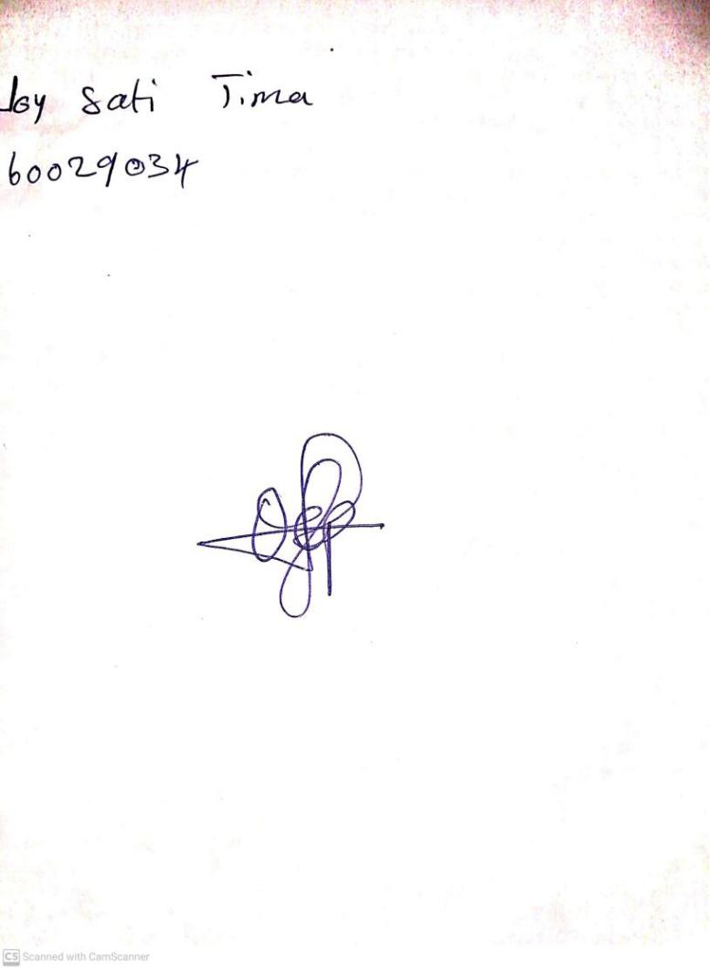

12TH January, 2024

Perpetual Ojoma Ocheja

Stream Head Nursery