**LESSON PLAN/NOTE FOR WEEK 7 ENDING 16/06/2923**

**Term**: 3rd

**Week**: 7

**Date**: 14/06/2023

**Class**: SS 1

**Subject**: Civic Education

**Topic**: Orderliness

**Sub**-**Topic**: Merits of orderliness

**Period**: 5th

**Time**: 11:10-11:50

**Duration**: 40 Minutes

**Number in class:** 8 students

**Average Age:** 14 Years

**Sex**: mixed

**Specific objectives:** By the end of the lesson, the students should be able to:

(1) state the merits of orderliness.

(11) Explain the merits of orderliness.

**Rationale**: For the students to be able to identify the importance of orderliness in the society.

**Previous knowledge:** The students have been seeing how things are done easily when order is followed.

**Instructional material:** A chart showing people orderly queuing and obeying order.

**Reference material:** Gbenga Babalola (2017) Essential civic Education for senior secondary schools.

**LESSON DEVELOPMENT**

|  |  |  |  |
| --- | --- | --- | --- |
| **Stages/Steps** | **Teacher's Activities** | **Students' Activities** | **Learning points** |
| **Introduction** | Review the previous lesson. | Participate actively in the class discussion | To arouse the students interest to learn. |
| **Step 1** | States the merits of orderliness as: (1) emulation (2) fulfilment etc. | Listen carefully to the teacher | For better understanding of the lesson. |
| **Step 11** | Guides the students to explain the merits of orderliness | Respond to the class activity | To encourage critical thinking. |
| **Board summary** | Summarizes the lesson as:  **Merits of orderliness**  (1) Emulation: others will like to copy from the orderly manner in which things are done.  (2) fulfilment: Orderliness beings about a sense of fulfilment in life.  (3) peace: orderliness avoids fighting, shouting and quarrelling and these fosters peaceful situation.  (4) friendliness: friendliness promotes friendship among people and society.  (5) possibility: Orderliness makes thinking and other things easy and possible. | Copy and submit the note book for marking. | For future reference. |
| **Evaluation** | Evaluates the students as:  (1) state 5 merits of orderliness in the society  (2) Explain 4 merits of orderliness in the society | Respond to the questions | Ascertaining the attainment of the stated objectives. |
| **Conclusion** | Rounds up the lesson by marking and correcting students work. | Check and do their correction | Consolidation of the lesson. |
| **Assignment** | Gives home work as:  (1) Explain 5 merits of orderliness in the society. | Respond by doing the home work at home. | To ensure continuity of learning. |

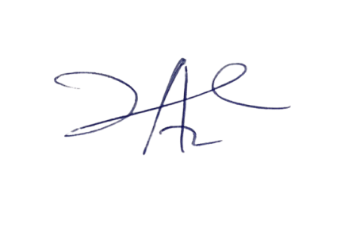

2/6/2023

Principal Head Instuctor