**EMERALD ROYAL INTERNATIONAL SCHOOL, MPAPE ABUJA**

**LESSON PLAN AND NOTE 1 FOR WEEK 4 ENDING FRIDAY, 26TH JANUARY, 2024**

**TERM:** FIRST TERM

**WEEK:** WEEK 4

**SUBJECT:** BASIC SCIENCE

**TOPIC:** IDENTIFICATION OF COLOURS

**SUB-TOPIC:** COLOURS OF A RAINBOW

**DATE:** TUESDAY, 23RD AND WEDNESDAY, 24TH JANUARY, 2024

**TIME:** 08:45 – 09:25AM AND 09:25 – 09:55AM

**DURATION:** 40 MINUTES

**PERIOD:** 2ND AND 3RD

**CLASS:** NURSERY 3

**NUMBER IN CLASS:** TWELVE

**AVERAGE AGE:** FIVE

**SEX:** MIXED

**LEARNING OBJECTIVES:** By the end of the lesson, the pupils should be able to:

1. Give the description of a rainbow.
2. State the colours of a rainbow.

**RATIONALE:** for pupils to learn rainbow and its colours.

**PREVIOUS KNOWLEGDE:** pupils have learnt to identify different objects and their colours

**INSTRUCTIONAL MATERIALS:**

1. Flash cards.
2. Road chart.

**REFERENCE MATERIALS:**

Smart Basic Science and Technology book 1 by D. I. Bika, Cambridge University Press

**LESSON DEVELOPMENT**

|  |  |  |  |
| --- | --- | --- | --- |
| **STAGES/STEPS** | **TEACHER’S ACTIVITIES** | **PUPILS’ ACTIVITIES** | **LEARNING POINTS** |
| **INTRODUCTION** | Review previous knowledge | Respond to the teacher | To arouse the pupils’ interest. |
| **PRESENTATION**  **STEP 1** | Teaches pupils the description of a rainbow.  **Description of a rainbow**  A rainbow has seven (7) colours and they are always in the same order. | Describe a rainbow | Description of a rainbow. |
| **STEP 2** | Guides pupils to state the seven (7) colours of the rainbow  The colours of the rainbow are:   1. Red 2. Orange 3. Yellow 4. Green 5. Blue 6. Indigo 7. Violet | State the colours of a rainbow | Colours of a rainbow. |
| **SUMMARY** | Summarises the lesson by emphasising on the main concept and writes note on the board | Listen and copy their notes | For onward study |
| **EVALUATION** | Asks pupils to:   1. Describe a rainbow. 2. List out the colours of a rainbow. | Respond to the teacher’s question. | To test the pupils understanding on the lesson. |
| **CONCLUSION** | Summarizes, corrects and mark pupils’ notebooks | Submit their notebooks for marking. | Clarifying the concept. |
| **HOME WORK** | 1. Write out the colours of a rainbow. | Cope and return with task. | Extending lesson home. |

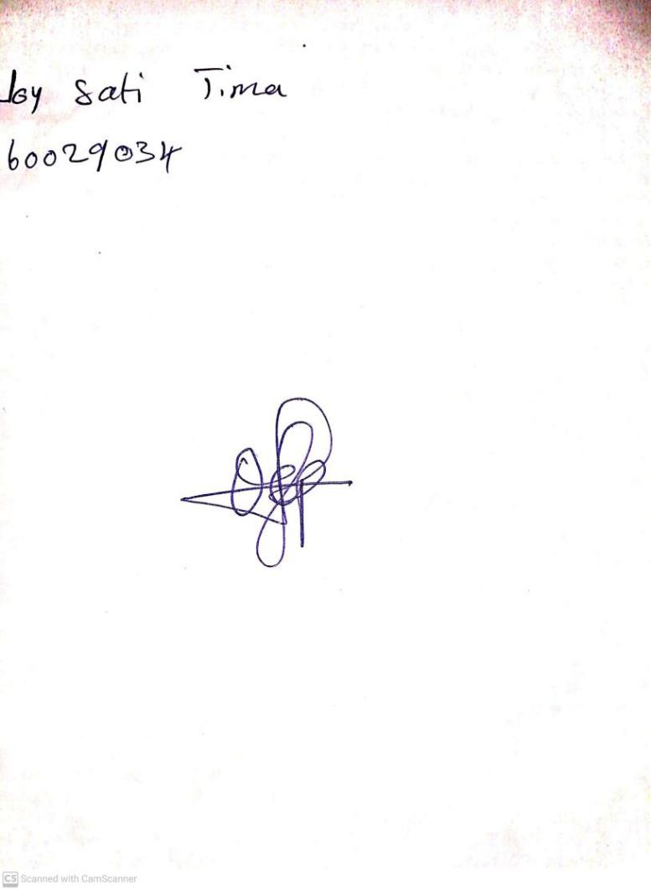

19TH January, 2024

Perpetual Ojoma Ocheja

Stream Head Nursery