**EMERALD ROYAL INTERNATIONAL SCHOOL, MPAPE ABUJA**

**LESSON PLAN AND NOTE 1 FOR WEEK 1 ENDING FRIDAY, 12TH JANUARY, 2024**

**TERM:** FIRST TERM

**WEEK:** WEEK 1

**SUBJECT:** BASIC SCIENCE

**TOPIC:** IDENTIFICATION OF COLOURS

**SUB-TOPIC:** MEANING AND TYPES OF COLOURS

**DATE:** TUESDAY, 9TH AND WEDNESDAY, 10TH JANUARY, 2024

**TIME:** 08:45 – 09:25AM AND 09:25 – 09:55AM

**DURATION:** 40 MINUTES

**PERIOD:** 2ND AND 3RD

**CLASS:** NURSERY 3

**NUMBER IN CLASS:** TWELVE

**AVERAGE AGE:** FIVE

**SEX:** MIXED

**LEARNING OBJECTIVES:** By the end of the lesson, the pupils should be able to:

1. Define colour.
2. State the types of colours.

**RATIONALE:** for pupils to learn the meaning of colour and the types of colours.

**PREVIOUS KNOWLEGDE:** pupils are familiar with colours.

**INSTRUCTIONAL MATERIALS:**

1. Textbook
2. Colour charts
3. Crayon
4. Paper

**REFERENCE MATERIALS:**

1. Smart Basic Science and Technology book 1 by D. I. Bika, Cambridge University Press.

**LESSON DEVELOPMENT**

|  |  |  |  |
| --- | --- | --- | --- |
| **STAGES/STEPS** | **TEACHER’S ACTIVITIES** | **PUPILS’ ACTIVITIES** | **LEARNING POINTS** |
| **INTRODUCTION** | Place chart of different colours. | Identify the different types of colours | To arouse the pupils’ interest. |
| **PRESENTATION**  **STEP 1** | Leads pupils to define colour.  **Meaning of colour**  Colour is the surface appearance of something within and around us. It is how our eyes see the light bounce off an object or thing. To see colour, we have to have light. | Define colour. | Meaning of colour. |
| **STEP 2** | Leads pupils to identify the different types of colour.  **Types of colours**  There are different types of colours. These include:   1. Red 2. Yellow 3. Blue 4. Black 5. White 6. Pink 7. Purple 8. Green 9. Grey 10. Orange 11. Brown | List the different types of colour | Types of colour. |
| **SUMMARY** | Summarises the lesson by emphasising on the main concept and writes note on the board | Listen and copy their notes | For onward study |
| **EVALUATION** | Asks pupils to:   1. define colour. 2. Mention different types of colour. | Respond to the teacher’s question. | To test the pupils understanding on the lesson. |
| **CONCLUSION** | Summarizes, corrects and mark pupils’ notebooks | Submit their notebooks for marking. | Clarifying the concept. |
| **HOME WORK** | 1.Write out five (5) types of colour. | Cope and return with task. | Extending lesson home. |

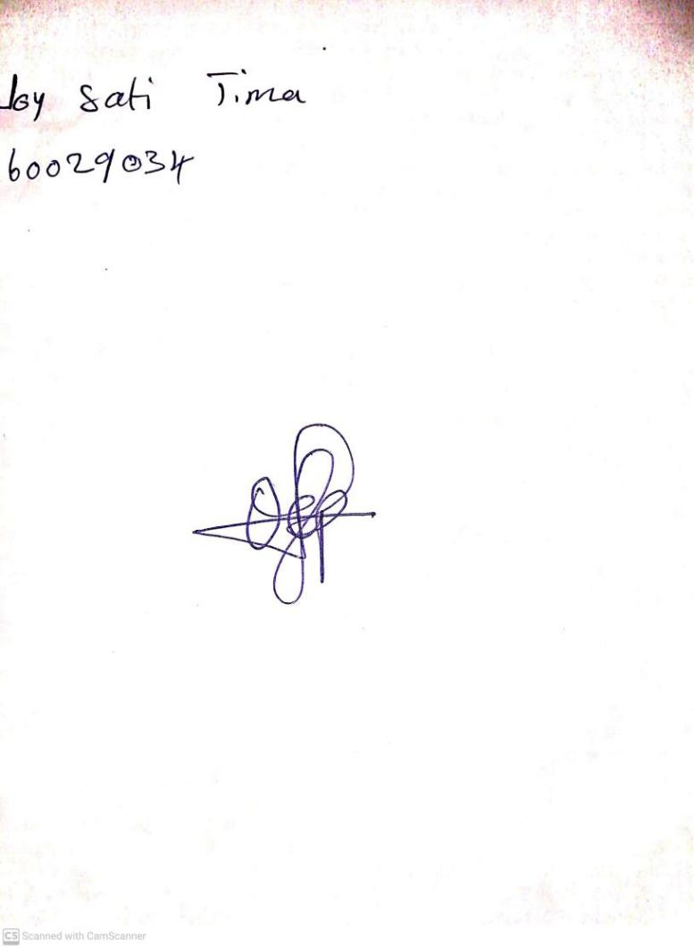

12TH January, 2024

Perpetual Ojoma Ocheja

Stream Head Nursery