**EMERALD ROYAL INTERNATIONAL SCHOOL**

**MPAPE, ABUJA.**

**LESSON PLAN AND NOTE FOR WEEK 1 PERIOD 1 ENDING 15/09/2023**

TERM: FIRST

WEEK: 1ST

DATE: 11/09/2023

CLASS: NURSERY 2

SUBJECT: LETTER WORK

TOPIC: REVISION

SUB-TOPIC: REVISION ONLETTER Aa-Zz

PERIOD: 1ST PERIOD

TIME: 08: 50 - 09:30am

DURATION: 40 MINUTES.

NUMBER IN CLASS: 14

AVERAGE AGE: 5 YEARS.

SEX: MIXED.

SPECIFIC OBJECTIVES: BY THE END OF THE LESSON,THE PUPILS SHOULD BE ABLE TO:

1. RECITE LETTER Aa - Zz ORALLY

2. IDENTIFY LETTER Aa - Zz ON FLASH CARDS

RATIONALE: FOR PUPILS TO REViEW THE PREVIOUS CLASS WORK.

PREVIOU KNOWLEDGE: PUPILS HAVE LEARNT ABOUT THE TOPIC IN PREVIOUS CLASS.

INSTRUCTIONAL MATERIALS: CHART OF LETTERS Aa - Zz

REFERENCE MATERIALS: MASTERING ENGLISH FOR NURSERY SCHOOLS BOOK 2 BY J . M OMOGBAI .

**LESSON DEVELOPMENT**

|  |  |  |  |
| --- | --- | --- | --- |
| STAGES/STEPS | TEACHER’S ACTIVITIES | PUPILS’ ACTIVITIES | LEARNING POINTS |
| INTRODUCTION | Teacher introduces the lesson by singing new nursery rhymes to pupils. | Pupils sing the rhymes along with the teacher. | To arouse pupils interest for the lesson ahead. |
| PRESENTATION  STEP 1 | Teacher recites letter Aa - Zz to pupils and asks them to repeat after her. | Pupils listen attentively to the teacher and repeat after her. | For proper understanding . |
| STEP 2 | Teacher displays letter Aa - Zz on flash cards, identify to pupils and also asks them to repeat after her. | Pupils pay attention to the teacher and repeat after her. | For better understanding of the lesson. |
| BOARD SUMMARY | Teacher writes the whole not of lesson on the board for pupils to copy. That is:  Letter Aa - Zz:  Aa Bb Cc Dd Ee Ff Gg Hh Ii Jj Kk Ll Mm Nn Oo Pp Qq Rr Ss Tt Uu Vv Ww Xx Yy Zz | Pupils copy the note into their exercise books. | For onward study. |
| EVALUATION | Teacher evaluates the lesson by:   1. Recite letter Aa–Zz. 2. Identify letter Aa–Zz on flash cards. | Pupils listen to the teacher and read the note on the board one after another. | To assess pupils reading skills. |
| CONCLUTION | Teacher concludes the lesson by marking pupils books. | Pupils submit their books for marking. | For endorsement. |
| ASSIGNMENT | Answer the following questions:  Fill in the missing letters  Aa ----- Cc ----- Ee -----  Gg Hh ----- Jj ----- Ll ---- Nn ----- Pp ----- Rr ---- Tt Uu Vv ------ Xx ------ Zz | Pupils do their assignment at home. | To encourage learning at home. |

**LESSON PLAN AND NOTE FOR WEEK 1 PERIOD 2 ENDING 15/09/2023**

TERM: FIRST

WEEK: 1ST

DATE: 12/09/2023

CLASS: NURSERY 2

SUBJECT: LETTER WORK

TOPIC: REVISION

SUB-TOPIC: REVITION ON 2 LETTER WORDS

PERIOD : 2ND PERIOD

TIME: 08: 50 - 09:30am

DURATION: 40 MINUTES.

NUMBER IN CLASS: 14

AVERAGE AGE: 5 YEARS.

SEX: MIXED.

SPECIFIC OBJECTIVES: BY THE END OF THE LESSON,THE PUPILS SHOULD BE ABLE TO:

1. IDENTIFY 2 LETTER WORDS.
2. SPELL AND PRONOUNCE 2 LETTER WORDS.

RATIONALE: FOR PUPILS TO REVIEW THE PREVIOUS CLASS WORK.

PREVIOU KNOWLEDGE: PUPILS HAVE LEARNT ABOUT THE TOPIC IN PREVIOUS CLASS.

INSTRUCTIONAL MATERIALS: CHART OF TWO LETTER WORDS.

REFERENCE MATERIALS: MASTERING ENGLISH FOR NURSERY SCHOOLS BOOK 3 BY J.M OMOGBAI .

**LESSON DEVELOPMENT**

|  |  |  |  |
| --- | --- | --- | --- |
| STAGES/STEPS | TEACHER’S ACTIVITIES | PUPILS’ ACTIVITIES | LEARNING POINTS |
| INTRODUCTION | Teacher introduces the lesson by asking pupils to all stand and recite the alphabets Aa - Zz. | Pupils all stand and recite the alphabets Aa -Zz. | To arouse pupils interest for the lesson ahead. |
| PRESENTATION  STEP 1 | Teacher writes two letter words on the board, identify to pupils and then asks them to repeat after her. | Pupils listen attentively to the teacher and repeat after her. | For proper understanding . |
| STEP 2 | Teacher quides pupils on how to spell and pronounce the two letter words on the board and also asks them to repeat after her. | Pupils pay attention to the teacher and repeat after her. | For better understanding of the lesson. |
| BOARD SUMMARY | Teacher writes the whole not of lesson on the board for pupils to copy. That is;  Two letter words  Two letter words are:  a + m = am  a + s = as  a + n = an  a + t = at  i + t = it  i + f = if  i + s = is  i + n = in  m + y = my  b + y = by  o + f = of  0 + n = on  o + r = or  o + x = ox  b + e = be  h + e = he  m + e = me  w + e = we  t + o = to  g + o = go  n + o = no  s + o = so  d + o = do  l + o = lo  u + p = up  u + s = us | Pupils copy the note into their exercise books. | For onward study. |
| EVALUATION | Teacher evaluates the lesson by asking the following questions:   1. Mention two letter words. 2. Spell and pronounced two letter words. | Pupils listen to the teacher and read the note on the board one after another. | To assess pupils reading skills. |
| CONCLUTION | Teacher concludes the lesson by marking pupils books. | Pupils submit their books for marking. | For endorsement. |
| ASSIGNMENT | Spell and write 20 two letter words. | Pupils do their assignment at home. | To encourage learning at home. |

**LESSON PLAN AND NOTE FOR WEEK 1 PERIOD 3 ENDING 15/09/2023**

TERM: FIRST

WEEK: 1ST

DATE: 15/09/2023

CLASS: NURSERY 2

SUBJECT: LETTER WORK

TOPIC: REVISION OF TWO LETTER WORDS

SUB-TOPIC: SIMPLE SENTENCES ON TWO LETTER WORDS.

PERIOD: 3RD PERIOD

TIME: 08: 50 - 09:30am

DURATION: 40 MINUTES.

NUMBER IN CLASS: 14

AVERAGE AGE: 5 YEARS.

SEX: MIXED.

SPECIFIC OBJECTIVES: BY THE END OF THE LESSON,THE PUPILS SHOULD BE ABLE TO:

1. IDENTIFY TWO LETTER WORDS
2. MAKE SIMPLE SENTENCES ON TWO LETTER WORDS

RATIONALE: FOR PUPILS TO REVEW THE THE PREVIOUS TERM WORK.

PREVIOU KNOWLEDGE: PUPILS HAVE LEARNT ABOUT THE TOPIC IN PREVIOUS CLASS.

REFERENCE MATERIALS: MASTERING ENGLISH FORNURSERY SCHOOLS BOOK 3 BY J.M OMOGBAI .

**LESSON DEVELOPMENT**

|  |  |  |  |
| --- | --- | --- | --- |
| STAGES/STEPS | TEACHER’S ACTIVITIES | PUPILS’ ACTIVITIES | LEARNING POINTS |
| INTRODUCTION | Teacher introduces the lesson by singing new nursery rhymes to pupils. | Pupils sing the rhymes along with the teacher. | To arouse pupils interest for the lesson ahead. |
| PRESENTATION  STEP 1 | Teacher writes two letter words on the board for pupils to identify. | Pupils listen attentively to the board and identify . | For proper understanding . |
| STEP 2 | Teacher also makes simple sentences with two letter words on the board, read and also asks them to repeat after her. | Pupils pay attention to the teacher and repeat after her. | For better understanding of the lesson. |
| BOARD SUMMARY | Teacher writes the whole not of lesson on the board for pupils to copy.ie,  Simple sentences on two letter words:  Simple sentences on two letter words are:  Go on. Go up  Go in or on.  I am up. Up I go.  I am on. On I go.  I go on. I go in.  If I go on. I go up.  He is to go up.  I am to go in. | Pupils copy the note into their exercise books. | For onward study. |
| EVALUATION | Teacher evaluates the lesson by:   1. Identify and pronounce the two letter words. 2. Make simple sentences with two letter words. | Pupils listen to the teacher and read the note on the board one after another. | To assess pupils reading skills. |
| CONCLUTION | Teacher concludes the lesson by marking pupils books. | Pupils submit their books for marking. | For endorsement. |
| ASSIGNMENT | Read the following:  I am to go up.  He is to go up.  Ox,go up. Ox, go in.  Go on ox,go on.  It is to go up.  It is to go on.  I go up. He is up.  Is he to go in?  No,he is to go up.  So,it is up.  No, it is in. | Pupils do their assignment at home. | To encourage learning at home. |

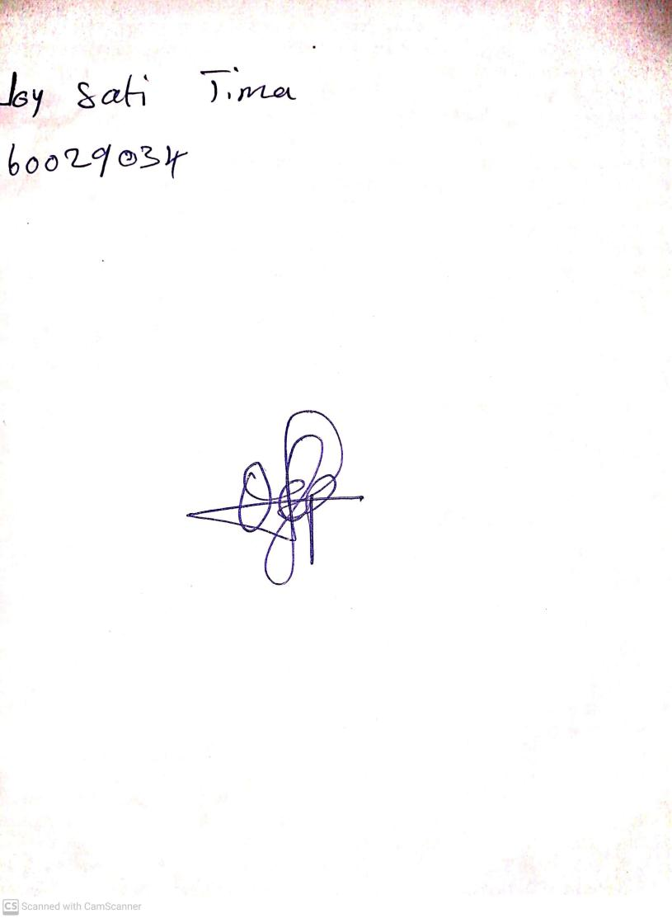

18th September, 2023

Perpetual Ojoma Ocheja

Stream Head Nursery