**EMERALD ROYAL INTERNATIONAL SCHOOL**

**MPAPE, ABUJA.**

**LESSON PLAN AND NOTE FOR WEEK 3 ENDING 19TH MAY, 2023.**

TERM : Third term.

WEEK : 3rd

SUBJECT: Social Norms

TOPIC: People who helps us in our society.

SUB-TOPIC: Identifying a teacher, soldier and a traffic warden.

DATE: 19/5/2023

DURATION: 40 minutes

TIME: 10:40-11:20

PERIOD: 4th

CLASS: pre-nursery

NUMBER OF PUPILS: 11

AVERAGE AGE: 2

SEX: Mixed

SPECIFIC OBJECTIVES: By the end of the lesson, the pupils should be able to:-

1. Identify a teacher and what they do to help us in our society.

2. Identify a soldier and how they help us in our society.

1. Identify a traffic warden and how they help us in our society.

RATIONALE: For pupils to be friendly and social.

PREVIOUS KNOWLEDGE: For pupils to know more about our society..

INSTRUCTIONAL MATERIALS: pictures of a teacher and a soldier.

REFERENCE: Smart start Civic education for nursery Schools book 1 by T.Y. Alabi and A. M. Solu.

LESSON DEVELOPMENT

|  |  |  |  |
| --- | --- | --- | --- |
| Stages/steps | Teacher's activities | Pupils' activities | Learning points |
| Introduction | Teacher introduces the lesson by singing nursery rhymes for the pupils | Pupils sing the rhymes along with the teacher. | To get pupils attention for the lesson. |
| Presentation  Step 1 | Teacher shows the pupils the picture of a teacher. Teacher asks the pupils to point at the picture and say"teacher" repeatedly. Teacher also explains to the pupils that a teacher is a person who teaches them how to read and write and also takes care of them at school. | Pupils point at a teacher on the picture. Pupils again pay attention to the teacher's explanation. | For proper identification of a teacher. |
| Step 2 | Teacher again shows the pupils the picture of a soldier and what they do. | Pupils look and point at the picture and also pay attention to the teacher as she tells them more about the soldier . That's,  A soldier protects us from the bad people.  Soldiers guide the country. | To enhance pupils knowledge about a soldier and their duties. |
| Step 3 | Teacher shows the pupils the picture of a traffic warden. The teacher asks the pupils one after another to point at the picture and repeat after her to say " Traffic warder". The teacher also tells the pupils what traffic warder does on the road.   1. They control traffic. 2. They ensure orderliness on the road. | Pupils take turns to point at the picture and also repeat after the teacher to say " Traffic warder". Pupils also list to the teacher as she is explaining how the traffic warder help us in our society. | To ensure better understanding of the lesson. |
| Summary | Teacher summarizes the lesson by going over the lesson again for more clarification. | Pupils listen and participate in the activities. | To ensure proper understanding of the lesson. |
| Evaluation | Teacher asks the pupils to:-   1. Point at a soldier. 2. Say what a teacher does. | Pupils answer the questions correctly. | To assess the level of pupils understanding of the lesson. |
| Conclusion | Teacher ends the lesson by singing rhymes for the pupils. | Pupils sing along with the teacher. | To consolidate the lesson. |
| Assignment | Teacher asks the pupils to colour a teacher in their text books. | Pupils do the assignment at home . | To encourage learning at home. |

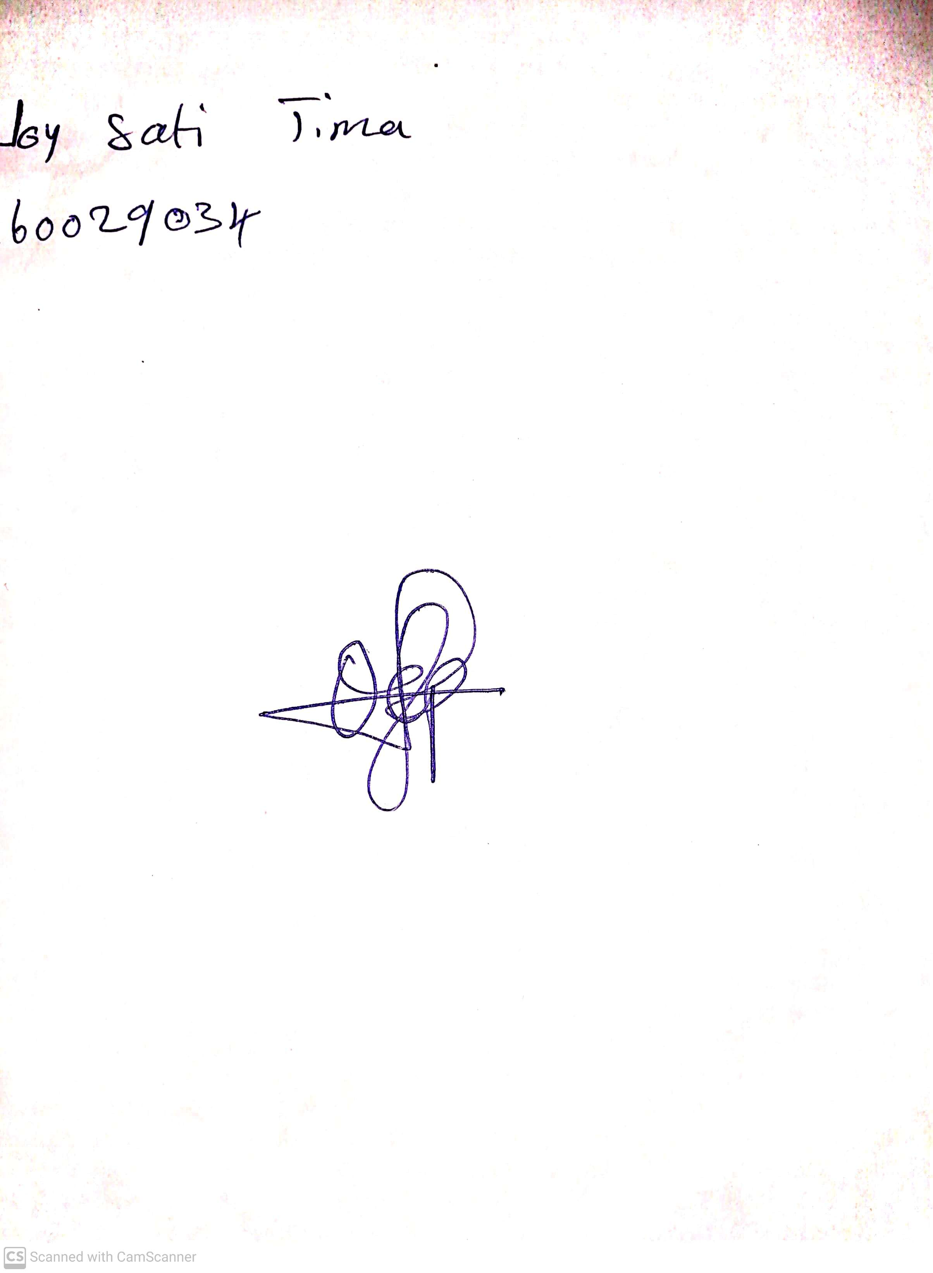

29th April, 2023

Perpetual Ojoma

Stream Head Nursery