**LESSON PLAN FOR WEEK 7 ENDING 27/10/2023**

**Term 1st term**

**Week 7th  week**

**Date 25th October,2023**

**Class Nursery One**

**Subject Nature studies**

**Topic Rocks as larger stones.**

**Sub-topic Definition of rocks as larger stones.**

**Period 4th period**

**Time 10:40 am**

**Duration 35 minutes**

**No in class 15**

**Average Age 3 years**

**Sex Mixed**

**Specific Objectives: By the end of the lesson, the pupils should be able to:**

1. **Define the rocks as larger stones.**
2. **Identify rocks in different sizes .**

**Rationale: To ensure the pupils define and identify rocks.**

**Previous Knowledge: The pupils can identify things in the sky.**

**Instructional Resources: Online research.**

**Reference Material: Elementary science by Showers kiddies nursery 1**

**LESSON PRESENTATION**

|  |  |  |  |
| --- | --- | --- | --- |
| **Steps** | **Teacher’s Activities** | **Pupils’ Activities** | **Learning Points** |
| **Introduction** | **The teacher introduces the lesson (Rocks as larger stones) to the pupils.** | **The pupils listens attentively to their teacher.** | **To arose the pupils’ interest.** |
| **Step 1** | **The teacher defines rocks as the “solids made up of minerals”.** | **The pupils together with the teacher define rocks as larger stones.** | **For proper understanding.** |
| **Step 2** | **The teacher leads the pupils to identify rocks in different sizes**  **image of small rocks Small rocks**  **image of large rocksLarge rocks** | **The pupils with the teacher identifies rocks in different sizes.** | **For better understanding.** |
| **Summary** | **The teacher summarizes the lesson by defining rocks as larger stones for the pupils.** | **The pupils can define rocks as larger stones.** | **For onward study.** |
| **Evaluation** | 1. **Define rocks as larger stones?** 2. **Identify the size of rock below?**   **image of large rocks** | **The pupils answer the question correctly.** | **To ascertain the pupils’ understanding.** |
| **Conclusion** | **The teacher summarizes, reacts, and corrects the pupils.** | **The pupils gives answer to the teacher’s questions** | **To consolidate the lesson.** |
| **Assignment** | 1. **Define rocks as larger stones?** 2. **Identify the size of rock below?**   **image of small rocks**   1. **Colour the rocks below**   **plain rocks** | **The pupils copy and do their homework at home.** | **To encourage learning while at home.** |

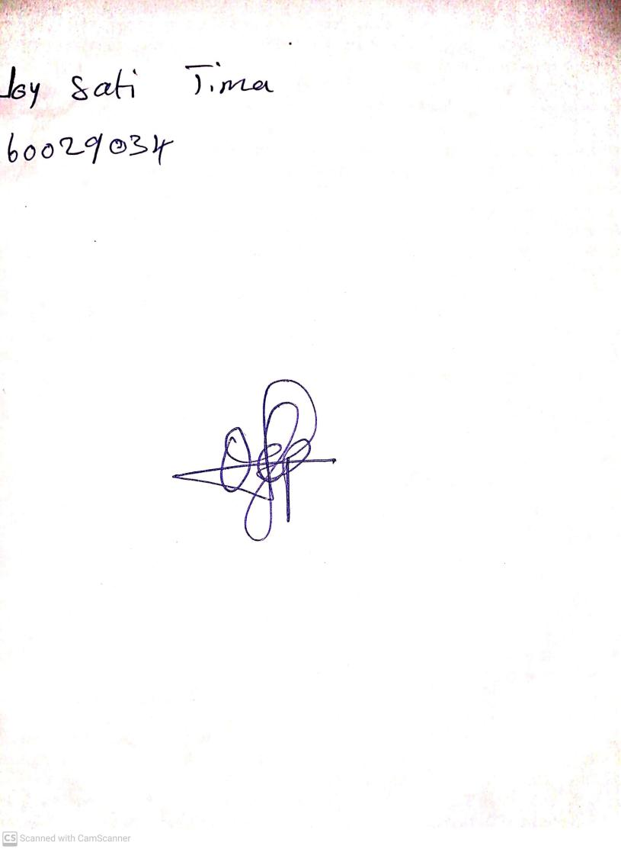

15th August, 2023

Perpetual Ojoma Ocheja

Stream Head Nursery