**EMERALD ROYAL INTERNATIONAL SCHOOL MPAPE, ABUJA**

**LESSON PLAN AND NOTE FOR WEEK 1 ENDING 12/01/2024**

**TERM: 2nd**

**WEEK: 1**

**DATE: 08/01/2024**

**CLASS: Nursery 2**

**SUBJECT: Letter work**

**TOPIC: Revision on 3 letter words.**

**SUB—TOPIC: Revision on 3 and 4 letter words spread cover a, e,i, o,u**

**PERIOD: 3rd**

**TIME: 09:30—10:10am**

**DURATION: 40 minutes**

**NUMBER IN CLASS: 13**

**AVERAGE AGE: 5 years**

**SEX: Mixed**

**LEARNING OBJECTIVES: By the end of the lesson, the Pupils should be able to:**

**1. Identify words with vowel“a”and “e”**

**2. Make words with vowel “a”and “e”**

**RATIONALE: For Pupils to know words with vowel “a ”and “ e”**

**PREVIOUS KNOWLEDGE: Pupils have learnt 3 letter words in previous term**

**INSTRUCTIONAL MATERIALS: A chart of 3 letter words across“ a”“e”“i”“o”“u”**

**REFERENCE MATERIALS: The New Mastering English for Nursery schools book 3 by J.M**

**OMOGBAI**

**LESSON DEVELOPMENT**

|  |  |  |  |
| --- | --- | --- | --- |
| **Steps** | **Teacher's activities** | **Pupils' activities** | **Learning point** |
| **Introduction** | **Teacher introduces the lesson by singing alphabet song .** | **Pupils sing the song along with the teacher.** | **To prepare pupils minds for the lesson ahead.** |
| **Presentation step 1** | **Teacher writes words with vowel“ a ”and “e ”on the board, spell and pronounce and then ask Pupils to repeat after her. As**   |  |  | | --- | --- | | **“a”** | **“e”** | | **f a t** | **l e g** | | **p a t** | **h e a d** | | **b a n d** | **w e a r** | | **h a n d** | **b e d** | | **M a t** | **m e n** | | **M a n** | **n e t** | | **l a n d** | **w e a r** | | **a n d** | **g e t** | | **Pupils pay attention to the teacher and repeat after the teacher.** | **For proper understanding.** |
| **Step 2** | **Teacher guides pupils to make words with vowel “a” and “ e”as;**  **1).f → a → n**  **2). r →a → m**  **3). b →a →g**  **4). m→ a →d**  **5). m →a →t**  **6). f→ a →t**  **7). a→ n→ d**  **8). M→ a →n**  **9). s→ a→ n→ d**  **10). h →a→ n→ d**  **11). m →e →t**  **12). p →e →n**  **13). b→ e →t**  **14). d →e →n**  **15). p→ e→ t** | **Pupils make words with vowel“ a” and “e” on the board as;**  **1). fan**  **2). ram**  **3). bag**  **4). mad**  **5). mat**  **6). fat**  **7). and**  **8). man**  **9). sand**  **10). hand**  **11). met**  **12). pen**  **13). bet**  **14). den**  **15). pet** | **For better understanding.** |
| **Board summary** | **Teacher summarizes the lesson by going through the lesson on the board over again and then prepare pupils books for them to copy the note on the board.** | **Pupils listen attentively to the teacher and copy the note into their exercise books.** | **To create platform for slow learners.**  **And for onward study.** |
| **Evaluation** | **Teacher evaluates the lesson by asking pupils to spell and pronounce the words on the board one after another.** | **Pupils spell and pronounce the words on the board one after the other.** | **To assess Pupils level of understanding.** |
| **Conclusion** | **Teacher concludes the lesson by marking pupils books.** | **Pupils submit their books for marking.** | **For endorsement** |
| **Assignment** | **Make words with the following.**  **1). m →a →p**  **2). l →e →g**  **3).b→ a → g**  **4).n →e→ t**  **5).l→ a→ p** | **Pupils do their assignment at home.** | **To encourage learning at home.** |

**LESSON PLAN AND NOTE FOR WEEK 1 ENDING 12/01/2024**

**TERM: 2nd**

**WEEK: 1**

**DATE: 11/01/2024**

**CLASS: Nursery 2**

**SUBJECT: Letter work**

**TOPIC: Revision on previous term**

**SUB—TOPIC: Words with vowel“ i ”and“ o”**

**PERIOD: 2nd**

**TIME: 08:50—09:30am**

**DURATION: 40 minutes**

**NUMBER IN CLASS: 13**

**AVERAGE AGE: 5 years**

**SEX: Mixed**

**LEARNING OBJECTIVES: By the end of the lesson, the Pupils should be able to:**

**1. Identify words with vowel“ i”and “o”**

**2. Write words with vowel “i ”and “o”**

**RATIONALE: For Pupils to know words with vowel“ i” and“ o”**

**PREVIOUS KNOWLEDGE: Pupils have learnt words with vowel“ a” and“ e”**

**INSTRUCTIONAL MATERIALS: A chart of words with vowel “a”“ e”“ i ”“o ”“u”**

**REFERENCE MATERIALS: The New Mastering English for Nursery schools book 3 by J. M**

**OMOGBAI**

**LESSON DEVELOPMENT**

|  |  |  |  |
| --- | --- | --- | --- |
| **Steps** | **Teacher's activities** | **Pupils' activities** | **Learning point** |
| **Introduction** | **Teacher introduces the lesson by singing nursery rhymes** | **Pupils sing the rhymes along with the teacher.** | **To arouse pupils interest for the lesson.** |
| **Presentation step 1** | **Teacher writes words with vowel i and o on the board, read and ask Pupils to repeat after her. That is;**   |  |  | | --- | --- | | **“ i”** | **“o”** | | **f i n** | **p o p** | | **l i p** | **l o t** | | **d i g** | **c o t** | | **p i g** | **t o p** | | **s i t** | **d o g** | | **r i b** | **p o t** | | **p i n** | **n o t** | | **n i b** | **g o t** | | **Pupils listen to the teacher and repeat after her.** | **For proper understanding.** |
| **Step 2** | **Teacher guides pupils to sound and pronounce words with vowel“ i” and“o”** | **Pupils sound and pronounce words with vowel“ i ”and“ o”as;**   |  |  | | --- | --- | | **“i”** | **“o”** | | **fin** | **pot** | | **big** | **rod** | | **rib** | **god** | | **lid** | **son** | | **sit** | **mop** | | **bib** | **cot** | | **dig** | **top** | | **him** | **not** | | **For better understanding.** |
| **Board summary** | **Teacher summarizes the lesson by reading the words on the board out loud and also ask Pupils to repeat after her. And then prepare their books for them to copy the note on the board into their books.** | **Pupils listen and repeat the reading after the teacher. And then copy the note into their exercise books.** | **To create platform for slow learners. And for onward study.** |
| **Evaluation** | **Teacher evaluates the lesson by asking pupils to point at the words on the board and read one after the other.** | **Pupils go to the board one after another and read.** | **To enhance Pupils reading skills.** |
| **Conclusion** | **Teacher concludes the lesson by marking pupils books.** | **Pupils submit their books for marking.** | **For endorsement.** |
| **Assignment** | **Sound and write 5 words each of the following: "a" "e" " i "and" o"** | **Pupils do their assignment at home.** | **To encourage learning at home.** |

**LESSON PLAN AND NOTE FOR WEEK 1 ENDING 12/01/2024**

**TERM: 2ND**

**WEEK: 1**

**DATE: 12/01/2024**

**CLASS: Nursery 2**

**SUBJECT: Letter work**

**TOPIC: Revision on last term work**

**SUB—TOPIC: words with vowel "u"**

**PERIOD: 3rd**

**TIME: 09:30—10:10am**

**DURATION: 40 minutes**

**NUMBER IN CLASS: 13**

**AVERAGE AGE: 5 years**

**SEX: Mixed**

**LEARNING OBJECTIVES: By the end of the lesson, the Pupils should be able to:**

**1. Identify words with vowel "u"**

**2. Spell and write words with vowel "u"**

**RATIONALE: For Pupils to know words with vowel "u"**

**PREVIOUS KNOWLEDGE: Pupils have learnt words with vowel“a”“e”“i”and “o”**

**INSTRUCTIONAL MATERIALS: A chart of vowel letters.**

**REFERENCE MATERIALS: The New Mastering English for Nursery schools book 3 by J. M**

**OMOGBAI**

**LESSON DEVELOPMENT**

|  |  |  |  |
| --- | --- | --- | --- |
| **Steps** | **Teacher's activities** | **Pupils' activities** | **Learning point** |
| **Introduction** | **Teacher reviews the previous Lesson.** | **Pupils pay attention to the teacher** | **To arouse pupils interest.** |
| **Presentation step 1** | **Teacher presents the lesson by writing words with vowel "u" on the board, read and then ask Pupils to repeat after her.That is ;**  **" u " as in**  **1. bus**  **2. cup**  **3. buy**  **4. gun**  **5. cut**  **6. dug**  **7. fun**  **8. dun**  **9. hut**  **10. bug**  **11. mug**  **12. put**  **13. rug**  **14. run**  **15. sun** | **Pupils listen and repeat after the teacher.** | **For proper understanding.** |
| **Step 2** | **Teacher guides pupils to sound and pronounce the words with vowel "u" on the board.** | **Pupils spell and pronounce the words with vowel "u" on the board.** | **For better understanding.** |
| **Board summary** | **Teacher summarizes the lesson by preparing pupils books for them to copy the note on the board into their books.** | **Pupils copy the note into their exercise books.** | **For onward study.** |
| **Evaluation** | **Teacher asks pupils to spell and pronounce the words on the board one after the other.** | **Pupils spell and pronounce the words on the board one after the other.** | **To assess Pupils reading ability.** |
| **Conclusion** | **Teacher concludes the lesson by marking pupils books.** | **Pupils submit their books for marking.** | **For endorsement.** |
| **Assignment** | **1. What is initial consonant?**  **2.Mention 10 examples of initial consonant.** | **Pupils do their assignment at home.** | **To encourage learning at home.** |

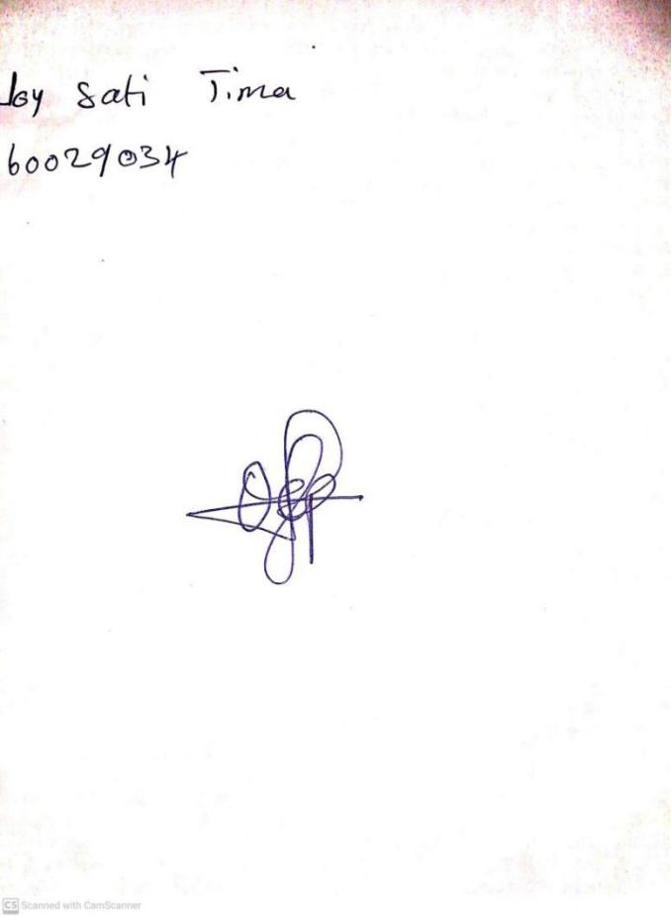

**10TH JANUARY, 2024**

**Perpetual Ojoma Ocheja**

**Stream Head Nursery**