**Summary of the compilation of FDA Approved Drugs from ChEMBL database 23**

We compiled drg-target dataset from ChEMBL 23. We defined this drug target set based on the concentration with which the drug affects the protein. We considered a drug as a small molecule with therapeutic application, which has a direct binding to a single protein (ASSAY_TYPE ="B"), with a maximaum phase of development ="4" which indicate that the drug has been approved. We filtered out weak activity by considering drug-target activity stronger than 1uM and a pchembl value>=6).

The ATC code was used to filter the drug-dataset such that only the protein kinase inhibitor was obtained. The ATC code classifies drug into groups at different levels. The code “L01XE” are antineoplastic drugs that are basically ptoein kinase inhibitors.

The approved drug-target set contains 29 approved drugs that interacts with 324 targets. The targets were filtered to exclude those that are not kinases reducing the numbers of targets to 305 kinases. This was used for further analysis.

**Target Promiscuity of the FDA approved drugs**

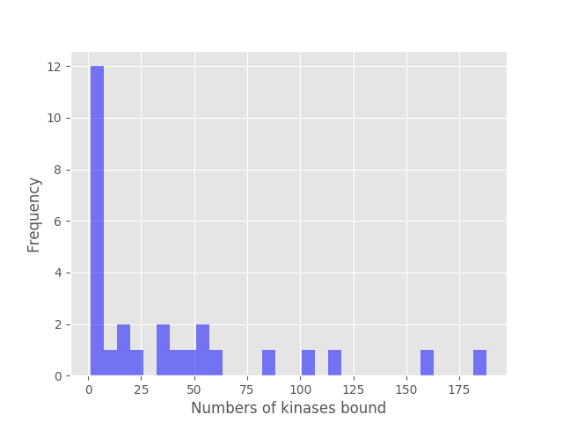

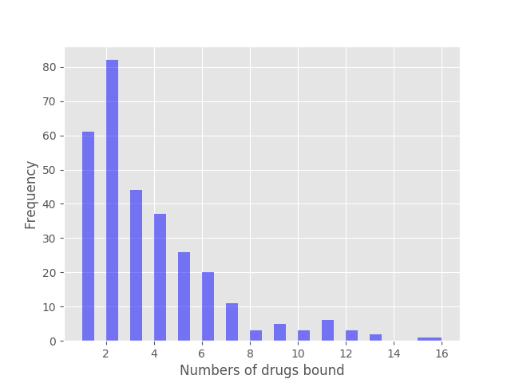

**Dispersion of targets in the network**





Note: The kinase targets here is a combination of the FDA and GSKI-drug targets, the Drug-targets are other druggable targets without the kinases while the off-targets are compiled based on the affinity (those that have lower affinity for the targets).

**Comparing similarity measures of targets of FDA-drugs and GSK-PKIS**



**Kernel similarity of FunFams:comparing drug-targets and other relatives**

