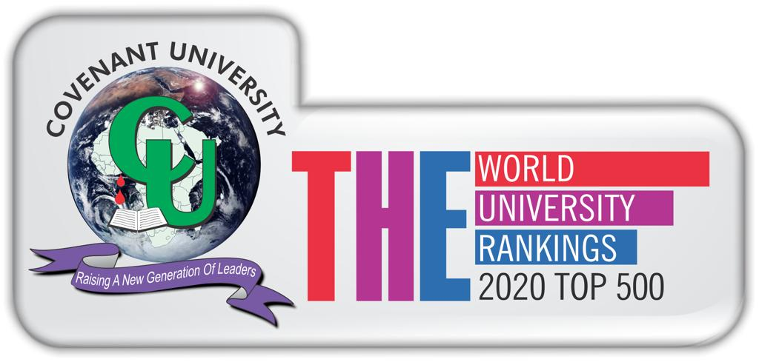

**COVENANT UNIVERSITY**

**CANAANLAND, KM 10, IDIROKO ROAD**

**P.M.B 1023, OTA, OGUN STATE, NIGERIA.**

**COURSE COMPACT**

**College**: Science and Technology

**Department**: Computer and Information Sciences

**Programme**: B.Sc Management Information System

C**ourse Code**: MIS 412

**Course Title**: Knowledge Management

**Units**: 2

**Course Lecturers**: Okuboyejo S.R & Iheanetu O.

**Session:** 2019/2020

**Semester**: Alpha

**Time**: Tuesday, 12noon – 2pm/Friday, 12noon – 2pm

**Location**: Hall 204

1. **Brief Overview of Course**

The value of most organizations today greatly exceeds their net tangible assets. This course addresses contemporary issues in managing knowledge, intellectual capital and other intangible assets. Beginning with a view that these intangibles are strategic assets, the course will introduce the fundamentals of managing knowledge and intellectual capital, understanding some of the measurement issues, processes and cycles involved in their management and the specific issues in managing knowledge-based workers and the organizations in which they work. The course then turns to the strategic issues of creating value from flows in intangible assets and organization structures to support knowledge and intellectual capital development leading to an examination of the management of knowledge intensive businesses. The course concludes with a review of specific application issues, global issues, application to the public sector and current developments in the field.

1. **Course Learning Outcomes**

At the end of this course, students are expected to:

* Apply complex theories and practice of knowledge and intellectual capital management;
* Apply theories to a wide range of scenarios;
* Formulate action plans for knowledge intensive organizations;
* Distinguish aspects of industrial era management that may be inappropriate for knowledge intensive organizations and provide alternatives;
* Formulate a framework for thinking about knowledge intensive organizations;
* Describe and work with intangibles.

1. **Methods of Lecture Delivery/Teaching Aids**

* Lecture Delivery Methods
  + Interactive classroom session
  + Group assignments
  + Lecture notes
* Teaching Aids
  + Multimedia projection

1. **Course Outlines**

* Modules & Details of Topics

**Module I Introduction to Knowledge Management (Dr. Okuboyejo)**

Weeks 1-2: Introduction to Knowledge Management; foundations of knowledge management, including cultural issues, technology application, organizational concepts and processes, management aspect and decision support system.

Week 3: Evolution of knowledge management, from information management to knowledge management, key challenges facing evolution of knowledge management, ethics for knowledge management, knowledge management system life cycle.

**Module II Organization learning and Learning Organization (Dr. Okuboyejo)**

Week 4-5 Understanding Knowledge Management Processes, KM Architecture and codification

Week 6 Organization and knowledge management, Building the learning organization

(the learning organization and organizational learning)

Week 7 Components of a knowledge strategy, case studies from library to knowledge center, knowledge management in the health sciences, knowledge management in developing countries.

**Module III Role of Information Technology in Knowledge Management (Dr. Iheanetu)**

Week 8 Telecommunications and Networks in knowledge management, role of technology in knowledge management (Internet search and knowledge management),

Week 9 Technologies to manage Knowledge: Artificial Intelligence; Human Expertise Application: Knowledge-based systems; Explicitly using historical knowledge: Case-based reasoning Systems

**Module IV Intellectual Capital (Dr. Iheanetu)**

Week 10 Knowledge Transfer in the e-world, Knowledge Portals and KM tools, Managing knowledge workers.

Week 11 Intellectual capital, intellectual components, intellectual capital measurement.

**Module V Organizational culture in Knowledge Management (Dr. Iheanetu)**

Week 12 Communication and organizational culture in knowledge management, cultural enabler, cultural barrier, communication and resistance to change.

Week 13 Revision

1. **Structure of the Programme/Method of Grading**

* Continuous Assessment
  + Class test/Assignments 20 Marks
  + Mid Semester test 10 Marks
* Examination 70 Marks

1. **Ground Rules & Regulations**
   * 70% Attendance is required to seat for the examination.
   * Assignments must be submitted as at when due.
   * Contributions to group discussion and class work are noted.
2. **Alignment with Covenant University Vision/Goals**

The students are groomed to provide solutions to a wide array of knowledge management problems through the skills acquired in the course.

1. **Contemporary Issues/Industry Relevance**

Business information system will continue to drive modern business organization. Corporate organizations invest heavily in the development of management information system in order to have competitive advantage and provide effective service delivery to their client.

1. **Recommended Reading/Texts**

**Recommended Reading:**

1. Liebowitz, Jay. *Knowledge Management Handbook*.
2. Liebowitz, Jay. *Knowledge Management – Learning from Knowledge Engineering*
3. Al-Hawamdeh, Suliman. *Knowledge Management – Cultivating Knowledge Professional*
4. Manlio Del Giudice , Elias G. Carayannis, Maria Rosaria Della Peruta (2012), *Cross-Cultural Knowledge Management: Fostering Innovation and Collaboration Inside the Multicultural Enterprise*, Springer