NUMERICAL COMPUTATION LABORATORY 1

COURSE CODE:CSC 307

TITLE:ERROR AND ERROR PROPAGATION

SUBMITTED BY
LABORATORY GROUP 20

SUBMITTED TO
DR ODEJOBI
HOD OF THE DEPARTMENT OF COMPUTER SCIENCE AND ENGINEERING
OBAFEMI AWOLOWO UNIVERSITY
ILE-IFE, OSUN STATE.

GROUP 20 MEMBERS

Sholesi Kofoworola Victoria Computer Sci with Mathematics CSC/2014/080
Oseni Taslim Oghenakogie Computer Engineering CSC/2014/074

TABLE OF CONTENTS

NAME AND TITLE OF REPORT 1
TABLE OF CONTENTS 3
GLOSSARY 4
INTRODUCTION 5
PROBLEM STATEMENT 6
OBJECTIVES OF EXPERIMENT 7
EXPERIMENT PROCEDURE 8
DISCUSSION OF RESULTS 11
TECHNOLOGICAL INTERPRETATION 13
CONCLUSION AND SUGGESTION 14
REFERENCES 15

GLOSSARY

MACHINE EPSILON
The epsilon (represented using the symbol ε) of a computer refers to the smallest number a computer can store. Any number smaller than the machine epsilon of a machine will be stored as zero.

MACHINE GAMMA
The Machine Gamma (Γ) of a computer is the largest real number that it can be correctly store. A number that is bigger than the machine Gamma is considered will not be store by the computer and is considered Not a Numbers (NaN). The machine Gamma is related to the machine epsilon by the formula
Epsilon = (Gamma−1)/2 .0
Ɛ=(1/Γ)/2.0

INTRODUCTION

This report will first describe the terms “errors and error propagation”, and then will go on to emphasize on the different types of errors we have, how they can be propagated, and most importantly, how best we can avoid them in order for us to develop accurate, effective and efficient numerical solution.
Errors can be variation in measurements, calculation
ns or in the observing of a quantity due to mistakes or to some uncontrollable factors. There are three classes of errors and they are:
- Conceptual Error: This as the name implies is the error that occurs when one has a wrong concept of the problem or its solution.
- Inherent Error: This error occurs as a result of limitation in the capacity of the language and instrument (measuring or computing) used to express the problem.
- Arithmetic Error: These are errors in calculation, and could be further divided into Subtractive cancellation, negligible addition, negligible subtraction, Magnification error and Counter-Intuitive error.
Error propagation can be seen as spreading error from one step of computing into the next step, and subsequent steps. This occurs as a result of the fact that at every step of calculation, there is an error and when the result gotten from a step is used in another step, which in itself has error, then error is being propagated

PROBLEM STATEMENT

The experiment above required us to find the error inherent in both single and double precision arithmetic and more so the existing relation between the double precision values for both the machine gamma and epsilon and their single precision values.
The epsilon of a computer is the smallest number it can store. Any number smaller than the machine epsilon of a machine will be stored as zero. Algorithms for determining the machine epsilon are meant to find the smallest number such that when added to one (1) will be greater than one that is, 1.0 + epsilon > 1.0. A way to do this is to start with a small number and repeatedly divide it by a small number say 2 until the expression 1.0 + epsilon > 1.0 becomes false. The last number that was obtained before this is taken as the machine epsilon, while the machine gamma is the largest real number that the computer can store.

OBJECTIVES OF THE EXPERIMENT
The main objective of this laboratory experiment is to get us familiar with the sources of some of the possible and likely errors in computational methods and algorithms implemented on digital computer system as a result of improper use of computational tool.
They help to improve our proficiency in algorithm design and computational problem solving. This proficiency will be useful in modeling and simulation of engineering concepts and systems.
They also help in understanding the principles of scientific and engineering experiment documentation.

In this experiment, the epsilon (smallest number that the computer can store) and the gamma (largest real number that the computer system can store) are determined. The machine will automatically store any value less than this will be stored as zero.
The Machine Gamma of a computer is the largest real number that it can correctly store. Any number bigger than the machine Gamma is considered as NAN (not a number)

EXPERIMENT PROCEDURE
Initial settings/materials and tools:
- Numerical computation 1(laboratory report 1) pdf
- Fortran plato 2003
- Octave
Experiment processes:
The pdf file,fortran and octave were downloaded online and the various experiments in the laboratory report 1 were carried out.for example computation of machine epsilon,machine gamma and error and error propagation.
Measurement and recording processes:
No measurement was taken but the recordings were done on a spare note for further comparison while making observation.
Algorithm design:
Most of the algorithm design was gotten from the laboratory report.i.e
1.ALGORITHM FOR MACHINE EPSILON USING SUBTRACTION

START:
REAL epsilon = 1.0
r := 1.0 +epsilon
WHILE (r <1.0)
Epsilon=epsilon/2.0
r=1.0-epsilon
Write epsilon
ENDWHILE
END:

2. ALGORITHM FOR MACHINE EPSILON USING ADDITION

START:
REAL epsilon = 1.0
r := 1.0 + epsilon
WHILE (r >1.0)
epsilon = epsilon/2.0
r = 1.0 + epsilon
WRITE epsilon
ENDWHILE
END:

3. ALGORITHM FOR MACHINE GAMMA USING SUBTRACTION

START:
REAL epsilon = 1.0
REAL gamma
r := 1.0 – epsilon
WHILE (r < 1.0)
epsilon = epsilon/2.0
gamma = 0.5/epsilon
r = 1.0 – epsilon
WRITE epsilon
WRITE gamma
ENDWHILE
END:
4.

ALGORITHM FOR MACHINE GAMMA USING ADDITION

START:
REAL epsilon = 1.0
REAL gamma
r := 1.0 + epsilon
WHILE (r >1.0)
epsilon = epsilon/2.0
gamma = 0.5/epsilon
r = 1.0 + epsilon
WRITE epsilon
WRITE gamma
ENDWHILE
END

Program development and running:
Fortran and octave software were used in developing and running the programs.

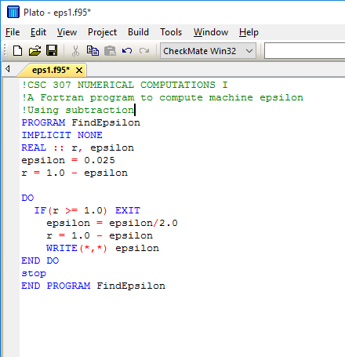

figure 1: FORTRAN code for computing machine epsilon with subtraction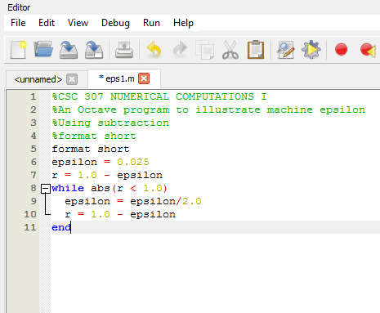
Octave code for computing epsilon with subtraction

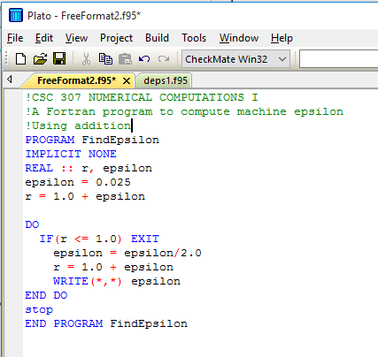
Figure 7: FORTRAN code for computing machine epsilon with addition

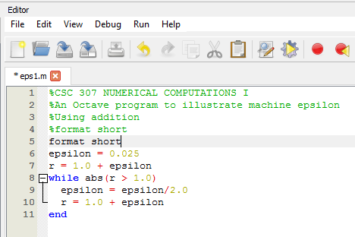
Figure 8: Octave code for computing machine epsilon using addition

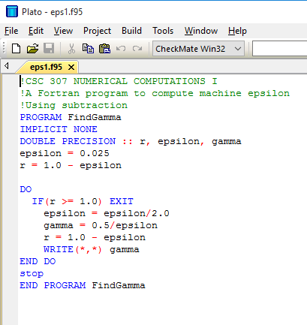
Figure 14: FORTRAN code for computing machine gamma

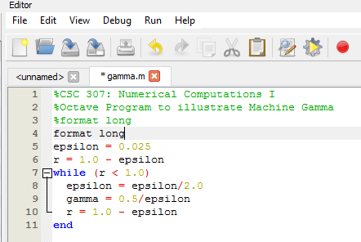
Octave code for computing gamma

DIE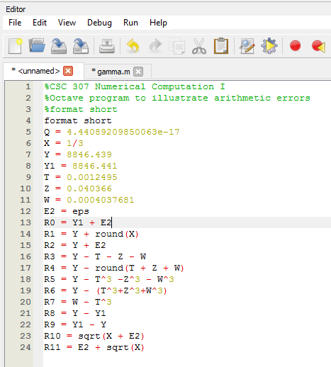
Figure 17: Octave code to evaluate arithmetic errors using “format short”.

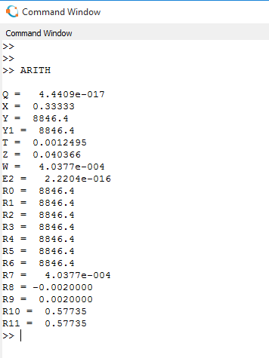
Output of the Octave program when using format short
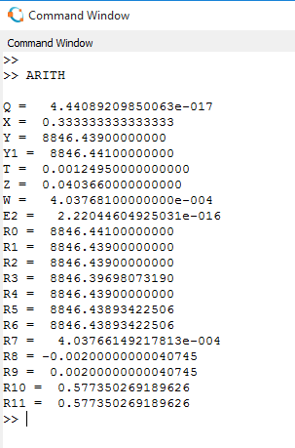
Output for octave program when using format long

DISCUSSION OF RESULTS

Task set 1:
OBSERVATIONS
- It was observed that when the program for computing machine epsilon(with subtraction) was copied on the computer using fortran and octave ,the machine epsilon obtained from both fortran and octave differ immensely.The machine epsilon value for fortran was 2.384186E-08 while the machine epsilon for octave was 4.4409E-017.

2. When the keyword “eps” was entered in the command window of octave,it gives the machine epsilon of the particular computer in use.The epsilon of the computer in use is 2.2204e-016.

- Replacing the format short with format long in octave gave the value of the machine epsilon(with subtraction) and the computer machine epsilon with double precision(i.e increasing the number of mantissa for better precision). The machine epsilons are 4.440892098500e-017 and 2.220446049250e-016 respectively.

- It was observed that modifying line 8 of the algorithm i.e epsilon=epsilon/2.0 using different divisors gives different values for the epsilon .When divisor equals 3.0,machine epsilon=4.0474e-017.When divisor equals 5.0,machine epsilon=5.2429e-017.When divisor equals 10.0,machine epsilon=2.5000e-017.

- It was observed that using the algorithm with addition to calculate the machine epsilon gave the same values as with the algorithm with subtraction for each divisors that was inputed whether format short or format long was used except for the one with divisor 2.0.
Machine epsilon for divisor 2.0(with subtraction)
Epsilon=4.4409e-017
Machine epsilon for divisor 2.0(with addition)
Epsilon=8.8818e-017

RESULT
The machine epsilon of the computer in use is greater than the epsilon values that was computed.Therefore since we know the computed machine epsilon and the computer’s epsilon,we can proceed to calculating the errors.
Computer’s epsilon=2.2204e-016
Epsilon with divisor 2.0=4.4409e-017
Epsilon with divisor 3.0=4.0474e-017
Epsilon with divisor 5.0=5.2429e-017
Epsilon with divisor 10.0=2.5000e-017

Error=|real value-computed value|
Error epsilon with divisor 2.0=2.2204e-016-4.4409e-017
Error epsilon with divisor 3.0=2.2204e-016-4.0474e-017
Error epsilon with divisor 5.0=2.2204e-016-5.2429e-017
Error epsilon with divisor 10.0=2.2204e-016-2.5000e-017

TASK 2:
OBSERVATION
- It was observed that the machine Gamma differs with each divisors just like the epsilon because the epsilon is a function of the machine gamma.It was also noted that the machine Gamma is a very large value compared to the machine epsilon.

RESULT
Gamma with divisor 2.0=5.6295e+015
Gamma with divisor 3.0=1.2353e+016
Gamma with divisor 5.0=9.5367e+015
Gamma with divisor 10.0=2.0000e+016
Therefore it was concluded that the numerical space of the computer is truly defined by the closed interval [Ɛ,Γ]

TASK 3:
OBSERVATION
Reproducing the octave program in format short:
R0 and R1 gives equal values though the function used in their computation was different.

R2,R3,R4,R5,R6 gives equal values too though the function used in their computation was also different.It was observed that the values of E2,T,Z and W used in the computation of R2 through R6 was too small to affect the result of Y and Y1 in format short which results in the values of R2 through R6 being similar.

R7 gave the same value as W.This reason being that the value of T^3 was negligible compared to W in format short.

R8 and R9 gave the negative values of each other which is expected because Y1 is greater than Y and the difference between them is quite significant in format short.

R10 and R11 was observed to have the same value when computed.The reason being that E2 is the epsilon of the computer and further computation like multiplication and finding of roots gives zero.Therefore sqrt[x+E2]=sqrt X.
Also the addition of E2 to sqrt(X) gives the smae value as sqrt(X) since it is in format short which doesn’t show all the mantissa.

Reproducing the octave program in format long:
It was observed that R0 and R1 doesn’t exactly give the same value
It was also observed that R2 through R6 gave different values also which are quite different from the value of Y and Y1.

R7 also gave a different value from W.
R8 and R9 still gave the same values as before when using format short
R10 and R11 still gave the same value as before when using format short.

RESULT
The result of the octave program for figure 4 both for format long and format short can be seen from the command window program above.
It was therefore concluded that using the format long gives more mantissa which enables a user compute and compare different functions effectively with little or no errors.

Case 1:for conceptual error
For example,when computing simple arithmetic like 3+6/3.the user may end up interpreting the question by adding 3 to 6 before dividing by 3 which gives instead of dividing 6 by 3 before adding 3 to it which gives 5.And 5 is not equal to 3.

Case 2:inherent error
It is well known that the computer cannot compute most problem efficiently with infinity and zero which can be solved efficiently by humans thereby resulting into mathematical errors.

Case 3:Arithmetic error
Take for example,when computing the sum of a large number with a nearly negligibly small number,the computer just iggnores the negligibly small number and the gives the answer the same as the large number.i.e 24-3.8e-17.

ALGORITHM TO IMPLEMENT THE PROGRAM FOR COMPUTING SOME EXPRESSIONS

- Y=(1.0-C0S X)/X^2
START:
Real X,R,Y
R=1.0-cos X
Y=R/X^2
Write Y
END:

- Z=A-B-C-D-E
START:
Real A,B,C,D,E,Z
Z=A-B-C-D-E
Write Z
END:

- R=(A^2-X^2)/(A-X)
START:
Real A,X,R,U,V
U=A^2-X^2
V=A-X
R=U/V
Write R
END:

4. S= 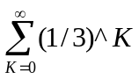
As a series,formula to compute to infinity =a/(1-r)
Where a=first term
r=common ratio
START:
Real K,a,r,u,S
a=3^0=1
r=3/1=3
u=1-r
S=a/u
Write S
END:
CODE FOR COMPUTING THESE EXPRESSIONS ON OCTAVE

format short
x=60
r=1.0-x
y=r/x
end

Format short
a=45
b=32
c=4
d=8
e=16
z=a-b-c-d-e
End

format short
a=5
x=4
u=a^2-x^2
v=a-x
r=u/v
end

format short
a=1
r=3
u=1-r
s=a/u
End

TECHNOLOGICAL INTERPRETATION AND APPLICATION OF RESULTS

Scientist and laboratory workers that deal with measure of minute quantities can apply these results when experimenting with chemicals.

Physicist and mathematicians could also find this experiment useful when computing equations and solving some mathematical expressions which requires minimum or no errors

CONCLUSION AND SUGGESTION FOR FURTHER WORKS

From this laboratory result,the machine epsilon and gamma computed shows that it could vary depending on the approach to which an individual computes it and the type of machine being used for computation.

Furthermore,this result confirms the type of errors that could occur during computation like conceptual,inherent and arithmetic errors.It also expantiate on how to make use of applications like fortran and octave for efficient and effective computation.

APPEDIXES
Table of values for the computation of machine epsilon and gamma(with subtraction) making use of octave.
index | divisor | epsilon | gamma
1 | 2.0 | 4.4409e-017 | 5.6295e+015
2 | 3.0 | 4.0474e-017 | 1.2353e+016
3 | 5.0 | 5.2429e-017 | 9.5367e+015
4 | 10.0 | 2.5000e-017 | 2.0000e+016

Programs used are fortran and octave which are cited above in the experiment procedure.

REFERENCE
Wikipedia
Fortran library
Lecture notes on CSC 307

