**Abstract**

Undoubtedly, one of the biggest disadvantages of solar energy is that solar energy is intermittent. It is not possible to benefit from solar energy at night, and it is not possible to benefit from it on cloudy days. At the same time, solar radiation values show great differences between summer and winter. In addition to being intermittent, another disadvantage of solar energy is that solar energy is not an intensive energy source. The average daily value of solar energy for Turkey is measured as 3.6 kWh/m2-day. For this reason, it is necessary to monitor the sun throughout the day (east-west) and throughout the year (north-south) in order to benefit from solar energy at the maximum level. For this purpose, solar tracking systems have been developed and used. The purpose of solar tracking systems is to orient the solar cells perpendicular to the sun.

# Contents

Contents 4

List Of Figures 6

Chapter 1 7

Introduction 7

* 1. Aim And Goal 7
  2. Subject, Scope and Literature Review 8
  3. Importance And Conribution 10
  4. PV Systems 12

Chapter 2 16

Equipments 16

* 1. Arduino UNO 16
  2. Servomotor 19
  3. LDR Sensor (Photoresistor) 22
  4. Resistor 24
  5. Breadboard 25
  6. Jumper 26
  7. Solar Panel 28

Chapter 3 30

Design, Implementation and Software 30

* 1. Mechanical Assembly 30
  2. Circuit 33

3.2 The Code 35

Chapter 4 39

Result 39

Costing 41

Chapter 5 42

References 42

**Figure 1.1:** Sun’s position.

# List Of Figures

**Figure 1.2:** Environmental pollution. **Figure 2.1:** Arduino UNO R3 **Figure 2.2:** Arduino UNO Schematic **Figure 2.3:** MG90 Servo

**Figure 2.4:** LDR Sensor

**Figure 2.5:** Resistor

**Figure 2.6:** Breadboard

**Figure 2.7:** Jumper

**Figure 2.8:** Solar Panel

**Figure 3.1:** Mechanical Assembly level 1

**Figure 3.2:** Mechanical Assembly level 2

**Figure 3.3:** Mechanical Assembly level 3

**Figure 3.4:** Mechanical Assembly level 4

**Figure 3.5:** Mechanical Assembly level 5

**Figure 3.6:** Circuit Diagram

**Figure 3.7:** Flawchart

**Figure 4.1:** Circuit Diagram of a PV Cell Model

**Figure 4.2:** Fixed PV Panel Model

**Figure 4.3:** Actual and Simulated net Output Current Value of Fixed Panel

**Figure 4.4: Effective** Sun Irradiance Model

**Chapter 1** **Introduction**

## Aim And Goal

This project is a solar tracking system. Electricity production can be maximized by moving solar panels and making them point towards the sun. Solar panels convert solar heat directly into electrical energy. The highest efficiency is obtained if the solar rays are perpendicular.

The main objective of this project is to improve the efficiency of the device for photovoltaic generation. We know that the use of solar panels to transform solar energy into electricity is very common, but it may not be possible for a fixed solar panel to produce optimum energy due to the sun's transition from east to west. This problem is addressed by the proposed device by an arrangement for the solar panel to control the sun. By connecting a servo motor to the solar panel, this tracking movement is done so that the panel retains its face at all times perpendicular to the sun to produce optimum energy. This project uses a solar panel mounted on a time-programmed servo motor to control the sun such that at any given time of the day, maximum sunlight occurs on the panel. This is accomplished by using an Arduino designed to send stepped pulses to the servo motor in periodic time intervals to rotate the installed panel in one direction and then return as desired to the starting point for Next Day Illumination. This is easier compared to the technique of light-sensing, which might not be still specific, on cloudy days, for example. This project was based on a servo motor and an Arduino Uno. Since the sun during the day does not shift its vertical location significantly.

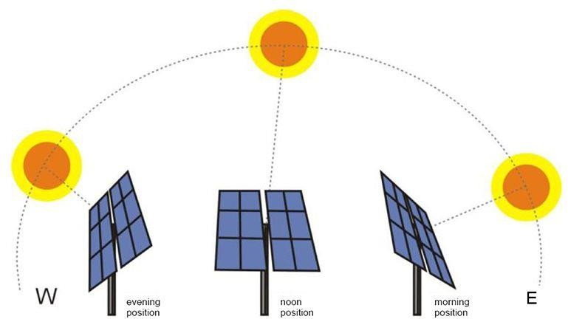

**Figure 1.1**

## Subject, Scope and Literature Review

Edmond Becquerel first discovered photovolltaic energy. Mankind's interest in solar energy and its work to work goes back in 100 years. Initially, solar energy was used only to generate the steam required for some machines to operate. But later he discovered the photovoltaic effect of Edmond Becquerel's solar conversion into electrical energy.

After this stage, the effective use of solar energy was realized by turning it into electricity. In 1893, shortly after Becquerel's discovery of photovoltaic energy, Charles Fritts first covered selenium plates with a thin layer of gold. Thus, the first solar panel was made by Charles Fritts. This humble beginning at that time led to the emergence of communications today called the solar panel.

Russel Ohl, the American inventor who later worked at Bell Laboratories, patented the world's first silicon manager in 1941. Ohl's invention led to the production of a new solar panel using silicon in 1954 by the same company. Solar panels have found an effective area below in space applications for the first time. The second person encountered the solar panel for the first time in their lives, probably in 1970's calculations.

Today, daytime solar panels and complete solar panel systems are used as a wide variety of power sources. Solar panels, in the form of solar cells, are still used in calculators. However, solar panels are also used by Google for a very broad scope, such as supplying central electricity from solar energy to all homes and commercial buildings in California.

The solar tracker makes the solar panel inclined towards the rays coming during the day. Depending on the type of tracking system, the panel is aimed either directly at the sun or at the brightest part of the cloudy part of the sky. Tracking devices greatly increase their performance in the early morning or late afternoon hours, the total power generated by the system is for a single tracking device in the 20-25% band, and 30% belongs to the dual axis tracker depending on the latitude. Trackers are more effective when they receive large amounts of direct sunlight. The emitted air (under cloud or fog conditions) has little or no value. Because the most concentrated photovoltaic systems are very sensitive to the angle of the sun, tracking systems make it useful to generate more power for certain periods of the day. Tracking systems increase performance for two main reasons.

First, if the sun's rays are perpendicular to the solar panel, it will receive more light from its surface than if it is inclined. Second, the direct beam is more effective than the curved beam. Specially designed anti-reflective coatings increase the efficiency of the solar panel for direct and inclined lights, although they greatly reduce the benefits of the tracking system. Tracking devices and sensors are offered optionally to optimize performance, but tracking systems can increase the applicable efficiency up to 45%. Those that can approach or exceed one megawatt from a photovoltaic system often use a solar tracker. In the calculation for clouds and since most of the Earth is not at the equator, the correct measurement of solar power is due to solar radiation, which is usually the average number of kilowatt-hours per square meter per day. For air and latitudes, typical solar radiation ranges in America and Europe are 2.26 kWh / m² in northern climates and 5.61 kWh / m² sunny regions. For large systems, the energy gained from the tracking device can exceed the added complexity (tracking devices can increase efficiency by up to 30% or more). For very large systems, it is a significant damage to the sustainability of the added tracking system. Tracking system is not required for floor panels and low density photovoltaic systems. For high density photovoltaic systems, a biaxial tracking system is a requirement. Price trends provide a balance between

the shelved panels, despite the added fixed panels. When solar panel prices fall, tracking systems become less attractive.

Energy Ministry is prepared Turkey's Solar Energy Potential Atlas to (GEPA) based on annual sunshine duration of 2,737 hours (daily total of 7.5 hours), the annual total incoming solar energy 1,527 kWh / m².yıl (daily total of 4.2 kWh / m²) was identified as has been.

General Directorate of Electrical Works Survey Administration (EİE), Department of Energy Resources Survey, Solar Energy Branch, since 1982 research, development, information and demonstration studies on solar energy have been carried out by the newly established General Directorate of Renewable Energy (YEGM) since 2 November 2011. conducts. Among his studies; technology follow-up, evaluation, determination of resource and potential, research of usage areas and realization of research-development and demonstration projects.

All active power plants use photovoltaic (PV) systems and their number is 370 as of June 2016; all of this is covered by unlicensed electricity generation. Most of the power plants are below the unlicensed electricity generation limit of 1 MW (megawatt), the remaining ones continue their activities with the partnership of 1 MW power plants. The biggest power plant is Konya Karatay Kızören SPP with 23 MW installed power. According to the 2023 target of the Ministry of Energy; At least 3000 MW licensed PV plant installed power will be reached.

It has been calculated that the energy that can be produced by Concentrated Solar Energy (CSP) method in the country is 380 billion kWh / year.

Solar geothermal systems are found in few places.

## Importance And Conribution

With the increasing population, the desire of people to live in comfortable and comfortable conditions constantly increases the energy demand. It is getting harder every day to meet the increasing energy demand with fossil-based fuels with limited reserves. Energy use based on fossil fuels until today; Environmental pollution, decrease in reserves, greenhouse effect in

the atmosphere, natural vegetation as well as negative effects on human health caused the necessity to find new energy sourcesrapidly.

#### Renewable Energy Sources:

They are sources offered as an alternative to conventional energy sources. Solar, wind, hydrogen, hydroelectric, wave and geothermal sources are examples. The most important feature of these resources, which are based on factors that are constantly present in nature, is that they are renewable and do not harm nature.

#### Solar Energy:

* + - Solar energy is the only energy source that has no waste, is abundant and inexhaustible.
    - Turkey, solar energy because of its geographical location is lucky in terms of potential.
    - Average sunbathing time is 7.2 hours / day per day.
    - Solar energy applications have a high initial investment cost, especially to generate electricity.
    - The prices of solar cell panels in recent years are 3-6 $
    - Heat and electricity is obtained through technology from solar energy.
    - It can be used directly in residences.

The energy of the sun reaching the earth, the seasons and the day It shows according to the time zones within. For this reason, when designing the project annual average meteorological information of the place where it will be installed (number of days off, number of cloudy days the number of days passed) is very important. Turkey 42-36 is located in the northern latitudes, and so cut and summer sun in the light, there is an average of 300 angle changes. Sun rays are steepest in summer on June 21 reaches the ground with an angle, and the angle of December 21 varies by decreasing. Daytime on both dates, 12-13 Maximum efficiency is obtained when the panel is adjusted to be perpendicular to the solar rays during hours. With this project, the country's climate can be optimized and the energy types used today can be

used much cheaper. Moreover, while many energy systems damage the ecological balance, the solar tracking system is environmentally friendly.



**Figure 1.2**

## PV Systems

The PV applications could be grouped according to the scheme of interaction with utility grid: grid connected, stand alone, and hybrid. PV systems consist of a PV generator (cell, module, and array), energy storage devices (such as batteries), AC and DC consumers and elements for power conditioning. The most common method uses the PV cells in the grid network. However, to understand the performance and to maximize the efficiency of the irradiation of the PV cells, the standalone PV cells have spurred some interest, especially, in the area of the solar tracker system.

Over the years, test and researchers had proven that development of smart solar tracker maximizes the energy generation. In this competitive world of advanced scientific discoveries, the introductions of automated systems improve existing power generation methods. Before the introduction of solar tracking methods, fixed solar panels were positioned within a reasonable tilted direction based on the location. The tilt angle depending on whether a slight winter or summer bias is preferred in the system. The PV systems would face “true north” in the northern hemisphere and “true south” in the southern hemisphere. Solar tracking is best achieved when the tilt angle of the tracking PV systems is synchronized

with the seasonal changes of the sun’s altitude. Several methods of sun tracking systems have been surveyed and evaluated to keep the PV cells perpendicular to the sun beam. An ideal tracker would allow the PV cells to point towards the sun, compensating for both changes in the altitude angle of the sun (throughout the day), latitudinal offset of the sun (during seasonal changes) and changes in azimuth angle. In the light of this, two main types of sun trackers exist: passive (mechanical) and active (electrical) trackers. The detailed literatures review can be found in.

One class of the passive solar trackers is the fixed solar panel. It is placed horizontally on the fixed ground and face upwards to the sky. But most of the passive solar trackers are based on manual adjustment of the panel, thermal expansion of a shape memory alloy or two bimetallic strips made of aluminum and steel. Usually this kind of tracker is composed of a couple of actuators working against each other, which are, by equal illumination, balanced. By differential illumination of actuators, unbalanced forces are used for orientation of the apparatus in such direction where equal illumination of actuators and balance of forces is restored. Another passive tracking technology is based on the mass imbalance between both ends of the panel. This kind of trackers does not use any kind of electronic control or motor. Two identical cylindrical tubes are filled with a fluid under partial pressure. The sun heats the fluid causing evaporation and transfer from one cylinder to another, which creates the mass imbalance. Passive solar trackers, compared to active trackers, are less complex but works in low efficiency. Although passive trackers are often less expensive, they have not yet been widely accepted by consumers.

Even though there are many characteristics that affect how the PV system works, the solar radiation, G (W / m2), and the temperature, T (°C) are the most important of them. The PV system can be modeled mathematically based on these two parameters. The photocurrent *Iph*, depends on both radiation and the temperature.

*G*

*I* (*G*,*T* )  *I*

* *K* *T*  *T*  *G*

*ph*

(1.1)

Here

 *scn i n* 

*n*

*Iscn*, is the nominal short circuit current

*Ki*, is the temperature coefficient

*Gn*, is the nominal solar radiation, usually taken as 1000 W/m2.

*Tn*, is the nominal temperature of the PV cell, usually taken as 25 °C.

These values for a PV cell can be obtained from the listed datasheets for the PVs that are commercially available. And the diode current *Id* and the diode voltage *Vd*, can be expressed as an exponential function.

*I* (*T* ,*V*

  *V*

)  *I* (*T* ) exp *d*

  

*d d s*

  *aV* (*T* )  1

(1.2)

Here

  *t*  

*Is*, is the diode saturation current

*a*, is the diode coefficient

*Vd*, is the diode voltage

*Vt*, is the semiconductor thermal voltage

The diode saturation current depends on the temperature

*I* (*T* ) 

*Iscn*  *Ki* (*T*  *Tn* )

*s*  *V*  *K* (*T*  *T* ) 

exp *ocn v n*  1

(1.3)

There

 *aVt* (*T* ) 

*Iscn* is the nominal short circuit current

*Ki* is the temperature coefficient

*Tn*, nominal cell temperature

*Vocn* nominal open circuit voltage *Kv* voltage temperature coefficient *a* ideal diode coefficient

*Vt* thermal voltage

It should be noted that in the ideal model, the diode voltage *Vd*, and the PV voltage *Vpv* are the same. And the thermal voltage *Vt*, depends on the temperature *T*, and it is defined as;

*V* (*t*)  *kT N*

*t*

(1.4)

Here

*q s*

*k* is the Boltzmann constant (approximately 1.3807 × 10−23 J·K-1)

*q* is the charge of an electron (1.60217662 × 10−19 C)

*Ns*, is the number of PV cells in the system

Using Kirchhoff's laws as well, we can describe the relationship between *Ipv* and *Vpv* as;

*I pv*  *I ph* (*G*,*T* )  *Id* (*T* ,*Vpv* )

(1.5)

According to these formulas, the ideal current-voltage characteristics is given in Figure 2.4 and the power-voltage characteristics is given in Figure 2.5. In Figures, G = 1000 W/m² and T

= 25 °C; VOC: open-circuit voltage; ISC: short-circuit current; MPP: Maximum power point.

**Chapter 2** **Equipments**

Arduino UNO, servomotor, ldr sensor, resistor, breadboard, jumper and solar panel was used in this project.

## Arduino UNO

The Arduino Uno is an open-source microcontroller board based on the Microchip ATmega328P microcontroller and developed by Arduino.cc. The board is equipped with sets of digital and analog input/output (I/O) pins that may be interfaced to various expansion boards (shields) and other circuits. The board has 14 digital I/O pins (six capable of PWM output), 6 analog I/O pins, and is programmable with the Arduino IDE (Integrated Development Environment), via a type B USB cable. It can be powered by the USB cable or by an external 9-volt battery, though it accepts voltages between 7 and 20 volts. It is similar to the Arduino Nano and Leonardo. The hardware reference design is distributed under a Creative Commons Attribution Share-Alike 2.5 license and is available on the Arduino website. Layout and production files for some versions of the hardware are also available.

The word "uno" means "one" in Italian and was chosen to mark the initial release of Arduino Software. The Uno board is the first in a series of USB-based Arduino boards; it and version 1.0 of the Arduino IDE were the reference versions of Arduino, which have now evolved to newer releases. The ATmega328 on the board comes preprogrammed with a bootloader that allows uploading new code to it without the use of an external hardware programmer.

While the Uno communicates using the original STK500 protocol,[1] it differs from all preceding boards in that it does not use the FTDI USB-to-serial driver chip. Instead, it uses the Atmega16U2 (Atmega8U2 up to version R2) programmed as a USB-to-serial converter.

The Arduino project started at the Interaction Design Institute Ivrea (IDII) in Ivrea, Italy. At that time, the students used a BASIC Stamp microcontroller, at a cost that was a

considerable expense for many students. In 2003, Hernando Barragán created the development platform Wiring as a Master's thesis project at IDII, under the supervision of Massimo Banzi and Casey Reas, who are known for work on the Processing language. The project goal was to create simple, low-cost tools for creating digital projects by non-engineers. The Wiring platform consisted of a printed circuit board (PCB) with an ATmega168 microcontroller, an IDE based on Processing, and library functions to easily program the microcontroller. In 2003, Massimo Banzi, with David Mellis, another IDII student, and David Cuartielles, added support for the cheaper ATmega8 microcontroller to Wiring. But instead of continuing the work on Wiring, they forked the project and renamed it Arduino. Early arduino boards used the FTDI USB-to-serial driver chip and an ATmega168. The Uno differed from all preceding boards by featuring the ATmega328P microcontroller and an ATmega16U2 (Atmega8U2 up to version R2) programmed as a USB-to-serial converter.

#### Technical Specifications:

* + - Microcontroller: Microchip ATmega328P
    - Operating Voltage: 5 Volts
    - Input Voltage: 7 to 20 Volts
    - Digital I/O Pins: 14 (of which 6 can provide PWM output)
    - UART: 1
    - I2C: 1
    - SPPI: 1
    - Analog Input Pins: 6
    - DC Current per I/O Pin: 20 mA
    - DC Current for 3.3V Pin: 50 mA
    - Flash Memory: 32 KB of which 0.5 KB used by bootloader
    - SRAM: 2 KB
    - EEPROM: 1 KB
    - Clock Speed: 16 MHz
    - Length: 68.6 mm
    - Width: 53.4 mm
    - Weight: 25 g

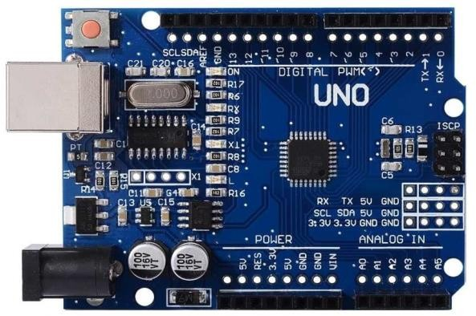

**Figure 2.1**

#### Headers:

**LED**: There is a built-in LED driven by digital pin 13. When the pin is high value, the LED is on, when the pin is low, it is off.

**VIN**: The input voltage to the Arduino/Genuino board when it is using an external power source (as opposed to 5 volts from the USB connection or other regulated power source). You can supply voltage through this pin, or, if supplying voltage via the power jack, access it through this pin.

**5V**: This pin outputs a regulated 5V from the regulator on the board. The board can be supplied with power either from the DC power jack (7 - 20V), the USB connector (5V), or the VIN pin of the board (7-20V). Supplying voltage via the 5V or 3.3V pins bypasses the regulator, and can damage the board.

**3V3**: A 3.3 volt supply generated by the on-board regulator. Maximum current draw is 50 mA.

**GND**: Ground pins.

**IOREF**: This pin on the Arduino/Genuino board provides the voltage reference with which the microcontroller operates. A properly configured shield can read the IOREF pin voltage and select the appropriate power source, or enable voltage translators on the outputs to work with the 5V or 3.3V.

**Reset**: Typically used to add a reset button to shields that block the one on the board.

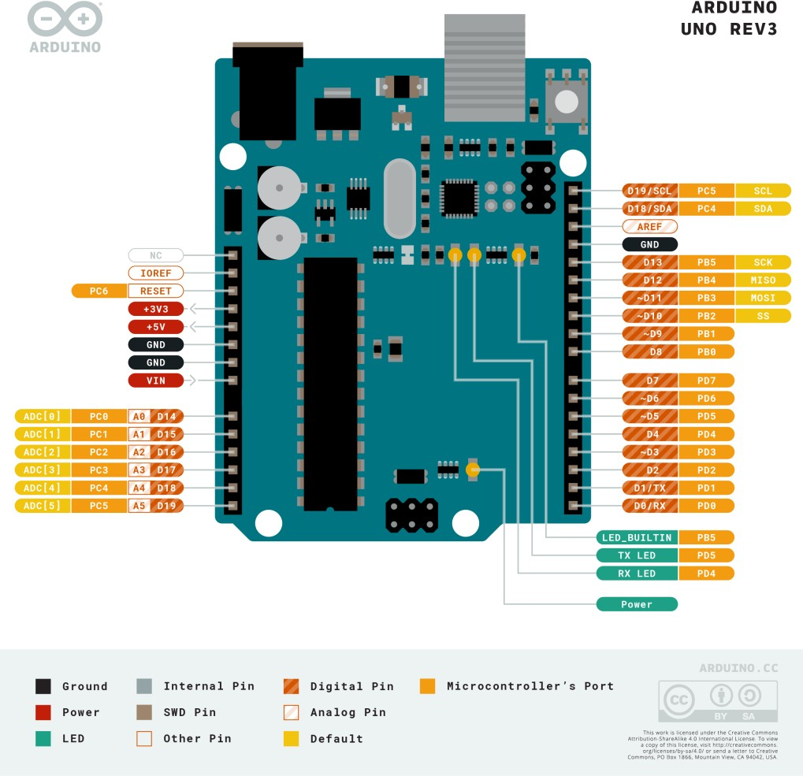

**Figure 2.2**

## Servomotor

A servomotor is a rotary actuator or linear actuator that allows for precise control of angular or linear position, velocity and acceleration. It consists of a suitable motor coupled to a sensor for position feedback. It also requires a relatively sophisticated controller, often a dedicated module designed specifically for use with servomotors.

Servomotors are not a specific class of motor, although the term servomotor is often used to refer to a motor suitable for use in a closed-loop control system.

Servomotors are used in applications such as robotics, CNC machinery or automated manufacturing.

A servomotor is a closed-loop servomechanism that uses position feedback to control its motion and final position. The input to its control is a signal (either analogue or digital) representing the position commanded for the output shaft.

The motor is paired with some type of position encoder to provide position and speed feedback. In the simplest case, only the position is measured. The measured position of the output is compared to the command position, the external input to the controller. If the output position differs from that required, an error signal is generated which then causes the motor to rotate in either direction, as needed to bring the output shaft to the appropriate position. As the positions approach, the error signal reduces to zero and the motor stops.

The very simplest servomotors use position-only sensing via a potentiometer and bang- bang control of their motor; the motor always rotates at full speed (or is stopped). This type of servomotor is not widely used in industrial motion control, but it forms the basis of the simple and cheap servos used for radio-controlled models.

More sophisticated servomotors use optical rotary encoders to measure the speed of the output shaft and a variable-speed drive to control the motor speed. Both of these enhancements, usually in combination with a PID control algorithm, allow the servomotor to be brought to its commanded position more quickly and more precisely, with less overshooting.

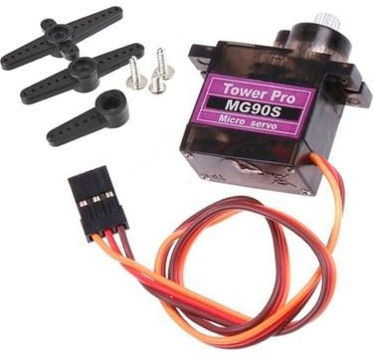

**Figure 2.3**

The first servomotors were developed with synchros as their encoders. Much work was done with these systems in the development of radar and anti-aircraft artillery during World War II.

Simple servomotors may use resistive potentiometers as their position encoder. These are only used at the very simplest and cheapest level, and are in close competition with stepper motors. They suffer from wear and electrical noise in the potentiometer track. Although it would be possible to electrically differentiate their position signal to obtain a speed signal, PID controllers that can make use of such a speed signal generally warrant a more precise encoder.

Modern servomotors use rotary encoders, either absolute or incremental. Absolute encoders can determine their position at power-on, but are more complicated and expensive. Incremental encoders are simpler, cheaper and work at faster speeds. Incremental systems, like stepper motors, often combine their inherent ability to measure intervals of rotation with a simple zero-position sensor to set their position at start-up.

Instead of servomotors, sometimes a motor with a separate, external linear encoder is used. These motor + linear encoder systems avoid inaccuracies in the drivetrain between the motor and linear carriage, but their design is made more complicated as they are no longer a pre- packaged factory-made system.

The type of motor is not critical to a servomotor and different types may be used. At the simplest, brushed permanent magnet DC motors are used, owing to their simplicity and low cost. Small industrial servomotors are typically electronically commutated brushless motors. For large industrial servomotors, AC induction motors are typically used, often with variable frequency drives to allow control of their speed. For ultimate performance in a compact package, brushless AC motors with permanent magnet fields are used, effectively large versions of Brushless DC electric motors.

Drive modules for servomotors are a standard industrial component. Their design is a branch of power electronics, usually based on a three-phase MOSFET or IGBT H bridge. These standard modules accept a single direction and pulse count (rotation distance) as input. They may also include over-temperature monitoring, over-torque and stall detection features.

As the encoder type, gearhead ratio and overall system dynamics are application specific, it is more difficult to produce the overall controller as an off-the-shelf module and so these are often implemented as part of the main controller.

Most modern servomotors are designed and supplied around a dedicated controller module from the same manufacturer. Controllers may also be developed around microcontrollers in order to reduce cost for large-volume applications.

## LDR Sensor (Photoresistor)

A photoresistor (also known as a light-dependent resistor, LDR, or photo-conductive cell) is a passive component that decreases resistance with respect to receiving luminosity (light) on the component's sensitive surface. The resistance of a photoresistor decreases with increase in incident light intensity; in other words, it exhibits photoconductivity. A photoresistor can be applied in light-sensitive detector circuits and light-activated and dark-activated switching circuits acting as a resistance semiconductor. In the dark, a photoresistor can have a resistance as high as several megaohms (MΩ), while in the light, a photoresistor can have a resistance as low as a few hundred ohms. If incident light on a photoresistor exceeds a certain frequency, photons absorbed by the semiconductor give bound electrons enough energy to jump into the conduction band. The resulting free electrons (and their hole partners) conduct electricity, thereby lowering resistance. The resistance range and sensitivity of a photoresistor can substantially differ among dissimilar devices. Moreover, unique photoresistors may react substantially differently to photons within certain wavelength bands.

A photoelectric device can be either intrinsic or extrinsic. An intrinsic semiconductor has its own charge carriers and is not an efficient semiconductor, for example, silicon. In intrinsic devices, the only available electrons are in the valence band, and hence the photon must have enough energy to excite the electron across the entire bandgap. Extrinsic devices have impurities, also called dopants, added whose ground state energy is closer to the conduction band; since the electrons do not have as far to jump, lower energy photons (that is, longer wavelengths and lower frequencies) are sufficient to trigger the device. If a sample of silicon has some of its atoms replaced by phosphorus atoms (impurities), there will be extra electrons available for conduction. This is an example of an extrinsic semiconductor.

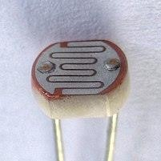

**Figure 2.4**

A photoresistor is less light-sensitive than a photodiode or a phototransistor. The latter two components are true semiconductor devices, while a photoresistor is an active component that does not have a PN-junction. The photoresistivity of any photoresistor may vary widely depending on ambient temperature, making them unsuitable for applications requiring precise measurement of or sensitivity to light photons.

Photoresistors also exhibit a certain degree of latency between exposure to light and the subsequent decrease in resistance, usually around 10 milliseconds. The lag time when going from lit to dark environments is even greater, often as long as one second. This property makes them unsuitable for sensing rapidly flashing lights, but is sometimes used to smooth the response of audio signal compression.

Photoresistors come in many types. Inexpensive cadmium sulfide (CdS) cells can be found in many consumer items such as camera light meters, clock radios, alarm devices (as the detector for a light beam), nightlights, outdoor clocks, solar street lamps, and solar road studs, etc.

Photoresistors can be placed in streetlights to control when the light is on. Ambient light falling on the photoresistor causes the streetlight to turn off. Thus energy is saved by ensuring the light is only on during hours of darkness.

Photoresistors or LDRs are also used in laser-based security systems to detect the change in the light intensity when a person/object passes through the laser beam.

They are also used in some dynamic compressors together with a small incandescent or neon lamp, or light-emitting diode to control gain reduction. A common usage of this application can be found in many guitar amplifiers that incorporate an onboard tremolo effect, as the oscillating light patterns control the level of signal running through the amp circuit.

The use of CdS and CdSe photoresistors is severely restricted in Europe due to the RoHS ban on cadmium.

Lead sulfide (PbS) and indium antimonide (InSb) LDRs (light-dependent resistors) are used for the mid-infrared spectral region. Ge:Cu photoconductors are among the best far-infrared detectors available, and are used for infrared astronomy and infrared spectroscopy.

## Resistor

A resistor is a passive two-terminal electrical component that implements electrical resistance as a circuit element. In electronic circuits, resistors are used to reduce current flow, adjust signal levels, to divide voltages, bias active elements, and terminate transmission lines, among other uses. High-power resistors that can dissipate many watts of electrical power as heat, may be used as part of motor controls, in power distribution systems, or as test loads for generators. Fixed resistors have resistances that only change slightly with temperature, time or operating voltage. Variable resistors can be used to adjust circuit elements (such as a volume control or a lamp dimmer), or as sensing devices for heat, light, humidity, force, or chemical activity.

Resistors are common elements of electrical networks and electronic circuits and are ubiquitous in electronic equipment. Practical resistors as discrete components can be composed of various compounds and forms. Resistors are also implemented within integrated circuits.

The electrical function of a resistor is specified by its resistance: common commercial resistors are manufactured over a range of more than nine orders of magnitude. The nominal value of the resistance falls within the manufacturing tolerance, indicated on the component.

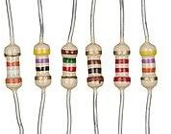

**Figure 2.5**

## Breadboard

A breadboard, or protoboard, is a construction base for prototyping of electronics. Originally the word referred to a literal bread board, a polished piece of wood used when slicing bread. In the 1970s the solderless breadboard (a.k.a. plugboard, a terminal array board) became available and nowadays the term "breadboard" is commonly used to refer to these.

Because the solderless breadboard does not require soldering, it is reusable. This makes it easy to use for creating temporary prototypes and experimenting with circuit design. For this reason, solderless breadboards are also popular with students and in technological education. Older breadboard types did not have this property. A stripboard (Veroboard) and similar prototyping printed circuit boards, which are used to build semi-permanent soldered prototypes or one-offs, cannot easily be reused. A variety of electronic systems may be prototyped by using breadboards, from small analog and digital circuits to complete central processing units (CPUs).

Compared to more permanent circuit connection methods, modern breadboards have high parasitic capacitance, relatively high resistance, and less reliable connections, which are subject to jostle and physical degradation. Signaling is limited to about 10 MHz, and not everything works properly even well below that frequency.

A common use in the system on a chip (SoC) era is to obtain an microcontroller (MCU) on a pre-assembled printed circuit board (PCB) which exposes an array of input/output (IO) pins in a header suitable to plug into a breadboard, and then to prototype a circuit which exploits one or more of the MCU's peripherals, such as general-purpose input/output (GPIO),

UART/USART serial transceivers, analog-to-digital converter (ADC), digital-to-analog converter (DAC), pulse-width modulation (PWM; used in motor control), Serial Peripheral Interface (SPI), or I²C.

Firmware is then developed for the MCU to test, debug, and interact with the circuit prototype. High frequency operation is then largely confined to the SoC's PCB. In the case of high speed interconnects such as SPI and I²C, these can be debugged at a lower speed and later rewired using a different circuit assembly methodology to exploit full-speed operation. A single small SoC often provides most of these electrical interface options in a form factor barely larger than a large postage stamp, available in the American hobby market (and elsewhere) for a few dollars, allowing fairly sophisticated breadboard projects to be created at modest expense.

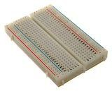

**Figure 2.6**

## Jumper

A jump wire (also known as jumper, jumper wire, jumper cable, DuPont wire or cable) is an electrical wire, or group of them in a cable, with a connector or pin at each end (or sometimes without them – simply "tinned"), which is normally used to interconnect the components of a breadboard or other prototype or test circuit, internally or with other equipment or components, without soldering.

Individual jump wires are fitted by inserting their "end connectors" into the slots provided in a breadboard, the header connector of a circuit board, or a piece of test equipment.

There are different types of jumper wires. Some have the same type of electrical connector at both ends, while others have different connectors. Some common connectors are:

* + - Solid tips – are used to connect on/with a breadboard or female header connector. The arrangement of the elements and ease of insertion on a breadboard allows increasing the mounting density of both components and jump wires without fear of short- circuits. The jump wires vary in size and colour to distinguish the different working signals.
    - Crocodile clips – are used, among other applications, to temporarily bridge sensors, buttons and other elements of prototypes with components or equipment that have arbitrary connectors, wires, screw terminals, etc.
    - Banana connectors – are commonly used on test equipment for DC and low-frequency AC signals.
    - Registered jack (RJnn) – are commonly used in telephone (RJ11) and computer networking (RJ45).
    - RCA connectors – are often used for audio, low-resolution composite video signals, or other low-frequency applications requiring a shielded cable.
    - RF connectors – are used to carry radio frequency signals between circuits, test equipment, and antennas.
    - RF jumper cables - Jumper cables is a smaller and more bendable corrugated cable which is used to connect antennas and other components to network cabling. Jumpers are also used in base stations to connect antennas to radio units. Usually the most bendable jumper cable diameter is 1/2".

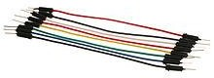

**Figure 2.7**

## Solar Panel

A solar panel, or photo-voltaic (PV) module, is an assembly of photo-voltaic cells mounted in a framework for installation. Solar panels use sunlight as a source of energy to generate direct current electricity. A collection of PV modules is called a PV panel, and a system of panels is an array. Arrays of a photovoltaic system supply solar electricity to electrical equipment.

In 1839, the ability of some materials to create an electrical charge from light exposure was first observed by Alexandre-Edmond Becquerel. Though the premiere solar panels were too inefficient for even simple electric devices they were used as an instrument to measure light. The observation by Becquerel was not replicated again until 1873, when Willoughby Smith discovered that the charge could be caused by light hitting selenium. After this discovery, William Grylls Adams and Richard Evans Day published "The action of light on selenium" in 1876, describing the experiment they used to replicate Smith's results.

In 1881, Charles Fritts created the first commercial solar panel, which was reported by Fritts as "continuous, constant and of considerable force not only by exposure to sunlight but also to dim, diffused daylight." However, these solar panels were very inefficient, especially compared to coal-fired power plants. In 1939, Russell Ohl created the solar cell design that is used in many modern solar panels. He patented his design in 1941. In 1954, this design was first used by Bell Labs to create the first commercially viable silicon solar cell. In 1957, Mohamed M. Atalla developed the process of silicon surface passivation by thermal oxidation at Bell Labs. The surface passivation process has since been critical to solar cell efficiency.

Photovoltaic modules use light energy (photons) from the Sun to generate electricity through the photovoltaic effect. Most modules use wafer-based crystalline silicon cells or thin-film cells. The structural (load carrying) member of a module can be either the top layer or the back layer. Cells must be protected from mechanical damage and moisture. Most modules are rigid, but semi-flexible ones based on thin-film cells are also available. The cells are usually connected electrically in series, one to another to the desired voltage, and then in parallel to increase current. The power (watts) of the module is the mathematical product of the voltage (volts) and the current (amps) of the module. The manufacture specifications on

solar panels are obtained under standard condition which is not the real operating condition the solar panels are exposed to on the installation site.

A PV junction box is attached to the back of the solar panel and functions as its output interface. External connections for most photovoltaic modules use MC4 connectors to facilitate easy weatherproof connections to the rest of the system. A USB power interface can also be used.

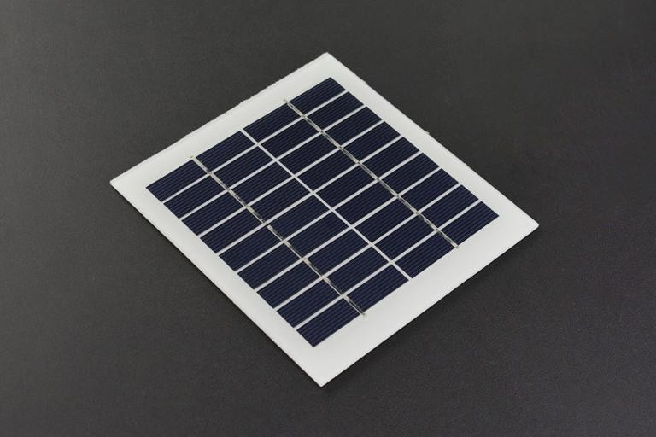

**Figure 2.8**

**Chapter 3**

**Design, Implementation and Software**

## Mechanical Assembly

Combine the body design that we produced with a 3D printer.

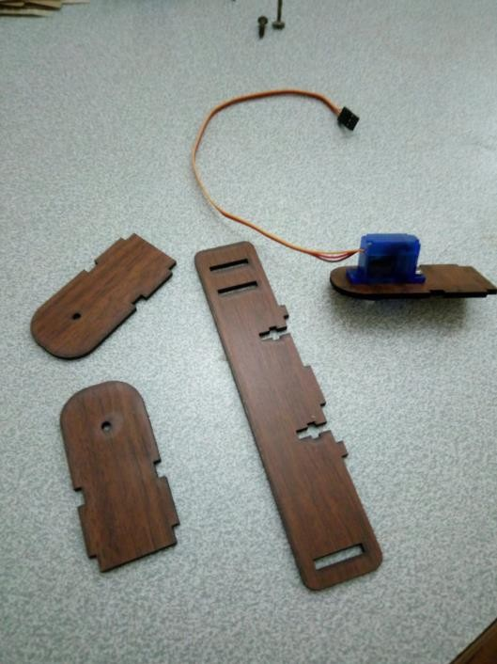

**Figure 3.1**

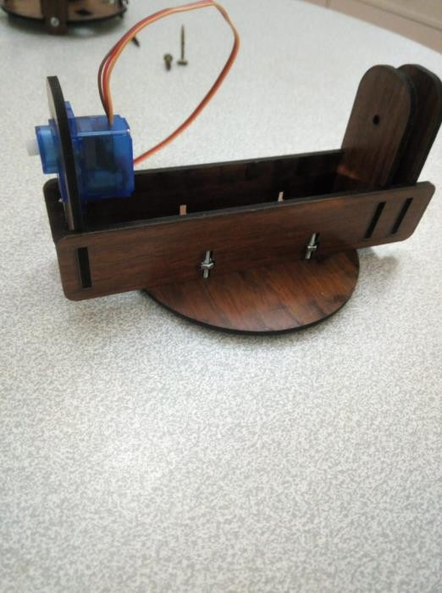

**Figure 3.2**

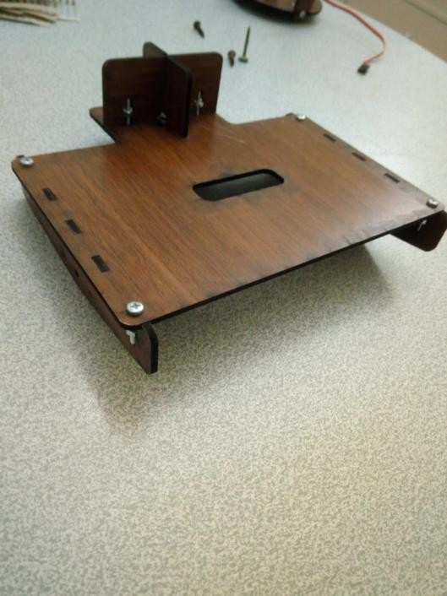

**Figure 3.3**

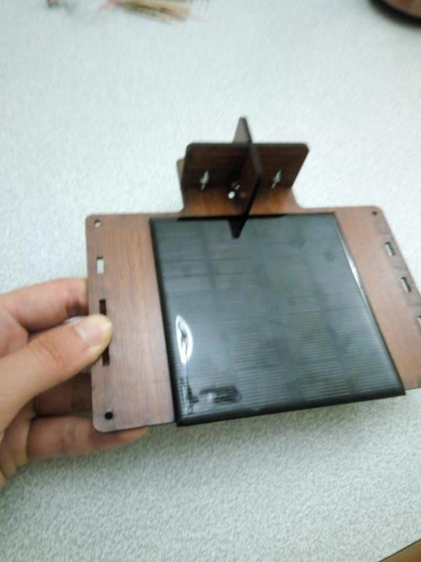

**Figure 3.4**

Assembly the servo motors and the panel on the stand.

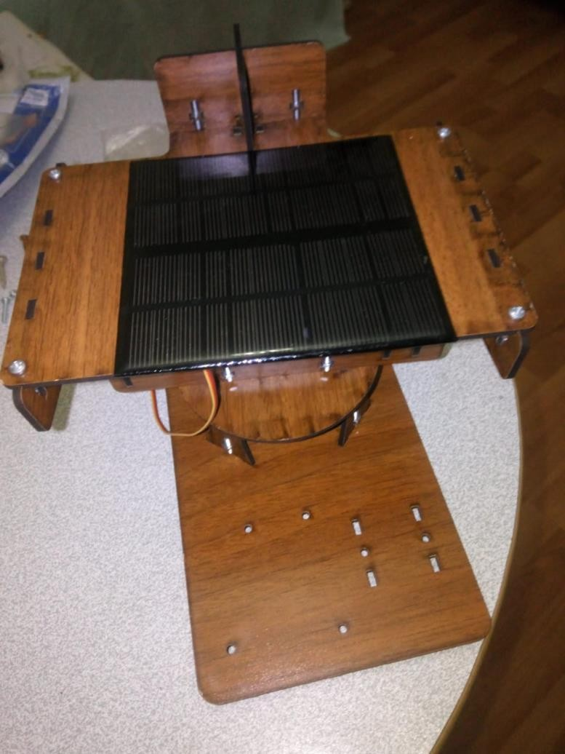

## Circuit

**Figure 3.5**

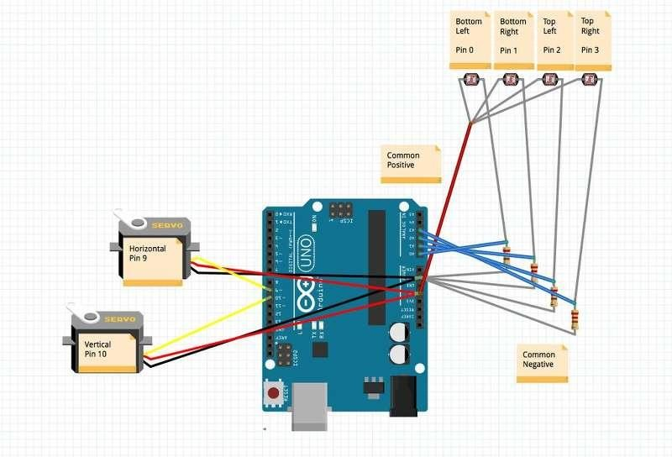

**Figure 3.6**

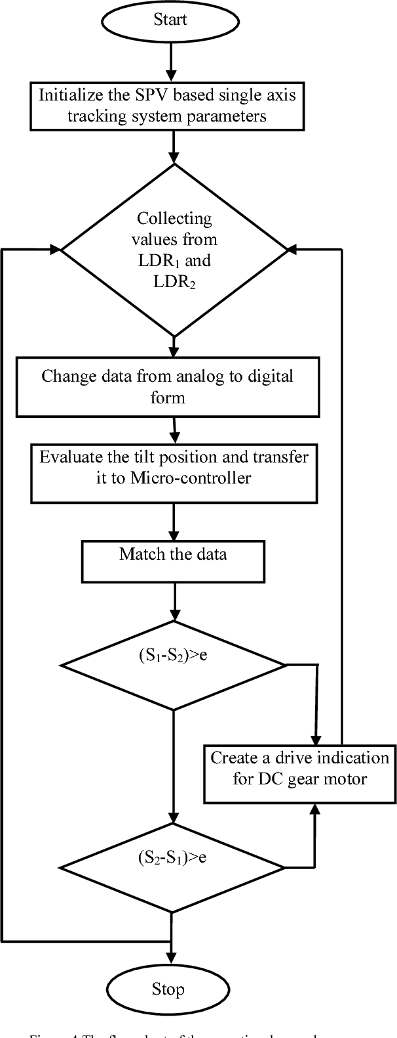

**Figure 3.7**

According to above Flowchart programming will be done. ARDUINO control the servomotors according to Delay program. Servomotors rotates east to west (morning to evening). After evening servomotors rotates suddenly to its original position. Next till day same process repeated.

## 3.2 The Code

#include <Servo.h> // include Servo library

// 180 horizontal MAX

Servo horizontal; // horizontal servo

int servoh = 180; // 90; // stand horizontal servo

int servohLimitHigh = 180; int servohLimitLow = 65;

// 65 degrees MAX

Servo vertical; // vertical servo

int servov = 45; // 90; // stand vertical servo

int servovLimitHigh = 80; int servovLimitLow = 15;

// LDR pin connections

// name = analogpin;

int ldrlt = 0; //LDR top left - BOTTOM LEFT <--- BDG int ldrrt = 1; //LDR top rigt - BOTTOM RIGHT

int ldrld = 2; //LDR down left - TOP LEFT int ldrrd = 3; //ldr down rigt - TOP RIGHT

void setup()

{

Serial.begin(9600);

// servo connections

// name.attacht(pin); horizontal.attach(9); vertical.attach(10);

horizontal.write(180); vertical.write(45); delay(3000);

}

void loop()

{

int lt = analogRead(ldrlt); // top left int rt = analogRead(ldrrt); // top right

int ld = analogRead(ldrld); // down left int rd = analogRead(ldrrd); // down rigt

// int dtime = analogRead(4)/20; // read potentiometers

// int tol = analogRead(5)/4; int dtime = 10;

int tol = 50;

int avt = (lt + rt) / 2; // average value top

int avd = (ld + rd) / 2; // average value down int avl = (lt + ld) / 2; // average value left

int avr = (rt + rd) / 2; // average value right

int dvert = avt - avd; // check the diffirence of up and down int dhoriz = avl - avr;// check the diffirence og left and rigt

Serial.print(avt);

Serial.print(" ");

Serial.print(avd);

Serial.print(" ");

Serial.print(avl);

Serial.print(" ");

Serial.print(avr);

Serial.print(" ");

Serial.print(dtime); Serial.print(" "); Serial.print(tol); Serial.println(" ");

if (-1*tol > dvert || dvert > tol) // check if the diffirence is in the tolerance else change vertical angle

{

if (avt > avd)

{

servov = ++servov;

if (servov > servovLimitHigh)

{

servov = servovLimitHigh;

}

}

else if (avt < avd)

{

servov= --servov;

if (servov < servovLimitLow)

{

servov = servovLimitLow;

}

}

vertical.write(servov);

}

if (-1*tol > dhoriz || dhoriz > tol) // check if the diffirence is in the tolerance else change horizontal angle

{

if (avl > avr)

{

servoh = --servoh;

if (servoh < servohLimitLow)

{

servoh = servohLimitLow;

}

}

else if (avl < avr)

{

servoh = ++servoh;

if (servoh > servohLimitHigh)

{

servoh = servohLimitHigh;

}

}

else if (avl = avr)

{

// nothing

}

horizontal.write(servoh);

}

delay(dtime);

}

**Chapter 4** **Result**

The simplest equivalent circuit of a solar cell is a current source in parallel with a diode as shown in Figure 4.1. The current source represents the current generated by the PV cell due to the photons received by it, and is constant under constant sun irradiance and temperature. During darkness, the solar cell is not an active device; it works as a diode. It produces neither a current nor a voltage. However, if it is connected to an external supply (large voltage) it generates a saturation current or dark current. The key parameters for a PV cell are short circuit current (Isc or the current from the solar cell when the voltage across the cell is zero), open circuit voltage (Voc) and sun irradiance value. Usually these values are given by the manufacturer in the data sheet.

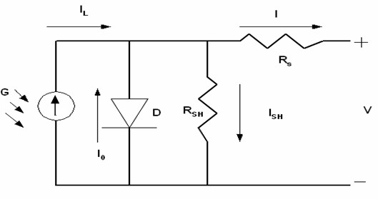

#### Figure 4.1

Normally a single PV cell produces a rather small voltage that have less practical use. The real PV panel always uses many cells to generate a large voltage.

By using MATLABTM, the above function can be computed numerically to obtain the net output current from the PV cells.

The fixed PV panel was modeled as shown in Figure 4.2 using the equations. The output voltage of the battery is 12V. The temperature (TaC) obtained during the experiment and the sun irradiance data (G) that represents the intensity (or the power of sunlight falling per unit area) were used. The solar irradiance data were taken hourly, and the averages in each hour were then tabulated. The PV Cells Array block diagram computes the net current from the PV cells using the embedded MATLAB function. The plot for the actual and simulated net output current is shown in Figure 4.3. The deviation in the plot may due to the averaging done during each hour and the power consumed before noon was actually higher than expected. This is reasonable as the sunlight is stronger during the day.

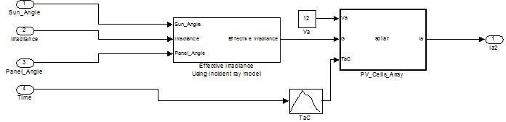

#### Figure 4.2

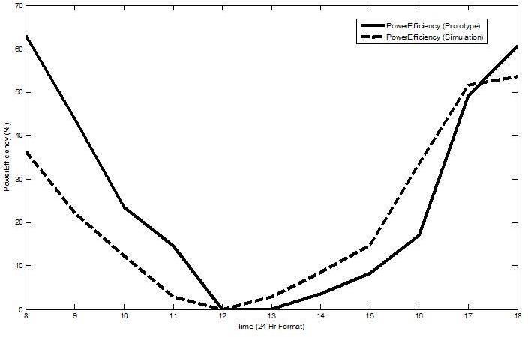

#### Figure 4.3

To simulate the sun irradiance at different PV panel’s angle, the effective irradiance was used. Details of the effective irradiance block diagram can be seen in Figure 4.4. The block diagram defined the angle between sun’s incident ray and PV panel. For a static panel, it is always parallel to the ground that is at 90 degrees (0 degree for sunrise and 180 degrees for sun set). A simple program was written to obtain the relationship of the effective sun irradiance when the difference between the sun angle and panel angle is more than +/-90 degrees. To limit the angle to 90 degrees, the cosine trigonometric function was introduced in the model to create the zero sun irradiance when such a situation occurs.

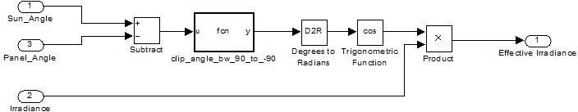

#### Figure 4.4

## Costing

|  |  |  |
| --- | --- | --- |
| **Component Name** | **Piece** | **Value** |
| Arduino UNO R3 | 1 | $12 |
| LDR | 4 | $1 |
| Servomotor | 2 | $5 |
| Resistor | - | $1 |
| Jumper | - | $1 |
| Breadboard | - | $2 |
| Panel | 1 | $15 |

#### Totally = $37

**Chapter 5** **References**

[www.electronicsforu.com](http://www.electronicsforu.com/) [www.interestingengineering.com](http://www.interestingengineering.com/) https://en.wikipedia.org/ [www.researchgate.net](http://www.researchgate.net/) https:/[/www.sol](http://www.solarreviews.com/)a[rreviews.com/](http://www.solarreviews.com/) electronics.ege.edu.tr/ <http://ee.eng.marmara.edu.tr/>

H., Saadat, (1999) Power System Analysis McGraw-Hill Series in Electrical Computer Engineering.

D. Song, et al. (2012) "Progress in n-type Si solar cell and module technology for high efficiency and low cost. in Photovoltaic Specialists Conference (PVSC)", 38th IEEE

F. Blaabjerg, and D.M. Ionel, (2017) Renewable Energy Devices and Systems with Simulations in MATLAB® and ANSYS®. CRC Press.

K. Fekete, Z. Klaic, and L. Majdandzic, (2012) "Expansion of the residential photovoltaic systems and its harmonic impact on the distribution grid". Renewable Energy, 43: p. 140-148.

K.H. Chua, et al., (2011) "Mitigation of voltage unbalance in low voltage distribution network with high level of photovoltaic system". Energy Procedia, 12: p. 495-501.

L. Freris, and D. Infield, Renewable energy in power systems. (2008). John Wiley & Sons.