**HIDA (<https://www.accessbankplc.com/Personal-Banking/SAVINGS-INVESTMENT/High-Interest-Deposit-Account.aspx> )**

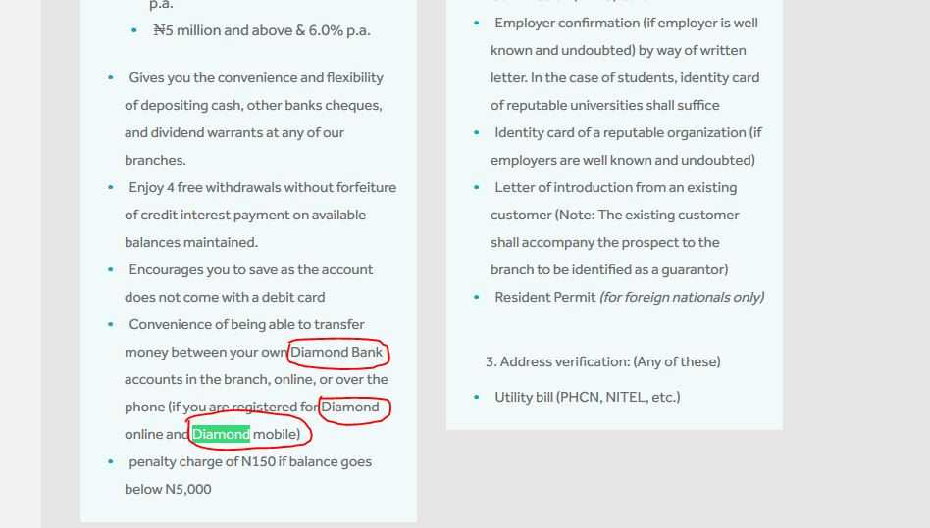

**Visa Signature Card (https://www.accessbankplc.com/Ways-To-Bank/Cards/visa-signature-card.aspx )**

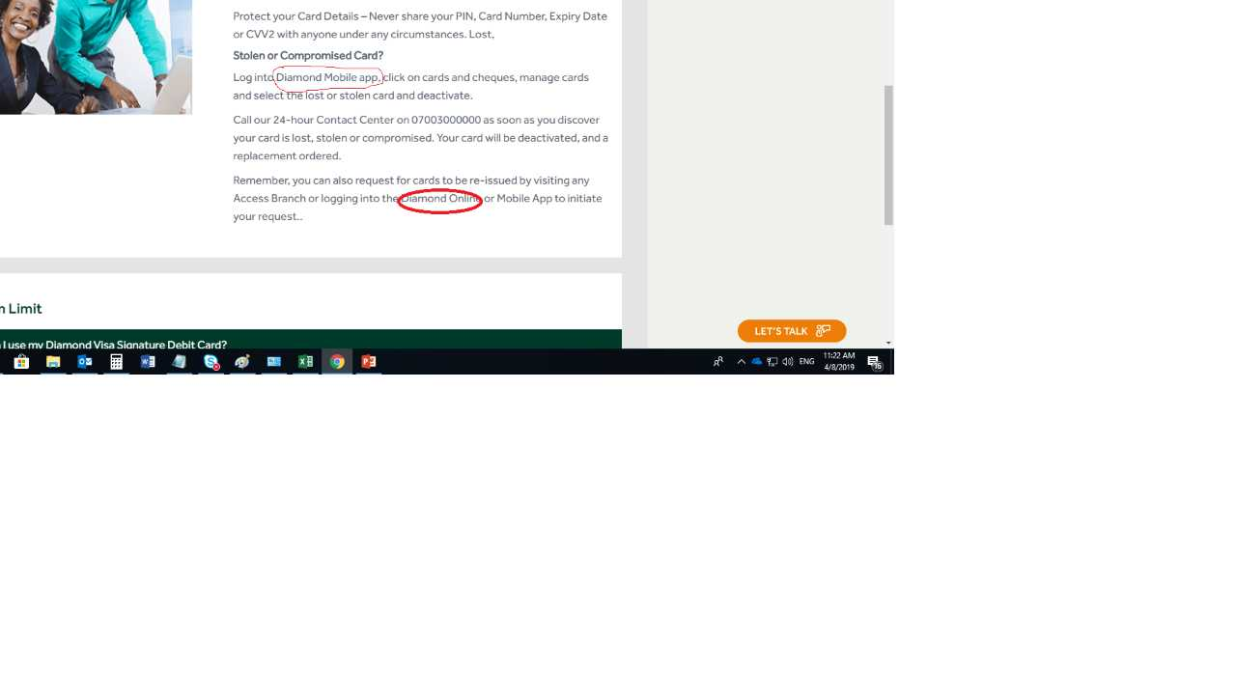

**Tamada(https://www.accessbankplc.com/Ways-To-Bank/Tamada.aspx)**

