ANALYSTLAB AFRICA — EXPERIENCE LAB
ML Pipeline Integration & Validation Report
HealthConnect Clinic Experience Lab — Week 6: Integration, Advanced Development & Validation
Field | Value
Track | Machine Learning Engineering
Prepared by | Raji Toluwanimi Samuel, Junior Machine Learning Engineer
Repository | healthconnect-repo (src/, tests/, notebooks/, docs/, data/, models/, logs/)

1. Week 5 → Week 6 Transition
Main Week 5 output: a working src/ pipeline (ingestion, validation, feature engineering, a swappable model wrapper, a baseline training script), covered by 22 passing tests. Most important result: two confirmed data problems (waiting_time_minutes leakage; chronologically inconsistent historical fields) with engineered fixes. Main limitation discovered: Week 5 validated each pipeline stage in isolation but never validated the boundary between preprocessing and the model, and its own “Next Steps” explicitly flagged that a batch-scoring script had not been built.
Relevant track for Week 6: Data Science (model improvement is that track's stated focus). Week 6 goal: integrate an improved candidate model into the existing pipeline, add the missing input/output validation, and implement batch scoring — without rebuilding what Week 5 already proved worked.

2. Cross-Track Integration
Transparency note: this Experience Lab track is being completed solo, without a separate Data-Science-track collaborator producing an independent candidate model. Rather than represent a hand-off that did not occur, this report documents that the Data-Science-style work below (error analysis, feature refinement, candidate modelling) was self-performed, and integrated into the ML Engineering pipeline exactly as the brief's integration matrix describes for a genuine Data Science → ML Engineering hand-off. This is stated plainly here so the work is not misrepresented, consistent with the programme's professional-development requirement to accurately reflect actual contribution.
Field | Detail
Track collaborated with | Data Science (self-performed; see note above)
Project dependency | ML Engineering pipeline needs a validated, improved model to integrate, per the Week 4 architecture's model-agnostic design
Information/output received | Error-analysis findings and a candidate model (Random Forest) that outperforms the Week 5 baseline on Recall
Information/output provided | A tested, validated pipeline and swappable model interface for that candidate to be trained and served through, plus the Week 5/6 leakage and data-quality findings
Integration activity completed | Random Forest integrated via the unchanged NoShowRiskModel interface; input/output validation added at the preprocessing/model boundary; batch scoring implemented
What changed as a result | Recall improved from 0.621 (baseline) to 0.654 (integrated candidate); two real integration bugs were found and fixed; a scored, risk-tiered appointment list now exists where none did before
Evidence | src/train_candidate_models.py, models/model_comparison_report.json, models/error_analysis_report.json, data/scored/appointment_risk_scores.csv, 24 new passing tests

3. Review of Week 5 Pipeline — Integration Gaps Identified
- No validation existed at the boundary between feature_engineering's output and a model's .fit()/.predict() input — a schema drift or dtype issue would have reached scikit-learn as an opaque error, or worse, silently produced wrong predictions.
- NoShowRiskModel's swappable-estimator design was specified in Week 5 but never actually tested with a second estimator — it was unproven whether the interface genuinely supported anything beyond the one hardcoded Logistic Regression.
- The Week 4 architecture's Batch Scoring Service and Risk Score Output Store stages had not been implemented.
- Every entry-point script called logging.basicConfig() independently — a latent bug, since Python only honours the first such call per process.

4. Input/Output Validation (New This Week)
validation_checks.py adds two functions used at every point data crosses the preprocessing/model boundary:
- validate_feature_matrix() — confirms the matrix is non-empty, every column is genuinely numeric, no missing or infinite values remain, and (optionally) the column set/order matches what a loaded model expects.
- validate_predictions() — confirms every probability is in [0, 1], contains no NaNs, and the output length matches the input row count.
Running the fully integrated pipeline end-to-end for the first time immediately surfaced two real integration bugs via these checks — exactly the kind of issue Week 6 exists to catch.

4.1 Bug 1: one-hot encoded columns rejected as non-numeric
dtype of a get_dummies() output column: bool
FeatureValidationError: Feature matrix contains non-numeric columns: [...]
pandas' get_dummies() returns bool-dtype columns by default in the pandas version used here. bool is not a subtype of numpy's numeric type, so validate_feature_matrix() correctly rejected every one-hot encoded column. scikit-learn happens to accept bool columns silently, which is exactly why this went unnoticed during Week 5 — nothing was checking dtypes explicitly before. Fixed at the source: feature_engineering.encode_categoricals() now casts every dummy column to int immediately after encoding.

4.2 Bug 2: ensemble estimators crashed at initialisation
self.estimator = estimator or LogisticRegression(...) # BEFORE (buggy)
self.estimator = estimator if estimator is not None else LogisticRegression(...) # AFTER (fixed)
The original line evaluates the incoming estimator's truthiness. scikit-learn ensemble estimators (RandomForestClassifier, GradientBoostingClassifier) define __len__ via their base class, and Python falls back to __len__ for truthiness when __bool__ is undefined — but __len__ on an unfitted ensemble reads self.estimators_, which does not exist until after .fit(). Passing a fresh RandomForestClassifier() into NoShowRiskModel raised an AttributeError from inside __init__, before any of the wrapper's own code had a chance to run. This was purely a property of how the Week 5 wrapper was written; it had never been tested with a non-default estimator until this week's integration work. Fixed with an explicit is None check.
Both bugs now have dedicated regression tests (Section 8) so they cannot silently reappear.

5. Error Analysis on the Week 5 Baseline
Week 5 reported an overall Recall of 0.627 but never examined which specific appointments the model got wrong. error_analysis.py classifies every test-set prediction as a true/false positive/negative and profiles feature averages across those four groups.
Outcome | Count | Share of test set
True Positive (caught a real no-show) | 300 | 31.6%
False Positive (false alarm) | 176 | 18.6%
True Negative (correctly predicted attendance) | 289 | 30.5%
False Negative (missed a real no-show) | 183 | 19.3%

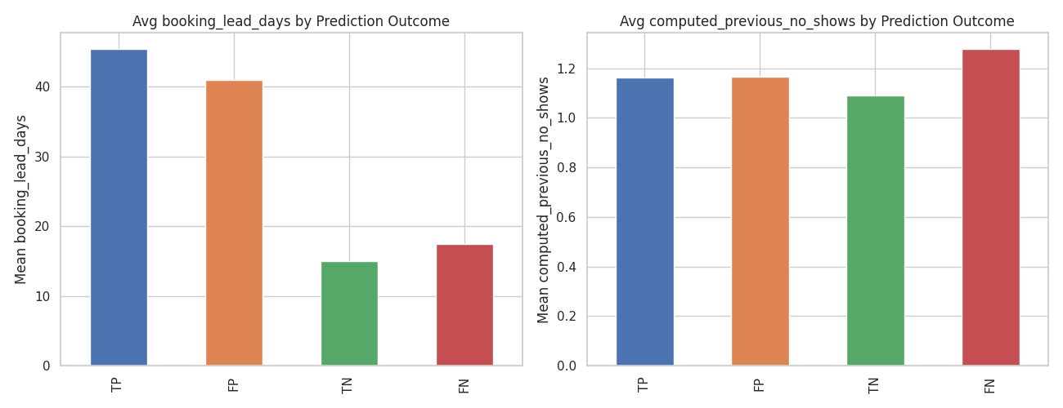
Average booking_lead_days and computed_previous_no_shows across the four prediction-outcome groups.
booking_lead_days does almost all of the model's separating work: True Positives average ~45.5 lead days, True Negatives ~15.0. But False Negatives (missed no-shows) average only ~17.5 lead days — nearly indistinguishable from True Negatives on this feature alone. The model's blind spot is short-lead-time no-shows, precisely because its dominant signal runs out of separating power in that regime. computed_previous_no_shows is directionally useful there (False Negatives average 1.28 vs True Negatives' 1.09) but too weak alone to move the metrics on its own.

6. Evidence-Based Feature Refinement
Based directly on the pattern above, feature_engineering.add_short_lead_high_risk_flag() adds one new feature: short_lead_high_risk_flag = 1 when booking_lead_days ≤ 14 AND computed_previous_no_shows ≥ 1. This makes the interaction explicit for a model, in exactly the regime where the baseline currently struggles, rather than requiring a model to discover the combination unaided. This is the “refine features where there is a justified reason” requirement satisfied with an actual justification, not a default addition.

7. Candidate Model Integration & Comparison
Three models were trained through the identical, unmodified NoShowRiskModel interface — the strongest proof available that the Week 5 design goal (a genuinely swappable estimator) works in practice, not just in principle.
Model | Accuracy | Precision | Recall | F1 | ROC-AUC
Logistic Regression (Week 5 baseline) | 0.621 | 0.630 | 0.621 | 0.626 | 0.668
Random Forest (selected) | 0.616 | 0.616 | 0.654 | 0.635 | 0.666
Gradient Boosting | 0.598 | 0.600 | 0.634 | 0.616 | 0.643

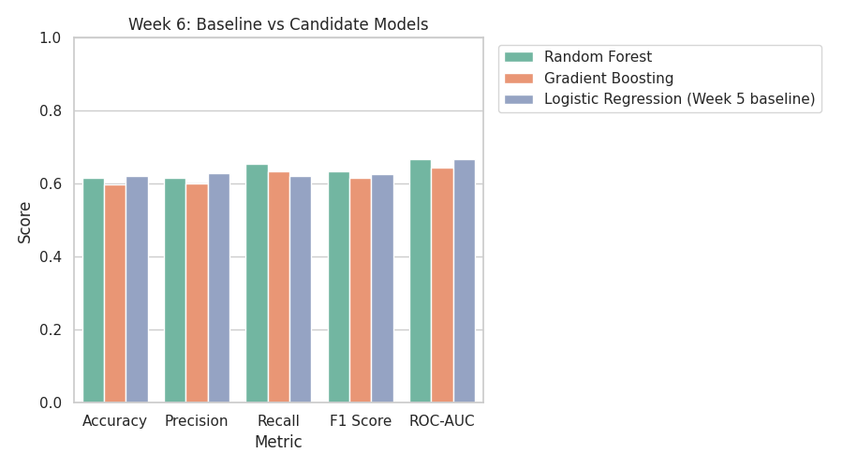
Baseline vs candidate models across all five evaluation metrics.
Consistent with the Recall-first rationale established in Weeks 4-5 (a missed no-show wastes an appointment slot with zero intervention, which outweighs the cost of one unnecessary extra reminder), Random Forest is selected: it improves Recall over the baseline (0.654 vs 0.621) and F1 (0.635 vs 0.626), while ROC-AUC is essentially unchanged (0.666 vs 0.668). Gradient Boosting is not selected — weaker than both alternatives on every metric here. This is a modest, honestly-reported improvement, not a breakthrough, consistent with Week 6's scope being integration and validation rather than a final production model.

8. Testing Evidence
46 automated tests now pass (22 from Week 5 plus 24 new this week), including dedicated regression tests for both integration bugs found in Section 4.
Test file | What it adds this week
test_validation_checks.py | 10 tests covering every validate_feature_matrix / validate_predictions failure mode, including the bool-dtype regression case
test_error_analysis.py | 5 tests covering outcome classification, error counting, and feature profiling
test_score_appointments.py | 4 tests covering risk-tier boundary assignment
test_model.py (extended) | 1 new test: an ensemble estimator must not crash at initialisation (regression test for Bug 2)
test_feature_engineering.py (extended) | 2 new tests: the new interaction feature's logic, and that encoded dummy columns are int, not bool (regression test for Bug 1)

9. Batch Scoring — Closing the Week 5 Gap
score_appointments.py implements the Batch Scoring Service and Risk Score Output Store stages from the Week 4 architecture, which Week 5's own Next Steps had explicitly deferred: load the saved candidate model, validate the scoring feature matrix, generate probabilities, validate them, assign a risk tier, and write a traceable result (appointment_id, probability, tier, timestamp, model version) to data/scored/appointment_risk_scores.csv.
Risk tier | Appointments | Share
Low | 229 | 24.2%
Medium | 579 | 61.1%
High | 140 | 14.8%

Note: this dataset has no genuinely future/upcoming appointments to score, so the pipeline's own held-out time-based test segment stands in for “the next batch awaiting a risk score” for this demonstration. A live deployment would instead point this script at a fresh extract of not-yet-occurred appointments.

10. Logging & Reproducibility Improvements
logging_config.py centralises logging setup with force=True, fixing a latent bug where every entry-point script's independent logging.basicConfig() call was silently discarded by Python's first-call-wins behaviour, and adds a persistent file handler (logs/pipeline_run.log) so run history survives across scripts rather than only appearing in a scrolling console.

11. Assumptions, Limitations, Risks and Dependencies (Week 5 → Week 6 Update)

Resolved
- Preprocessing-to-model validation gap — closed by validation_checks.py.
- Missing batch-scoring stage — closed by score_appointments.py.
- Logging configuration bug — closed by logging_config.py.

Still relevant
- Dataset remains fictional/synthetic; production data will differ and this pipeline must be re-validated against it before production use.
- The reminder_sent/reminder_channel circularity risk flagged in Week 4 remains unresolved.

New this week
- Two integration bugs (Section 4) were found only once components were actually connected — a concrete reminder that unit-level correctness (Week 5's 22 tests) does not guarantee integration-level correctness, which is precisely why Week 6 exists as a distinct project stage.
- Cross-track dependency: this week's Data-Science-style work was self-performed (Section 2); a real Data Science collaborator's independent choices might differ from what is integrated here and should be reconciled if one becomes available.

12. Candidate Model Recommendation for Week 7
Random Forest (models/candidate_random_forest.joblib) is recommended to carry forward into Week 7 testing, on the basis of its Recall and F1 improvement over the Week 5 baseline. It should be tested there against a broader evaluation than the single time-based split used this week — see Week 7 Testing Requirements below.

13. Week 7 Testing Plan
- Run multiple time-window backtests (not just one train/test split) to check how stable the Recall/F1 improvement is across different periods.
- Add an end-to-end integration test that runs the full pipeline → scoring flow in a single assertion, not just its individual components.
- Resolve the reminder_sent/reminder_channel circularity question.
- Explore SHAP-based explanations for individual risk scores, so a clinic operator can see why a specific appointment was flagged, not just its tier.

