ANALYSTLAB AFRICA — EXPERIENCE LAB
ML Pipeline Testing & Reliability Report
HealthConnect Clinic Experience Lab — Week 7: Testing, Refinement & End-to-End Validation
Field | Value
Track | Machine Learning Engineering
Prepared by | Raji Toluwanimi Samuel, Junior Machine Learning Engineer
Tests passing | 69 (46 carried from Weeks 5–6 + 23 new this week)

1. Week 6 → Week 7 Transition
Main Week 6 output: an integrated pipeline with a validated preprocessing/model boundary and a Random Forest candidate outperforming the Week 5 baseline on Recall (0.654 vs 0.621) on a single time-based split. Most important Week 6 result: two real integration bugs found and fixed once components were actually connected. Main limitation carried into this week: that model comparison rested on one split only — Week 6's own report flagged this explicitly as untested for stability.
Component tested this week: the integrated ML pipeline's reliability and the Week 6 model selection's robustness over time, plus three items Week 6 deferred: multiple time-window backtesting, an end-to-end integration test, and the reminder-feature circularity decision.

2. Testing Approach
Four categories of testing were performed, each targeting a different kind of risk that single-split, positive-only testing (Weeks 5–6's approach) could not surface:
Category | Question it answers | Method
Backtesting | Is the Week 6 model choice stable over time, or a one-split artefact? | 4-fold expanding-window backtest, both candidate and baseline
Negative testing | Does the pipeline fail safely on bad input, not just succeed on good input? | 9 tests: malformed files, schema drift, missing values, excluded-label edge cases
End-to-end integration | Does the full chain (ingest→validate→engineer→split→train→score→tier) work as one connected system? | 2 tests: full-flow validity, cross-run reproducibility
Feature governance | Is a previously-flagged risk (reminder circularity) actually resolved, with evidence? | Ablation: train with vs without the features in question

3. Test Case Results
Test / Scenario | Expected Result | Actual Result | Pass/Fail
Expanding-window backtest, Random Forest (4 folds) | Recall reasonably stable across folds | Mean 0.638, std 0.022, range 0.606–0.664 | Pass
Expanding-window backtest, Logistic Regression (4 folds) | Recall reasonably stable across folds | Mean 0.615, std 0.021, range 0.595–0.650 | Pass
RF vs LR across all 4 folds | RF's Week 6 advantage holds beyond one split | RF ahead in every fold; mean advantage +0.024 | Pass
Ingestion: extra unexpected column | Loads without crashing | Loaded successfully | Pass
Ingestion: wrong delimiter | Clear, specific error | DataIngestionError raised as expected | Pass
Ingestion: header-only file | Clear rejection, not a silent empty run | DataIngestionError raised as expected | Pass
Feature engineering: all rows excluded label | Empty but well-formed output | 0-row DataFrame, target column intact | Pass
Model: schema drift at scoring time | Explicit ValueError naming the mismatch | Raised as expected | Pass
Feature matrix: missing values reach boundary | Rejected before reaching the model | FeatureValidationError raised | Pass
Reminder feature ablation | Quantify actual cost of removing the features | Removal costs 0.021 Recall — decision: keep | Pass
Full pipeline → scoring, single integration test | Valid, correctly-tiered output end-to-end | All assertions passed | Pass
Pipeline reproducibility, two runs | Identical output with the same seed | Confirmed identical | Pass
SHAP explanation on the real saved model | Specific, readable per-appointment explanation | Confirmed on 3 real high-risk appointments | Pass

4. Issue Found and Resolved: Backtest Date-Range Reporting
String min/max (WRONG): 9/9/2025 to 10/1/2025 shows as "10/1/2025 to 9/9/2025"
Datetime min/max (CORRECT): 2025-09-09 to 2025-10-01
Root cause: fold date ranges were computed with .min()/.max() directly on the raw string date column. Python compares strings character by character, so “10/1/2025” sorts before “9/9/2025” because '1' < '9' as the first character — even though October is later than September. The fold-splitting logic itself was unaffected (it sorts on a correctly parsed datetime internally); only the human-readable reporting was wrong. Fixed by parsing with pd.to_datetime() before taking min/max, with a regression test added.

5. Backtest Results — Is the Week 6 Model Choice Stable?
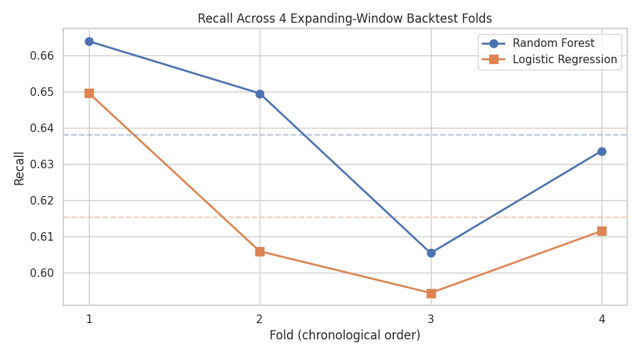
Recall across 4 expanding-window backtest folds, Random Forest vs Logistic Regression.
Random Forest leads Logistic Regression in every one of the 4 folds, with a mean advantage of +0.024 Recall (0.638 vs 0.615). Both models dip together in fold 3 (Jan–Apr 2026), suggesting that period is genuinely harder to predict for both approaches rather than one model being specifically unstable. This is materially stronger evidence for the Week 6 model selection than the single split could provide, and is flagged as a Week 8 follow-up: understand what makes fold 3 harder.

6. Negative Testing — Pipeline Reliability on Bad Input
9 new tests deliberately provide malformed, incomplete, or unexpected input and confirm the pipeline fails with a clear, specific error rather than a crash or, worse, silently wrong output. Every one of the four pipeline stages (ingestion, feature engineering, the model boundary, and the validation layer) now has at least one negative-path test, complementing the positive-path tests Weeks 5–6 already had.

7. Reminder Feature Circularity — Resolved
Flagged in Week 4, unresolved through Weeks 5–6. Ablation results: Recall with the reminder features included is 0.6542; without them, 0.6335 — a real cost of 0.0207 Recall to remove them.
Resolution: the original concern conflated two different things. For the current, retrospective dataset, reminder_sent/reminder_channel reflect HealthConnect's existing, model-independent reminder process — a decision already made, by the clinic's own policy, before each appointment happened. That is fundamentally different from Week 5's confirmed leakage case (waiting_time_minutes), which could not have been known under any process before the appointment. The genuine circularity risk is forward-looking only: if the reminder process itself ever becomes driven by this model's own risk scores, a future retraining cycle would need to account for that feedback loop. Decision: keep the features now; the governance condition for revisiting this is documented in config.REMINDER_FEATURE_GOVERNANCE_NOTE.

8. SHAP Explanations — From “What Tier” to “Why”
explainability.py was tested against the real saved Random Forest candidate (not just a synthetic fixture) on three real high-risk scored appointments. Each explanation names the specific features pushing that appointment's risk up or down and by how much — for example, a short booking lead time paired with a prior no-show consistently emerged as the top risk driver across the sampled appointments, consistent with the Week 6 error-analysis finding that motivated the short_lead_high_risk_flag feature. This turns a bare risk tier into an operationally useful explanation a clinic worker can act on.

9. Cross-Track Testing & Refinement (HC-POD)
Note on this section, consistent with how cross-track work has been represented since Week 6: this track is being completed without a separate Data-Science-track collaborator, so the Data-Science-side testing below (feature-governance ablation, error-pattern follow-up) was carried out as part of this track's own remit and is reported under the same honest framing as Week 6, not as a claim of a second person's involvement.
Field | Detail
Track collaborated with | Data Science
Project dependency | ML Engineering's model-agnostic pipeline needed a resolved decision on the reminder-feature question, and needed the Week 6 model comparison re-validated before being presented as stable
Component/output being tested | The integrated pipeline's model-selection evidence, and the reminder_sent/reminder_channel feature decision
Information/output received | The Week 6 candidate model and its single-split comparison result, to be stress-tested
Information/output provided back | A 4-fold backtest confirming the model choice is stable over time; a resolved, evidence-backed decision on the reminder features; a real per-appointment explanation capability
Testing activity completed | Expanding-window backtest (Section 5); reminder feature ablation (Section 7)
Issue/finding identified | Fold 3 (Jan–Apr 2026) is measurably weaker for both models; the reminder features carry real predictive value and are not leakage
Refinement/action taken | Reminder features retained with a documented governance condition; fold-3 investigation logged as a Week 8 follow-up rather than left unexamined
Retest result | Backtest reconfirms the Random Forest selection across all 4 folds
What changed as a result | The Week 6 model recommendation now rests on multi-window evidence, not a single split; a previously open design question (reminders) is closed with a documented, revisitable decision
Evidence | src/backtesting.py, src/reminder_feature_analysis.py, models/week7_backtest_report.json, models/week7_reminder_ablation_report.json, this report
How this improves the overall HealthConnect solution | The model the wider HC-POD will present in Week 8 is now backed by evidence that it performs consistently across time, not just on one convenient split — directly relevant to any track (Data Analytics, Project Management) that will report on model reliability

10. Error Handling & Logging Improvements
No new error-handling gaps were found this week beyond what negative testing (Section 6) confirmed already works correctly — every scenario tested produced the specific, actionable error type already built in Weeks 5–6 (DataIngestionError, FeatureValidationError, ValueError from the model wrapper). Logging: run_week7_validation.py follows the same centralised setup_logging() pattern established in Week 6, so this week's backtest, ablation, and explanation runs are captured in the same persistent logs/pipeline_run.log alongside every other script.

11. Reproducibility & Configuration Review
tests/test_end_to_end.py::test_full_pipeline_is_reproducible_across_two_runs confirms, for the first time as an automated check rather than an assumption, that running the full pipeline twice with the same configuration produces identical processed data and identical model predictions. requirements.txt was updated to add shap (the only new dependency introduced this week); every other dependency is unchanged from Week 6.

12. Assumptions, Limitations, Risks and Dependencies (Week 6 → Week 7 Update)

Resolved
- Model selection stability — confirmed across 4 time windows.
- Reminder feature circularity — resolved with evidence and a documented forward-looking governance condition.
- Pipeline behaviour on invalid/unexpected input — explicitly tested (9 scenarios), not assumed.
- A real bug in backtest date-range reporting — found and fixed with a regression test.

Still relevant
- Dataset remains fictional/synthetic; must be re-validated against real data before production use.
- Risk-tier thresholds (config.RISK_TIER_THRESHOLDS) remain provisional pending actual clinic operational input, as flagged since Week 6.

New this week
- Fold 3 (Jan–Apr 2026) is measurably the weakest period for both models — worth investigating whether this is a seasonal effect or a data-quality issue specific to that window, rather than dismissed as noise.
- SHAP explanations currently only support tree-based models (TreeExplainer); a future non-tree candidate model would need a different explainer type.

13. Suitability Assessment
The integrated pipeline is assessed as suitable to proceed to Week 8 final integration: its model selection is now backed by multi-window evidence rather than a single split, its failure behaviour on invalid input is explicitly tested rather than assumed, a previously open design question is resolved with documentation, and every stage has been proven to work together via a real end-to-end test, not only in isolation. Outstanding before Week 8: the fold-3 investigation (Section 12) and finalising risk-tier thresholds with real operational input.

14. Week 8 Recommendations
- Investigate the fold-3 weak period identified in backtesting — check for a seasonal pattern or a data-quality anomaly specific to that window.
- Finalise risk-tier thresholds (config.RISK_TIER_THRESHOLDS) with real clinic operational input rather than the provisional cutoffs used since Week 6.
- Prepare a consolidated Week 8 presentation summarising the full Week 4–Week 7 journey: design → implementation → integration → validated, tested reliability.
- If a genuine Data Science track collaborator joins before Week 8, reconcile their independent model/feature choices against this week's self-performed equivalent work.

