ANALYSTLAB AFRICA — EXPERIENCE LAB
ML System Design Document
HealthConnect Clinic Experience Lab — Week 4: Project Kickoff & Problem Understanding
Field | Value
Project | HealthConnect Clinic — Improving Patient Appointment Attendance and Healthcare Support Using Data and AI
Track | Machine Learning Engineering
Prepared by | Raji Toluwanimi Samuel, Junior Machine Learning Engineer
Week | Week 4 — Project Kickoff & Problem Understanding (design only, no implementation)

1. Project and Resource Review
HealthConnect Clinic is experiencing missed appointments, inefficient use of appointment slots, difficulty understanding no-show drivers, repetitive patient enquiries, and a general need to improve patient engagement and administrative support. The Central Project Question is: how can HealthConnect Clinic use data and AI to reduce missed appointments and improve the patient support experience?
As the Machine Learning Engineering track, my role is not to select the final predictive model (that decision sits with the Data Science track) or to build the analytics dashboard (Data Analytics track) or the conversational assistant (Generative AI track). My responsibility is to design the initial structure of a reliable, reproducible ML system — the pipeline, architecture, and engineering standards — that will carry a no-show prediction capability from raw data through to a usable output that other tracks and clinic operations can act on.

Resources reviewed
- HealthConnect_Appointment_Data.csv — 5,000 fictional, anonymised appointment records across 18 columns (reviewed directly; see Section 3).
- HealthConnect_Data_Dictionary.csv — variable definitions, data types, and example values for every column.
- HealthConnect_Clinic_Knowledge_Base.docx — reviewed for cross-track context (clinic policies, AI assistant scope and safety rules); primarily a Generative AI track resource, but relevant here because the Knowledge Base defines what the Downstream Consumers of this system (Section 5) are and are not allowed to do with a no-show risk score.
- AnalystLab Africa Week 4 Experience Lab Assignment brief.
Per the brief's resource instructions, the original files were not modified; all inspection was performed on copies, and any processed output will be saved separately from the raw source (see Section 5).

2. ML Problem Overview
Proposed ML framing: given a scheduled appointment's characteristics known at a defined point before the appointment occurs, predict the probability that the patient will not attend (no-show), so clinic staff can prioritise proactive intervention — additional reminders, confirmation calls, or controlled overbooking — for the appointments at highest risk.
This is a binary classification problem framed around a single appointment record as the unit of prediction, not the patient as a whole — the same patient can carry a different risk score for different appointments depending on appointment type, lead time, and their evolving history.
Week 4 scope note: this document defines the system design only. The exact target variable treatment, feature list, and model choice remain the Data Science track's decision; this design is intentionally model-agnostic so it can accommodate whichever model that track proposes in Week 5.

3. Initial Data Assessment (Engineering Perspective)
Property | Value
Rows / columns | 5,000 rows, 18 columns
Missing data | reminder_channel 27.3% (structural — null exactly when reminder_sent = No); distance_to_clinic_km 1.8%; waiting_time_minutes 1.2%
Duplicate rows | 0
appointment_outcome split | No-Show 48.5% / Attended 46.3% / Cancelled 5.3%
Date range | appointment_date spans Jan 2025 – Sep 2025

Two engineering-relevant findings from this review directly shape the design in Section 4:
- No-show is not a rare minority class here (48.5%), unlike a typical churn-style problem — this changes evaluation and sampling assumptions the Data Science track will need to revisit, and means the pipeline should not assume heavy class-imbalance correction is required by default.
- waiting_time_minutes is populated even for No-Show and Cancelled appointments (average ~24 minutes in every outcome category). In reality a patient cannot accumulate a clinic waiting time for a visit they never attended — this is a data leakage red flag and the field must be excluded from any pre-appointment prediction pipeline (detailed in Section 4).

4. Input and Output Definition

4.1 Prediction unit and timing
Input: one scheduled appointment record, scored at a defined lead time before the appointment (e.g. at booking, and optionally re-scored at a fixed cutoff such as 48 hours before the appointment as more information becomes available). The system must only use fields that would genuinely be known at that cutoff — this is the single most important engineering constraint on the feature set.

4.2 Candidate input features (available pre-appointment)
Feature | Available pre-appointment? | Engineering note
gender, age, age_group | Yes | Static patient attributes
appointment_type, appointment_day, appointment_time | Yes | Known at booking
booking_lead_days | Yes | Derived from booking_date and appointment_date at booking time
previous_appointments, previous_no_shows | Yes, with care | Must be computed as a point-in-time rolling count — only appointments strictly before the one being scored, to avoid leaking future history into a past prediction
distance_to_clinic_km | Yes | Static; 1.8% missing — needs an imputation or exclusion rule
reminder_sent, reminder_channel | Conditional | Known before the appointment, but see the circularity risk flagged in Section 7

4.3 Excluded fields (leakage or non-predictive)
- waiting_time_minutes — excluded. Confirmed populated for No-Show/Cancelled rows, which is not physically possible pre-appointment; a genuine post-appointment field and a leakage risk regardless.
- appointment_outcome — this is the source of the target label, not an input.
- appointment_id, patient_id — identifiers only. patient_id is used to compute historical aggregates (previous_appointments, previous_no_shows) but is not passed to the model directly, so the model learns generalisable behaviour patterns rather than memorising individual patient IDs.

4.4 Output
- A no-show risk probability (0–1) per scored appointment.
- A risk tier (e.g. Low / Medium / High) derived from the probability, with thresholds to be set in a later week based on clinic capacity and intervention cost — not fixed arbitrarily at this stage.
- Output is written to a versioned Risk Score Output Store carrying the appointment ID, probability, tier, timestamp, and the model version that produced it, so every score is traceable (Section 5).

5. High-Level System Architecture
The proposed architecture separates the pipeline into clear stages so that the Data Science track's modelling work plugs into a stable, reusable engineering foundation rather than being re-built ad hoc each week.
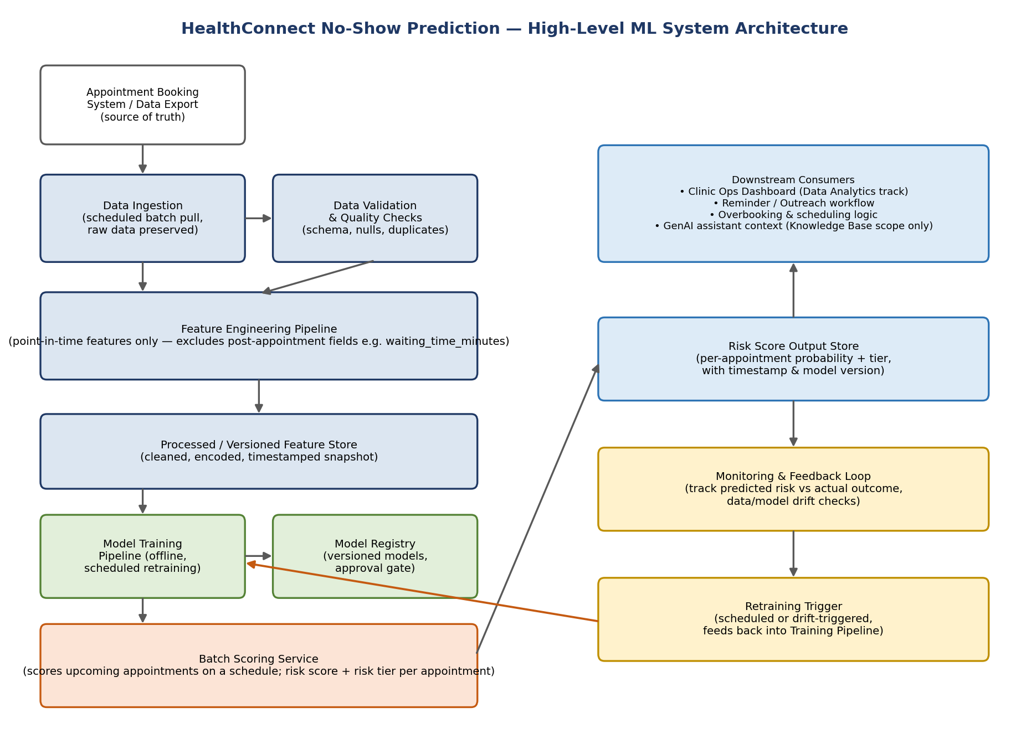
Proposed high-level architecture for the HealthConnect no-show prediction system.
- Data Ingestion — scheduled batch pull from the appointment booking system; raw data is always preserved untouched, per the brief's resource instructions.
- Data Validation & Quality Checks — automated schema, missing-value, and duplicate checks before any data reaches the feature pipeline, catching issues like the waiting_time_minutes anomaly early and consistently rather than relying on manual review each time.
- Feature Engineering Pipeline — a single, shared code path that computes point-in-time features identically at training time and at scoring time, which prevents the common real-world bug where training and live-scoring features quietly drift apart.
- Processed / Versioned Feature Store — the cleaned, encoded, timestamped output, saved separately from the raw source file as required.
- Model Training Pipeline & Model Registry — offline, scheduled retraining with every trained model version stored and gated behind an approval step before it can be promoted to scoring.
- Batch Scoring Service — runs on a schedule against upcoming appointments and writes results to the Risk Score Output Store.
- Downstream Consumers — the Data Analytics track's dashboard, a reminder/outreach workflow, overbooking logic, and (within strict Knowledge Base boundaries) the Generative AI assistant.
- Monitoring & Feedback Loop — compares predicted risk against actual recorded outcomes over time and checks for data or model drift, feeding a Retraining Trigger back into the Training Pipeline.

6. Proposed ML Workflow
- Data ingestion and validation.
- Feature engineering, using one shared implementation for both training and scoring.
- Train/test split — recommended as a time-based split (e.g. train on earlier months, test on later months) rather than a random split, since appointment_date spans a real calendar range and a random split risks letting the model implicitly learn from future dates when predicting the past.
- Model training and experimentation — in coordination with the Data Science track's chosen target definition and candidate models.
- Model evaluation against agreed metrics — likely Recall-weighted given the operational cost of a missed no-show is a wasted appointment slot, but this is a joint decision with the Data Science track.
- Model registration and versioning before any model is promoted to scoring.
- Batch scoring pipeline execution on a defined schedule.
- Monitoring, feedback capture, and scheduled or drift-triggered retraining.

7. Key Dependencies
- Data Science track — final target variable treatment (in particular, how Cancelled appointments are handled: excluded, merged with No-Show, or modelled as a third class), feature selection, and model choice. This design is intentionally model-agnostic to accommodate that decision.
- Data Analytics track — the business questions and KPIs the dashboard needs, which shape what the Risk Score Output Store and downstream reporting must expose.
- Generative AI track — if the assistant is to reference appointment risk or reminders at all, it must stay within the approved Knowledge Base scope (it must not diagnose, invent policy, or make clinical judgements) — a hard boundary this system's outputs must respect if ever surfaced through the assistant.
- Project Management track — overall timeline and resourcing dependencies across tracks.
- Infrastructure — reminder_channel delivery systems (SMS/WhatsApp/Email) if reminder actions are ever automated from this system's output; version control (Git/GitHub) and a reproducible Python environment (requirements.txt) for the pipeline code itself.

8. Initial Implementation Approach
Week 4 deliverable is this design document only — no pipeline code has been implemented yet, consistent with the brief's note that Week 4 focuses on understanding, planning, and initial exploration.
Proposed Week 5+ approach:
- Implement the data ingestion and validation steps as reproducible Python scripts (not just ad hoc notebook cells), organised into clear modules from the outset.
- Implement the point-in-time feature engineering pipeline, with automated tests confirming that previous_appointments/previous_no_shows are computed correctly as of each appointment's booking date, and that waiting_time_minutes is excluded.
- Align the training pipeline with the Data Science track's finalised problem definition once available.
- Set up the GitHub repository structure for the HealthConnect project (mirroring the organisation used for the customer churn project in Weeks 1–3), with the README updated to reflect Week 4 progress.

9. Assumptions, Limitations, Risks and Dependencies

Assumptions
- Prediction lead time is configurable but assumed to default to “at booking” with an optional re-score closer to the appointment date.
- previous_appointments and previous_no_shows in the provided dataset are already historically accurate as of each row; a production system would need to compute these itself from a full appointment history rather than trust a pre-aggregated column.

Limitations
- The dataset is fictional and synthetic (5,000 rows); production data volume, quality, and real-world drift patterns will likely differ substantially, and this design must be re-validated against real data before any production use.
- distance_to_clinic_km (1.8% missing) and waiting_time_minutes (1.2% missing, and excluded anyway) will need a documented imputation or exclusion rule once the Data Science track finalises the feature set.

Risks
- Data leakage risk: waiting_time_minutes, if accidentally included, would leak post-appointment information into a pre-appointment prediction — flagged for explicit exclusion in the feature pipeline (Section 4.3).
- Circularity risk: if reminder_sent/reminder_channel are used as model inputs, and the same model's output is later used to decide who receives a reminder, the system would be predicting risk partly from a variable it itself may influence in future cycles. This should be resolved by the Data Science track — options include training with and without reminder features for comparison, or treating reminders as a separate downstream decision rather than a model input.
- Adoption risk: a risk score that clinic operations does not act on produces no business value regardless of model accuracy; success depends on coordination with clinic operations and the Project Management track.

Dependencies
- This design depends on the Data Science track's Week 4 output (target variable and feature decisions) before the training pipeline (Section 6, steps 3–6) can be implemented.
- Ethical/privacy consideration: patient_id is anonymised in this dataset, but any production system handling real patient data must apply appropriate access control to the Risk Score Output Store given its clinical sensitivity.

10. Summary
This document establishes the initial engineering foundation for a HealthConnect no-show prediction system: a model-agnostic, point-in-time-correct pipeline architecture that avoids the leakage risk identified in the raw data (waiting_time_minutes), separates raw and processed data as required, and defines clear handoff points with the Data Science, Data Analytics, and Generative AI tracks. No modelling or implementation work has been performed this week, consistent with the Week 4 scope.

