Tel Aviv University

The Department of Sociology and Anthropology

Gershon H. Gordon Faculty of Social Sciences

Environmental Non-Governmental Organizations' Use of Emotional Framing

Sentiment Analysis of Twitter Posts During UN Climate Change Conferences

Thesis Submitted for the M.A. degree at Tel Aviv University

by

Tom Baz

Prepared under the supervision of

Prof. Isaac Sasson

Prof. Dan Rabinowitz

November 2024

Emotions play an essential role in Environmental Non-Governmental Organization (ENGO) messaging. ENGOs employ both positive emotions (hope, empathy) and negative emotions (guilt, anger) in their campaigns to influence environmental policy. This study broadens our understanding of how ENGOs' emotional framing is influenced by their relationships with the institutions they seek to change. The literature on environmental NGOs and social movements distinguishes between 'insider' and 'outsider' groups: insiders attempt to influence policy through direct interaction and cooperation with political elites, while outsiders use external levers of influence such as demonstrations and blame campaigns. Drawing on this distinction, the study examined ENGO Twitter activity around COP26 and COP27, classifying organizations into four categories based on their participation mode: representation in state delegations, independent representation, representation under other NGO banners, or no physical representation. Through sentiment analysis of 40,042 Twitter posts from 291 ENGOs, complemented by newsletter analysis, the research reveals distinct temporal patterns in emotional framing across both conferences. Notably, more institutionally embedded ENGOs demonstrated more negative messaging about the COPs, challenging existing assumptions about the relationship between institutional access and confrontational messaging. These findings suggest that insider ENGOs maintain critical stances along privileged positions.

Table of Contents

Introduction 4

Theoretical background 8

Environmental NGOs 8

Emotional framing 9

Insiders and Outsiders 13

COP26 18

COP27 19

Research Questions 21

Methodology 23

Identifying ENGOs 24

Classifying ENGOs into Groups 25

Extracting Twitter posts 27

Defining the Corpus 28

Sentiment Analysis 30

Contextualizing the findings 34

Results 35

Overview 35

General comparison of COP26 and COP27 36

Positive/Negative most frequent words 38

Active ENGOs 41

Changing sentiments throughout the COP 46

Insider/outside position and sentimental framing 48

Discussion 49

Sentimental Framing Trends 50

Differences in Sentimental Framing Between Insiders and Outsiders 52

Bibliography 54

Appendix 62

# Introduction

Environmental NGOs (ENGOs) are central actors in the environmental social movement, engaging in a diverse range of activities from advocacy and expert consultation to lobbying and activist mobilization, including organizing protests and serving as movement spokespeople (Berny & Rootes, 2018; Hadden & Bush, 2021; Brunnengräber, 2014; Caniglia, 2015). To influence national and international organizations, ENGOs strategically articulate their demands through public communication and media engagement (Cox & Schwarze, 2022). This articulation unfolds within specific frames, where framing serves as the process of highlighting and interpreting aspects of reality to build shared understanding around matters of public interest (Entman, 1993; Snow et al., 2018). Emotions are integral to framing, and play a critical role in human reasoning and opinion formation (Lakoff, 2010; Merry, 2010). Both negative and positive emotions are important in the ENGO toolkit (Goodwin et al., 2001; Hornsey & Fielding, 2016f in naming and shaming campaigns are means to pressure governments, corporations, and other stakeholders into action. On the other hand, positive emotions such as hope and empathy are central to attracting new supporters.

Scholars have recently explored how ENGOs shape their communication strategies over time, examining their use of emotional tone across both traditional media (Luxon, 2019; Dzhengiz et al., 2021) and social media platforms (Ji et al., 2018). While these studies interpret ENGOs' emotional framing as a strategy to mobilize broad public support against governmental or commercial targets, they overlook how existing relationships between ENGOs and their target institutions might influence the emotional tone of their messaging. This study aims to expand on the current literature on ENGOs' emotional framing through the perspective of political sociological theory, distinguishing between "insider" and "outsider" NGOs. In today’s political landscape, social movements and ENGOs do not merely act as opposition forces but can work collaboratively with political elites (Pettinicchio, 2017). "Insider" NGOs attempt to influence policy through direct interaction and cooperation with the political elite, whereas "outsider" NGOs use external levers of influence, such as demonstrations and blame campaigns.

Although researchers have examined the insider-outsider dynamic within ENGO operations (Caniglia, 2006; Newell, 2006; Rietig, 2011; Saunders, 2009), there remains a gap in our empirical understanding of how this distinction shapes their use of emotional framing. The position of ENGOs relative to governmental and inter-governmental organizations may dictate which framing strategy they adopt, as emotional framing can change based on an ENGO's perception of confronting oppositional or friendly crowds (Knight & Greenberg, 2011; Dzhengiz et al., 2021).

To investigate the relationship between insider/outsider status and emotional framing choices, this research examines ENGO reactions to two United Nations Climate Change Conferences: COP26 and COP27. The COPs are held under the United Nations Framework Convention on Climate Change (UNFCCC) and are grounds for negotiations on reducing greenhouse gas emissions. The COPs attract the attention of different political and activist actors as they determine future climate policy (Panday, 2015). The initial days of each COP represent an "agenda-setting" event; the exact way to define the problem at hand is discussed, and policymakers consider alternatives of appropriate and sustainable courses of action (Newell, 2006). Here, message framing by political actors is crucial in influencing problem conception (Pettinicchio, 2017). In that regard, COP26 was a pivotal event, as it was the first COP since the one held in Paris in 2015, in which countries aimed to update their climate commitments. COP26 did not achieve a treaty that could answer its demands. Thus, the effort continued in COP27 (Arora & Mishra, 2021; Hunter et al., 2021).

During COPs, ENGOs use insider and outsider tactics to influence negotiations toward favorable environmental outcomes (Rietig, 2011). The ability of ENGOs to engage the COP as outsiders or insiders depends on strategic preference and structural mechanisms imposed by the UNFCCC. I distinguish four groups of ENGOs engaging with the COP26 and COP27 based on their participation patterns and relation to the talks:

1. ENGOs with representatives in state delegations
2. ENGOs with independent representatives
3. ENGOs represented under other NGO banners
4. ENGOs without any representatives at the COPs venues

Instead of differentiating ENGOs as either outsiders or insiders, attuning to the four categories of participation will provide deeper insights into how an ENGO's position influences its choice of emotional framing strategies.

In order to understand the pattern of ENGOs' use of emotional framing, this study investigates two research questions:

(Q1) How has the sentimental framing by ENGOs of COP26 and COP27 changed throughout the events?

I expect that ENGOs strategically shift between positive and negative emotional tones: employing positive framing to foster hope and encourage desired outcomes during promising moments, while turning to negative framing when their channels of influence narrow and political opportunities diminish.

(Q2) To what extent are changes in sentiment levels influenced by the ENGOs' level of proximity to discussion floors?

The research assumption is that outsider organizations will adopt a more negative framing due to their initial more confrontational stance. At the same time, insiders will maintain a positive framing to preserve cooperative relationships (Saunders, 2009). This pattern is reinforced as insiders gain institutional legitimacy while potentially limiting their freedom to criticize (Saunders, 2009).

To address the research questions, I use a newly constructed dataset composed of ENGOs' social media posts on Twitter (now known as X). Twitter is a central space where climate politics discussions take place (Fownes et al., 2018). The social network has accounts of private users and official accounts for organizations and institutions to share their opinions regarding daily routines (Duncombe, 2019). I employ sentiment analysis to determine the attitude toward COP exhibited in each post. Sentiment analysis, also known as Opinion Mining, is a method for categorizing opinions expressed in a text about particular objects or topics (Ruz et al., 2020; Yue et al., 2019). Using sentiment calcification, changes in ENGOs' utilization of emotional framing throughout the COPs events can be monitored.

The analysis reveals distinctive emotional patterns across COP26 and COP27, characterized by positivity peaks in the early days, declining towards the end, followed by a rebound. The results regarding the difference between ENGOs groups classified by their proximity to the discussions were surprising: Overall, significant differences in ENGOs' methods of participation were observed only in COP26, where the inside-positioned ENGOs showed more negativity than the outsider ENGOs.

The paper will be constructed as follows. I begin with a literature review examining both ENGOs' use of emotional framing and their historical relationship with the UNFCCC, establishing the context for understanding how EGNOs' participation patterns in the COPs might influence their emotional framing strategies. The methodology section details the construction and refinement of the dataset and the application of sentiment analysis algorithms to evaluate tweet content. The results section will first summarize general data exploration, such as representative ENGOs participating in the COPs, the exact language observed in negative and positive posts, and additional textual material documenting how ENGOs perceived the events. This will be followed by presenting the statistical results addressing the research questions. Finally, the discussion explores the theoretical implications of findings for our understanding of ENGO communication strategies.

# Theoretical background

## Environmental NGOs

NGOs have become a dominant factor in the public and political sphere. Modern political structure is often perceived as comprising three sectors: the state, the market, and civil society.  Market forces are taken to be motivated solely by profit while supported by the state in order to facilitate economic growth. In contrast, civil society actors are viewed as representing the wants and needs of the broader public. As civil society is not subject to the constraints of the state and the market, it embodies the possibility of creating social change, and it is the field in which social movements act (Caniglia, 2015). Social movements are built of many groups and actors, often operating together in networks to achieve their goals. Within these networks, NGOs play a central role because they are organized in ways that enable efficient resource utilization, garner public attention, and forge connections with market and state actors. NGOs initiate action by pressing powerful entities to take positions, facilitate new ideas and frames, serve as centers for information and research, and lobby for policy changes (Keck & Sikkink, 1998, p. 21).

The environmental movement, in particular, features a robust network of NGOs. A cross-sectoral study (Hadden & Bush, 2021) reports that ENGOs are more institutionalized, better networked, and more collaborative than NGOs from other sectors. Furthermore, ENGOs often exhibit a geographic imbalance between the Northern and Southern hemispheres, with many headquartered in the Northern hemisphere.

Despite their high level of institutionalization, ENGOs are part of and maintain broader networks that include grassroots movements, highlighting the collaborative nature of the environmental movement as a whole. Rather than existing as opposing entities, the environmental movement is characterized by relatively hybrid structures composed of various activists and organizations. Structural and personal overlaps exist between ENGOs and these broader social networks (Brunnengräber, 2014, p. 275). ENGOs are diverse, encompassing a range of positions and mechanisms of action.

## Emotional framing

In their efforts to influence public opinion and policy, ENGOs create and disseminate messages through traditional and social media. These messages are formulated according to specific frames. The political landscape cannot be fully accounted for by relying on purely factual matters, and the social sphere is characterized by ambiguities that demand constant interpretive clarifications (Snow et al., 2018). Political groups work to facilitate and reinforce specific interpretations that resonate with their audience and support their actions. Framing is the process by which certain aspects of reality are emphasized and presented to promote specific interpretations of social reality (Entman, 1993).

Frames serve as interpretive lenses, highlighting specific elements of our sensory experience that resonate with and advance particular worldviews in ongoing debates. Through the framing process, these carefully selected aspects of reality are woven into coherent narratives that reshape our understanding of how different elements interconnect (Snow et al., 2018). his process is inherently dynamic, as frames evolve in response to specific issues, events, or political actors, with the same situation potentially evoking different frames across various contexts and periods (Chong & Druckman, 2007). For social movements seeking to address or transform problematic situations, framing becomes a crucial tool in their efforts to build shared understanding, assign responsibility, and envision alternative futures—ultimately mobilizing collective action for change (Benford & Snow, 2000).

There is a growing interest in the role of emotions in the literature about framing. While early studies of framing concentrated on the rational way in which people weigh different frames, a process in which emotions were assumed only to interfere (Goodwin et al., 2001), today, it is more acknowledged that emotions play an essential part in conveying messages; that the limit between rational thinking and emotions is not clear (Lakoff, 2010), and that emotions have a positive role in constructive reasoning (Merry, 2010). Emotions are essential in how we morally explain our daily lives. They are connected to moral sensibilities, such as shame, guilt, and pride, and are especially pervasive as motivators of action (Goodwin et al., 2001). Emotions have an important role in NGOs' framing constructions. To make their agenda prominent, NGOs and activists elicit emotions such as empathy, guilt, and anger (Reinecke & Ansari, 2016).

Since the 1960s, environmental activists have led campaigns that call for awareness of environmental harm through "mindbombs"—shocking visuals of natural and animal harm that should excite the audience and convince them to take action (Dauvergne & Neville, 2011). These campaigns aimed to challenge both the moral and environmental legitimacy of certain practices and choices. While social movements harness negative emotions like fear and anger, they also leverage positive emotions such as hope and security to drive change. Luxon (2019) identified three basic emotional frames used by ENGOs in the literature. The first frame appeals to the audience's reason rather than provoking a radical emotional response. It aims to deliver scientific facts about climate change to illuminate the risks it presents. The second frame focuses on the audience's negative emotions by describing the dangerous and catastrophic events that could occur. The third frame focuses on the audience's positive emotions, showing hope and the potential for overcoming the danger and highlighting the positive gains that could be achieved by taking action.

Choosing and promoting a particular emotional frame is a complex issue, as there are advantages and disadvantages to using either negative or positive sentiment. Thus, while it was suggested that positive emotions of hope can overcome feelings of despair and hopelessness and thus attract more activists, it was found that optimistic messages dilute the sense of risk and distress that are effective in motivating mitigation efforts (Hornsey et al., 2016). On the other hand, relying on presenting too much negativity and reliance on fear can backfire. When presenting a gloomy future without hope or pathways to overcoming obstacles, recipients tend to reduce the fear without reducing the danger, either by denying the danger or by concluding that the fear appeal was a manipulation attempt by an untrustworthy source (Stern, 2012). Furthermore, it has been argued that over time, the general public gets used to what was previously perceived as disturbing environmental and animal rights imagery, which reduces the effectiveness of campaigns relying on mindbombs (Dauvergne & Neville, 2011).

Different studies deal with how ENGOs change their emotional framing in public messaging over time. In a study of press release messages, Luxon (2019) found that the emotional tone of ENGOs' press releases is reflected in the media coverage that chooses to report it to their audience further and that overall, the media seem to be more reluctant to refer to releases with extreme emotional frames. Dzhengiz et al. (2021) researched ENGOs' press releases while distinguishing between reformative and radical ENGOs, finding an increased polarization in the sentimental tone between these two groups over time. In a study about ENGOs' messaging in social media, Ji et al. (2018) found that posts using a conflict frame generated more emotional comments from users.

These studies mainly assume that ENGOs' messages aim to reach the broadest public audience possible, facilitate action, and change the activity of governance institutions or commercial companies. It is important to acknowledge, however, that ENGOs can establish independent relationships to different degrees with the bodies they criticize and that these relationships are another factor that can influence framing choices. This study wishes to broaden the discussion on ENGOs' emotional framing by inquiring into ENGOs' messages through the sociological theory of social movements that differentiates between insider and outsider NGOs. In the following, I will present the theoretical literature concerning the influence of the position of ENGOs as insiders or outsiders. I will take the distinction between insiders and outsiders to be an expansion of the social movements' theory of political opportunity.

## Insiders and Outsiders

The sociological theory of political opportunity describes social movements' activity through the lens of the broader political context in which they operate, including the influence of the governmental bodies these movements act against and their mutual relationships. Social movements' actions evolve and are shaped in tandem with state governments, and the broader political structure dictates the possibilities of action for both (Meyer, 2004). Political systems are distinguished by the degree of openness and access to the political system, which enables non-governmental actors to participate in determining policy. Social movements tend to choose their strategy according to the political opportunities they deem available (Kriesi, H. 2004). In countries of a democratic nature, social movements arise when political parties and interest groups fail to fulfill specific public demands or are perceived as too weak to create change. In centralized and totalitarian countries where free expression of opinion is not possible, the activity of social movements, if they succeed, will be more radical and contentious from the outset.

The political opportunity theory helps explain differences in social movement activities across various political systems. However, it lacks explanatory power regarding the differences in activities of social movements operating under the same conditions toward a specific governance (Saunders, 2009). Pettinicchio (2012) argues that while the theory acknowledges the interrelationships between social movements and the political establishment, it erroneously creates a sharp distinction between them. The limits are increasingly blurred as the boundaries between activists and parliament members become less defined.

The distinction between insider and outsider social movements aims to explain their activities based on their position relative to the ruling body they wish to influence. A social movement that operates from the inside will try to influence policy through direct interaction with the political elite and cooperation with the establishment. On the other hand, a social movement that operates from the outside will try to use levers of influence external to the political system in the form of demonstrations and blame campaigns. NGOs' choice between insider or outsider strategies is influenced by limitations on resources, expertise, and access to key government officials (Rietig, 2011).

The insider-outsider distinction may also affect NGOs' emotional framing choices. Social movement actors aim to change the activities of governments and commercial companies, using emotional framing to portray them in a positive or negative light (Chen et al., 2023). There is significance in whether they portray their targets as 'enemies' or 'friends' (Dzhengiz et al., 2021). As the environmental social movement has undergone institutionalization, they have begun working more closely with political elites and representatives. This process could impact when and under what conditions the body they seek to influence can be perceived as entirely separate from their own (Panday, 2015; Berny & Rootes, 2018). These changes affect the strategic options available to social movements while potentially limiting how they publicly express their opinions. One can assume that a close relationship between an NGO and its target body may limit the negativity expressed in traditional and social media.

To investigate the difference between insider and outsider ENGOs' mobilization through emotional framing, this study will examine ENGO activity concerning the United Nations Climate Change Conference (COP). The COPs are held under the United Nations Framework Convention on Climate Change (UNFCCC), a UN body regulating global efforts to mitigate climate change. As part of the UNFCCC treaty, annual COPs provide a platform for nations to negotiate actions and assess progress in addressing climate issues.

The COPs are an important field for studying ENGO activity as insiders vs. outsiders, as they are organized to allow ENGOs to act at different levels of proximity to the main discussion floor. At the initiation of the UNFCCC, it was declared that ENGOs should play an important role in developing climate policy (Newell, 2006). Although the channels for ENGO influence were limited, the COP events have historically been regarded as important opportunities for the climate movement to expedite change.

The COPs attract ENGOs' attention as they represent a period of agenda-setting that precedes the initiation of new policies. During this initial stage, the problem at hand is defined, and actors contemplate viable courses of action. When interests are unclear, well-organized groups can shape the problem's dimensions, reflecting their preferences and agendas (Newell, 2006). In these agenda-setting events, framing is pivotal in shaping the resulting policy. Social movements are considered to have the most significant influence in shaping issue discourse at this pre-policy stage (Pettinicchio, 2017).

This study examines the case of ENGOs' framing around COP26, held in 2021 in Glasgow, and COP27 in 2022 in Sharm el-Sheikh. COP26 was a significant political event aiming to update states' commitments under the Paris Agreement treaty signed in 2015. The Paris Agreement has a long-term temperature goal to keep the rise in global surface temperature well below 2°C (3.6°F) above pre-industrial levels, with the preferable target of limiting the temperature rise to below 1.5°C. As predictions showed, actions taken after the Paris Agreement could not achieve that goal, and there were high expectations for COP26. Although various environmental achievements were acknowledged, and the agreements signed at the outcome of COP26 could potentially meet the goals of limiting global warming to below 2°C, it was decided that further amendments would be discussed at COP27 (Arora & Mishra, 2021; Hunter et al., 2021).

In the following sections, I discuss the political opportunities that the UNFCCC provides to ENGOs and how they act during the COPs. Subsequently, I provide a brief context to the events of COP26 and COP27, as well as their outcomes.

ENGOs' participation in the COPs

ENGOs' institutionalization trends are intertwined with their efforts to influence climate policy through the UNFCCC. The 1990s saw significant growth in the number and influence of environmental NGOs, coinciding with the foundation of the UNFCCC at the Rio Earth Summit in 1992 (Caniglia, 2015). The summit aimed to establish a binding treaty to reduce greenhouse gas emissions and laid the groundwork for articulating shared principles based on cooperative action. Many actors viewed this treaty as a preliminary step toward creating a more robust institutional framework. NGOs were actively involved in developing the convention (Brunnengräber, 2014). The UN's emphasis on the importance of including ENGOs in the process is evident in the fourth IPCC assessment, which states that climate policy results from the collaborative efforts of various institutions, including non-governmental actors and civil society (IPCC, 2007, p. 708).

During the COPs, environmental activists, social movements, and NGOs employ insider and outsider strategies to influence outcomes and final decisions. Insider strategies involve establishing direct contact with political elites and directly influencing decision-makers and their circles. Outsider strategies concern informal and public actions, such as organizing protests and delivering press and social media messages to pressure decision-makers.

While the IPCC's declaration regarding cooperation with NGOs might suggest that ENGOs and environmental activists would have assured critical roles in influencing negotiations through insider tactics, their ability to directly impact discussions remains significantly limited. Systematic procedures are in place to restrict non-state actors' participation in the COPs. ENGOs typically hold observer status, which is usually open to them only in the first week (out of the two weeks the COP takes place), during which the guiding lines for the final negotiations are discussed. In these plenary sessions, non-state actors can present opening comments to governments. ENGOs' presence in the discussions has the advantage of ensuring transparency, sharing expertise to combat climate change, and helping to set the agenda while putting pressure on politicians to respond to civil society demands (Panday, 2015).

Because ENGOs' access to the negotiation floor is restricted, their most significant influence can often be achieved outside the negotiation rooms through informal avenues (Caniglia, 2015). NGO representatives' influence relies on trust relationships with intergovernmental and governmental representatives. In recent years, well-resourced ENGOs have joined COPs as part of state delegations, placing them in close contact with policymakers.

While some ENGOs gain access to the COPs through state delegations, many do not gain entrance for various reasons. Attending the COPs requires sufficient funds for travel and accommodation. Furthermore, the UNFCCC is less likely to approve smaller organizations for the COPs, as the secretariat prioritizes those with an international presence (Caniglia, 2015). Even with entry permissions, NGOs' participation in the COPs is not legally protected and depends on the host country's decisions. International institutions can abruptly restrict political participation if, for example, national interests or conflicts arise that are not intended for public disclosure (Brunnengräber, 2014).

During the COPs, NGOs engage in various outsider activities. They cover daily events through pamphlets and social media, reporting on decisions and statements made by politicians, both praising and criticizing them. NGO members also actively participate in public demonstrations, traditionally held on the Friday of each conference week, aiming to mobilize public opinion to pressure parties toward desired outcomes.

## COP26

COP26 aimed to strengthen the targets set under the Paris Agreement, an international treaty signed by 196 parties at COP21 in 2015. The Paris Agreement outlined commitments to reduce emissions and keep global surface temperatures well below 2°C above pre-industrial levels, ideally limiting the increase to 1.5°C. During COPs, states commit to policies and measures called Nationally Determined Contributions (NDCs). Although NDCs specify governmental actions, they are not legally binding; enforcement relies on mutual trust among countries. Despite significant advancements made by the Paris Agreement in global climate politics, the NDCs submitted by countries did not meet the reductions in greenhouse gas emissions projected by the IPCC. COP26 was an opportunity to revise the NDCs and bridge this gap.

The success of COP26 is debatable and varies among different perspectives. Despite pioneering statements by world leaders and extensive debates about NDCs and their implications, the goal of securing temperatures to prevent dangerous consequences was not achieved. Many climate activists expressed significant disappointment, questioning the effectiveness of such conferences in driving meaningful change. Conversely, some commentators argue that given the complexity of international agreements, COP26 laid the groundwork for mitigating climate change (Hunter et al., 2021) and achieved a notable reduction in emissions (Jacobs, 2022).

COP26 concluded with a 'climate pact' signed by nearly 200 countries, building upon the Paris Agreement by expanding its measures. This was the first COP where the necessity of phasing down fossil fuels and coal use was formally recognized. In contrast, the Paris Agreement had previously emphasized the importance of lowering greenhouse emissions without directly addressing the cessation of fossil fuel usage (Asselt & Green, 2023). The agreement included commitments to phase down, though not phase out, coal use and to cut fossil fuel subsidies. Most participating countries submitted updated NDCs. Additionally, COP26 led to advancements in NDC monitoring, with new measures formulated to enhance the transparency and accuracy of the compliance process (Hunter et al., 2021).

While COP26 achieved significant reductions in fossil fuel emissions, the outcomes fell short of the initial objectives. Most observers agreed that the formal commitments were insufficient. The NDCs set by the 'climate pact' were deemed inadequate for achieving the initial goal, as even with full enforcement, temperatures are predicted to rise by 2.4°C by 2100, far exceeding the target of 1.5°C (Arora & Mishra, 2021). Furthermore, many commitments were criticized for projecting large-scale changes over decades, which could be an excuse for delaying implementation (Hunter et al., 2021). Recognizing these shortcomings, it was decided to revisit the NDC discussions at COP27 (Jacobs, 2022).

## COP27

COP27, held in Sharm El Sheikh, Egypt, from November 6th to November 18th, 2022, aimed to build on COP26's momentum by strengthening commitments to NDCs and enhancing mitigation efforts to maintain global warming below 1.5°C. Another critical aspect of the negotiations was developing a "loss and damage" agreement. This component, intended to promote social justice, was presented as part of COP27's appeal as the "African COP," highlighting the disparities where countries most affected by global warming are not the main contributors to the crisis.

Regarding NDC updates, the desired outcome was still lacking. At the outset of the negotiations, the Environmental Integrity Group proposed prioritizing the 1.5C goal as a critical agenda item, but the proposal was rejected (Pflieger, 2023). Furthermore, a suggestion made by some countries to add to the COP26 statement of phasing down coal and fossil fuels was not approved (Arora & Arora, 2023).

On a positive note, COP27 made significant strides in implementing the loss and damage framework. Building on discussions from earlier COPs about the importance of a just transition—which emphasizes the support wealthier countries need to provide to poorer countries to transition away from fossil fuels and coal—COP27 created a new fund to aid climate mitigation and adaptation in developing countries. This fund may also support conservation projects and biodiversity protection in the developed world (Arora & Arora, 2023). Despite this progress, the fund has yet to secure the $100 billion deemed necessary, leaving substantial negotiations to be conducted (Pflieger, 2023). This initiative marks a shift towards addressing the climate crisis through a social justice perspective, recognizing that funding should not only prevent future warming but also address its current impacts.

In contrast to the cautious optimism at the initial stages of COP26, COP27 was met with significant criticism from the outset. The Egyptian government imposed severe restrictions on civil society's ability to express itself, with social activists arrested in the weeks leading up to the conference. Protests were banned in Sharm El Sheikh, prompting many environmental activists to boycott the event. Criticisms were also levied against the large delegations arriving by flights and the numerous energy-intensive pavilions (Pflieger, 2023), highlighting a disconnect between the conference's environmental goals and its operations.

## Research Questions

ENGOs have acted during COP26 and COP27 through various routes to influence negotiation outcomes. They employed different emotional strategies to frame events via messages published in traditional and social media. The dynamic nature of COPs complicates the choice of emotional tone during the event. COPs consist of various agenda-driven meetings and sessions, culminating in declarations and commitments that shape global climate policy. Statements from public officials and politicians require ENGOs' timely commentary, either endorsing them as beneficial or criticizing them as detrimental to the environmental cause. These dynamic challenges ENGOs to adapt their framing strategies to immediate circumstances, balancing the need for prompt response with calculated and strategic emotional tone choices. Thus, this study first aims to answer:

(Q1) How has the sentimental framing by ENGOs of COP26 and COP27 changed throughout the events?

I hypothesize a correlation between positive framing and ENGO endorsement of daily COP outcomes while expecting negative framing to accompany rejection and criticism. Moreover, drawing from political opportunity theory, I anticipate that as ENGOs' channels of influence narrow, their messaging will become more negative and confrontational.

The research literature further suggests that adopting insider and outsider positions is correlated with employing a particular emotional framing tone. Newell (2006) categorized environmental NGOs and social movements into three ideological groups based on their insider or outsider strategies. The first group, the 'insiders-insiders,' participates extensively in COP discussions and generally embraces ideologies that support free-market principles and regulatory change. The second group, termed 'inside-insiders,' also engages in the discussions but has a limited capacity to influence outcomes and adopts a more confrontational approach. The third group, 'outsider-outsiders,' has marginal access to global discussions, operates outside formal institutional systems, and challenges them significantly (Caniglia, 2015; Newell, 2006). Thus, I pose a second research question:

(Q2) To what extent are changes in sentiment levels influenced by the ENGOs' level of proximity to discussion floors?

I hypothesize that outsider organizations tend toward more negative framing, reflecting their inherently confrontational stance toward state institutions, while insider organizations employ more positive framing to maintain cooperative relationships. This dynamic may be reinforced by institutional relationships: insider NGOs often receive legitimacy and recognition from political institutions, while those operating externally may be viewed as less legitimate (Saunders, 2009). Consequently, an insider position might constrain an NGO's ability to express public criticism.

Sentimental framing will be monitored by analyzing messages published by ENGOs on the social network X, formerly Twitter. In recent years, Twitter has become a pivotal platform for expressing viewpoints on environmental issues. The network hosts extensive discussions on various social and political matters, attracting a broad audience that uses it to disseminate news and respond to current events. Research indicates that climate change is a frequent topic on Twitter, with users from diverse backgrounds engaging in a discourse encompassing official publications from NGOs, social movements, politicians, and prominent spokespeople (Fownes et al, 2018). Many environmental organizations maintain active Twitter accounts to broadcast their messages and foster connections with other entities within the environmental community.

# Methodology

The process of assessing ENGOs' sentimental framing regarding COP26 and COP27 was conducted by composing a dataset of ENGOs' Twitter posts and running a sentiment analysis algorithm to assess their leading sentimental tone.

Sentiment analysis utilizes computational methods to classify the polarity of a specific text at the level of a sentence or a whole document. In recent years, sentiment analysis has been used to investigate the framing strategies of ENGOs across extensive datasets of press releases and social media content (Luxon, 2019; Dzhengiz et al., 2021; Ji et al., 2018). The posts will be categorized using sentiment analysis as positive, negative, or neutral. A more general index that considers all the posts published by a specific ENGO for a day will be created to monitor changes in sentiment over time.

The sentiment labels for each post will be taken to represent a conscious choice by the ENGOs to deliver a message embedded in a sentimental framing to their audience. Private users and organizations use Twitter to both represent and provoke emotions in their efforts to escalate or de-escalate conflicts, and expressing emotions on Twitter, when done as part of a cohesive stance, counts as "authentic" and as a form of political expression (Duncombe, 2019).

To create a dataset of ENGOs' Twitter posts, a representative sample of ENGOs was created, and all their posts published around COP26 and COP27 were extracted. Out of these initial pools of tweets, only a subset deemed relevant to the research was used as the final dataset. It will be assumed that ENGOs are elevating emotional tone to influence the outcome of the COPs. Following that assumption, the dataset will be composed of posts that either implicitly mention the UNFCCC, the organizing structure, and the participating countries or refer to environmental issues relevant to the talks.

## Identifying ENGOs

The initial sample list of ENGOs was compiled from the 2021 edition of the Yearbook of International Organizations. The Yearbook, published by the Union of International Associations (UIA), contains information on governmental and nongovernmental organizations, categorized and updated annually through surveys conducted by the UIA. The Yearbook has also been used to study the activity of ENGOs in Hadden (2017) and Binette (2018). Organizations were selected from the database based on the earth, climate, and environment categories, excluding governmental organizations (Intra-governmental organizations - INGs). This filtering process resulted in a list of 6,066 NGOs.

Not all of these environment-related organizations were considered relevant for this study. First, there was the apparent limitation that only ENGOs with an active Twitter account could be selected. Beyond that, there were two further conditions. First, it was important that the ENGOs deal with climate-related issues. This would ensure that they are motivated to influence the outcome of the COP and how public opinion perceives it. Second, they should not be officially connected to the UN, automatically making them unattainable to the distinction between insiders and outsiders. ENGOs that are subsidiary organizations of the UN could inherently limit their capacity for critical reporting and are insiders by default. The verification of each organization was done by checking its internet presence. It was first confirmed whether the NGO had an active Twitter account. For those with Twitter accounts, further investigation examined how the NGO presented itself on Twitter and its official website. NGOs were removed from the sample list if they focused on limited environmental issues unrelated to climate change, such as research on organic food or activities tied to specific local nature reserves. Additionally, NGOs were excluded if their online presentations indicated strong relationships or funding from the UN.

Verifying NGOs listed in the UIA's Yearbook included searching Google for their Twitter pages using keywords such as "climate" and "environment." This search identified additional Twitter accounts of ENGOs not initially listed in the Yearbook. The suitability of these additional NGOs for inclusion in the study was assessed based on the criteria outlined above. While the Yearbook presents a comprehensive review of the ENGOs field, the fact that identifying the online activity of ENGOs requires using specific relevant keywords ensures that the addition of further ENGOs to the initial sample will be reasonable.

The resulting list of relevant NGOs extracted from the UIA's Yearbook included 345 ENGOs. In addition, 19 ENGOs were identified by searching Google using relevant keywords.

## Classifying ENGOs into Groups

To assess the level of the ENGOs' proximity to the COPs, their participation pattern was checked against the UN-published guest lists. The methodology was similar to that of Binette (2018), who investigated network structure relationships among ENGOs participating in COPs. The process made use of two kinds of official UN documents: the first is a table that included all the NGOs that at some point received permission to participate in the COPs, and the second is the guest lists of the COPs.

The sample list of ENGOs includes naming according to the yearbook, and to ensure that we could identify them in the UN long lists, it was important to verify how the UN spells them. A matching algorithm was developed to compare names from our research list to those on a general UN table list that documented NGOs historically granted access to the COPs. Initially, the algorithm sought exact matches between names from both lists. For names without exact matches, the algorithm analyzed individual words within the ENGOs' names from our research list against those of the UN to find possible correspondences. Names that did not directly match were grouped, and manual verification was then conducted to confirm whether these correspondences were accurate and whether the UN had indeed admitted the NGOs.

Following the resolution of finding out how the UN recorded the ENGOs in the research list, the mode of participation for each ENGO at the COPs was manually tracked using additional UN documents. Post-COP, the UN releases a detailed guest list, noting all approved participants and their affiliated organizations. This study focused on two lists: one documenting guests attending with country delegations and another for those affiliated with NGOs. Each NGO's presence was manually verified across these lists to determine whether representatives attended under the auspices of their NGO, another NGO, or a state delegation.

Based on this verification, ENGOs were stratified into four distinct categories for each COP event:

1. NGOs that sent representatives as part of a state delegation.
2. NGOs that sent representatives independently, not affiliated with any state delegation.
3. NGOs that were represented under the banner of different NGOs.
4. NGOs that did not send any representatives to the COPs.

## Extracting Twitter posts

The ENGOs’ Twitter posts dataset was established based on the ENGOs sample list. The ENGOs' posts were extracted by communicating with Twitter API using Python's Tweepy library. The API was queried to retrieve all published posts during the periods of the two COPs, including the week before and after each COP. The first period was from 23 October to 19 November 2021, and the second was from 29 October to 25 November 2022. For each post, the following information was recorded: post ID number, text, date, and time of posting. Not all ENGOs maintained active Twitter accounts during these periods, and some active accounts did not publish any posts. During COP26, 77 ENGOs were inactive in tweeting, while 56 ENGOs were inactive during COP27.

The dataset comprises tweets from 313 ENGOs across both events. Specifically, 21,852 tweets were extracted from 276 ENGOs during COP26 and 25,648 from 292 ENGOs during COP27. Notably, 21 ENGOs appeared exclusively on the COP26 list and were not featured on the COP27 list. Conversely, 37 ENGOs appeared only in the COP27 list, absent from the COP26 records.

The process of extracting posts from Twitter encountered a significant limitation, wherein all retweets—posts not originally published by the NGOs but shared from other accounts—were truncated beyond 140 characters. Regrettably, by the time this error was identified, Twitter had already altered their API's policy, preventing the re-extraction of the affected tweets. Analysis of the tweets from COP26 revealed that 42% of the posts were retweets; for COP27, this figure was 40%. This data deficiency poses a substantial challenge, resulting in a loss of information crucial for subsequent text analysis. Despite this, retweets were vital for the research as they reflected the endorsed messages of the ENGOs. As discussed in the following paragraphs, an additional filtering process was implemented to ensure that only posts containing specific keywords were included in the final analysis. This step ensures that even truncated texts were used only in cases identified as presenting information relevant to the research.

## Defining the Corpus

The dataset derived from Twitter encompassed tweets from ENGOs around COP26 and COP27 non-selectively, and not all posts directly pertained to the COPs or related issues. Given the research objective to analyze how ENGOs frame their messages concerning the COPs, it was essential to exclude irrelevant posts. To achieve this, 500 randomly selected tweets were analyzed to identify keywords indicative of relevance to the COPs. These keywords were selected based on direct references to "COP26" or "COP27" in the tweet text or hashtags or their association with pertinent issues discussed during the COPs.

The selection criteria extended beyond mere mentions of the letters "COP" to capture a broader range of discussions influenced by or potentially influencing the conference dialogues. This approach acknowledges that COP events serve as a platform for NGOs to highlight various environmental concerns, thus shaping public discourse and potentially influencing the agenda. The basic assumption here is that ENGOs, in their posts, will generally adopt a consistent sentimental frame when they directly mention the COP's name or discuss issues concerning the discussion without invoking the COP's name directly. Keywords were specifically chosen if they concerned the themes: activity arrangements, the conference zone, climate and energy, civil society and social movements, UN organizations, discourse about participating states, and critical COP topics like the 1.5°C goal and social justice issues, including loss and damage.

|  |  |  |  |  |  |  |
| --- | --- | --- | --- | --- | --- | --- |
| Table 3: List of words for identifying relevant tweets by subject | | | | | | |
| **COPs' Direct mentioning/ COPs location** | **ENGO activity in the COPs** | **Climate and Energy** | **COPs Aims and Actions** | **Civil society activity** | **UN organizations** | **Participating countries' related words** |
| COP26 | panel | Climate Change | 1.5 degrees | Coalition | EU | China |
| COP27 | Blue Zone | climate | 1.5°C | grassroots | UN | government |
| COP2 | Green Zone | energy | 1point5 | activists | United Nations | UK |
| COP1 | Pavilion | coal | temp rise | civil society | UNFCCC | BorisJohnson |
| COP | Innovation Zone | oil | global South | protest | IPCC | United States |
| conference |  | gas | just transition |  | framework | Egypt |
| Glasgow |  | carbon | transition |  | UNEP | India |
| Sharm El-Sheikh |  | Fossil Fuels | loss and damage |  |  | Parties |
| discussions |  | emissions | net zero |  |  | countries |
| Convention |  | CO2 | Indigenous |  |  | leaders |
|  |  | methane | 2030 |  |  |  |
|  |  | global heating | ParisAgreement |  |  |  |
|  |  | temperature | Net-Zero |  |  |  |

To ensure the precision of this filtering process, multi-word expressions were searched both with and without spaces to account for their use in hashtags. Care was taken to add spaces before and after words to prevent the inclusion of unrelated terms (for example, "cop" would be included, but not "copyright").

This keyword-based filtering significantly refined the dataset: from the initial 21,852 tweets during COP26, 14,394 were retained, representing 259 out of the original 276 ENGOs. Of COP27's 25,648 tweets, 17,142 remained relevant, involving 252 of the original 292 ENGOs.

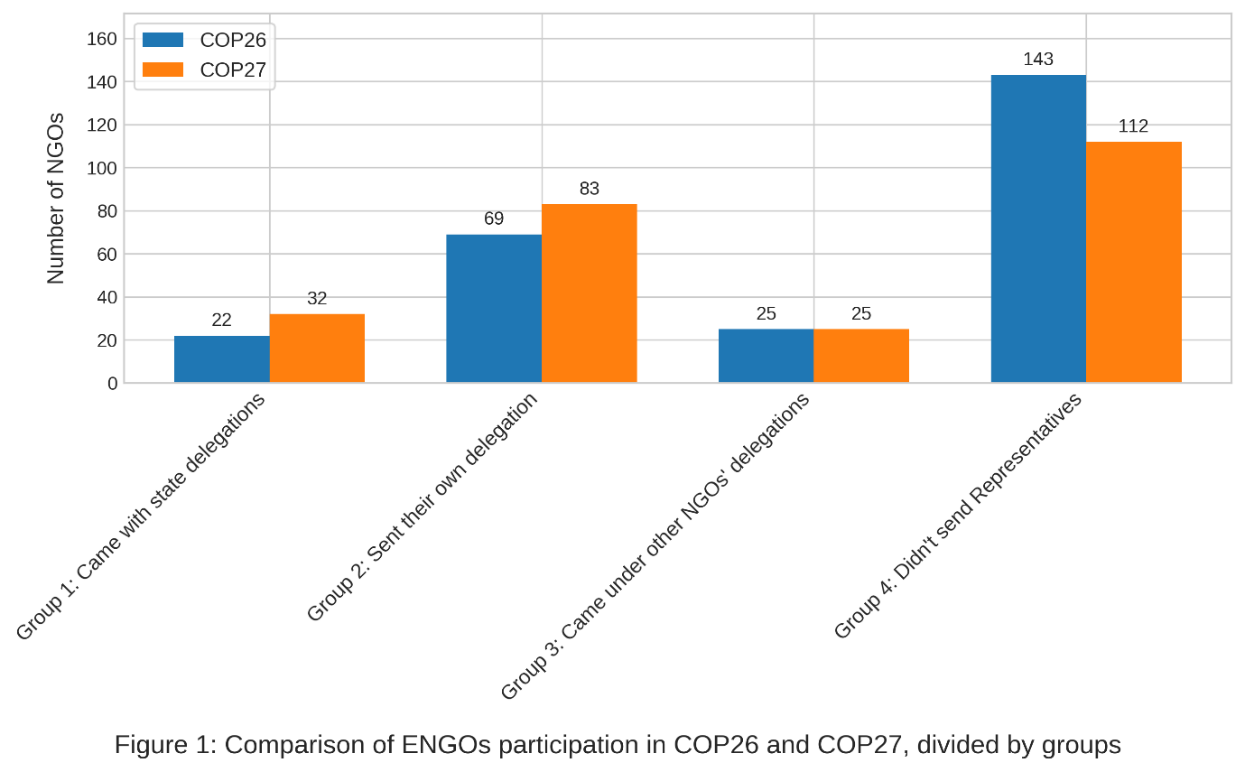

## Sentiment Analysis

A RoBERTa-based model, an advancement over its predecessor BERT (Liu et al., 2017), was employed to analyze the sentiment of the tweets. This large language model (LLM) is built on the attention mechanism, a core component of transformer architectures introduced by Vaswani et al. (2017). The attention mechanism enables the model to focus selectively on pertinent aspects of the input data during the prediction process. Before adopting transformers, language models typically represented words as static vectors, which failed to capture the variations in meaning that words can exhibit in different contexts. The introduction of the attention mechanism allowed for the encoding of contextual nuances directly into the vectors, thereby enhancing the model's ability to interpret text. The RoBERTa model chosen for this study was adapted explicitly for sentiment analysis. It was trained on a dataset comprising 124 million tweets collected between January 2018 and December 2021 (Loureiro et al., 2022), ensuring robust performance in capturing sentiment trends.

The model predicts for each post whether it is "Positive," "Neutral," or "Negative." A random sample of 500 tweets from the dataset was selected to assess the use of the model. Two research assistants and I manually labeled these tweets. A consensus method was employed to assign a final sentiment label to each tweet, based predominantly on majority rule. When each labeler provided a different sentiment, the tweet was designated "Neutral" (see Appendix for a table comparing the agreement's proportions between classifiers).

Table 1 presents the basic model's metrics to benchmark its performance, comparing them against the final labels from the sample.

|  |  |  |  |  |
| --- | --- | --- | --- | --- |
| Table 1: Performance metrics for the basic model | | | | |
|  | precision | recall | f1-score | support |
| negative | 0.94 | 0.51 | 0.66 | 24 |
| neutral | 0.66 | 0.84 | 0.74 | 48 |
| positive | 0.73 | 0.7 | 0.71 | 28 |
|  |  |  |  |  |
| accuracy |  |  | 0.72 | 100 |

Precision is the proportion of true positive predictions out of all positive predictions. It measures how many tweets predicted by the model as belonging to a certain class agree with the human-classified corpus. A high score in precision means a lower chance of false positives. Recall is the proportion of true positive predictions out of all actual positive instances. It measures how many of the actual instances of a class were correctly identified. A high score in recall means a lower chance of false negatives. Taking the labeling of the "negative" posts as an example, the base model had a high precision value (94%) and a low recall value (0.51). This means that whereas most posts labeled as negative were truly negative, a considerable number of negative posts were missed.

Achieving the study's aims requires minimizing both false positives and false negatives while accurately capturing sentiment trends over time. The F1-score, representing the harmonic mean of precision and recall, is particularly valuable for assessing model performance in this context. The harmonic mean is a type of average calculated by dividing the number of values by the sum of their reciprocals. It is advantageous when dealing with rates or ratios, as it gives more weight to lower values than the arithmetic mean. Here, we have 0.66 for negative, 0.74 for neutral, and 0.71 for positive.

Accuracy is a global metric that measures the overall correctness of predictions across all classes. It is all the True Positives and the True Negatives divided by total predictions. The accuracy of the model is 0.72.

To further improve the model, a fine-tuning process was performed to match the specificity of the discussion domain of the data at hand. Fine-tuning involves additional training of a pre-trained language model on a new dataset pertinent to a specific task. The fine-tuning aimed to make the sentiment algorithm more sensitive to the context of ENGO discourse regarding the COPs.

To evaluate and validate the effectiveness of the fine-tuning, a cross-validation approach was utilized, partitioning the sample into five folds to ensure generalizability to other datasets. In each fold, the sampled 500 tweets were divided into training and test sets (80% and 20%, respectively), with the training set further split into training and validation subsets. The fine-tuned models improved performance metrics compared to the pre-trained baseline, as evidenced by the average F1 scores of 0.82 with a standard deviation of 0.02 across the five models (shown in Table 2).

|  |  |
| --- | --- |
| Table 2: Average F1-scores of 5 fine-tuned models | |
| Model | Average F1-score  For “Positive”, “Neural” and “Negative” |
| model 1 | 0.81 |
| model 2 | 0.82 |
| model 3 | 0.79 |
| model 4 | 0.86 |
| model 5 | 0.83 |
| Mean | 0.82 |
| Standard Deviation | 0.02 |

The model with the F1 score closest to this average was selected to minimize overfitting. The performance metrics of this model are detailed in Table 3. The F1-scores are 0.87 for negative, 0.82 for neutral, and 0.77 for positive. The model has an accuracy score of 0.82. This model was subsequently applied to label all tweets in the dataset.

|  |  |  |  |  |
| --- | --- | --- | --- | --- |
| Table 3: Performance metrics for fine-tuned model | | | | |
|  | precision | recall | f1-score | support |
| negative | 0.91 | 0.83 | 0.87 | 24 |
| neutral | 0.78 | 0.88 | 0.82 | 48 |
| positive | 0.83 | 0.71 | 0.77 | 28 |
|  |  |  |  |  |
| accuracy |  |  | 0.82 | 100 |

To better understand the overall change in sentimental framing along the examined period, a variable named "Sentiment Index" was created. For each NGO, the Sentiment Index is calculated as the sum of positive posts minus the sum of negative posts, divided by the total number of posts published that day (including "Neutral" posts). Sentiment index values range from -1 to 1. The index can assess the general stance between each day's positive and negative polarity for the ENGOs. The creation of the index shares some of the ideas behind dictionary methods in conducting sentiment analysis, which calculates the sentiment level for each examined text by examining the ratio between positive and negative words (Kharde & Sonawane, 2016).

## Contextualizing the findings

To gain a more comprehensive understanding of the events during the COPs and how the ENGOs perceive and interpret these events, we also analyzed two newsletters covering the COPs. These resources help highlight the background against which the ENGOs used a particular emotional frame.

The first source was the ECO Newsletter, published by the Climate Action Network (CAN). Established in 1989, CAN is a vast coalition comprising over 1,900 civil society organizations across more than 130 countries. The ECO Newsletter offers daily insights, including reports and opinion columns on the UNFCCC negotiations, reflecting CAN's views on the progress and outcomes of these discussions and providing an insider's perspective on the current happenings and desired actions from the viewpoint of its member organizations.

The second source was daily updates published by the Third World Network (TWN). Established in 1984 and headquartered in Penang, TWN is an independent NGO consisting of a network of organizations and individuals focused on supporting and advocating for the needs of developing countries through policy research and advocacy on development issues, especially those related to the rights and needs of these countries.

# Results

## Overview

The first part of the results chapter provides descriptive statistics to contextualize the necessary background to discuss the research questions. I begin by assessing the overall difference in sentiment between the COP26 and COP27 periods. These differences will be compared with textual sources from the ECO and TWN newsletters. I also present the most common words among positive and negative posts, allowing a better understanding of the issues ENGOs consider positive or negative. Lastly, I identify the ENGOs with the most Twitter posts regarding the COPs, revealing which organizations had the most dominant online presence.

### General comparison of COP26 and COP27

Figure 2 illustrates the distribution of posts by sentiment ("Negative," "Neutral," "Positive") for the COP26 and COP27. During the observation period—one month for each COP, starting one week before and ending one week after the event—a trend toward an increasing ratio of negative posts was observed.

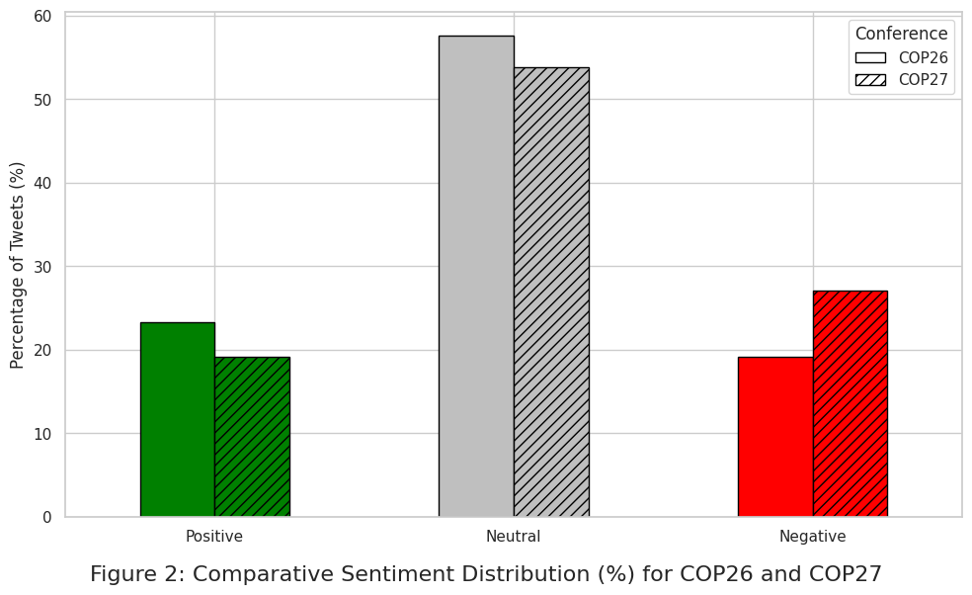

The notable shift towards a higher volume of negative posts between the two COPs aligns with the climate movement's overall perception of the events. COP26 was considered a critical test of the UNFCCC's ability to facilitate substantial change. This perception is reflected in the ECO Newsletter, which maintained a thread of optimism in the early days. For example, a report from the first week of COP26 noted, “ECO was awaiting yesterday’s Open Dialogue with excitement. After all, this is a key event to enable admitted NGO constituencies to have an open dialogue with Parties as mandated in (FCCC/SBI/2017/7) ... That’s why all nine constituencies jointly request to repeat the meeting in week two of COP26 – this time with an actual presence from Parties. ECO looks forward to a real dialogue” (Climate Action Network, 2021).

ECO also engaged in specific naming and shaming, as seen in its November 1st report: “Like cramming the night before a big exam, the Australian Prime Minister Scott Morrison has rushed out a last-minute net zero plan five days before this conference with no new policy and no accountability. This so-called plan is what Mr. Morrison proudly calls the ‘Australian way’. But anyone who has been to the last 25 COPs knows the Australian way is to block, destroy, and delay negotiations and undermine global ambition.”

The conclusion of COP26 was heavily criticized by the more radical elements of the environmental movement (Hunter et al., 2021). This decline in trust towards the UNFCCC persisted into COP27, further exacerbated by the Egyptian government's treatment of civil movements. Before the conference, activists were arrested, and demonstrations in Sharm El Sheikh were banned. During COP27, CAN expressed its displeasure with the logistical arrangements, noting, "The first sign of COP27 logistics trouble came before the Bonn sessions when, out of the blue, hotel contracts and bookings (some fully paid for) were summarily canceled with no notice because a new minimum price had supposedly been set... at double the price." The restrictions on applying outsider strategies align with the more negative stance adopted by the ENGOs.

### Positive/Negative most frequent words

Tables 4 and 5 present the 30 most frequent words identified in the datasets of "Positive" and "Negative" posts for COP26 and COP27, respectively. These lists exclude common stop words and terms such as 'climate,' 'COP26', 'COP27', and 'rt' (an abbreviation for "retweet" or reposting), which, despite their frequency, do not contribute additional contextual information to this analysis.

The resulting lists provide insight into the language ENGOs used to construct positive or negative frames. A recurring theme across both COPs is the specific mention of energy resources such as oil, gas, coal, and fuels in the negative posts, contrasting with the more general term "energy" appearing in the list of frequent positive words. This differentiation highlights the ENGOs' efforts to focus on specific causes of climate change rather than discussing it as an abstract concept. This strategy aligns with one of the primary goals promoted during COP26—to initiate action through reducing fossil fuels and coal use, culminating in a global declaration to phase them out (Asselt & Green, 2023).

|  |  |  |  |
| --- | --- | --- | --- |
| Table 4: COP26 – 30 most frequent words in positive and negative posts | | | |
| **Positive posts** | | **Negative posts** | |
| **Word** | **Frequency** | **Word** | **Frequency** |
| us | 350 | fossil | 286 |
| action | 316 | people | 266 |
| today | 313 | countries | 245 |
| new | 308 | emissions | 240 |
| join | 279 | change | 240 |
| energy | 276 | new | 226 |
| world | 268 | us | 209 |
| global | 262 | global | 207 |
| event | 247 | crisis | 202 |
| great | 242 | world | 199 |
| leaders | 232 | need | 193 |
| change | 218 | action | 186 |
| climateaction | 205 | must | 180 |
| day | 204 | oil | 180 |
| adaptation | 202 | gas | 174 |
| support | 198 | indigenous | 161 |
| help | 175 | carbon | 160 |
| solutions | 175 | leaders | 158 |
| climatechange | 171 | communities | 150 |
| countries | 171 | fuel | 148 |
| carbon | 170 | climatechange | 144 |
| youth | 167 | time | 144 |
| people | 165 | read | 141 |
| glasgow | 163 | climatecrisis | 137 |
| emissions | 157 | stop | 132 |
| work | 155 | energy | 131 |
| nature | 153 | coal | 130 |
| read | 153 | fuels | 129 |
| need | 149 | today | 127 |
| see | 140 | end | 118 |

|  |  |  |  |
| --- | --- | --- | --- |
| Table 5: COP27 – 30 most frequent words in positive and negative posts | | | |
| **Positive posts** | | **Negative posts** | |
| **Word** | **Frequency** | **Word** | **Frequency** |
| action | 359 | fossil | 829 |
| us | 357 | must | 452 |
| energy | 356 | gas | 446 |
| new | 302 | countries | 435 |
| global | ­­290 | people | 427 |
| join | 243 | new | 409 |
| today | 242 | fuel | 401 |
| leaders | 241 | crisis | 390 |
| change | 239 | change | 387 |
| adaptation | 238 | fuels | 378 |
| people | 235 | need | 366 |
| world | 226 | global | 363 |
| support | 223 | oil | 362 |
| solutions | 202 | energy | 342 |
| great | 190 | world | 341 |
| help | 184 | lossanddamage | 339 |
| work | 182 | action | 334 |
| event | 182 | us | 310 |
| youth | 181 | rights | 277 |
| future | 168 | emissions | 272 |
| africa | 166 | loss | 270 |
| indigenous | 161 | leaders | 270 |
| communities | 158 | time | 257 |
| countries | 157 | without | 246 |
| emissions | 151 | finance | 245 |
| day | 149 | communities | 240 |
| learn | 148 | human | 239 |
| carbon | 148 | carbon | 232 |
| thank | 147 | damage | 232 |
| finance | 146 | read | 216 |

### Active ENGOs

Not all ENGOs contribute equally to the coverage of the COPs. During COP26, each ENGO published an average of 55.6 posts, with a standard deviation of 77.5 and an average daily posting rate of 4.24. During COP27, each ENGO published an average of 68 posts, with a standard deviation of 112.4 and an average daily posting rate of 5.2.

What characterizes the most active ENGOs? Figures 3 and 4 show the distribution of positive/negative posts for the most active ENGO accounts during COP26 and COP27. We can see that while in COP26, most ENGOs shared more positive than negative posts, in COP27, the situation was reversed, with a majority of negative posts. This indicates that a select group of ENGOs primarily did the positive and negative coverage in both COPs.

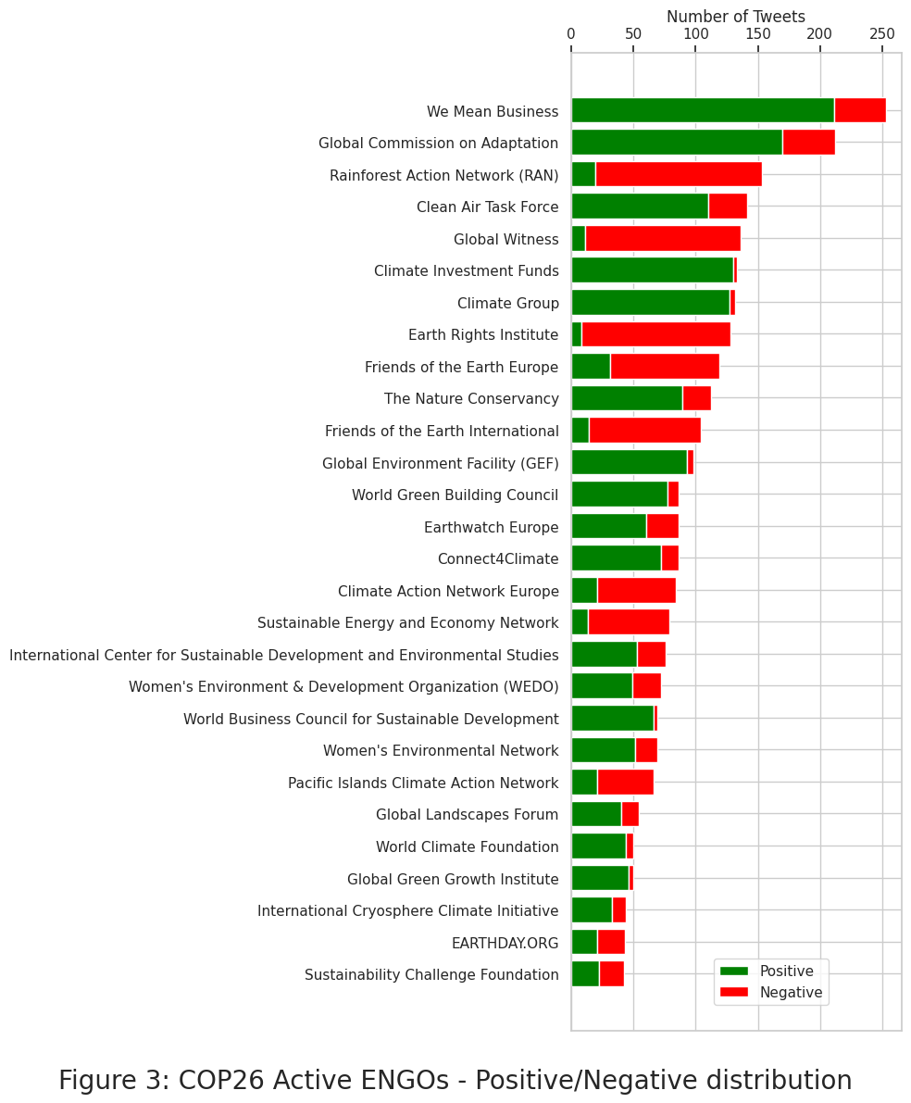

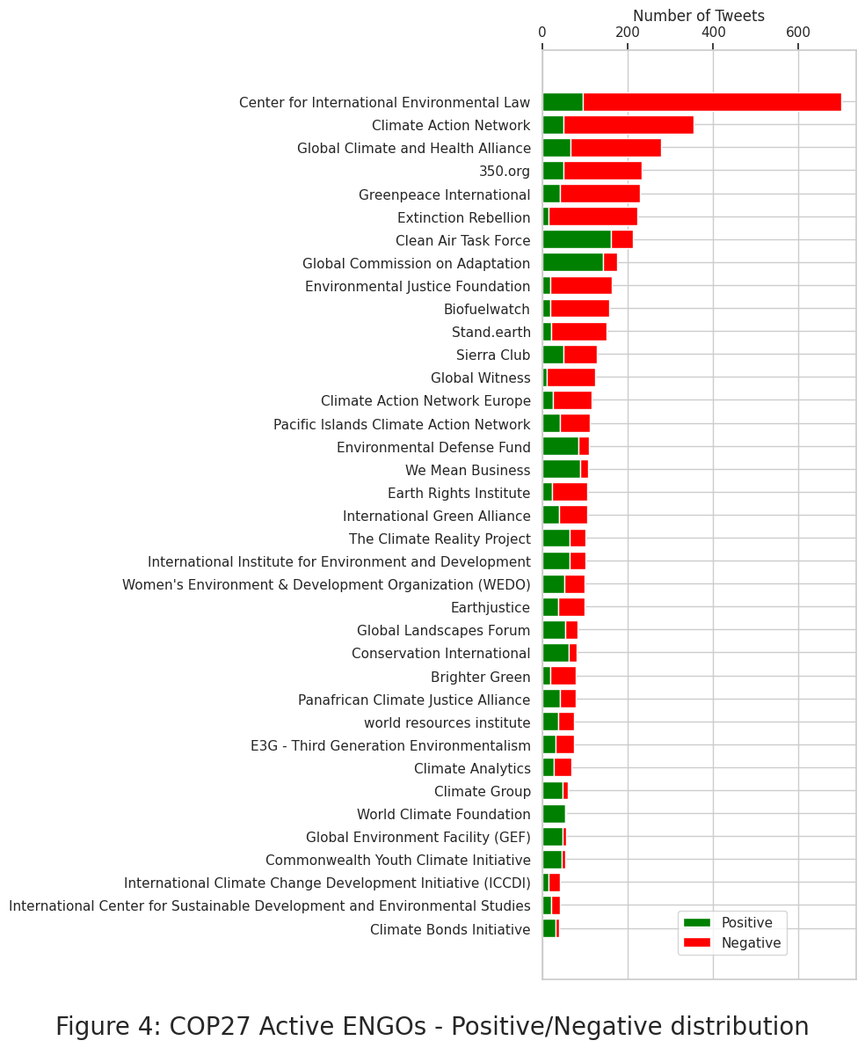

We can consider some representative examples of active ENGOs. During COP26, the most active account belonged to "We Mean Business," a coalition of organizations working with businesses to address climate change. According to its official website, We Mean Business is a "global nonprofit coalition working with the world's most influential businesses to take action on climate change. Together, we catalyze business and policy action to halve global emissions by 2030 in line with a 1.5°C pathway." We Mean Business represents a reformative organization that believes in solutions within capitalist markets rather than radical structural societal changes. This aligns with its relatively positive stance, which persisted during COP27.

The second most active account during COP26, also showing a mostly positive stance, is a prime example of an insider NGO. The Global Commission on Adaptation (GCOA) was founded by the Netherlands government in cooperation with other countries and key social relations experts. GCOA releases reports highlighting the economic, social, and environmental benefits of investing in climate adaptation. The organization emphasized the importance of addressing societal inequalities and involving vulnerable populations in decision-making. GCOA's positive stance continued through COP27.

On the more confrontational end of the spectrum, organizations like Greenpeace, the Climate Action Network (CAN), and 350.org predominantly employed negative framing during COP27. Greenpeace International, founded in 1971 in Canada, is an independent global environmental campaigning organization focusing on climate change, deforestation, overfishing, commercial whaling, genetic engineering, and anti-nuclear concerns. With its headquarters in Amsterdam, Greenpeace operates through a network of 26 independent national/regional organizations. Greenpeace was established with the aim of changing the world using 'media bombs' - distributing images and sounds that raise high levels of anger and fear in observers to mobilize action. The NGO has been accused of elitism, as it does not primarily consist of grassroots organizations, and its employees are not typically part of the local communities or share the socioeconomic standards of the poor or working-class people they serve (Panday, 2015). Greenpeace mostly used negative framing in COP27.

As mentioned earlier, CAN is a large coalition of over 1,900 civil society organizations. CAN operates through regional and national nodes, such as CAN Europe, CAN South Asia, and CAN Latin America. These nodes work on localized climate issues while contributing to the global agenda. CAN prioritizes protecting the atmosphere while allowing for sustainable and equitable development worldwide. Experts from CAN's diverse global membership base collaborate to develop resources driving international action on climate change, primarily focusing on international negotiations (Panday, 2015).

350.org is another well-established NGO that concentrates on elevating global grassroots activities in leading environmental and fossil fuel divestment campaigns. Before the Copenhagen Climate Conference 2009, 350.org orchestrated simultaneous rallies in 181 countries worldwide, possibly the largest coordinated protest in history (Panday, 2015).

On the radical side, organizations like Earth Rights and Extinction Rebellion (XR) consistently use negative framing. Earth Rights is an American nonprofit human rights and environmental organization founded in 1995. On its official website, Earth Rights describes itself as "a non-governmental, non-profit organization that combines the power of law with the power of people in defense of human rights and the environment, which we define as 'earth rights.' We take legal action against perpetrators of earth rights abuses, train activists, and work with communities to demand meaningful and lasting change." Earth Rights’ legal and environmental experts support campaigns challenging corporations and governments. XR is an international movement that uses non-violent direct action and civil disobedience to compel governments to take urgent action on climate and ecological emergencies. It operates as a decentralized, grassroots movement with over 200 local groups in the UK alone. XR is known for its high-profile protests and acts of civil disobedience. It has led many occupational acts to shut down the activities of companies it confronts. Both organizations predominantly utilized negative framing in their tweets about the COPs.

## Changing sentiments throughout the COP

The first research question deals with the changing trend in sentimental framing in response to events during COP26 and COP27. Figure 5 illustrates the fluctuation in the average Sentiment Index attributed to ENGO posts for each day of the investigated period. A discernible pattern is notable in each COP, where positivity peaks at the beginning and declines towards the end, followed by a rebound. Notably, the transition from initial positivity to end-stage negativity was more pronounced during COP26 than COP27.

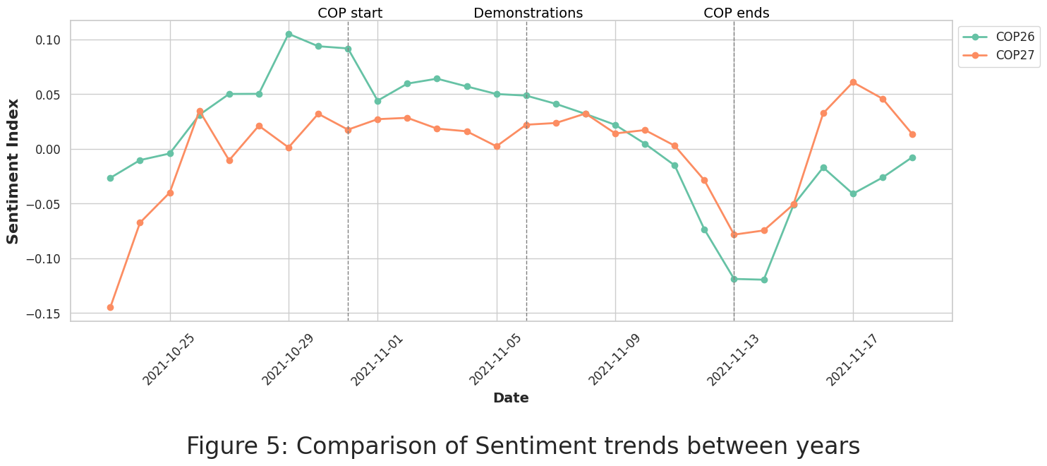

A mixed-effects model was employed to analyze the Sentiment Index for each COP (see Tables 6 and 7 the Appendix). The fixed effects included the day number and group classification of the NGOs (mode of participation in the COP) to capture the temporal dynamics of sentiments during the conferences and systematic differences between organizations based on their position in relation to the UNFCCC. Additionally, a random effect was included for each ENGO to account for variation between organizations at baseline. The model utilized maximum likelihood estimation (MLE) for its calculations.

As shown in Figure 5, the beginning of each conference was characterized by overall excitement and optimism, reflected in peak positive sentiment. This positive sentiment declined steadily throughout both conferences, and by the time they ended, the positive sentiment was at its lowest (negative sentiment was highest). To test these differences, I used a chi-square test to compare the Sentiment Index on the first day of COP26 (day 9 of the study) with that of the last day (day 22). The results indicated a significant difference between the start and end of COP26 (χ²(1) = 6.24, p = .0125). A similar model and test were applied to COP27; however, no significant difference was found, suggesting a more subdued sentiment cycle with less pronounced peaks of positivity and negativity.

Despite this, overall sentiment trends for the two COPs did not show significant discrepancies. Another mixed-effect model predicting the Sentiment level, including an interaction between the two COPs, the ENGOs group, and the day variables, was created to check the differences between the years (see Table 8 in the Appendix). The analysis showed that the Year variable did not have a statistically significant effect, indicating no substantial difference in sentiment across the two years.

## Insider/outside position and sentimental framing

The second research question deals with the difference in sentimental framing between types of organizations. Mixed-effects models were utilized to evaluate potential differences in the level of sentimental framing among various modes of ENGOs participation at the COPs.

Figures 6 and 7 display the daily average Sentiment Index for the two COPs. Regarding COP26, the results indicated significant differences in Sentiment levels between Group 1 (ENGOs in state delegations) and Groups 3 (NGOs represented under different ENGOs) and 4 (ENGOs not sending representatives). There was no significant difference between Group 1 and Group 2 (ENGOs that sent representatives independently).

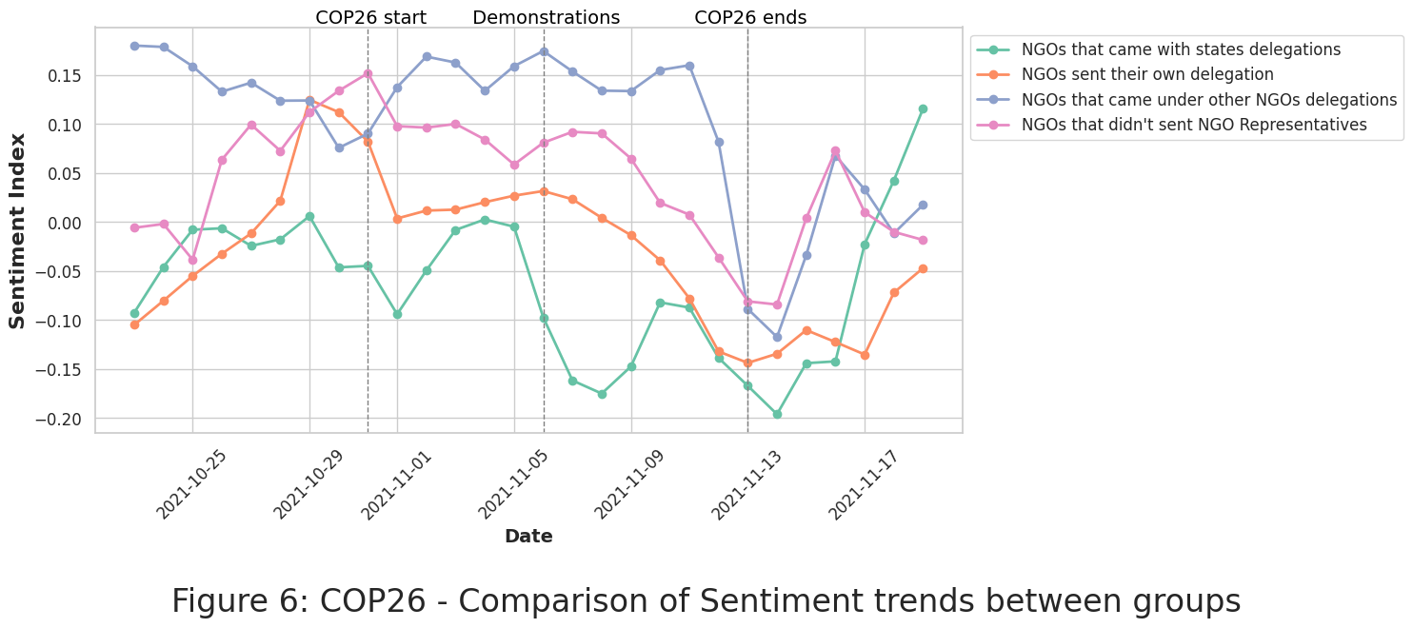

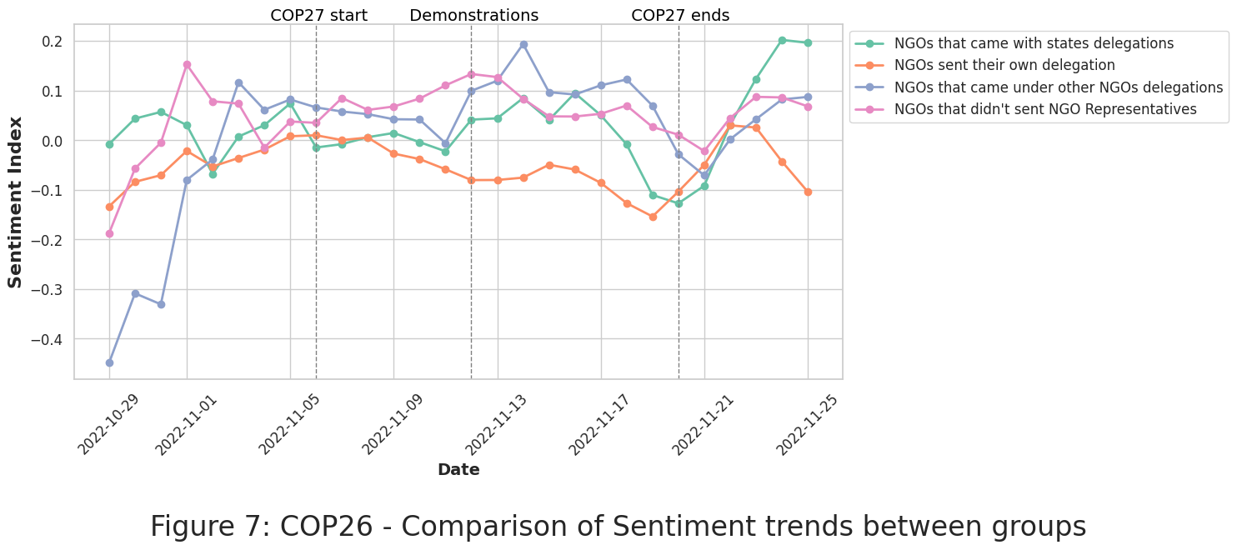

This shows that during COP26, emotional framing was similar for the two most institutionalized groups of ENGOs that physically participated on the COP's floor, either by sending their delegations or by joining an official nation-state delegation. Both groups exhibited more negative framing than relatively more “Outsiders” ENGOs that came to the COP under other ENGO delegations or did not send any members to the COP.

In contrast, during COP27, no significant differences in the Sentiment Index were observed between Group 1 and any of the other groups. Generally, a definite difference in the pattern of emotional framing was not found.

# Discussion

This study aimed to analyze the patterns of emotional framing that Environmental Non-Governmental Organizations (ENGOs) employed during COP26 and COP27, examining how these patterns differed between organizations with insider versus outsider participation status. There were no statistically significant differences in overall ENGO sentimental tone between COP26 and COP27. In both conferences, the findings revealed a similar dynamic over time. The climate conferences began with positive sentiments on average, which tended to decline and turn negative toward the second week of the COPs. Considering differences in sentimental framing patterns between ENGOs that participated in the COPs as insiders compared to those that participated as outsiders, significant differences were observed only in COP26. In this conference, the most insider ENGOs—those that participated either as part of state delegations or independently—exhibited more negative sentiment than ENGOs that participated as part of other ENGO delegations or did not send any representatives to the conference venues.

## Sentimental Framing Trends

The changing pattern of emotional framing concerning each COP can be interpreted in light of the political opportunities the UNFCCC enables. The COPs are "agenda-setting" events in which new policies are created, and interests are still unclear, allowing different political actors to aim to influence their final form (Newell, 2006). Social movements have a more challenging time influencing policy in the later stages of the policymaking process (Pettinicchio, 2017). As the COP events progressed, ENGOs had fewer routes to influence their outcomes.

The United Nations Climate Change Conference adheres to a two-week structured schedule. The first week is devoted to detailed technical discussions and groundwork, while the second week shifts focus to high-level political engagement and the finalization of agreements. Although ENGOs are typically granted observer status, their access is often restricted during the crucial second week. These restrictions are reflected in ENGOs' more hostile commentary about the COPs, as illustrated by this excerpt from the ECO newsletter, published on November 12th, just before COP26 concluded: "High-level ministers have finally arrived in Glasgow and are discussing Article 6. Hooray! Surely, they've been paying attention to all of ECO's tasks and will quickly agree on an extremely robust Article 6 package! Right? Except, well, that's not quite what we're hearing... It can be challenging to discern what's happening behind closed doors in ministerial discussions from which observers are largely excluded." ENGOs are often frustrated by limited access to the spaces where the concluding part of the negotiations happens, where they perceive national capitals to exercise strong control (Newell, 2006). The results show a trend toward negativity during the second week of the COPs, when ENGOs can less effectively influence the negotiations. Here, negative sentiment is associated with a critical framing of the COPs. Negative messages are aimed at influencing the negotiations through blaming and shaming tactics directed at state organizations and representatives.

The influence of closing political opportunities on the decrease in positive tone can also be detected in the differences between COP26 and COP27. Despite a degree of similarity in sentiment trends over the two weeks of both COPs, COP26's fluctuation in sentiment is starker. This could result from the unique status of this COP in the history of the UNFCCC. COP26 was the first conference post-COP21 where countries discussed amending the Nationally Determined Contributions (NDCs). As COP26 started, interests were unclear, and ENGOs had more opportunities to articulate the problem in a way that aligned with their goals. In these initial stages of the COPs, we see a rise in positivity, which later declines as time passes and ENGOs perceive fewer channels for influence.

During COP27, the shift towards a more negative tone by the final days was subtler, but this should be understood in light of the fact that the overall sentiment of posts published about this COP was more negative from the outset. COP27 was marked by a more restricted capacity for ENGOs to exert influence through outsider tactics, correlating with the predominantly negative sentiment observed. When NGOs approached with more criticism and less feeling of being able to influence, the changes in emotional framing were also milder. As political opportunity theory predicts, a closed political structure tends to motivate radicalization from social movements (Della Porta, 2018), where here it was shown in the elevation of negative framing.

A further conclusion that can be drawn from the results is that shifts in the sentimental framing of ENGOs do not necessarily align with broader environmental movement activity. The significant global demonstration at the end of the first week of COP26 and the more subdued demonstration during the same period at COP27 did not cause a shift in the emotional framing adopted by ENGOs. This indicates that ENGOs maintain a distinct strategic messaging approach from the broader environmental movements and operate within a different sphere, at least officially.

## Differences in Sentimental Framing Between Insiders and Outsiders

The results regarding the sentimental framing of different ENGO groups were surprising. The initial expectation was that ENGOs without direct COP participation would show more negative emotions compared to those who joined the discussion floor or came with state delegations. This expectation was based on previous theorizing about the difference between insiders and outsiders, according to which outsiders tend to take a more oppositional stance towards the COPs than insiders (Caniglia, 2015; Newell, 2006). Additionally, since insider ENGOs typically maintain better relationships with the institutions they seek to influence (Saunders, 2009), those attending with state delegations were expected to be more restrained in expressing negative sentiment, as political elites tend to view insiders as more credible allies. However, the findings revealed that insider ENGOs can adopt adversarial framing (Knight & Greenberg, 2011) with negative sentiment. During COP26 and COP27, organizations with direct access to the discussion floor and political representatives produced most of the negative posts. During COP27, no significant differences emerged between ENGO participation types.

 While Dzhengiz et al. (2021) found that radical NGOs use more negative framing than reformative ENGOs in press releases, this study shows that sentimental framing patterns of reformative versus radical ENGOs do not perfectly align with the distinction between insiders versus outsiders. During COP26, ENGOs with state delegations showed similar emotional patterns to those who sent independent representatives, with both groups leading a relatively more negative strand than more outsider ENGOs. This suggests that institutionalized ENGOs with resources to attend COPs share similar emotional framing patterns, and insiders can employ negative sentiments in response to shifting political opportunities.

The results challenge a specific strand of criticism toward ENGOs, according to which the process of institutionalization they are undergoing might limit their ability to take a confrontational attitude (Berny & Rootes, 2018). ENGOs granted access to statesmen still use negative framing in their messages. However, critics might still argue that ENGOs' sentimental framing strategy on social media proves ineffective, given the COPs' failure to achieve necessary environmental goals.

Findings call for a more nuanced understanding of how ENGOs utilize emotional framing. It appears that the level of an organization's involvement in the conference influences changes in sentiment framing. ENGOs more actively engaged in COP daily activities are more affected by changing events and tend to exhibit more dramatic shifts in their sentimental framing. In COP27, ENGOs were generally less committed to effecting change. Their responses were more uniform, with fewer shifts in framing. This consistency highlights a less dynamic engagement than the previous COP, suggesting that the degree of active participation may dictate variability in sentiment framing.

What can explain the main role of insider ENGOs in reporting COP events and leading the negative stance toward them? The results call for a revision of the research's initial theorizing. Here it can be illuminating to take a comparative approach and consider civil society actions in climate change cases compared to other social movement struggles. Borbáth (2023) researched differentiation in protest politics, focusing on how political insiders and outsiders participate differently in protests around the COVID-19 crisis. He shows that climate issue struggles are generally led by social movements that include more established activists, compared to participants at other protests, such as those that took place against COVID-19 civil liberties restrictions, who were more hostile to political institutions. Borbáth suggests that differences between insiders and outsiders are topic-bound, as some social struggles organized around certain grievances are inherently led with more insider strategies than others. Assuming that activists organized to act in relation to the UNFCCC are generally more comfortable with insider tactics can explain the dominance of insider activity around the COPs. From this perspective, it is understandable that ENGO messaging could be either positive or negative while still working within a general insider framework.

# Bibliography

Arora, P., & Arora, N. K. (2023). COP27: A summit of more misses than hits. Environmental Sustainability, 6(1), 99-105.

Arora, N. K., & Mishra, I. (2021). COP26: more challenges than achievements. Environmental Sustainability, 4, 585-588.

Bain, P. G., Hornsey, M. J., Bongiorno, R., & Jeffries, C. (2012). Promoting pro-environmental action in climate change deniers. Nature Climate Change, 2(8), 600-603.Bain, P. G., Hornsey, M. J., Bongiorno, R., & Jeffries, C. (2012). Promoting pro-environmental action in climate change deniers. Nature Climate Change, 2(8), 600-603.

Benford, R. D., & Snow, D. A. (2000). Framing processes and social movements: An overview and assessment. Annual review of sociology, 26(1), 611-639.

Berny, N., & Rootes, C. (2018). Environmental NGOs at a crossroads? In Environmental Politics (Vol. 27, Issue 6, pp. 947–972). Taylor & Francis.

Binette, A. J. (2018). Positions of Authority and Influence in Environmental Nongovernmental Organizations' Networks: An Examination of Network Structure and Participation at Un Climate Change Summits. Temple University.

Borbáth, E. (2024). Differentiation in protest politics: participation by political insiders and outsiders. Political Behavior, 46(2), 727-750.

Brunnengräber, A. (2014). Between Pragmatism And Radicalization: NGOs and social movements in international climate politics 1. In Routledge handbook of the climate change movement (pp. 269-279). Routledge.

Chong, D., & Druckman, J. N. (2007). Framing theory. Annu. Rev. Polit. Sci., 10(1), 103-126.

Caniglia, B. S., Brulle, R. J., & Szasz, A. (2015). Civil society, social movements, and climate change. Climate change and society: Sociological perspectives, 1, 235-268.

Climate Action Network. (2021). ECO Newsletter. Retrieved July 09, 2024, from https://climatenetwork.org/resource_type/eco-newsletter/

Dauvergne, P., & Neville, K. J. (2011). Mindbombs of right and wrong: cycles of contention in the activist campaign to stop Canada's seal hunt. Environmental Politics, 20(2), 192-209.

Della Porta, D. (2018). Radicalization: A relational perspective. Annual Review of Political Science, 21(1), 461-474.

Duncombe, C. (2019). The politics of Twitter: emotions and the power of social media. International Political Sociology, 13(4), 409-429.

Durnová, A. (2015). Lost in translation: Expressing emotions in policy deliberation. In Handbook of critical policy studies (pp. 222-238). Edward Elgar Publishing.

Dzhengiz, T., Barkemeyer, R., & Napolitano, G. (2021). Emotional framing of NGO press releases: Reformative versus radical NGOs. Business Strategy and the Environment, 30(5), 2468-2488.

Entman, R. M. (1993). Framing: Toward clarification of a fractured paradigm. Journal of communication, 43(4), 51-58.

Fownes, J. R., Yu, C., & Margolin, D. B. (2018). Twitter and climate change. Sociology Compass, 12(6), e12587.

Gifford, R., & Comeau, L. A. (2011). Message framing influences perceived climate change competence, engagement, and behavioral intentions. Global Environmental Change, 21(4), 1301-1307.

Goodwin, J., Jasper, J.M., and Polletta, F., 2001. Why emotions matter. In: J. Goodwin, J.M. Jasper, and F. Polletta, eds. Passionate politics: emotions and social movements. Chicago: University of Chicago Press, 1–24.

Hadden, J., & Bush, S. S. (2021). What’s different about the environment? Environmental INGOs in comparative perspective. Environmental politics, 30(1-2), 202-223.

Hornsey, M. J., & Fielding, K. S. (2016). A cautionary note about messages of hope: Focusing on progress in reducing carbon emissions weakens mitigation motivation. Global Environmental Change, 39, 26-34.

Hunter, D. B., Salzman, J. E., & Zaelke, D. (2021). Glasgow climate summit: Cop26. UCLA School of Law, Public Law Research Paper, (22-02).

Jacobs, M. (2022). Reflections on COP26: International diplomacy, global justice and the greening of capitalism. The Political Quarterly, 93(2), 270-277.

Ji, Q., Harlow, S., Cui, D., & Wang, Z. (2018). Discussing environmental issues in Chinese social media: An analysis of Greenpeace China’s Weibo posts and audience responses. The Journal of Social Media in Society, 7(1), 37-60.

Keck, M. E., & Sikkink, K. (1998). Activists beyond borders: Advocacy networks in international politics. Cornell University Press.

Kharde, V., & Sonawane, P. (2016). Sentiment analysis of twitter data: a survey of techniques. arXiv preprint arXiv:1601.06971.

Kriesi, H. (2004). Political context and opportunity. The Blackwell companion to social movements, 67-90.

Lakoff, G. (2010). Why it matters how we frame the environment. Environmental communication, 4(1), 70-81.

Liu, Y., Ott, M., Goyal, N., Du, J., Joshi, M., Chen, D., ... & Stoyanov, V. (2019). Roberta: A robustly optimized bert pretraining approach. arXiv preprint arXiv:1907.11692.

Loureiro, D., Barbieri, F., Neves, L., Anke, L. E., & Camacho-Collados, J. (2022). TimeLMs: Diachronic language models from Twitter. arXiv preprint arXiv:2202.03829.

Luxon, E. M. (2019). Mobilizing environmental sentiment through the media. Environmental Politics, 28(4), 639-662.

Meyer, D. S. (2004). Protest and political opportunities. Annu. Rev. Sociol., 30, 125–145.

Merry, M. K. (2010). Emotional appeals in environmental group communications. American Politics Research, 38(5), 862-889.

Newell, P. (2006). Climate for Change? Civil Society and the Politics of Global Warming. Pp. 90–119 in Global Civil Society 2005/2006, edited by M. Glasius, M. Kaldor, and H. Anheier. Thousand Oaks, CA: Sage.

Pandey, C. L. (2015). Managing climate change: Shifting roles for NGOs in the climate negotiations. Environmental Values, 24(6), 799-824.

Pettinicchio, D. (2012). Institutional activism: Reconsidering the insider/outsider dichotomy. Sociology Compass, 6(6), 499-510.

Pettinicchio, D. (2017). Elites, policy, and social movements. In On the cross road of polity, political elites and mobilization. Emerald Group Publishing Limited.

Pflieger, G. (2023). COP27: One step on loss and damage for the most vulnerable countries, no step for the fight against climate change. PLOS Climate, 2(1), e0000136.

Reinecke, J., & Ansari, S. (2016). Taming wicked problems: The role of framing in the construction of corporate social responsibility. Journal of Management Studies, 53(3), 299-329.

Rietig, K. (2011). Public Pressure Versus Lobbying-How do Environmental NGOs matter most in Climate Negotiations?. Grantham Research Institute on Climate Change and the Environment Working Paper No. 70.

Saunders, C. (2009). It's not just structural: Social movements are not homogenous responses to structural features, but networks shaped by organizational strategies and status. Sociological Research Online, 14(1), 26-41.

Snow, D. A., Vliegenthart, R., & Ketelaars, P. (2018). The framing perspective on social movements: Its conceptual roots and architecture. The Wiley Blackwell companion to social movements, 392-410.

Stern, P. C. (2012). Fear and hope in climate messages. Nature Climate Change, 2(8), 572-573.

Third World Network. (2021). Glasgow climate news update. Retrieved July 09, 2024, from <https://www.twn.my/title2/climate/climate_updates-briefings.htm>

Union of International Associations. (2021). *Yearbook of international organizations 2021*. Brill.

van Asselt, H., & Green, F. (2023). COP26 and the dynamics of anti‐fossil fuel norms. Wiley Interdisciplinary Reviews: Climate Change, 14(3), e816.

Vaswani, A., Shazeer, N., Parmar, N., Uszkoreit, J., Jones, L., Gomez, A. N., ... & Polosukhin, I. (2017). Attention is all you need. Advances in neural information processing systems, 30.

# Appendix

|  |  |
| --- | --- |
| Table 9: Proportion of agreement between the classifiers | |
| Comparison | Agreement Proportion |
| Classifier 1 vs Classifier 2 | 0.816 |
| Classifier 1 vs Classifier 3 | 0.724 |
| Classifier 2 vs Classifier 3 | 0.658 |
| All Classifiers | 0.614 |

|  |  |  |  |
| --- | --- | --- | --- |
| Table 6: COP26 – Mixed-effects model Results | | | |
|  | (1) | (2) | (3) |
| VARIABLES | SentimentIndex | lns1_1_1 | lnsig_e |
|  |  |  |  |
| 2.day_number | -0.0613 |  |  |
|  | (0.0933) |  |  |
| 3.day_number | 0.0240 |  |  |
|  | (0.0760) |  |  |
| 4.day_number | 0.0243 |  |  |
|  | (0.0765) |  |  |
| 5.day_number | 0.0582 |  |  |
|  | (0.0760) |  |  |
| 6.day_number | 0.0865 |  |  |
|  | (0.0756) |  |  |
| 7.day_number | 0.0476 |  |  |
|  | (0.0758) |  |  |
| 8.day_number | 0.190** |  |  |
|  | (0.0844) |  |  |
| 9.day_number | 0.0705 |  |  |
|  | (0.0831) |  |  |
| 10.day_number | 0.0195 |  |  |
|  | (0.0740) |  |  |
| 11.day_number | 0.0592 |  |  |
|  | (0.0734) |  |  |
| 12.day_number | 0.0918 |  |  |
|  | (0.0732) |  |  |
| 13.day_number | 0.0415 |  |  |
|  | (0.0737) |  |  |
| 14.day_number | 0.0548 |  |  |
|  | (0.0742) |  |  |
| 15.day_number | 0.0674 |  |  |
|  | (0.0784) |  |  |
| 16.day_number | 0.0409 |  |  |
|  | (0.0822) |  |  |
| 17.day_number | 0.0167 |  |  |
|  | (0.0737) |  |  |
| 18.day_number | 0.0361 |  |  |
|  | (0.0739) |  |  |
| 19.day_number | 0.0126 |  |  |
|  | (0.0741) |  |  |
| 20.day_number | -0.0185 |  |  |
|  | (0.0749) |  |  |
| 21.day_number | 0.0136 |  |  |
|  | (0.0747) |  |  |
| 22.day_number | -0.114 |  |  |
|  | (0.0840) |  |  |
| 23.day_number | -0.101 |  |  |
|  | (0.0885) |  |  |
| 24.day_number | -0.00935 |  |  |
|  | (0.0765) |  |  |
| 25.day_number | 0.0400 |  |  |
|  | (0.0770) |  |  |
| 26.day_number | -0.0335 |  |  |
|  | (0.0772) |  |  |
| 27.day_number | -0.0655 |  |  |
|  | (0.0774) |  |  |
| 28.day_number | 0.101 |  |  |
|  | (0.0774) |  |  |
| 2.Group | 0.0564 |  |  |
|  | (0.0708) |  |  |
| 3.Group | 0.181** |  |  |
|  | (0.0849) |  |  |
| 4.Group | 0.148** |  |  |
|  | (0.0672) |  |  |
| Constant | -0.0998 | -1.315*** | -0.825*** |
|  | (0.0890) | (0.0580) | (0.0126) |
|  |  |  |  |
| Observations | 3,395 | 3,395 | 3,395 |
| Number of groups | 259 | 259 | 259 |

|  |  |  |  |
| --- | --- | --- | --- |
| Table 7: COP27 – Mixed-effects model Results | | | |
|  | (1) | (2) | (3) |
| VARIABLES | SentimentIndex | lns1_1_1 | lnsig_e |
|  |  |  |  |
| 2.day_number | -0.103 |  |  |
|  | (0.0989) |  |  |
| 3.day_number | 0.0982 |  |  |
|  | (0.0777) |  |  |
| 4.day_number | -0.00859 |  |  |
|  | (0.0791) |  |  |
| 5.day_number | 0.0477 |  |  |
|  | (0.0766) |  |  |
| 6.day_number | -0.0257 |  |  |
|  | (0.0771) |  |  |
| 7.day_number | 0.0973 |  |  |
|  | (0.0777) |  |  |
| 8.day_number | 0.0424 |  |  |
|  | (0.0853) |  |  |
| 9.day_number | 0.0557 |  |  |
|  | (0.0864) |  |  |
| 10.day_number | 0.0610 |  |  |
|  | (0.0757) |  |  |
| 11.day_number | 0.0121 |  |  |
|  | (0.0750) |  |  |
| 12.day_number | 0.0600 |  |  |
|  | (0.0746) |  |  |
| 13.day_number | 0.0226 |  |  |
|  | (0.0747) |  |  |
| 14.day_number | 0.0115 |  |  |
|  | (0.0761) |  |  |
| 15.day_number | 0.0316 |  |  |
|  | (0.0801) |  |  |
| 16.day_number | 0.111 |  |  |
|  | (0.0841) |  |  |
| 17.day_number | 0.0112 |  |  |
|  | (0.0751) |  |  |
| 18.day_number | 0.0486 |  |  |
|  | (0.0755) |  |  |
| 19.day_number | 0.0290 |  |  |
|  | (0.0756) |  |  |
| 20.day_number | 0.0274 |  |  |
|  | (0.0758) |  |  |
| 21.day_number | 0.00389 |  |  |
|  | (0.0765) |  |  |
| 22.day_number | 0.0186 |  |  |
|  | (0.0875) |  |  |
| 23.day_number | -0.0826 |  |  |
|  | (0.0855) |  |  |
| 24.day_number | 0.00966 |  |  |
|  | (0.0773) |  |  |
| 25.day_number | 0.00779 |  |  |
|  | (0.0782) |  |  |
| 26.day_number | 0.124 |  |  |
|  | (0.0781) |  |  |
| 27.day_number | 0.101 |  |  |
|  | (0.0800) |  |  |
| 28.day_number | -0.0133 |  |  |
|  | (0.0811) |  |  |
| 2.Group | -0.0422 |  |  |
|  | (0.0589) |  |  |
| 3.Group | 0.0168 |  |  |
|  | (0.0764) |  |  |
| 4.Group | 0.0650 |  |  |
|  | (0.0580) |  |  |
| Constant | -0.00871 | -1.388*** | -0.815*** |
|  | (0.0824) | (0.0598) | (0.0128) |
|  |  |  |  |
| Observations | 3,293 | 3,293 | 3,293 |
| Number of groups | 252 | 252 | 252 |

|  |  |  |  |
| --- | --- | --- | --- |
| Table 8: COP26 Interaction with COP27 – Mixed-effects model Results | | | |
|  | (1) | (2) | (3) |
| VARIABLES | SentimentIndex | lns1_1_1 | lnsig_e |
|  |  |  |  |
| 1.Year | 0.0566 |  |  |
|  | (0.0978) |  |  |
| 2.Group | 0.0700 |  |  |
|  | (0.0427) |  |  |
| 3.Group | 0.0846 |  |  |
|  | (0.0542) |  |  |
| 4.Group | 0.124*** |  |  |
|  | (0.0457) |  |  |
| 2.day_number | -0.0639 |  |  |
|  | (0.0942) |  |  |
| 3.day_number | 0.0144 |  |  |
|  | (0.0767) |  |  |
| 4.day_number | 0.00988 |  |  |
|  | (0.0772) |  |  |
| 5.day_number | 0.0455 |  |  |
|  | (0.0767) |  |  |
| 6.day_number | 0.0773 |  |  |
|  | (0.0763) |  |  |
| 7.day_number | 0.0350 |  |  |
|  | (0.0766) |  |  |
| 8.day_number | 0.190** |  |  |
|  | (0.0852) |  |  |
| 9.day_number | 0.0605 |  |  |
|  | (0.0839) |  |  |
| 10.day_number | 0.00793 |  |  |
|  | (0.0747) |  |  |
| 11.day_number | 0.0473 |  |  |
|  | (0.0741) |  |  |
| 12.day_number | 0.0737 |  |  |
|  | (0.0738) |  |  |
| 13.day_number | 0.0312 |  |  |
|  | (0.0744) |  |  |
| 14.day_number | 0.0438 |  |  |
|  | (0.0748) |  |  |
| 15.day_number | 0.0665 |  |  |
|  | (0.0791) |  |  |
| 16.day_number | 0.0357 |  |  |
|  | (0.0829) |  |  |
| 17.day_number | 0.00966 |  |  |
|  | (0.0744) |  |  |
| 18.day_number | 0.0225 |  |  |
|  | (0.0746) |  |  |
| 19.day_number | 0.00127 |  |  |
|  | (0.0748) |  |  |
| 20.day_number | -0.0323 |  |  |
|  | (0.0756) |  |  |
| 21.day_number | 0.00243 |  |  |
|  | (0.0754) |  |  |
| 22.day_number | -0.115 |  |  |
|  | (0.0847) |  |  |
| 23.day_number | -0.121 |  |  |
|  | (0.0892) |  |  |
| 24.day_number | -0.0288 |  |  |
|  | (0.0772) |  |  |
| 25.day_number | 0.0269 |  |  |
|  | (0.0777) |  |  |
| 26.day_number | -0.0498 |  |  |
|  | (0.0779) |  |  |
| 27.day_number | -0.0774 |  |  |
|  | (0.0781) |  |  |
| 28.day_number | 0.0819 |  |  |
|  | (0.0781) |  |  |
| 0b.Year#1b.Group | 0 |  |  |
|  | (0) |  |  |
| 0b.Year#2o.Group | 0 |  |  |
|  | (0) |  |  |
| 0b.Year#3o.Group | 0 |  |  |
|  | (0) |  |  |
| 0b.Year#4o.Group | 0 |  |  |
|  | (0) |  |  |
| 1o.Year#1b.Group | 0 |  |  |
|  | (0) |  |  |
| 1.Year#2.Group | -0.0575 |  |  |
|  | (0.0400) |  |  |
| 1.Year#3.Group | -0.0538 |  |  |
|  | (0.0512) |  |  |
| 1.Year#4.Group | -0.0399 |  |  |
|  | (0.0395) |  |  |
| 0b.Year#1b.day_number | 0 |  |  |
|  | (0) |  |  |
| 0b.Year#2o.day_number | 0 |  |  |
|  | (0) |  |  |
| 0b.Year#3o.day_number | 0 |  |  |
|  | (0) |  |  |
| 0b.Year#4o.day_number | 0 |  |  |
|  | (0) |  |  |
| 0b.Year#5o.day_number | 0 |  |  |
|  | (0) |  |  |
| 0b.Year#6o.day_number | 0 |  |  |
|  | (0) |  |  |
| 0b.Year#7o.day_number | 0 |  |  |
|  | (0) |  |  |
| 0b.Year#8o.day_number | 0 |  |  |
|  | (0) |  |  |
| 0b.Year#9o.day_number | 0 |  |  |
|  | (0) |  |  |
| 0b.Year#10o.day_number | 0 |  |  |
|  | (0) |  |  |
| 0b.Year#11o.day_number | 0 |  |  |
|  | (0) |  |  |
| 0b.Year#12o.day_number | 0 |  |  |
|  | (0) |  |  |
| 0b.Year#13o.day_number | 0 |  |  |
|  | (0) |  |  |
| 0b.Year#14o.day_number | 0 |  |  |
|  | (0) |  |  |
| 0b.Year#15o.day_number | 0 |  |  |
|  | (0) |  |  |
| 0b.Year#16o.day_number | 0 |  |  |
|  | (0) |  |  |
| 0b.Year#17o.day_number | 0 |  |  |
|  | (0) |  |  |
| 0b.Year#18o.day_number | 0 |  |  |
|  | (0) |  |  |
| 0b.Year#19o.day_number | 0 |  |  |
|  | (0) |  |  |
| 0b.Year#20o.day_number | 0 |  |  |
|  | (0) |  |  |
| 0b.Year#21o.day_number | 0 |  |  |
|  | (0) |  |  |
| 0b.Year#22o.day_number | 0 |  |  |
|  | (0) |  |  |
| 0b.Year#23o.day_number | 0 |  |  |
|  | (0) |  |  |
| 0b.Year#24o.day_number | 0 |  |  |
|  | (0) |  |  |
| 0b.Year#25o.day_number | 0 |  |  |
|  | (0) |  |  |
| 0b.Year#26o.day_number | 0 |  |  |
|  | (0) |  |  |
| 0b.Year#27o.day_number | 0 |  |  |
|  | (0) |  |  |
| 0b.Year#28o.day_number | 0 |  |  |
|  | (0) |  |  |
| 1o.Year#1b.day_number | 0 |  |  |
|  | (0) |  |  |
| 1.Year#2.day_number | -0.0284 |  |  |
|  | (0.137) |  |  |
| 1.Year#3.day_number | 0.0977 |  |  |
|  | (0.109) |  |  |
| 1.Year#4.day_number | -0.0293 |  |  |
|  | (0.110) |  |  |
| 1.Year#5.day_number | 0.0114 |  |  |
|  | (0.108) |  |  |
| 1.Year#6.day_number | -0.109 |  |  |
|  | (0.108) |  |  |
| 1.Year#7.day_number | 0.0508 |  |  |
|  | (0.109) |  |  |
| 1.Year#8.day_number | -0.156 |  |  |
|  | (0.120) |  |  |
| 1.Year#9.day_number | 0.000382 |  |  |
|  | (0.120) |  |  |
| 1.Year#10.day_number | 0.0421 |  |  |
|  | (0.106) |  |  |
| 1.Year#11.day_number | -0.0417 |  |  |
|  | (0.105) |  |  |
| 1.Year#12.day_number | -0.00811 |  |  |
|  | (0.105) |  |  |
| 1.Year#13.day_number | -0.00341 |  |  |
|  | (0.105) |  |  |
| 1.Year#14.day_number | -0.0317 |  |  |
|  | (0.106) |  |  |
| 1.Year#15.day_number | -0.0393 |  |  |
|  | (0.112) |  |  |
| 1.Year#16.day_number | 0.0708 |  |  |
|  | (0.118) |  |  |
| 1.Year#17.day_number | -0.000382 |  |  |
|  | (0.105) |  |  |
| 1.Year#18.day_number | 0.0236 |  |  |
|  | (0.106) |  |  |
| 1.Year#19.day_number | 0.0211 |  |  |
|  | (0.106) |  |  |
| 1.Year#20.day_number | 0.0569 |  |  |
|  | (0.107) |  |  |
| 1.Year#21.day_number | 0.000149 |  |  |
|  | (0.107) |  |  |
| 1.Year#22.day_number | 0.139 |  |  |
|  | (0.122) |  |  |
| 1.Year#23.day_number | 0.0363 |  |  |
|  | (0.124) |  |  |
| 1.Year#24.day_number | 0.0366 |  |  |
|  | (0.109) |  |  |
| 1.Year#25.day_number | -0.0178 |  |  |
|  | (0.110) |  |  |
| 1.Year#26.day_number | 0.168 |  |  |
|  | (0.110) |  |  |
| 1.Year#27.day_number | 0.184* |  |  |
|  | (0.112) |  |  |
| 1.Year#28.day_number | -0.0926 |  |  |
|  | (0.112) |  |  |
| Constant | -0.0842 | -1.356*** | -0.810*** |
|  | (0.0768) | (0.0518) | (0.00884) |
|  |  |  |  |
| Observations | 6,688 | 6,688 | 6,688 |
| Number of groups | 291 | 291 | 291 |

Standard errors in parentheses

*** p<0.01, ** p<0.05, * p<0.1

לרגשות תפקיד חשוב במסגור המסרים של ארגוני מגזר שלישי סביבתיים. בקמפיינים שלהם להשפיע על מדיניות סביבתית, ארגונים אלה עושים שימוש ברגשות חיוביים כמו תקווה ואמפתיה ורגשות שליליים כמו אשמה וכעס. מחקר זה מבקש להרחיב את הבנתנו כיצד היחסים שארגוני סביבה מקיימים עם הגופים אותם הם מבקשים לשנות משפיעים על המסגור הרגשי בו הם בוחרים להשתמש. הספרות על תנועות חברתיות וארגוני מגזר שלישי מבדילה בין ארגונים שפועלים "מבפנים" לבין ארגונים שפועלים "מבחוץ": הראשונים מנסים להשפיע על מדיניות דרך יחסים ישירים ושיתוף פעולה עם אליטה פוליטית, בעוד השניים משתמשים במנופי השפעה חיצוניים למערכת הפוליטית כמו ארגון הפגנות והובלת קמפיינים של הטלת אשמה. בהסתמכות על הבחנה זו, מחקר זה בוחן את הפעילות של ארגונים סביבתיים ברשת החברתית טוויטר סביב ועידות האקלים ה-26 וה-27 של האו"ם, בחלוקה של הארגונים השונים לארבע קטגוריות המשקפות את אופן השתתפותם בוועידה: נציגות כחלק ממשלחות מדיניות, נציגות עצמאית, נציגות תחת משלחות של ארגוני סביבה אחרים, ללא נציגות בוועידה. מתוך ניתוח סנטימנט של 40,042 פוסטים בטוויטר שפורסמו על ידי 291 ארגונים, ועיון בעלוני חדשות, המחקר חושף תבניות טמפורליות ייחודיות שחוזרות במהלך הוועידות ה-26 וה-27. הממצאים מראים כי ארגוני סביבה ממוסדים בעלי גישה קרובה יחסית למערכת הפוליטית עשו שימוש במסגור שלילי יותר מארגונים שפעלו ממרחק לוועידה, דבר שמאתגר הנחות קיימות לגבי גישה מוסדית של ארגוני סביבה ושימוש במסרים לעומתיים, ומצביע על כך שארגוני סביבה שפועלים מבפנים שומרים על קו ביקורתי.

אוניברסיטת תל אביב

המחלקה לסוציולוגיה ואנתרופולוגיה

הפקולטה למדעי החברה ע"ש גרשון גורדון

השימוש של ארגוני סביבה במסגור רגשי

ניתוח סנטימנט של פוסטים במדיה החברתית במהלך ועידות האקלים של האו"ם

חיבור זה הוגש כעבודת גמר לקראת התואר

"מוסמך אוניברסיטה" - מ.א.

באוניברסיטת תל-אביב

על ידי

תום בז

העבודה הוכנה בהדרכת:

פרופסור יצחק ששון

פרופסור דן רבינוביץ'

נובמבר 2024