电子科技大学计算机科学与工程学院（网络空间安全学院）

**标 准 实 验 报 告**

（实验）课程名称 数据库原理及应用

**电子科技大学教务处制表**

**电 子 科 技 大 学**

**实 验 报 告**

**学生姓名：刘芷溢 学 号： 2020080907009**

**指导教师： 胡旺**

**实验地点： 主楼A2-412 实验时间：2022.4.16**

**一、实验室名称：主楼A2-412**

**二、实验项目名称：思政资源数据库概念模型设计**

**三、实验学时：4学时**

**四、实验原理：**

1. **实验目的：**

课程思政指以构建全员、全程、全课程育人格局的形式将各类课程与思想政治理论课同向同行，形成协同效应，把“立德树人”作为教育的根本任务的一种综合教育理念。课程思政建设需要学科资源素材支撑，旨在为不同学科课程思政建设提供资源采编、管理和共享服务技术平台。

本实验结合数据库基础理论和设计方法，以课程思政资源数据库的建设任务为应用场景，综合锻炼学生的数据库分析设计能力，融合课程思政素材收集、管理和分享过程提升学生的综合素养。

本实现要求学生熟练掌握数据库概念设计原理和E-R图设计方法，熟练掌握一种E-R辅助设计软件工具。提高学生数据库模式结构的分析设计能力和动手操作实践能力。

1. **实验内容：**

**七、实验器材（设备、元器件）：**实验室PC机一台，E-R图设计软件Power Designer 16.0版以上

1. **实验步骤：**
2. **实验数据及结果分析：**

**视图：**

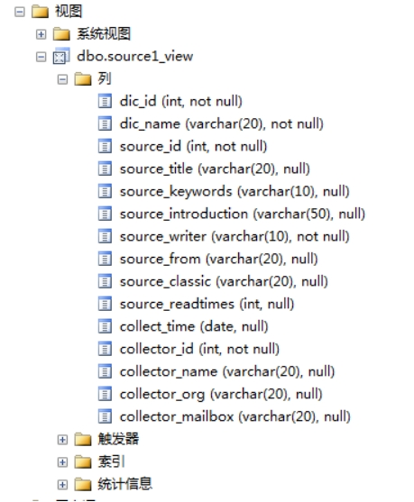

实体索引：

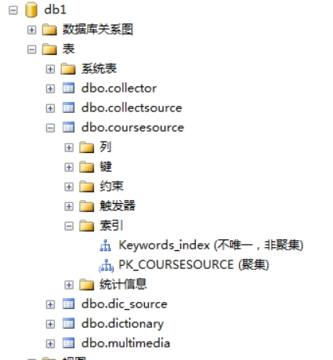

视图索引：

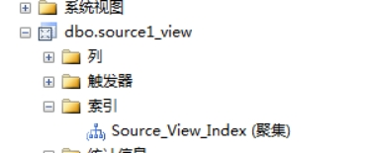

**Insert:**

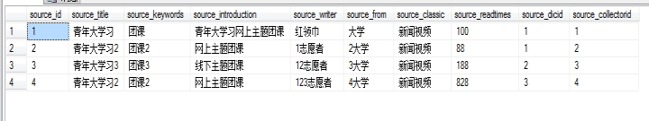

Update:

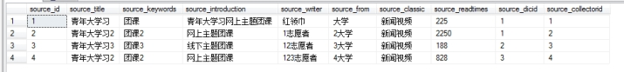

Select:

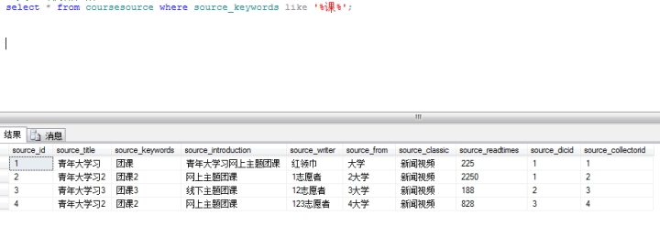

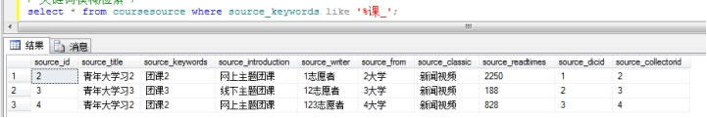

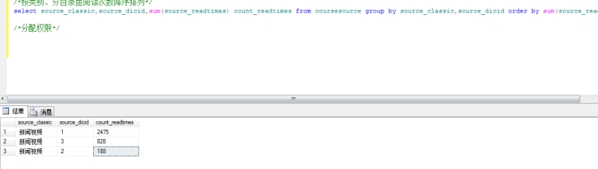

自动生成数据库脚本：

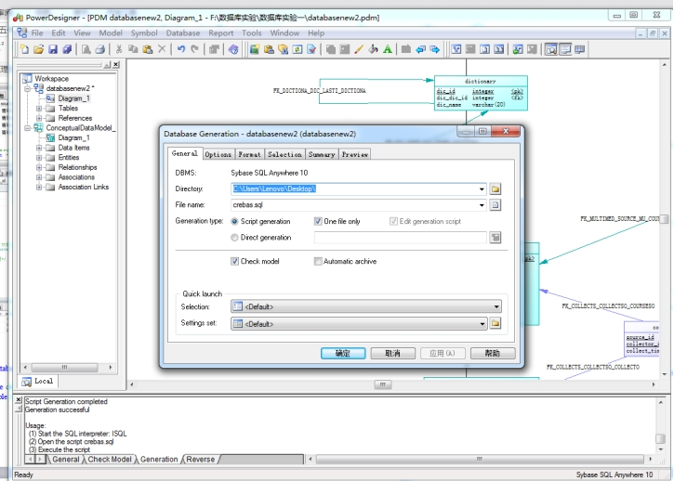

代码：

create database db1;

use db1;

drop table dictionary;

create table dictionary

(

dic_id integer not null

constraint CKC_DIC_ID_DICTIONA check (dic_id >= 1),

dic_dic_id integer

constraint CKC_DIC_DIC_ID_DICTIONA check (dic_dic_id is null or (dic_dic_id >= 1)),

dic_name varchar(20) not null,

constraint PK_DICTIONARY primary key (dic_id)

);

create table coursesource

(

source_id integer not null,

source_title varchar(20),

source_keywords varchar(10),

source_introduction varchar(50),

source_writer varchar(10) not null,

source_from varchar(20),

source_classic varchar(20),

source_readtimes integer,

source_dicid integer,

source_collectorid integer,

constraint PK_COURSESOURCE primary key (source_id)

);

alter table multimedia add media_path varchar(50);

create table multimedia

(

source_id integer not null,

multimedia_id integer,

multimedia_classic varchar(10),

constraint PK_MULTIMEDIA primary key clustered (source_id)

);

create table collector

(

collector_id integer not null,

collector_name varchar(20),

collector_org varchar(20),

collector_mailbox varchar(20),

constraint PK_COLLECTOR primary key (collector_id)

);

/*关系建表*/

create table dic_source

(

dic_id integer not null

constraint CKC_DIC_ID_DIC_SOUR check (dic_id >= 1),

source_id integer not null,

constraint PK_DIC_SOURCE primary key clustered (dic_id, source_id)

);

create table collectsource

(

source_id integer not null,

collector_id integer not null,

collect_time date,

constraint PK_COLLECTSOURCE primary key clustered (source_id, collector_id)

);

/*定义外键*/

alter table collectsource

add constraint FK_COLLECTS_COLLECTSO_COURSESO foreign key (source_id)

references coursesource (source_id)

on update cascade

on delete cascade;

alter table collectsource

add constraint FK_COLLECTS_COLLECTSO_COLLECTO foreign key (collector_id)

references collector (collector_id)

on update cascade

on delete cascade;

alter table dic_source

add constraint FK_DIC_SOUR_DIC_SOURC_DICTIONA foreign key (dic_id)

references dictionary (dic_id)

on update cascade

on delete cascade;

alter table dic_source

add constraint FK_DIC_SOUR_DIC_SOURC_COURSESO foreign key (source_id)

references coursesource (source_id)

on update cascade

on delete cascade;

alter table dictionary

add constraint FK_DICTIONA_DIC_LASTI_DICTIONA foreign key (dic_dic_id)

references dictionary (dic_id)

on update cascade

on delete cascade;

alter table multimedia

add constraint FK_MULTIMED_SOURCE_MU_COURSESO foreign key (source_id)

references coursesource (source_id)

on update cascade

on delete cascade;

/*创建视图*/

create view source1_view

with SCHEMABINDING

as select d.dic_id,d.dic_name,s.source_id,source_title,source_keywords,source_introduction,source_writer,source_from,source_classic,

source_readtimes,cs.collect_time,c.collector_id,c.collector_name,c.collector_org,c.collector_mailbox

from dbo.coursesource s ,dbo.collector c ,dbo.dictionary d,dbo.collectsource cs

where d.dic_id=s.source_dicid and s.source_collectorid=c.collector_id and cs.source_id=s.source_id and

cs.collector_id=c.collector_id

/*创建索引*/

/*单索引*/

create nonclustered index Keywords_index on coursesource(source_keywords);

/*复合索引*/

create unique clustered index Source_View_Index on source1_view(source_title,source_keywords,source_introduction,source_classic,source_writer);

/*向courcesource添加数据*/

insert into dictionary(dic_id,dic_name) values(1,'思想道德修养');

insert into dictionary(dic_id,dic_name) values(2,'思想道德修养');

insert into dictionary(dic_id,dic_name) values(3,'思想道德修养');

insert into collector(collector_id,collector_name,collector_org,collector_mailbox) values(1,'张三','宣传部门','123@163.com');

insert into collector(collector_id,collector_name,collector_org,collector_mailbox) values(2,'李四','组织部门','456@163.com');

insert into collector(collector_id,collector_name,collector_org,collector_mailbox) values(3,'王五','宣传部门','789@163.com');

insert into collector(collector_id,collector_name,collector_org,collector_mailbox) values(4,'赵柳','宣传部门','145@163.com');

insert into coursesource values(1,'青年大学习','团课','网上主题团课','红领巾','1大学','新闻视频',100,1,1) ;

insert into multimedia values(1,1,'视频','https://h5.cyol.com/m.html');

insert into coursesource values(2,'青年大学习','团课','网上主题团课','1志愿者','2大学','新闻视频',88,1,2) ;

insert into multimedia values(2,2,'视频','https://h5.cyol.com/m.html');

insert into coursesource values(3,'青年大学习','团课','线下主题团课','12志愿者','3大学','新闻视频',188,2,3) ;

insert into multimedia values(3,3,'视频','https://h5.cyol.com/m.html');

insert into coursesource values(4,'青年大学习','团课','网上主题团课','123志愿者','4大学','新闻视频',828,3,4) ;

insert into multimedia values(4,4,'视频','https://h5.cyol.com/m.html');

/*更新阅读次数*/

update coursesource set source_readtimes=225 where source_id=1;

update coursesource set source_readtimes=2250 where source_id=2;

/*关键词模糊检索*/

select * from coursesource where source_keywords like '%课%';

select * from coursesource where source_keywords like '%课_';

/*按类别、分目录由阅读次数降序排列*/

select source_classic,source_dicid,sum(source_readtimes) count_readtimes from coursesource group by source_classic,source_dicid order by sum(source_readtimes) DESC;

/*分配权限*/

create role Teacher

grant select on coursesource to Teacher;

create user Wang@localhost identified by '111111';

create user Li@localhost identified by '111111';

create user Zhang@localhost identified by '111111';

grant Teacher to Wang@localhost;

/*显示角色分配*/

show grants for Teacher;

/*撤销权限*/

revoke select on coursesource from Teacher;

**十、实验结论：**

**十一、总结及心得体会：**

**十二、对本实验过程及方法、手段的改进建议：**

**报告评分：**

**指导教师签字：**